Financial Management

Subject Number 18

Study Pack

Strathmore
University
Distance Learning Centre

P.O. Box 59857,
00200, Nairobi,
Kenya.

Tel: +254 (02) 606155
Fax: +254 (02) 607498

Email dlc@strathmore.edu
Copyright
ALL RIGHTS RESERVED. No part of this publication may be reproduced, stored in a retrieval system or transmitted in any form or by any means, electronic, mechanical, photocopying, recording or otherwise without the prior written permission of the copyright owner. This publication may not be lent, resold, hired or otherwise disposed of by any way of trade without the prior written consent of the copyright owner.

© THE REGISTERED TRUSTEES STRATHMORE EDUCATION TRUST 1992

ACKNOWLEDGMENT
We gratefully acknowledge permission to quote from the past examination papers of the following bodies: Kenya Accountants and Secretaries National Examination Board (KASNEB); Chartered Institute of Management Accountants (CIMA); Chartered Association of Certified Accountants (ACCA).

We also wish to express our sincere gratitude and deep appreciation to Mr. Cyrus Iraya MBA, B.COM (Accounting), CPA (K), currently pursuing his PhD in Finance at the University of Nairobi. He is a senior lecturer at Strathmore University, School of Accountancy. He has generously given his time and expertise and skilfully co-ordinated the detailed effort of reviewing this study pack.

INSTRUCTIONS FOR STUDENTS
This study guide is intended to assist distance-learning students in their independent studies. In addition, it is only for the personal use of the purchaser, see copyright clause. The course has been broken down into eight lessons each of which should be considered as approximately one week of study for a full time student. Solve the reinforcement problems verifying your answer with the suggested solution contained at the back of the distance learning pack. When the lesson is completed, repeat the same procedure for each of the following lessons.

At the end of lessons 2, 4, 6 and 8 there is a comprehensive assignment that you should complete and submit for marking to the distance learning administrator.

Submission Procedure
1. After you have completed a comprehensive assignment clearly identify each question and number your pages.
2. If you do not understand a portion of the course content or an assignment question indicate this in your answer so that your marker can respond to your problem areas. Be as specific as possible.
3. Arrange the order of your pages by question number and fix them securely to the data sheet provided. Adequate postage must be affixed to the envelope.
4. While waiting for your assignment to be marked and returned to you, continue to work through the next two lessons and the corresponding reinforcement problems and comprehensive assignment.

On the completion of the last comprehensive assignment a two-week period of revision should be carried out of the whole course using the material in the revision section of the study pack. At the completion of this period the final Mock Examination paper should be completed under examination conditions. This should be sent to the distance-learning administrator to arrive in Nairobi at least five weeks before the date of your sitting the KASNEB Examinations. This paper will be marked and posted back to you within two weeks of receipt by the Distance Learning Administrator.

CONTENTS
ACKNOWLEDGMENT ii
INSTRUCTIONS FOR STUDENTS iii
FINANCIAL MANAGEMENT COURSE DESCRIPTION vi
LESSON ONE 1
Framework Of Financial Management 1
LESSON TWO 12
Investment Decisions 12
LESSON THREE 41
Portfolio Management And Capm 41
LESSON FOUR 54
Mergers And Take- Overs 54
LESSON FIVE 70
Financing And Analysis Of Public Projects 70
LESSON SIX 78
Cost Of Capital And Capital Structure Decisions 78
LESSON SEVEN 99
Long Term Financing Decisions 99
LESSON EIGHT 129
International Financial Organizations And Arrangements 129
LESSON NINE 147
Revision Aid 147

FINANCIAL MANAGEMENT COURSE DESCRIPTION
Financial Management builds on material covered in Business Finance course in Part II. It looks at the major managerial decisions of the Finance Manager in any business firm.
These decisions are:

- Investment decisions
- Financing decisions
- Liquidity decisions
- Division of earnings decisions

The Finance Manager is usually faced with uncertainties and risk in making his decisions. The course therefore looks at how the finance manager deals with these risk and uncertainties in making each of the above decisions.

The course begins with a discussion of the framework of financial management, where the objectives and functions of financial management are considered.

The course then looks at each of the above decisions in detail. An introduction is also made on the operations and policies of major international financial organisations.

Analytical approach for solving financial problems is emphasized.

RECOMMENDED TEXTBOOKS
- Financial management, Eighth edition by Pandey I.M.
- Recommended Further Readings
Intermediate Financial management by Brigham E.F and Gapenski L.C
Managerial Finance by Weston and Copeland

LESSON ONE

FRAMEWORK OF FINANCIAL MANAGEMENT

INSTRUCTIONS:

- Read Chapter 1 of Financial Management by Pandey I.M. and the study text below.
- Complete answers to reinforcement questions at the end of the Lesson.
- Check model answers given in Lesson 9 of the Study Pack.

CONTENTS

- Definition of Financial Management and Required Rate of Return
- Scope of Finance Functions
- Objectives of a Business Entity
- Agency Theory
- Corporate Governance
- Efficient Market Hypothesis

1.1 DEFINITION OF FINANCIAL MANAGEMENT
Financial Management is a discipline concerned with the generation and allocation of scarce resources (usually funds) to the most efficient user within the firm (the competing projects) through a market pricing system (the required rate of return).
A firm requires resources in form of funds raised from investors. The funds must be allocated within the organization to projects which will yield the highest return.
We shall refer to this definition as we go through the subject.

1. 2 Required Rate of Return (R_{i})
The required rate of return (R_{i}) is the minimum rate of return that a project must generate if it has to receive funds. It’s therefore the opportunity cost of capital or returns expected from the second best alternative. In general,

Required Rate of Return = Risk-free rate + Risk premium

Risk free rate is compensation for time and is made up of the real rate of return (R_{r}) and the inflation premium (IR_{p}). The risk premium is compensation for risk of financial actions reflecting:

- The riskiness of the securities caused by term to maturity
- The security marketability or liquidity
- The effect of exchange rate fluctuations on the security, etc.

The required rate of return can therefore be expressed as follows:

R_{j} = R_{r} +IR_{p} +DR_{p} +MR_{p} + LR_{p} + ER_{p} + SR_{p} + OR_{p}.

Where:
- Rr is the real rate of return that compensate investors for giving up the use of their funds in an inflation free and risk free market.
- IRp is the Inflation Risk Premium which compensates the investor for the decrease in purchasing power of money caused by inflation.
- DRp is the Default Risk Premium which compensates the investor for the possibility that users of funds would be unable to repay the debts.
- MRp is the Maturity Risk Premium which compensates for the term to maturity.
- LRp is the Liquidity Risk Premium which compensates the investor for the possibility that the securities given are not easily marketable (or convertible to cash).
- ERp is the Exchange Risk Premium which compensates the investors for the fluctuation in exchange rate. This is mainly important if the funds are denominated in foreign currencies.
- SRp is the Sovereign Risk Premium which compensates the investors for the possibility of political instability in the country in which the funds have been provided.
- ORp is the Other Risk Premium e.g. the type of product, the type of market, etc.

2. SCOPE OF FINANCE FUNCTIONS
The functions of Financial Manager can broadly be divided into two: The Routine functions and the Managerial Functions.

2.1 Managerial Finance Functions
Require skilful planning, control and execution of financial activities. There are four important managerial finance functions. These are:

(a) Investment of Long-term asset-mix decisions
These decisions (also referred to as capital budgeting decisions) relates to the allocation of funds among investment projects. They refer to the firm's decision to commit current funds to the purchase of fixed assets in expectation of future cash inflows from these projects. Investment proposals are evaluated in terms of both risk and expected return.

Investment decisions also relates to recommitting funds when an old asset becomes less productive. This is referred to as replacement decision.

(b) Financing decisions
Financing decision refers to the decision on the sources of funds to finance investment projects. The finance manager must decide the proportion of equity and debt. The mix of debt and equity affects the firm's cost of financing as well as the financial risk. This will further be discussed under the risk return trade-off.

(c) Division of earnings decision
The finance manager must decide whether the firm should distribute all profits to the shareholder, retain them, or distribute a portion and retain a portion. The earnings must also be distributed to other providers of funds such as preference shareholder, and debt providers of funds such as preference shareholders and debt providers. The firm's divided policy may influence the determination of the value of the firm and therefore the finance manager must decide the optimum dividend - payout ratio so as to maximize the value of the firm.

(d) Liquidity decision
The firm's liquidity refers to its ability to meet its current obligations as and when they fall due. It can also be referred as current assets management. Investment in current assets affects the firm's liquidity, profitability and risk. The more current assets a firm has, the more liquid it is. This implies that the firm has a lower risk of becoming insolvent but since current assets are non-earning assets the profitability of the firm will be low. The converse will hold true.
The finance manager should develop sound techniques of managing current assets to ensure that neither insufficient nor unnecessary funds are invested in current assets.

2.2 Routine functions
For the effective execution of the managerial finance functions, routine functions have to be performed. These decisions concern procedures and systems and involve a lot of paper work and time. In most cases these decisions are delegated to junior staff in the organization. Some of the important routine functions are:

(a) Supervision of cash receipts and payments
(b) Safeguarding of cash balance
(c) Custody and safeguarding of important documents
(d) Record keeping and reporting

The finance manager will be involved with the managerial functions while the routine functions will be carried out by junior staff in the firm. He must however, supervise the activities of these junior staff.

3. OBJECTIVES OF A BUSINESS ENTITY
Any business firm would have certain objectives which it aims at achieving. The major goals of a firm are:

- Profit maximization
- Shareholders' wealth maximization
- Social responsibility
- Business Ethics
- Growth

(a) Profit maximization

Traditionally, this was considered to be the major goal of the firm. Profit maximization refers to achieving the highest possible profits during the year. This could be achieved by either increasing sales revenue or by reducing expenses. Note that:

Profit = Revenue – Expenses

The sales revenue can be increased by either increasing the sales volume or the selling price. It should be noted however, that maximizing sales revenue may at the same time result to increasing the firm's expenses.
The pricing mechanism will however, help the firm to determine which goods and services to provide so as to maximize profits of the firm.

The profit maximization goal has been criticized because of the following:

(a) It ignores time value of money
(b) It ignores risk and uncertainties
(c) it is vague
(d) it ignores other participants in the firm rather than the shareholders

(b) Shareholders' wealth maximization

Shareholders' wealth maximization refers to maximization of the net present value of every decision made in the firm. Net present value is equal to the difference between the present value of benefits received from a decision and the present value of the cost of the decision. (Note this will be discussed further in Lesson 2).

A financial action with a positive net present value will maximize the wealth of the shareholders, while a decision with a negative net present value will reduce the wealth of the shareholders. Under this goal, a firm will only take those decisions that result in a positive net present value.

Shareholder wealth maximization helps to solve the problems with profit maximization. This is because, the goal:

i. considers time value of money by discounting the expected future cashflows to the present.
ii. it recognises risk by using a discount rate (which is a measure of risk) to discount the cashflows to the present.

(c) Social responsibility

The firm must decide whether to operate strictly in their shareholders' best interests or be responsible to their employers, their customers, and the community in which they operate. The firm may be involved in activities which do not directly benefit the shareholders, but which will improve the business environment. This has a long term advantage to the firm and therefore in the long term the shareholders wealth may be maximized.

(d) Business Ethics

Related to the issue of social responsibility is the question of business ethics. Ethics are defined as the "standards of conduct or moral behaviour". It can be thought of as the company's attitude toward its stakeholders, that is, its employees, customers, suppliers, community in general, creditors, and shareholders. High standards of ethical behaviour demand that a firm treat each of these constituents in a fair and honest manner. A firm's commitment to business ethics can be measured by the tendency of the firm and its employees to adhere to laws and regulations relating to:

i. Product safety and quality
ii. Fair employment practices
iii. Fair marketing and selling practices
iv. The use of confidential information for personal gain
  - Illegal political involvement
  - bribery or illegal payments to obtain business

(e) Growth
This is a major objective of small companies which may even invest in projects with negative NPV so as to increase their size and enjoy economies of scale in the future.

4. 0 AGENCY THEORY
An agency relationship may be defined as a contract under which one or more people (the principals) hire another person (the agent) to perform some services on their behalf, and delegate some decision making authority to that agent. Within the financial management framework, agency relationship exist between:

(a) Shareholders and Managers
(b) Debtholders and Shareholders

4.1 Shareholders versus Managers
A Limited Liability company is owned by the shareholders but in most cases is managed by a board of directors appointed by the shareholders. This is because:

- There are very many shareholders who cannot effectively manage the firm all at the same time.
- Shareholders may lack the skills required to manage the firm.
- Shareholders may lack the required time.

Conflict of interest usually occur between managers and shareholders in the following ways:

- Managers may not work hard to maximize shareholders wealth if they perceive that they will not share in the benefit of their labour.
- Managers may award themselves huge salaries and other benefits more than what a shareholder would consider reasonable
- Managers may maximize leisure time at the expense of working hard.
- Manager may undertake projects with different risks than what shareholders would consider reasonable.
- Manager may undertake projects that improve their image at the expense of profitability.
- Where management buy out is threatened. ‘Management buy out’ occurs where management of companies buy the shares not owned by them and therefore make the company a private one.

Solutions to this Conflict
In general, to ensure that managers act to the best interest of shareholders, the firm will:

- Incur Agency Costs in the form of:

- Monitoring expenses such as audit fee;
- Expenditures to structure the organization so that the possibility of undesirable management behaviour would be limited. (This is the cost of internal control)
- Opportunity cost associated with loss of profitable opportunities resulting from structure not permit manager to take action on a timely basis as would be the case if manager were also owners. This is the cost of delaying decision.

- The Shareholder may offer the management profit-based remuneration. This remuneration includes:

- An offer of shares so that managers become owners.
- Share options: (Option to buy shares at a fixed price at a future date).
- Profit-based salaries e.g. bonus

- Threat of firing: Shareholders have the power to appoint and dismiss managers which is exercised at every Annual General Meeting (AGM). The threat of firing therefore motivates managers to make good decisions.
- Threat of Acquisition or Takeover: If managers do not make good decisions then the value of the company would decrease making it easier to be acquired especially if the predator (acquiring) company beliefs that the firm can be turned round.

4.2 Debt holders versus Shareholders
A second agency problem arises because of potential conflict between stockholders and creditors. Creditors lend funds to the firm at rates that are based on:

i. Riskiness of the firm's existing assets
ii. Expectations concerning the riskiness of future assets additions
iii. The firm's existing capital structure
iv. Expectations concerning future capital structure changes.

These are the factors that determine the riskiness of the firm's cashflows and hence the safety of its debt issue. Shareholders (acting through management) may make decisions which will cause the firm's risk to change. This will affect the value of debt. The firm may increase the level of debt to boost profits. This will reduce the value of old debt because it increases the risk of the firm.
Creditors will protect themselves against the above problems through:

  - Insisting on restrictive covenants to be incorporated in the debt contract. These covenants may restrict:

- The company’s asset base
- The company’s ability to acquire additional debts
- The company’s ability to pay future dividend and management remuneration.
- The management ability to make future decision (control related covenants)

  - if creditors perceive that shareholders are trying to take advantage of them in unethical ways, they will either refuse to deal further with the firm or else will require a much higher than normal rate of interest to compensate for the risks of such possible exploitations.

It therefore follows that shareholders wealth maximization require fair play with creditors. This is because shareholders wealth depends on continued access to capital markets which depends on fair play by shareholders as far as creditor's interests are concerned.

5.0 CORPORATE GOVERNANCE

5.1 Definition of corporate governance
Corporate governance can be defined in various ways, for example:

The Private Sector Corporate Governance Trust (PSCGT) states that corporate governance, “Refers to the manner in which the power of the corporation is exercised in the stewardship of the corporation total portfolio of assets and resources with the objective of maintaining and increasing shareholders value through the context of its corporate vision” (PSCGT, 1999)
The Cadbury Report (1992) defines corporate governance as the system by which companies are directed and controlled.
The Capital Market Authority (CMA) in year 2000 defined corporate governance as the process and structures used to direct and manage business affairs of the company towards enhancing prosperity and corporate accounting with the ultimate objective of realizing shareholders long-term value while taking into account the interests of other stakeholders.

5.2 Rationale for corporate governance

The organization of the world economy (especially in current years) has seen corporate governance gain prominence mainly because:
- Institutional investors, as they seek to invest funds in the global economy, insist on high standard of Corporate Governance in the companies they invest in.
- Public attention attracted by corporate scandals and collapses has forced stakeholders to carefully consider corporate governance issues.

Corporate governance is therefore important as it is concerned with:

- Profitability and efficiency of the firm.
- Long-term competitiveness of firms in the global economy.
- The relationship among firm’s stakeholders

5.3 Principles of corporate governance
There are 22 principles of Corporate Governance as given by the Common Wealth Association of Corporate Governance (CACG) in1999 and the Private Sector Corporate Governance Trust (PSCGT) in 1999 also. The first ten principles are summarized below.

1. The authority and duties of members (shareholders)
Members and shareholders shall jointly and severally protect, preserve and actively exercise the supreme authority of the corporation in general meeting (AGM). They have a duty to exercise that supreme authority to:

- Ensure that only competent and reliable persons who can add value are elected or appointed to the board of directors (BOD).
- Ensure that the BOD is constantly held accountable and responsible for the efficient and effective governance of the corporation so as to achieve corporate objective, prospering and sustainability.
- Change the composition of the BOD that does not perform to expectation or in accordance with mandate of the corporation

2. Leadership
Every corporation should be headed by an effective BOD, which should exercise leadership, enterprise, integrity and judgements in directing the corporation so as to achieve continuing prosperity and to act in the best interest of the enterprise in a manner based on transparency, accountability and responsibility.

3. Appointments to the BOD
It should be through a well managed and effective process to ensure that a balanced mix of proficient individuals is made and that each director appointed is able to add value and bring independent judgment on the decision making process.

4. Strategy and Values
The BOD should determine the purpose and values of the corporation, determine strategy to achieve that purpose and implement its values in order to ensure that the corporation survives and thrives and that procedures and values that protect the assets and reputation of the corporation are put in place.

5. Structure and organization
The BOD should ensure that a proper management structure is in place and make sure that the structure functions to maintain corporate integrity, reputation and responsibility.

6. Corporate Performance, Viability & Financial Sustainability
The BOD should monitor and evaluate the implementation of strategies, policies and management performance criteria and the plans of the organization. In addition, the BOD should constantly revise the viability and financial sustainability of the enterprise and must do so at least once in a year.

7. Corporate compliance
The BOD should ensure that corporation complies with all relevant laws, regulations, governance practices, accounting and auditing standards.

8. Corporate Communication
The BOD should ensure that corporation communicates with all its stakeholders effectively.

9. Accountability to Members
The BOD should serve legitimately all members and account to them fully.

10. Responsibility to stakeholders
The BOD should identify the firm’s internal and external stakeholders and agree on a policy (ies) determining how the firm should relate to and with them, increasing wealth, jobs and sustainability of a financially sound corporation while ensuring that the rights of the stakeholders are respected, recognized and protected.

6.0 EFFICIENT MARKET HYPOTHESIS (EMH)

6.1 Types of Efficiency

Efficient market hypothesis can be explained in 3 ways:
- Allocative Efficiency
A market is allocatively efficient if it directs savings towards the most efficient productive enterprise or project. In this situation, the most efficient enterprises will find it easier to raise funds and economic prosperity for the whole economy should result.

Allocative efficiency will be at its optimal level if there is no alternative allocation of funds channelled from savings that would result in higher economic prosperity. To be allocatively efficient, the market should have fewer financial intermediaries such that funds are allocated directly from savers to users, therefore financial disintermediation should be encouraged.

- Operational Efficiency
This concept relates to the cost, to the borrower and lender, of doing business in a particular market. The greater the transaction cost, the greater the cost of using financial market and therefore the lower the operational efficiency. Transaction cost is kept as low as possible where there is open competition between broker and other market participants. For a market to be operationally efficient, therefore, we need to have enough market markers who are able to play continuously.

- Information Efficiency
This reflects the extent to which the information regarding the future prospect of a security is reflected in its current price. If all known (public information) is reflected in the security price, then investing in securities becomes a fair game. All investors have the same chances mainly because all the information that can be known is already reflected in share prices. Information efficiency is important in financial management because it means that the effect of management decision will quickly and accurately be reflected in security prices. Efficient market hypothesis relates to information processing efficiency. It argues that stock markets are efficient such that information is reflected in share prices accurately and rapidly.

6.2 Forms of Efficiency

Informational efficiency is usually broken down into 3 different levels (forms):

a. Weak form level of efficiency
This level states that share prices fully reflect information in historic share price movement and patterns (past information/historic information). If this hypothesis is correct, then, it should be possible to predict future share price movement from historical patterns. E.g. If the company’s shares have increased steadily over the past few months to the current price of Shs.30, then this price will already fully reflect the information about the company’s growth and therefore the next change in share prices could either be upward, downward or constant with equal probability. It therefore follows that technical analysis or Chartism will not enable investors to make arbitrage profits. In markets that have achieved this level then security prices follow a trendles random walk.

Studies to test this level have been based on the principle that:

  - The share price changes are random
  - That there is no connection between share price movement and new share price changes. It is possible to prove statistically that there is no correlation between successive changes in price of shares and therefore trend in share price changes cannot be detected. This can be done by using serial correlation (or auto-correlation) test such as Durbin Watson Statistics.

b) Semi-Strong form level of Efficiency
This level states that share prices reflects all available public information. (past and present information). If the market has achieved this level, then fundamental analysis will not enable investors to earn consistently higher than average returns. Fundamental analysis involves the study of company’s accounts to determine its theoretical value and thereby find any undervalued share. Fundamental theory states that every share in the market has an intrinsic value, which is equal to the present value of cash flows expected from the security.

Tests to prove semi-strong form of efficiency have concentrated on the ability of the market to anticipate share price changes before new information is formally announced. These tests are referred to as Event Studies. E.g. if two companies plans to merge, share prices of the 2 companies will change once the merger plans are made public. The market would show semi-strong form of efficiency if it were able to anticipate such changes so that share prices of the company would change in advance of the merger plans being confirmed. Other events that can affect share prices are:

- Stock splits
- Death of CEO of company
- Investment in major profitable projects
- Changes in dividend policy, etc

c) Strong form level of Efficiency
This level states that price reflects all the available public and private information (past, present and future information). If the hypothesis is correct, then, the mere publication of information that was previously confidential should not have impact on share prices. This implies that insider trading is impossible. It follows therefore, that in order to maximize shareholders’ wealth, managers should concentrate on maximizing the NPV of each investment.

Tests that have been carried out on this level have concentrated on activities of fund managers and individual investors. If the markets have reached the strong form levels, then fund managers cannot consistently perform better than individual investors in the market.

6.3 IMPLICATIONS OF EMH FOR FINANCIAL DECISION MAKERS
- The Timing Of Financial Policy
Some financial managers argue that there is a right or wrong time to issue securities i.e. new shares should only be issued when the market is at the top rather than the bottom. If the market is efficient, however, price follows a trendless random walk and its impossible for managers to know whether today’s price is the highest or the lowest. Timing other policies e.g release of financial statements, announcement of stock splits, etc has no effect on share prices.

- Project Evaluation Based Upon NPV
When evaluating new projects, financial managers use the required rate of return drawn from securities traded in the capital market. For example, the rate of return required on a particular project may be determined by observing the rate of return required by shareholders of firms investing in projects of similar risk. This assumes that securities are fairly priced for the risks that they carry (i.e. the market is efficient).

If the market is inefficient, however, financial managers could be appraising projects on a wrong basis and therefore making bad investment decisions since their estimate on NPV is unreliable.

- Creative Accounting
In an efficient market, prices are based upon expected future cash flow and therefore they reflect all current information. There is no point therefore in firms attempting to distort current information to their advantage since investors will quickly see through such attempts. Studies have been done for example to show that changes from straight-line depreciation to reducing balance method, although it may result to increasing profit, may have no long-term effect on share prices. This is because the company’s cash flows remain the same. Other studies support the conclusion that investors cannot be fooled by manipulation of accounting profit figure or charges in capital structure of company. Eventually, the investors will know the cash flow consequences and alter the share prices consequently.

- Mergers and Takeovers
If shares are correctly priced then the purchase of a share is a zero NPV transaction. If this is true then, the rationale behind mergers and takeovers may be questioned. If companies are acquired at their correct equity position then purchasers are breaking even. If they have to make significant gains on the acquisition, then they have to rely on synergy in economies of scale to provide the saving. If the acquirer (or the predator) pays the current equity value plus a premium, then this may be a negative NPV decision unless the market is not fully efficient and therefore prices are not fair.

- Validity of the current market price
If markets are efficient then they reflect all known information in existing share prices and investors therefore know that if they purchase a security at the current market price they are receiving a fair return and risk combination. This means that under or over valued shares or market securities do not exist. Companies shouldn’t offer substantial discounts on security issues because investors would not need extra incentives to purchase the securities.

REINFORCEMENT QUESTIONS

QUESTION ONE
Within a financial management context, discuss the problems that might exist in the relationships (Sometimes referred to as agency relationships) between

(a) Shareholders and managers, and
(b) Shareholders and creditors

How might a company attempt to minimise such problems?

QUESTION TWO
Two neighbouring countries have chosen to organize their electricity supply industries in different ways. In country A, electricity supplies are provided by a nationalised industry. On the other hand in country B electricity supplies are provided by a number of private sector companies.

Required:

(a) Explain how the objectives of the nationalised industry in country A might differ from those of the private sector companies in country B.
(b) Briefly discuss whether investment planning and appraisal techniques are likely to differ in the nationalised industry and private sector companies.

QUESTION THREE
"The finance manager spends most of his time making managerial finance decisions as opposed to routine functions". Discuss.

CHECK YOUR ANSWERS WITH THOSE GIVEN IN LESSON 9 OF THE STUDY PACK

LESSON TWO

INVESTMENT DECISIONS

INSTRUCTIONS

1. Read Chapter 11, 12, 14, 15 and 16 of Pandey I.M. Then read study text below.
2. Complete answers to reinforcement questions at the end of the lesson.
3. Check model answers given in Lesson 9 of the Study Pack.

CONTENTS

1. Review of capital budgeting techniques
2. Investment appraisal techniques
3. Projects selection under capital rationing
4. Abandonment value
5. Risk analysis in capital budgeting
6. Actual measurement of risk
7. Incorporating risk in capital budgeting
8. Sensitivity analysis
9. Break-even analysis
10. A simulation approach to capital budgeting under risk
11. Decision tree for sequential decisions
12. Utility theory

1. REVIEW OF CAPITAL BUDGETING TECHNIQUES

Capital budgeting (investment) decisions may be defined as the firm's decisions to invest its current funds most efficiently in the long-term assets in anticipation of an expected flow of benefit over a series of years. The firm therefore:

(a) exchanges current funds for future benefits
(b) invests the funds in long-term assets
(c) expects future benefit over a series of years

2. INVESTMENT APPRAISAL TECHNIQUES

The investment appraisal techniques can be categorised into two groups:

(a) Discounted Cashflow methods

i. Net present value method
ii. Internal rate of return
iii. Profitability index

(b) Non-discounted cashflow method

i. Accounting rate of return
ii. Payback period

DISCOUNTED CASHFLOW METHODS

1. Net Present Value (NPV)

This is defined mathematically as the present value of cashflow less the initial outflow.
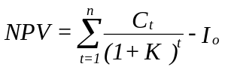

Where C_{t} is the cashflow
K is the opportunity cost of capital
I_{o} is the initial cash outflow
n is the useful life of the project

Decision Rule using NPV

The decision rule under NPV is to:

- Accept the project if the NPV is positive
- Reject the project if NPV is negative

Note: if the NPV = 0, use other methods to make the decision.

2. Internal Rate of Return (IRR)

The internal rate of return of a project is that rate of return at which the projects NPV = 0

Therefore IRR occurs where:

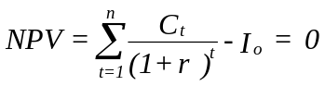

Where r = internal rate of return

Note that IRR is that ratio of return that causes the present value of cashflows to be equal to the initial cash outflow.

Decision Rule under IRR

If IRR > opportunity cost of capital - accept the project

- IRR < opportunity cost of capital - reject the project

- IRR = opportunity cost of capital - be indifferent

3. Profitability Index

This is a relative measure of projects profitability. It is given by the following formula.

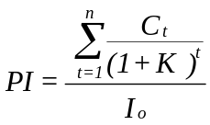

Decision Rule

If PI > 1 - Accept the project
PI < 1 - Reject the project
PI = 1 - Be indifferent

NON-DISCOUNTED CASHFLOW METHODS

1. Accounting rate of return (ARR)

ARR = Average annual income
Average investment

Where Average annual income = Average cashflows - Average Depreciation
Average investment = 1/2 (Cost of investment - Salvage value)
(assuming straight line depreciation method).
Projects with higher ARR are preferable.

2. Payback Period

This is defined as the time taken by the project to recoup the initial cash outlay.
The decision rule depends on the firms target payback period (i.e. the maximum period beyond which the project should not be accepted.

ILLUSTRATION

A company is considering two mutually exclusive projects requiring an initial cash outlay of Sh 10,000 each and with a useful life of 5 years. The company required rate of return is 10% and the appropriate corporate tax rate is 50%. The projects will be depreciated on a straight line basis. The before depreciation and taxes cashflows expected to be generated by the projects are as follows.

YEAR 1 2 3 4 5
Project A Shs 4,000 4,000 4,000 4,000 4,000
Project B Shs 6,000 3,000 2,000 5,000 5,000

Required:

Calculate for each project
i. The payback period
ii. The average rate of return
iii. The net present value
iv. Profitability index
v. The internal rate of return

Which project should be accepted? Why?

Suggested Solution

Computation of after tax cashflows

Depreciation = 10,000 - 0 = Sh 2,000
5

Project A Annual Cashflow
Cashflows before depreciation 4,000
Less Depreciation 2,000
Profits before taxes 2,000
Less taxes (50%) 1,000
Profits after tax 1,000
Add back depreciation 2,000
Cashflows after taxes 3,000

Project B

Year 1 2 3 4 5
Cashflow before depreciation 6,000 3,000 2,000 5,000 5,000
Less depreciation 2,000 2,000 2,000 2,000 2,000
Profits before taxes 4,000 1,000 0 3,000 3,000
Less taxes (50%) 2,000 500 0 1,500 1,500
Profits after taxes 2,000 500 0 1,500 1,500
Add back depreciation 2,000 2,000 2,000 2,000 2,000
Net cashflows after taxes 4,000 2,500 2,000 3,500 3,500

i. Payback Period (PB)

Project A = 10,000 = 3 1/3 years
3,000

Project B

Sh 4,000 + Sh 2,500 + Sh 2,000 = Sh 8,500 is recovered in three years. The remaining amount of Sh 10,000 - 8,500 = 1,500 is to be recovered in the fourth year.

Thus PB = 3 years + 1,500 = 3 3/7 years
3,500

According to PB Project A is better.

ii. Average Rate of Return (ARR)

Project A

Average income = 5 x 1,000 = Shs 1,000
5

Average investment = 10,000/2 = Shs 5,000

ARR = 1,000 = 0.20 or 20%
5,000

Project B

Average income = 2,000 + 500 + 0 + 1,500 + 1,500
5

= 5,500 = Shs 1,100
5

ARR = 1,100 = 0.22 or 22%
5,000

According to ARR Project B is better.

iii. Net Present Value Method

Project A

NPV = Annual Cashflows x PVIFA _{10%, 5 years} - Initial Cost (where PVIFA is the Present Value Interest Factor of annuity)

= 3,000 x 3.791 - 10,000 = Sh 1,373

Project B
NPV can be computed using the following table:
Year Cashflows PV.F _{10%} PV
1 4,000 0.909 3,636
2 2,500 0.826 2,065
3 2,000 0.751 1,502
4 3,500 0.683 2,390.5
5 3,500 0.621 2,173.5
Total PV 11,767
Less initial cost 10,000
NPV 1,767

Project B is better because it has a higher NPV.

iv. Profitability index (PI)

Project A

PI = 11,373 = 1.1373
10,000

Project B

PI = 11,767 = 1.1767
10,000

Project B is better since it has a higher PI.

v. The Internal Rate of Return

Project A

NPV = 3,000 X PVIFA _{r%, 5years} - 10,000 = 0

PVIFA _{r%, 5years} = 10,000 = 3.333
3,000

From the table r lies between 15% and 16%. We use linear interpolation to compute the exact rate.

PVIFA _{15%} = 3.352 PVIFA _{15%} = 3.352
PVIFA required = 3.333 PVIFA _{16%} = 3.274
Difference 0.019 Difference 0.078

IRR = 15% + (16 - 15) (0.019) = 15.24%
0.078

Project B

We use trial and error method since the cashflow are uneven:

NPV at 16% = 10,186 - 10,000 = 186
NPV at 17% = 9,960.5 - 10,000 = (39.5)

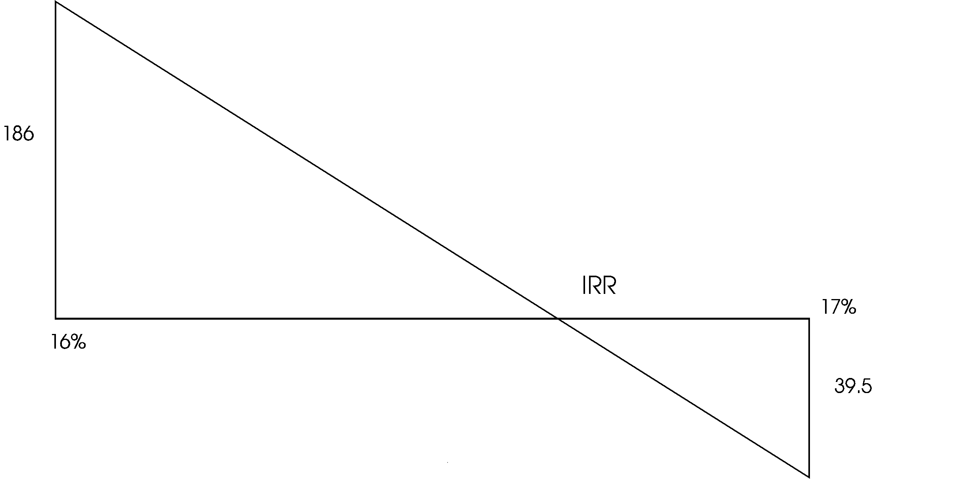

Using Similar Triangle

IRR - 16 = 17 - IRR
186 39.5

39.5 (IRR - 16) = 186 (17 - IRR)
39.5 IRR - 632 = 3,162 - 186 IRR

225.5 IRR = 3.794
IRR ≈ 16.8%

Project B is better because it has a higher IRR.

Generally, Project B should be selected because the discounted cashflow methods supports this decision.

Note: The methods discussed so far assume that investment decisions are made under conditions of certainty. In real life, however, this is not the case and therefore we shall consider risk and other complications in the following sections.

3. PROJECTS SELECTION UNDER CAPITAL RATIONING

If a firm rations capital its value is not being maximised. A value maximizing firm would invest in all projects with positive NPV. The firm may however want to maximize value subject to the constraint that the capital ceiling is not to be exceeded.

A linear programming method can be used to solve constrained maximization problems. The objective should be to select projects subject to the capital rationing constraint such that the sum of the projects NPVs is maximized.

Illustration
Management is faced with eight projects to invest in. The capital expenditures during the year has been rationed to Sh 500,000 and the projects have equal risk and therefore should be discounted at the firm's cost of capital of 10%.

Project Cost Project Cashflow NPV at the
t = 0(Shs) Life per year 10% cost
1 400,000 20 58,600 98,895
2 250,000 10 55,000 87,951
3 100,000 8 24,000 28,038
4 75,000 15 12,000 16,273
5 75,000 6 18,000 3,395
6 50,000 5 14,000 3,071
7 250,000 10 41,000 1,927
8 250,000 3 99,000 (3,802)

Required:

Determine the optimal investment sets.

Max Z = 98,895 X₁ + 87,951 X₂ + 28,038 X₃ + 16,273 X₃ + ... + (3,802) X₈

St 1 = 400,000 X₁ + 250,000 X₂ + 100,000 X₃ + ... + 250,000 X₈ ≤ 500,000

2 = 1 < X₁, X₂, X₃ ... X₈ > 0

The Optimal Budget:

Project Cost NPV
2 250,000 87,951
3 100,000 28,038
4 75,000 16,273
5 75,000 3,395
500,000 135,657

4. ABANDONMENT VALUE
It has been assumed so far that the firm will operate a project over its full physical life. However, this may not be the best option - it may be better to abandon a project prior to the end of potential life. Any project should be abandoned when the net abandonment value is greater than the present value of all cash flows beyond the abandonment year, discounted to the abandonment decision point. Consider the following example:

Project A has the following cashflows over its useful life of 3 years. The market value (Abandonment value) has also been given.

Year Cash Abandonment
flow value
Sh`000' Sh`000'
0 (4,800) 4,800
1 2,000 3,000
2 1,875 1,900
3 1,750 0

Required:

Determine when to abandon the project assuming a discount rate of 10%.

Suggested Solution:

If the project is used over its life, the NPV is negative as shown below:

NPV = 2,000 x PVIF _{10%, 1year} + 1,875 X PVIF _{10%, 2years} + 1,750 X PVIF _{10%, 2 yrs} - 4,800

= 2,000 x 0.909 + 1,875 x 0.826 + 1,750 x 0.751 - 4,800

= Shs -119

The project should not be accepted. However, if the project is abandoned after 1 year the NPV would be

NPV = 2,000 x 0.909 + 3,000 x 0.909 - 4,800
= Sh -255

If abandoned after 2 years

NPV = 2,000 x 0.909 + 1,875 x 0.826 + 1,900 x 0.826 - 4,800
= Sh 136

The NPV is positive if the project is abandoned after 2 years and therefore this is the optimal decision.

Note that abandonment value should be considered in the capital budgeting process because, as our example illustrates, there are cases in which recognition of abandonment can make an otherwise unacceptable project acceptable. This type of analysis is required to determine projects economic life.

5. RISK ANALYSIS IN CAPITAL BUDGETING

The Risk associated with a project may be defined as the variability that is likely to occur in the future returns from the project. Risk arises in investment evaluation because we cannot anticipate the occurrence of the possible future events with certainty and consequently, cannot make any correct prediction about the cashflow sequence.

Attitudes towards Risk

Three possible attitudes towards Risk can be identified. These are:

(a) Risk aversion
(b) Desire for Risk
(c) Indifference to Risk

A Risk averter is an individual who prefers less risky investment. The basic assumption in financial theory is that most investors and managers are risk averse.

Risk seekers on the other hand are individuals who prefer risk. Given a choice between more and less risky investments with identical expected monetary returns, they would prefer the riskier investment.

The person who is indifferent to risk would not care which investment he or she received.

To illustrate the attitudes towards risk assume two projects are available. The cashflows are not certain but we can assign probabilities to likely cashflows as shown below.

States of nature Project A's Project B's Probability
cashflow cashflow
Optimistic prediction Sh 900,000 600,000 0.2
Moderate prediction 600,000 600,000 0.6
Pessimistic prediction 300,000 600,000 0.2

The expected cashflow would be computed as follows:

Project A

Expected cashflow = 900,000 (0.2) + 600,000 (0.6) + 300,000 (0.2)
= Sh 600,000

Project B

Expected cashflow = 600,000 (0.2) + 600,000 (0.6) + 600,000 (0.2)
= Sh 600,000

Therefore, the two projects have the same expected cashflows (Sh 600,000). However, Project A is a riskier project since there is a chance that the cashflow will be Sh 300,000. Project B on the other hand is a less risky project since we are sure that Sh 600,000 will be received.

A risk seeker would choose Project A while a risk averter would choose Project B. A risk neutral decision maker would be indifferent between the two projects since the expected cashflows are equal.

6. ACTUAL MEASUREMENT OF RISK

A number of basic statistical devices may be employed to measure the extent of Risk Inherent in any given situation. Two important measures are:

(a) Standard deviation of cashflows
(b) Coefficient of variation
(c) The Beta (ß) can also be used and is dealt with under Portfolio Analysis

To illustrate the first two methods, let us assume that we are examining an investment with the possible outcomes and probability of outcomes as shown below:

Note: the outcome could either be cashflow or NPV.

Assumptions (states of nature) Outcome Sh`000' Probability
Pessimistic 300 0.2
Moderately successful 600 0.6
Optimistic 900 0.2

The expected value which is a weighted average of the outcomes times their probabilities can be computed as follows:

Expected value (D) = ΣDP

Where D is the outcome
P is the probability
D is the expected outcome

Figures in `000'
D P DP
300 0.2 60
600 0.6 360
900 0.2 180
ΣDP 600

The expected value is therefore Sh 600,000. We can therefore compute the standard deviation, which is given by the following formula.

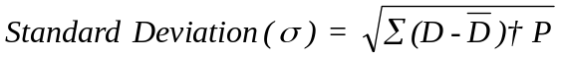

Computation of standard deviation
300 0.2 -300 90,000 18,000

600 0.6 0 0 0
900 0.2 300 90,000 18,000
36,000

= √36,000

= SH 190,000

The standard deviation of Sh 190,000 gives a rough average measure of how far each of the three outcomes falls away from the expected value. Generally, the larger the standard deviation, the greater the risk.

However, to compare projects of unequal size, we need a different measure since standard deviation would not do. Consider, for example two projects with the following expected outcome and standard deviation.

Project Expected value Standard deviation
A Sh 6,000 600
B Sh 600 190

To decide which of the two projects, is a more risky project we need to compute the coefficient of variation (C.V)

The coefficient of variation is a relative measure and is given by the following formula.

For investments Projects A and B discussed earlier, the coefficient of variation can be computed as follows:-

Project A

CV = 600 = 0.100
6,000

Project B

CV = 190 = 0.317
600

Generally, the larger the coefficient of variation, the greater the risk. Therefore, Project B carries a greater risk than Project A.

Another risk measure, the beta (ß) is widely used with portfolios of common stock. Beta measures the volatility of returns, on an individual stock relative to a stock market index of returns.
(Note: Beta will be discussed under portfolio analysis).

7. INCORPORATING RISK IN CAPITAL BUDGETING

Several methods can be used to incorporate risk into capital budgeting decisions. Some of these methods are:

(a) Payback period
(b) Risk-adjusted discount rate
(c) Certainty equivalents
(d) Sensitivity analysis
(e) Statistical techniques

1. Payback

Payback period is an attempt to allow for risk in capital budgeting. As discussed earlier, firms using Payback period usually prefer short payback to longer ones, and often establish guidelines such that the firm accepts only investments with some maximum payback period, say three or five years. This method suffers from the following limitations:

(a) It ignores the time value of cashflows
(b) It does not make any allowance for the time pattern of the initial capital recovered
(c) Setting the maximum payback period as two, three or five years usually has little logical relationship to risk preferences of individuals or firms.

2. Risk-adjusted discount rate

This approach uses different discount rates for proposals with different risk levels. A project that carries a normal amount of risk and does not change the overall risk composure of the firm should be discounted at the cost of capital. Investments carrying greater than normal risk will be discounted at a higher discount rate.

The NPV of the project will be given by the following formula.

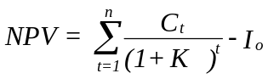

Where C_{t} is cashflows at period t
K is the risk adjusted discount rate
I_{o} is initial cash outflow (cost of project)

Note that K_{f} + φ

Where K_{f} = the risk-free rate
φ = the risk premium

The following diagram shows a possible risk-discount rate trade off scheme. Risk is assumed to be measured by the coefficient of variation, C.V)

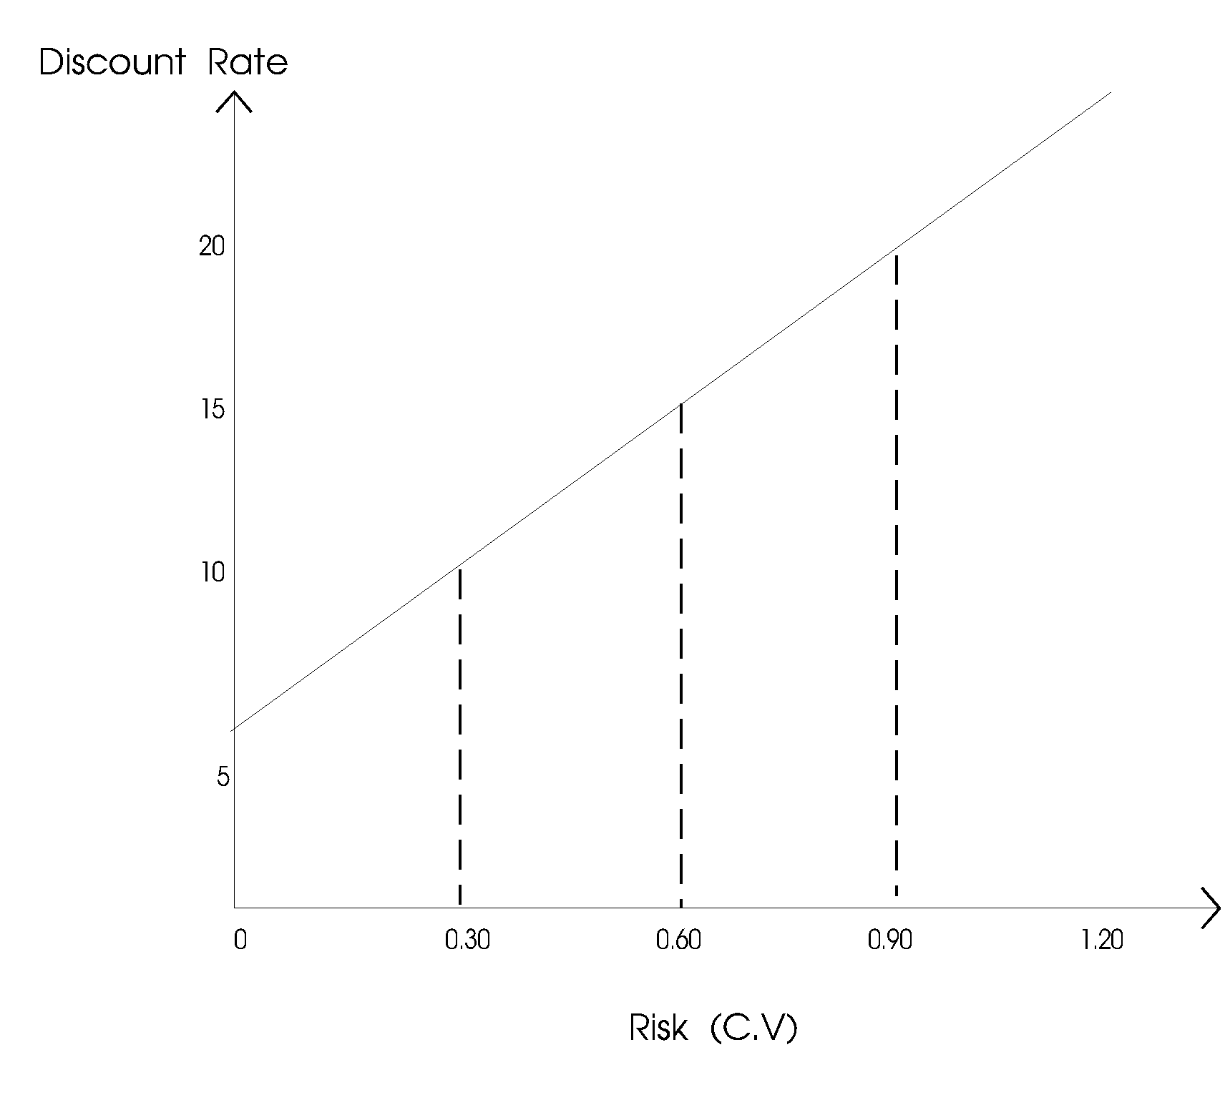

The normal risk for the firm is represented by a coefficient of variation of 0.30. An investment with this risk will be discounted at the firm's normal cost of capital of 10%. As the firm selects riskier projects with, for example, a C.V. of 0.90, a risk premium of 5% is added for an increase in C.V. of 0.60 (0.90 - 0.30). If the firm selects a project with a C.V. of 1.20, it will now add another 5% risk premium for this additional C.V. of 0.30 (1.20 - 0.90). Notice that the same risk premium was added for a smaller increase in risk. This is an example of being increasingly risk averse at higher levels of risk and potential return.

Advantages of Risk-adjusted discount rate

(a) It is simple and can be easily understood.
(b) It has a great deal of intuitive appeal for risk-averse businessmen.
(c) It incorporates an attitude (risk-aversion) towards uncertainty.

Disadvantages

(a) There is no easy way of deriving a risk-adjusted discount rate.
(b) It does not make any risk adjustments in the numerate - for the cashflows that are forecast over the future years.
(c) It is based on the assumption that investors are risk averse. (Not all investors are risk averse as discussed earlier).

3. Certainty Equivalent

Using this method the NPV will be given by the following formula:

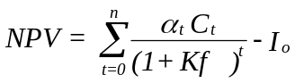

Where C_{t} = Forecasted cashflows (without risk adjustment)
α_{t} = the risk-adjusted factor or the certainty equivalent coefficient
I_{o} = Initial cash outflow (cost of project)
K_{f} = risk-free rate (assumed to be constant for all period).

The certainty equivalent coefficient assumes a value between 0 and 1 and varies inversely with risk. Therefore, a lower α_{t} will be used if greater risk is perceived and a higher α_{t} if lower risk is anticipated.

The coefficient are subjectively established by the decision maker and represents the decision maker's confidence in obtaining a particular cashflow in period t.

The certainty equivalent coefficient can be determined by the following formula.

α_{t} = certain net cashflow
risky net cashflow

For example, if an investor expects a risky cashflow of Sh 100,000 in period t and considers a certain cashflow of Sh 80,000 equally desirable, the α_{t} will be:

α_{t} = 80,000 = 0.8
100,000

Illustration:

Assume a project costs Sh 30,000 and yields the following uncertain cashflows:

Year Cashflow
1 12,000
2 14,000
3 10,000
4 6,000

Assume also that the certainty equivalent coefficients have been estimated as follows:

α₀ = 1.00
α₁ = 0.90
α₂ = 0.70
α₃ = 0.50
α₄ = 0.30

The risk-free discount rate is given as 10%

Required

Compute the NPV of the project

Solution:

= 0.9 (12,000) + 0.7 (14,000) + 0.5 (10,000) + 0.3 (6,000) - 30,000
1 + 0.1 (1 + 0.1)² (1 + 0.1)³ (1 + 0.1)⁴

Using the present value interest factor tables:

Year Certain Cashflows PVIF_{10%} PV
0 (30,000) 1.00 (30,000)
1 0.9 (12,000) 0.909 9,817.2
2 0.7 (14,000) 0.826 8,094.8
3 0.5 (10,000) 0.751 3,755.0
4 0.3 (6,000) 0.683 1,229.4
NPV (7,103.6)

The project has a negative NPV and therefore should not be undertaken.

Note that if risk was ignored the NPV would have been Sh 4,080 and the project would have been accepted.

Merits of certainty equivalent approach
1. This method explicitly recognises risk.
2. It recognises that cashflows further away into the future are less certain (therefore a lower α_{t})

Demerits
1. The method of determining α_{t} is subjective and is likely to differ from project to project.
2. The forecaster, expecting the reduction that will be made to his forecasts, may inflate them in anticipation.
3. When forecasts have to pass through several layers of management, the effect may be to greatly exaggerate the original forecast or to make it ultra conservative.

8. SENSITIVITY ANALYSIS
Sensitivity Analysis is a way of analysing change in the project's NPV for a given change in one of the variables affecting the NPV. It indicates how sensitive the NPV is to changes in particular variables. The more sensitive the NPV, the more critical the variable.

Steps followed in use of Sensitivity Analysis

1. Identification of all those variables which have an influence on the projects NPV.
2. Definition of the underlying (mathematical) relationship between variables.
3. Analysis of the impact of the change in each of the variables on the projects NPV.

Sensitivity Analysis allows the decision maker to ask "what if" questions.

To illustrate let us consider an example. A project has annual cashflows of Sh 30,000 and an initial cost of Sh 150,000. The useful life of the project is 10 years. The cashflows can further be broken as follows:

Sh
Revenue 375,000
Variable costs 300,000
Fixed costs 30,000
Depreciation 15,000 345,000
Before tax profit 30,000
Tax (50%) 15,000
After tax profits 15,000
Add back depreciation 15,000
Net annual cashflows 30,000

The cost of capital is 10% and depreciation method is straight line.

The NPV of the project is:

NPV = 30,000 x PVIFA _{10%, 10 yrs} - 150,000
= 30,000 x 6.145 - 150,000
= Sh 34,350

The NPV is positive and therefore the project is acceptable. However, the investor should consider how confident he is about the forecast and what would happen if the forecast goes wrong. A sensitivity can be conducted with regard to volume, price, cost etc. In order to do so we must obtain pessimistic and optimistic estimates of the underlying variables.

Assume that in the above example, the variables used in the forecasts are:

(a) Volume of sale ( = market size x market share)
(b) Unit price
(c) Unit variable costs
(d) Fixed costs

Assume further that the pessimistic, expected and optimistic estimates are:

Variable Pessimistic Expected Optimistic
Market Size 9,000 10,000 11,000
Market Share 0.004 0.01 0.016
Unit price (Sh) 3,500 3,750 3,800
Unit variable costs (Sh) 3,600 3,000 2,750
Fixed costs (Sh) 40,000 30,000 20,000

The resulting NPVs would be:
NPV in shillings
Pessimistic Expected Optimistic
Market size 11,306.25 34,350 57,393.75
Market share -103,912.5 34,350 172,612.5
Unit price -42,462.5 34,350 49,712.5
Unit variable cost -150,000 34,350 11,162.5
Fixed costs 3,625 34,350 65,075

Note that NPV under this category is: Sh

Revenue = 3,750(9,000 x 0.01) = 90 x 3,750 337,500
Variables cost = 3,000 (9,000 x 0.01) = 90 x 3,000 270,000
Contribution margin 67,500
Less Fixed costs + Depreciation 45,000
22,500
11,250
Less tax 11,250
Add back depreciation 15,000
Net cashflows 26,250

NPV = 26,250 X 6.145 - 150,000
= Sh 11,306.25

It is important to note that only one variable is allowed to vary at a time and all the others are held constant (at their expected values).

It has been assumed that a negative pre-tax profit will be reduced by tax credit from the government.

From the project the most dangerous variables appear to be market share and unit variable cost. If the market share is 0.004 (and all other variables are as expected), then the project's NPV is -Sh 103,912.5. If unit variable cost is Sh 3,600 (and all other variables are as expected), then the project has an NPV of -150,000. Therefore the most sensitive factor is the unit variable cost, followed by market share and unit price follows. Market size and fixed costs are not very sensitive.

9. BREAK-EVEN ANALYSIS

Sensitivity analysis is a variation of the break-even analysis. In sensitivity analysis we are asking; for example, what shall be the consequences if volume or price or cost changes? This question can be asked differently: How much lower the sales volume can become before the project becomes unprofitable? To answer this question we shall require the Breakeven point.

Continuing with the above example, let us compute the level of units variable costs above which the NPV is negative.

NPV = Annual cashflows x PVIFA _{10%, 10 yrs} - 150,000

But
Annual cashflows = Revenue - variable costs - Fixed costs - depreciation - Tax + depreciation.

Let variable cost per unit be V

Annual cashflows = (375,000 - 100 (V) - 45,000)0.5 + 15,000

Therefore NPV = [(330,000 - 100 V) 0.5 + 15,000] x 6.145 - 150,000

At Break even point NPV = 0

Therefore (165,000 - 50 V + 15,000) 6.145 = 150,000

1,106,100 - 307.25v = 150,000

307.25 V = 956,100
V = 3,111.8

Therefore the point above which the variable cost per unit will cause the NPV to be negative is about Sh 3,112.

To prove if variable unit cost is Sh 3,112 the NPV will be computed as follows:

Sh
Revenue 375,000
Variable costs 311,200
Fixed cost 30,000
Depreciation 15,000 356,200
18,800
Tax 9,400
9,400
Add back depreciation 15,000
Net cashflows 24,400

NPV = 24,400 x 6.145 - 150,000
= -62

Note: The NPV is not equal to zero due to rounding off effects.

Advantages and disadvantages of Sensitivity Analysis

Advantages

1. It compels the decision maker to identify the variables which affect the cashflow forecasts. This helps him in understanding the investment project in totality.
2. It indicates the critical variables for which additional information may be obtained. The decision maker can consider actions which may help in strengthening the "weak spots" in the project.
3. It helps to expose inappropriate forecasts and thus guides the decision maker to concentrate on relevant variables.

Disadvantages

1. It does not provide clear cut results. The terms optimistic and pessimistic could mean different things to different people.
2. It fails to focus on the interrelationship between underlying variables. For example sales volume may be related to price and cost but we analyse each variable differently.

10. A SIMULATION APPROACH TO CAPITAL BUDGETING UNDER RISK

In considering risky investments, we can use simulation to approximate the expected return for an investment proposal. Thus simulation is one way of dealing with the uncertainty involved in forecasting the outcomes of capital budgeting projects or other types of decisions.
The results of an investment proposal are tested before it actually occurs. Each of the factors affecting the projects NPV are assigned probability distributions. Example of these factors are:

i. Market size
ii. Selling price
iii. Market growth rate
iv. Share of market
v. Cost of the project
vi. Residual value
vii. Operating costs
viii. Fixed costs
ix. Useful life of project

Once the probability distributions are determined, the average rate of return resulting from a random combination of the above nine factors is determined.

A computer can be used to carry out simulation trials for each of the above factors. A simulation model relies on repetition of the same random process as many times as possible.

One of the benefits of simulation is its ability to test various possible combination of events. This sensitivity testing allows the planner to ask "what if" questions.

11. DECISION TREE FOR SEQUENTIAL DECISIONS

Illustration:

A project has the following cashflows

Year 1 Year 2
Cashflow Probability Cashflow Probability
60,000 0.3 50,000 0.3
60,000 0.5
70,000 0.2
80,000 0.4 60,000 0.3
80,000 0.5
100,000 0.2
100,000 0.3 80,000 0.3
100,000 0.5
120,000 0.2

The projects initial cash outlay is Sh 100,000 with a cost of capital of 12%.Required:
Determine:
(a) The projects expected monetary value (EMV)
(b) The projects NPV
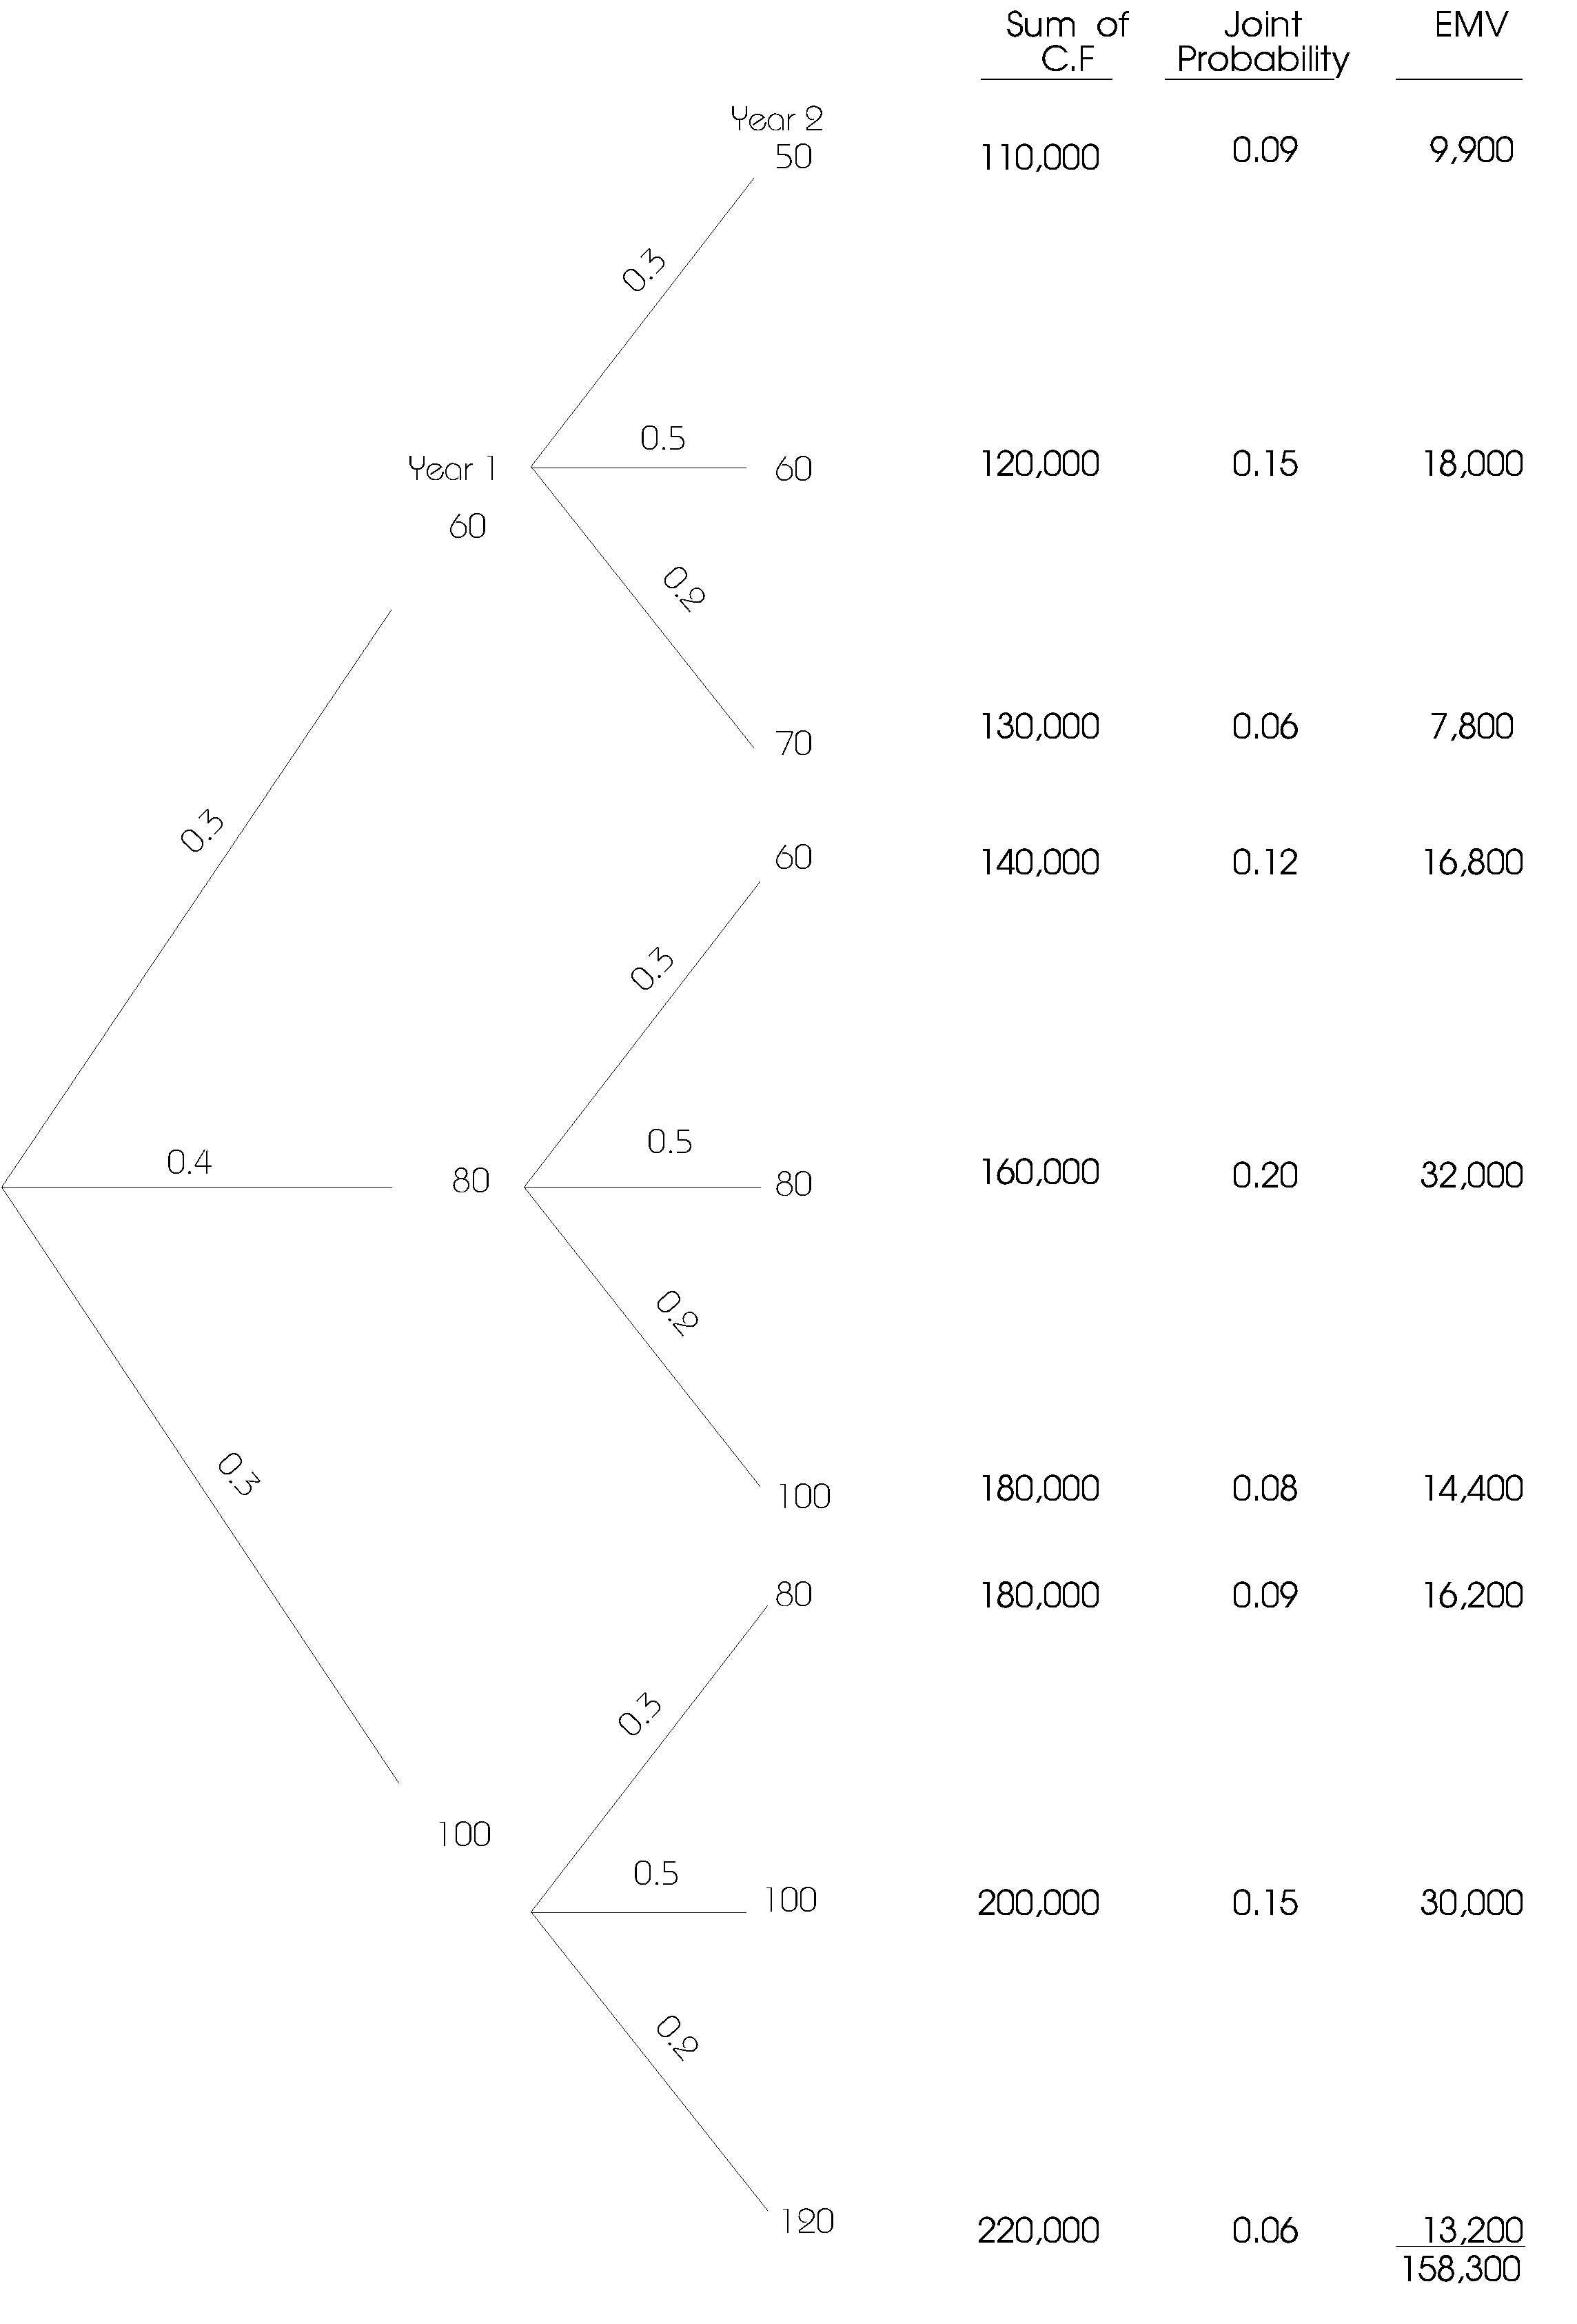

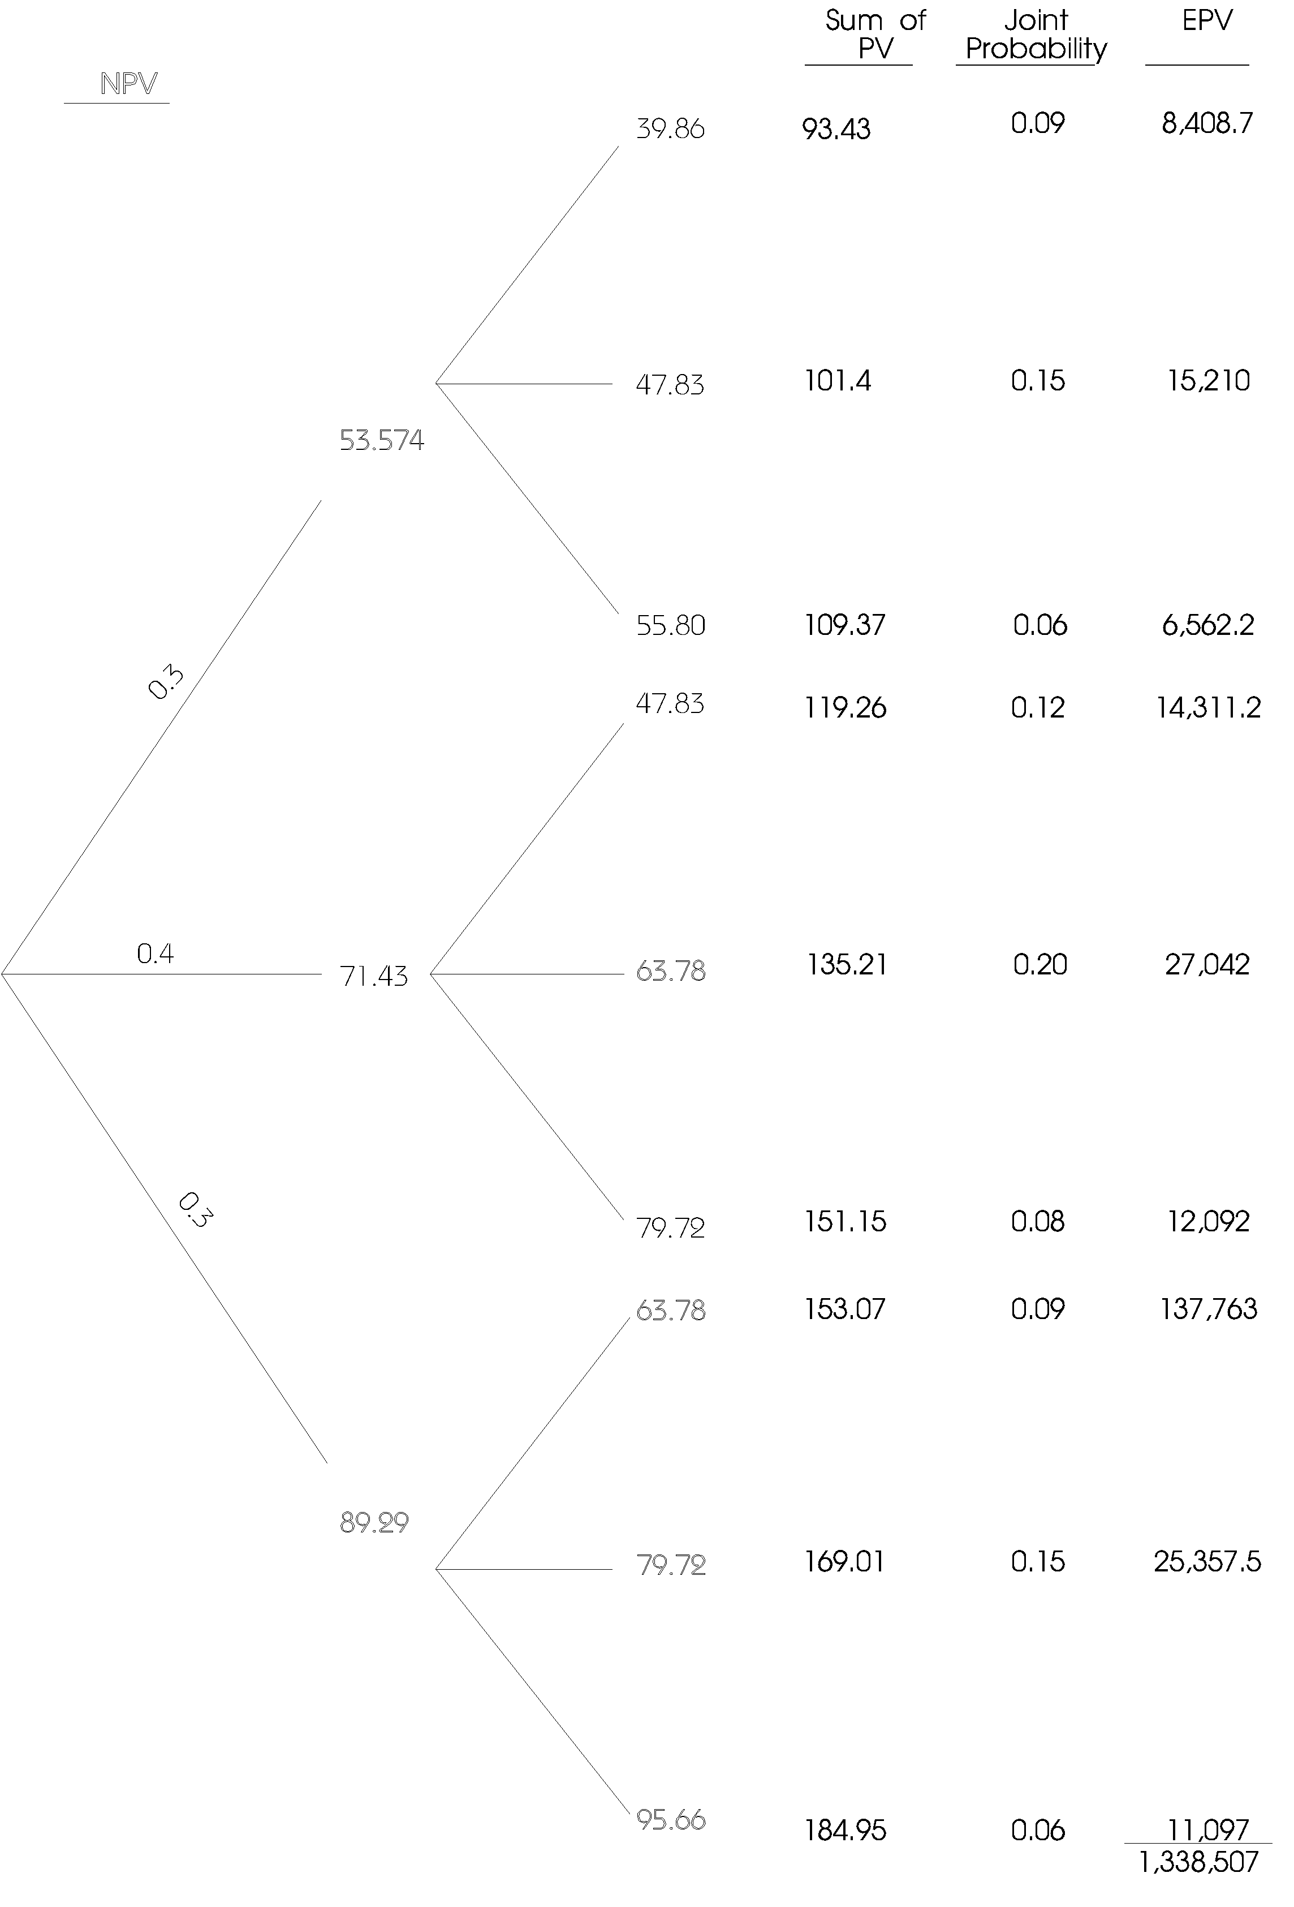

NPV = 133,850.7 - 100,000 = 33,850.7

Merits of decision tree
1. It clearly brings out the implicit assumptions and calculations for all to see, so that they may be questioned and revised.
2. The decision tree allows a decision maker to visualise assumptions and alternatives in graphic form, which is usually much easier to understand than more abstract, analytical form.

Demerits
1. The decision tree can become more and more complicated as more alternatives are included.
2. It cannot be used for dependent variables.

12. UTILITY THEORY

When discussing the expected value and the standard deviation we noted that decision makers can either be risk seekers, risk averse or risk neutral. Therefore, we cannot be able to tell with certainty whether a decision maker will choose a project with a high expected return and a high standard deviation, or a project with comparatively low expected return and low standard deviation.

Utility theory aims at incorporating the decision maker's preference explicitly into the decision procedure. We assume that a rational decision maker maximises his utility and therefore would accept the investment project which yields maximum utility to him.

We can graphically demonstrate the three attitudes towards risk as follows:
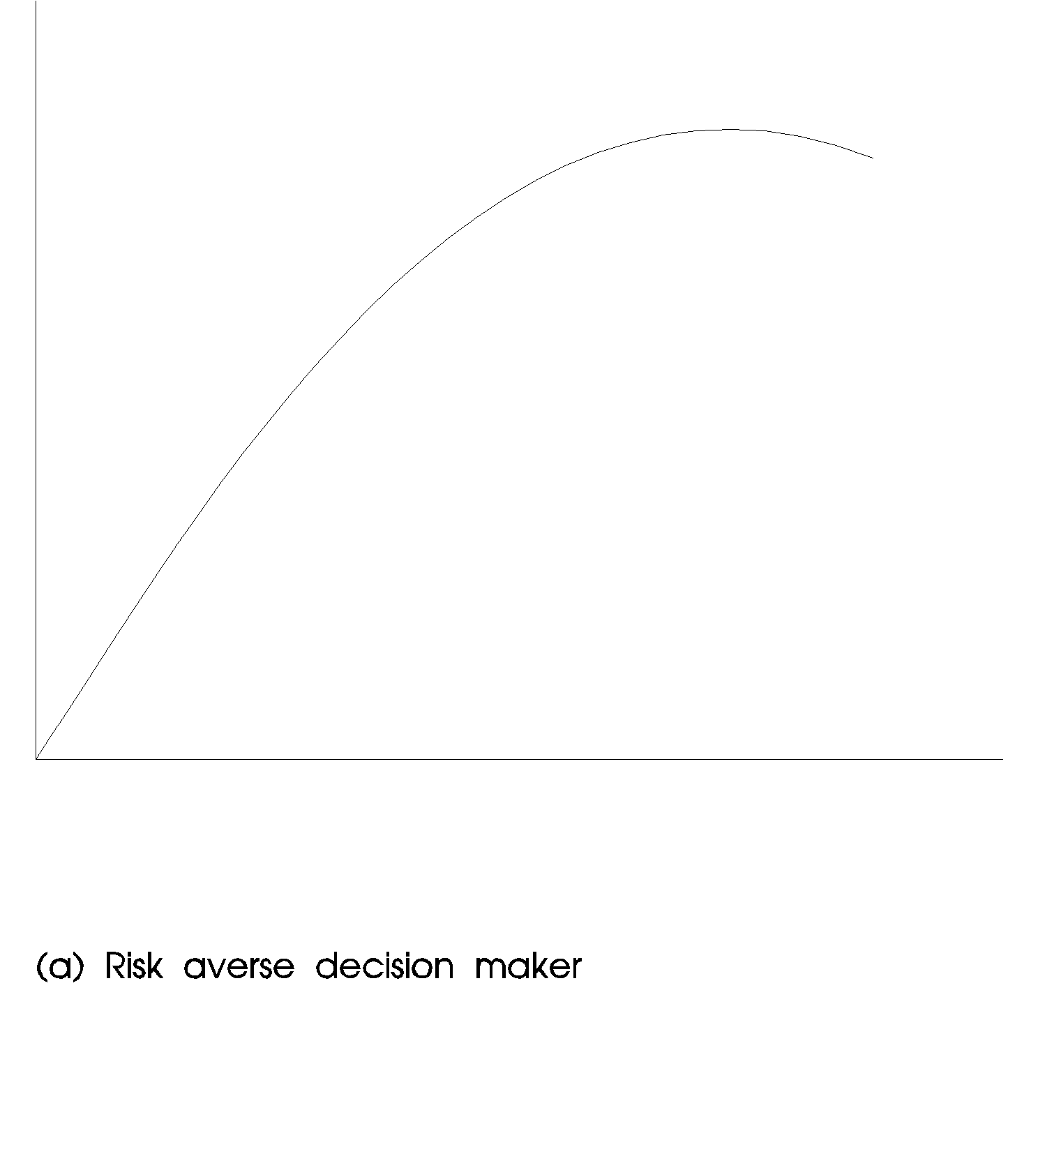

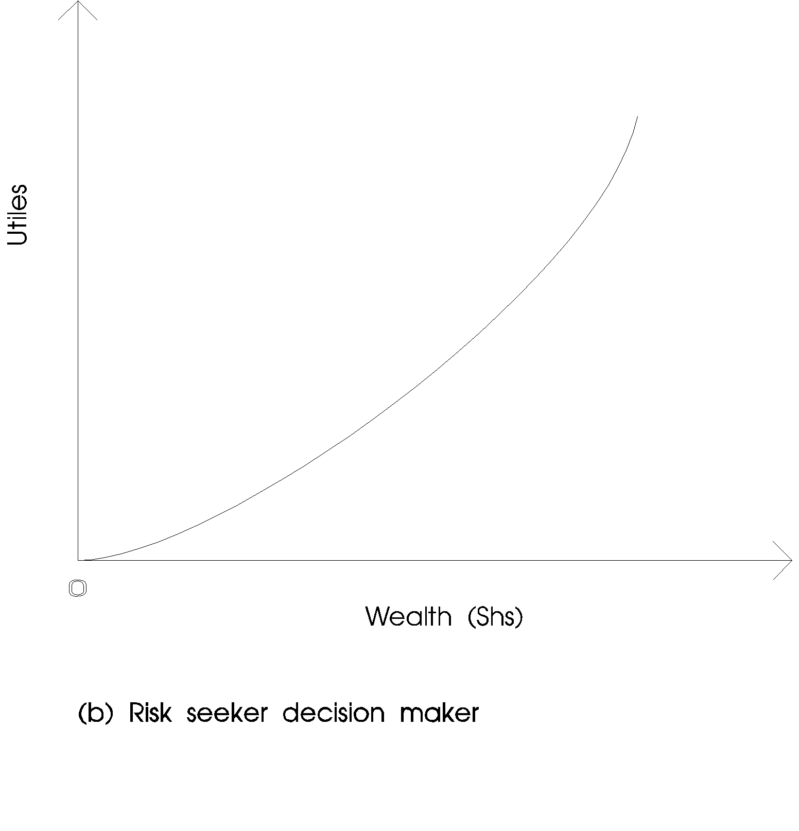

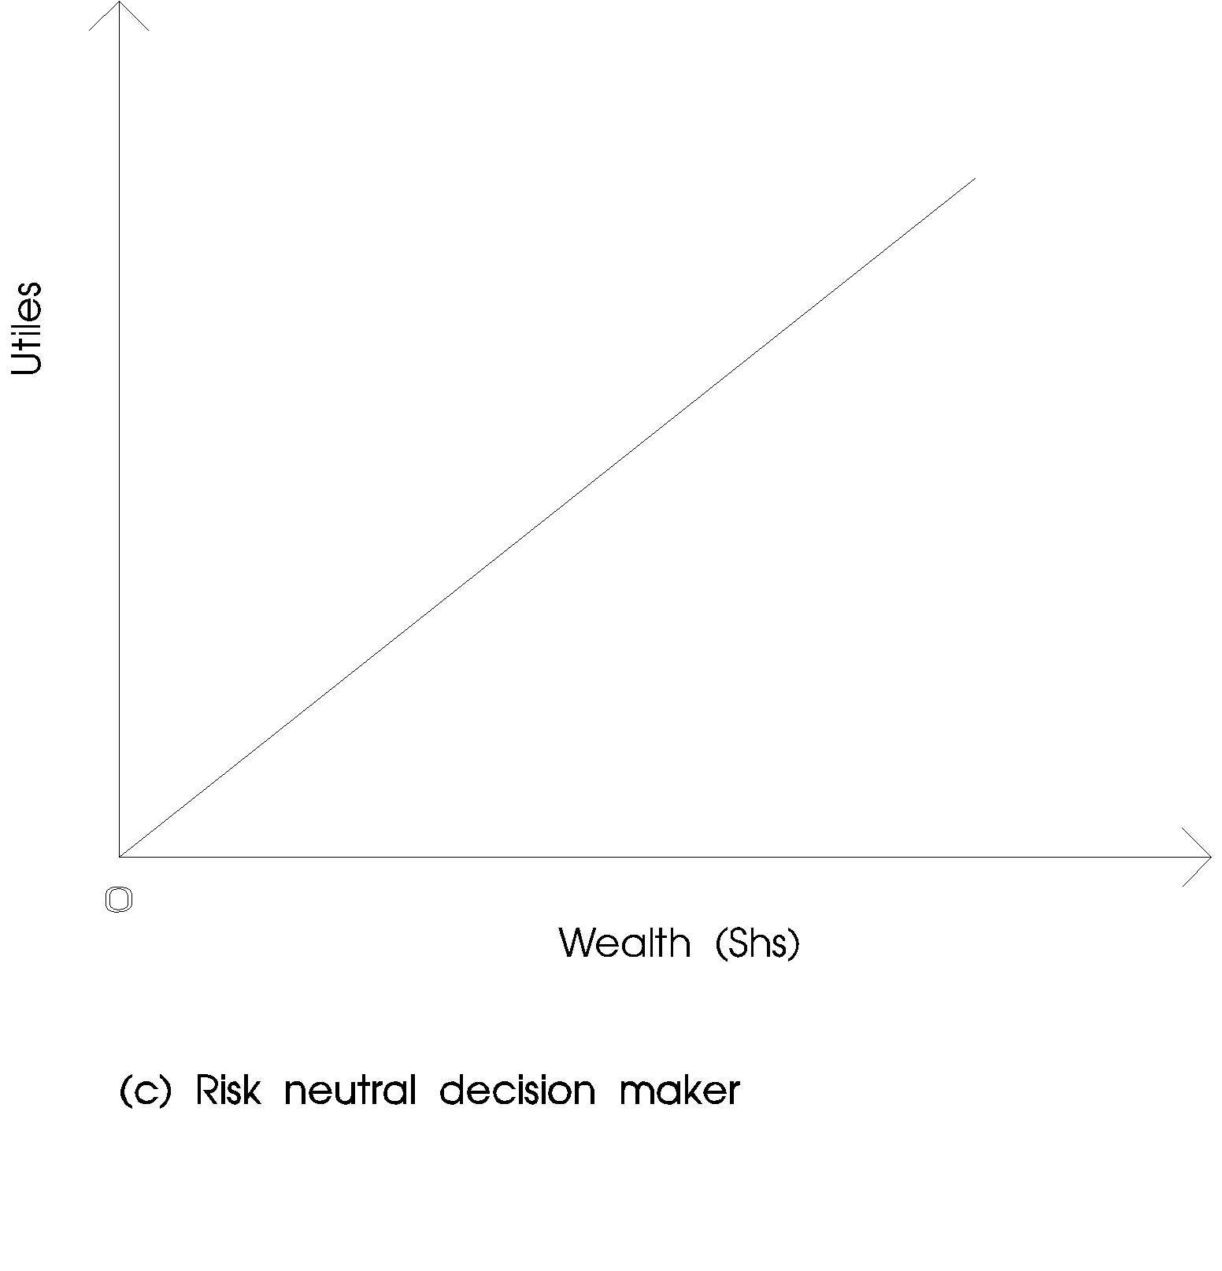

Note that utiles is a relative measure of utility. For the risk averse decision maker, the utility for wealth curve is upward-sloping and is convex to the origin. This curve indicates that an investor always prefer a higher return to a lower return, and that each successive identical increment of wealth is worth less to him than the preceding one - in other words, the marginal utility for money is positive but declining.

For a risk seeker, the marginal utility is positive and increasing. For a risk neutral decision maker, the marginal utility is positive but constant. To derive the utility function of an individual, we let him consider a group of lotteries within boundary limits.

Illustration: Derivation of utility functions

Assume that utiles of 0 and 1 are assigned to a pair of wealth representing two extremes (say, Sh 0 and Sh 100,000 respectively). To determine the utility function of a decision maker, we offer him a lottery with 0.5 chance of receiving no money and 0.5 chance of receiving Sh 100,000. Assume he is willing to pay Sh 33,000 for this lottery. (Therefore 0.5 utile = Sh 33,000).

Next, consider a lottery providing a 0.4 chance of receiving Sh 33,000 and a 0.6 chance of receiving Sh 100,000. Assume that the decision maker is willing to buy this lottery at Sh 63,000. The utile value of Sh 63,000 is

U(Sh 63,000) = 0.4 U(Sh 33,000) + 0.6 U(Sh 100,000)
= 0.4 x 0.5 + 0.6 x 1
= 0.8

Assume also a lottery providing a 0.3 chance of receiving Sh 0 and a 0.7 chance of receiving Sh 33,000 is also offered. The decision maker is willing to pay Sh 21,000 for this lottery. The utile value for Sh 21,000 can be computed as follows.

U (Sh 21,000) = (0.3 U(Sh 0) + 0.7 U(Sh 33,000)
= 0.3 x (0) + 0.7(0.5)
= 0.35

Note that other lotteries can be provided to the decision maker until we have enough points to construct his utility function.

12.2 Expected utility of an investment

Once your utility function is specified, we can calculate the expected utility of an investment. This calculation involves multiplying the utile value of a particular outcome by the probability of its occurrence and adding together the product for all probabilities.

Illustrations:
Consider two investments that have cashflow streams and assonated probabilities.

Project A Project B
Cashflows Utiles Prob. Cashflows Utiles Prob.
Sh -20,000 -0.20 0.10 Sh -25,000 -0.25 0.10
0 0 0.10 0 0 0.20
60,000 0.60 0.60 50,000 0.50 0.50
80,000 0.80 0.50 100,000 1.00 0.20

The expected monetary value for Project A is

-20,000 (0.10) + 0(0.10) + 60,000 x (0.6) + 80,000 (0.20)
= Shs 50,000

For Project B

-25,000 (0.10) + 0 (0.20) + 50,000 (0.50) + 100,000 (0.20)
= Sh 42,500

Using the expected monetary value, Project A is preferred then Project B.

Using the utility values (utiles) the expected utility value is computed as follows:
Project A Project B
Utile Prob. Weighted Utile Prob. Weighted
Utility Utility
-0.20 0.10 -0.02 -0.25 0.10 -0.025
0 0.10 0 0 0.20 0
0.60 0.60 0.36 0.50 0.50 0.25
0.80 0.20 0.16 1.00 0.20 0.20
Expect utility value 0.54 0.425

Using utility values Project A should be accepted since it has a higher utility value.

Advantages of utility approach

1. The risk preferences of the decision maker are directly incorporated in the capital budgeting analysis.
2. It facilitates the process of delegating the authority for decision.

Limitations
1. It is hard to determine the utility function (it is subjective).
2. The derived utility function is only valid at a point of time.
3. If the decision is taken by a group of people it is hard to determine the utility functions since individuals differ in their risk preferences.

REINFORCEMENT QUESTIONS

QUESTION ONE
The Zeda Company Ltd. is considering a substantial investment in a new production process. From a variety of sources, the total cost of the project has been estimated at Sh.20 million. However, if the investment were to be increased to Sh.30 million, the productive capacity of the plant could be substantially increased. Due to the nature of the process, it would be exorbitantly expensive to increase capacity once the equipment is installed.
Once of the problems facing the company is that there is a considerable degree of uncertainty regarding demand for the product. After some research which has been conducted jointly by the marketing and finance departments, some data has been produced. These are shown below:

Investment A (Sh.20 m) |  |  |  | Investment B (Sh.30m)
 | Year | Demand Probability | Annual Net Cash Flow | Demand Probability | Annual Net Cash Flow
 |  |  | Sh.(million) |  | Sh.(million)
1. | 1 - 4 | 0.4 | 6 | 0.3 | 10
 | 5 - 10 | 0.4 | 5 |  | 7
2. | 1 - 4 | 0.4 | 6 | 0.5 | 8
 | 5 - 10 |  | 2 |  | 4
3. | 1 - 10 | 0.2 | 2 | 0.2 | 1

Cost of capital for the firm is 10%.

REQUIRED:
(a) Prepare a statement which clearly indicates the financial implications of each of the two alternative investment scenarios. (12 marks)

(b) Comment on other matters which the management should take into account before reaching the final decision. (10 marks)
(Total: 22 marks)

PVIFA: 10% 5 years = 3.79
PVIFA: 10% 10 years = 6.14
PVIFA: 10% 10 years = 0.62

QUESTION TWO
(a) Explain the concept of "rate of interest" in the context of financial decisions. (5 marks)
(b) The Mentala Plastics Company has been dumping in the local council waste collection centre some 30,000 Kg. of unusable chemicals each year. In addition to being an eyesore, the residents of a nearby estate have started complaining of bad odour emanating from the dump and suspect that the company is to blame.

The company has received information that these chemicals can be recycled at relatively little cost. The equipment to do it is however rather expensive and, in addition, the chemicals recovered are of a relatively poor quality. Investigations have shown that these chemicals can be sold to another firm at an average price of Sh.35 per Kg. The direct cost of recycling has been calcultated at Sh.15 per Kg. but this is before depreciation and taxes.

The equipment for this process has an expected life of 10 years and a current cost of Sh.2 million. At the end of the ten years, it will be virtually worthless.

For financial analysis, the company uses the straight line method of depreciation and an average tax rate of 40%. It has a required rate of return of 15%.

REQUIRED:
i. Compute the project's net present value (N.P.V).
ii. Compute the payback period and the accounting rate of return.
iii. Compute the internal rate of return (IRR).
iv. Should this project be undertaken? Explain.

Are there any other important matters that the company should consider in evaluating this project?

QUESTION THREE
A piece of equipment requiring the investment of 2.2 million is being considered by Charo Foods Ltd. The equipment has a ten-year useful life and an expected salvage value of Sh 200,000. The company uses the straight-line method of depreciation for analysing investment decisions and faces a tax rate of 40%. For simplicity assume that the depreciation method is acceptable for tax purposes.

A pessimistic forecast projects cash earnings before depreciation and taxes at Sh 400,000 per year compared with an optimistic estimate of Sh 500,000 per year. The probability associated with the pessimistic estimate is 0.4 and 0.6 for the optimistic forecast. The company has a policy of using a hurdle rate of 10% for replacement investments, 12% (its cost of capital) for revenue expansion investments into existing product lines and 15% projects involving new areas or new product lines.

REQUIRED:
(a) Compute the expected annual cash flows associated with the proposed equipment investments.
(4 marks)
(b) Would you recommend acceptance of this project if it involved expansion of sales for an existing product? (5 marks)
(c) Would it be acceptable if it was for the replacement of equipment with a book value of Sh 200,000 at the end of the tenth year but which could be sold at that time for only Sh 40,000? (5 marks)
(d) Discounted cashflow methods were developed for idealised settings of complete and perfect capital, factor and commodity markets. Explain what complications arise when an attempt is made to apply these methods in real life markets that are neither complete nor perfect. (6 marks)
(Total: 20 marks)

CHECK YOUR ANSWERS WITH THOSE GIVEN IN LESSON 9 OF THE STUDY PACK

COMPREHENSIVE ASSIGNMENT NO.1
TO BE SUBMITTED AFTER LESSON 2

To be carried out under examination conditions and sent to the Distance Learning Administration for marking by the University.

EXAMINATION PAPER: TIME ALLOWED: 3 HRS. ANSWER ALL QUESTIONS.

QUESTION ONE
Discuss the goals of Financial Management and state which is the best goal? (12 marks)
(TOTAL 12 MARKS)
QUESTION TWO
XYZ Ltd is considering three possible capital projects for next year. Each project has a 1-year life, and project returns depend on next years state of the economy. The estimated return are shown in the table:

State of the Probability Rate of Return
economy of occurrence A B C

Recession 0.25 10% 9% 14%
Average 0.50 14 13 12
Boom 0.25 16 18 10

Required:

i. Compute each projects expected rate of return (6 marks)
ii. Compute the variance and standard deviation of each project (12 marks)
iii. Compute the co-efficient of variation for each project (3 marks)
iv. Which is a better project? Why? (3 marks)
(Total 24 Marks)
QUESTION THREE
Sammy and Jimmy Ltd purchased a machine 5 years ago at a cost of Sh 1,000,000. It had an expected life of 10 years at the time of purchase and an expected salvage value of Sh 100,000 at the end of its useful life. It is being depreciated by a straight line.

A new machine can be purchased for Sh 1,500,000 including installations costs. Over its 5 year life, it will reduce cash operating expenses by Sh 500,000 per year. Sales are not expected to change. At the end of its useful life the machine is considered to be worthless.

The old machine can be sold today for Sh 650,000. The firm's tax rate is 35% and the appropriate discount rate is 15%.

Required:

(a) Determine whether the machine should be replaced using the NPV criterion (16 marks)
(b) What other factors should be considered before making the decision at (a) above? (8 marks)
(Total 24 Marks)
QUESTION FOUR
Great Lakes utilities is deciding if it should build an oil or a coal generating plant. Its weighted average cost of capital is 8% for low-risk projects 10% for projects of average risk and 12% for high-risk projects. Management believes that an oil plant is of average risk but that a coal plant is of high risk. The cash outflows required to construct each plant are listed below. The revenue, fuel costs and other operating costs are expected to be the same under both plans.

Construction Cost (Shs`000')
Year Coal Plant Oil Plant
0 100 400
1 500 1,000
2 1,500 1,000
3 1,500 1,000
4 1,500 1,500
5 1,000 1,000
6 500 200

Required:

Which type of plant should be constructed? (20 marks)
Show your workings.
(Total 20 marks)
QUESTION FIVE
Describe instances in which the interests of the management of a company might conflict with those of the shareholders and suggest mechanisms for their resolutions. Discuss your answer in close reference to the provisions of agency theory. (20 marks)
(Total 20 marks)

END OF COMPREHENSIVE ASSIGNMENT No.1

NOW SEND YOUR ANSWERS TO THE DISTANCE LEARNING CENTRE FOR MARKING

LESSON THREE

PORTFOLIO MANAGEMENT AND CAPM

INSTRUCTIONS

1. Read Chapter 9 of Pandey I.M. and the Study Text below.
2. Complete answers to reinforcing questions at the end of the lesson.
3. Check model answers given in lesson 9 of the Study Pack.

CONTENTS

1.1 Portfolio theory
1.2 Portfolio expected return
1.3 Portfolio standard deviation
1.4 Portfolio of more than two assets
1.5 Covariance and the correlation coefficient
1.6 Efficient portfolios and the efficient frontier
2.1 The capital asset pricing model
2.2 Limitations of CAPM
3.1 Arbitrage pricing theory (APT)
3.2 Features of APT
3.3 Limitations of APT

1.1 PORTFOLIO THEORY

In Lesson 2, we looked at investment decisions for assets held in isolation. That is, we did not consider the synergistic effects of assets held together. This will, however, be considered in this lesson.

Definition:
A portfolio is a combination of assets held by the investor for investment purposes. Portfolio theory therefore attempts to show an investor how to combine a set of assets to maximise the assets' returns as well as minimise the assets' risk (Risk Diversification).

Diversification is defined as combining assets whose returns are not perfectly positively correlated to reduce the aggregate risk of the total asset holdings (or the portfolio).

1.2 PORTFOLIO EXPECTED RETURN
If the investor holds only two assets in the portfolio, we can therefore be able to compute the portfolio's expected return (sometimes referred to as the portfolio mean). This will be a weighted average of the expected return of each asset held in isolation, and can be given by the following formula:

E(R_{P}) = E(αX_{A} + ßX_{B}) ... (3.a)
Where (E(R_{P}) is the expected portfolio return
α is the investment in asset A
ß is the investment in asset B
X_{A} is the expected return of asset A
X_{B} is the expected return of asset B

Formula 3.a can be simplified as follows:

E(R_{P}) = αEX_{A} + ßEX_{B} ... (3.b)

Not also that α + ß = 1. This is because all the investor's wealth is invested in either asset A or asset B.

Illustration
Consider two investments, A and B each having the following investment characteristics;

Investment Expected Return (%) Proportion
A 10 2/3
B 20 1/3

REQUIRED:
Compute the expected return of a portfolio of the two assets.

Solution
Using formula (3.b)

Note α = 2/3 ß = 1/3
EX_{A} = 10 EX_{B} = 20

E(R_{P}) = 2 (10%) + 1 (20%)
3 3

= 13.3%

Note that the expected return is a weighted average of the expected return of assets held in isolation.

1.3 PORTFOLIO STANDARD DEVIATION

Remember that standard deviation is a measure of risk of the investment. Portfolio standard deviation therefore measure the risk of investing in a combination of assets.

The portfolio standard deviation is not a weighted average of standard deviations of assets held in isolation. This is because of the inter-relatedness of the assets, which reduces the risk when assets are held together. This relationship is measured by the correlation co-efficient (τ),

The coefficient of correlation (τ) lies between -1 and +1. Therefore -1 ≤ τ ≤+1.

If τ_{AB} = +1, this means that A and B are perfectly positively correlated and therefore the outcomes of A and B move in the same direction at the same time.

If τ_{AB} = -1, then A and B are perfectly negatively correlated and their results are inversely related. That is they move in opposite directions simultaneously.

If we consider the two asset case, then the portfolio standard deviation (δ_{A+B}) can be given by the following formula.

Where δ_{A} is the standard deviation of A

δ_{B} is the standard deviation of B
τ_{AB} is the correlation coefficient of asset A and B

Illustration

Consider two investments A & B each having the following characteristics:

Investment Expected Return (%) Proportion
A 20 2/3
B 40 1/3

REQUIRED:
Compute the portfolio standard deviation if the correlation coefficient between the assets is

a. 1
b. 0
c. -1

Solution
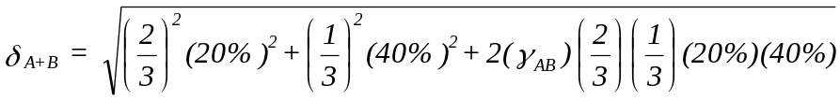

Using formula (3.c) we can compute the portfolio standard deviation as follows:

Note that the standard deviation depends on the correlation coefficient if the proportion of investment is fixed. Therefore if

a. r_{AB} = 1

δ_{A+B} = √(0.036 + 0.036) = 26.8%

b. If r_{AB} = 0 then

δ_{A+B} = √(0.036) = 18.7%

c. If r_{AB} = -1

δ_{A+B} = √(0.036 - 0.036) = √0 = 0

There is no risk at all.

Note: If assets are perfectly negatively correlated then holding them in a portfolio greatly reduces their risk.

1.4 PORTFOLIO OF MORE THAN 2 ASSETS

Usually investors will not hold only 2 assets. If the assets held in the portfolio are more than 2 then the following general formulas may be used:
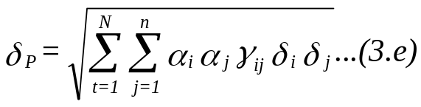

Where δ_{P} is the portfolio standard deviation
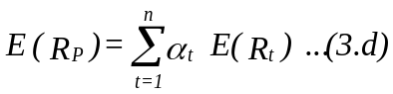

Note: we shall not spend much time on analysis of more than 2 assets due to the complication involved. It is however, assumed that the student can be able to extend the two asset case to more assets.

1.5 COVARIANCE AND THE CORRELATION COEFFICIENT

We have already introduced the correlation coefficient. We shall consider the Covariance and its relationship with the correlation coefficient.

The covariance is a measure which reflects both the variance of an asset's returns and the tendency of those returns to move up and down at the same time other assets move up or down. The covariance between two asset's return can be given by the following formula:
Where Cov(AB) is the covariance between And B
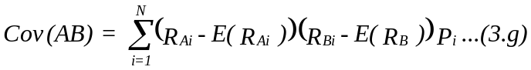

R_{Ai} is the return on asset A under the Ith state.
E(R_{A}) is the expected return of A
R_{Bi} is the return on asset B under the ith state
E(R_{B}) is the expected return of B
P_{i} is the probability of the ith state.

The correlation coefficient can be given by the following formula.

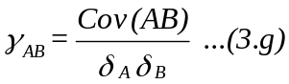

Illustration:
Four assets have the following distribution of returns.

Probability Rate of return (%)
Occurrence A B C D
0.1 10.0% 6.0% 14.0% 2.0%
0.2 10.0 8.0 12.0 6.0
0.4 10.0 10.0 10.0 9.0
0.2 10.0 12.0 8.0 15.0
0.1 10.0 14.0 6.0 20.0

REQUIRED:

a. Compute the expected return and standard deviation of each asset.

b. Compute the covariance of asset
i. A and B
ii. B and C
iii. B and D

c. Compute the correlation coefficient of the combination of assets in b above.

Solution

a. E(R_{A}) = 10(0.1) + 10(0.2) + 10(0.4) + 10(0.2) + 10(0.1) = 10%

E(R_{B}) = 6(0.1) + 8(0.2) + 10(0.4) + 12(0.2) + 14(0.1) = 10%

E(R_{C}) = 14(0.1) + 12(0.2) + 10(0.4) + 8(0.2) + 6(0.1) = 10%

E(R_{D}) = 2(0.1) + 6(0.2) + 9(0.4) + 15(0.2) + 20(0.1) = 10%

= 0 since (R_{Ai} - E(R)_{A}) = 0%
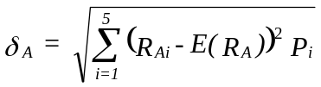

= √4.8 = 2.2%

Likewise δ_{C} = 2.2% and δ_{D} = 5.0%

b. i.
Note that since (R_{Ai} - ER_{A}) = 0
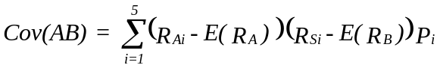

Cov(AB) = 0

ii Cov(BC) = (6-10)(14-10)(0.1) + (8-10)(12-10)0.2 + (10-10)(10-10)0.4
+ (12-10)(8-10)0.2 + (14-10)(6-10)0.1

= -4.8

iii Cov(BD) = (6-10)(2-10)(0.1) + (8-10)(6-10)0.2 + (10-10)(9-10)0.4 +
(12-10)(15-10)0.2 + (14-10)(20-10)0.1

= 10.8

Assets B and C tend to move in opposite directions and therefore their covariance is negative while Assets B and D tend to move in the same directions and therefore their covariance is positive.

Returns of A has no correlation with the returns of other assets and therefore the covariance between A and any other asset is zero.

c. Correlation coefficient

i. τ_{AB} = Cov_{(AB)} = 0 = 0
δ_{A}δ_{B} (0)(2.2)

ii. τ_{BC} = Cov_{(BC)} = -4.8 = -1.0
δ_{B}δ_{C} (2.2)(2.2)

i. τ_{BD} = Cov_{(BD)} = 10.8 = 0.98
δ_{B}δ_{D} (2.2)(5.0)

Therefore Assets B and C are perfectly negatively correlated while B and D have a strong positive correlation.

1.6 EFFICIENT PORTFOLIO AND THE EFFICIENT FRONTIER

Efficient portfolios can be defined as those portfolio which provide the highest expected return for any degree of risk, or the lowest degree of risk for any expected return.

The investor should ensure that he holds those assets which will minimise his risk. He should therefore diversify his risk.

The risk can be divided into two:

a. The diversifiable (unsystematic) risk;
b The non-diversifiable (systematic) risk.

The diversifiable risk is that risk which the investor can be able to eliminate if he held an efficient portfolio.
The non-diversifiable risk on the other hand is those risks that still exist in all well diversified efficient portfolios.
The investor therefore seeks to eliminate the diversifiable risk. This can be shown below:

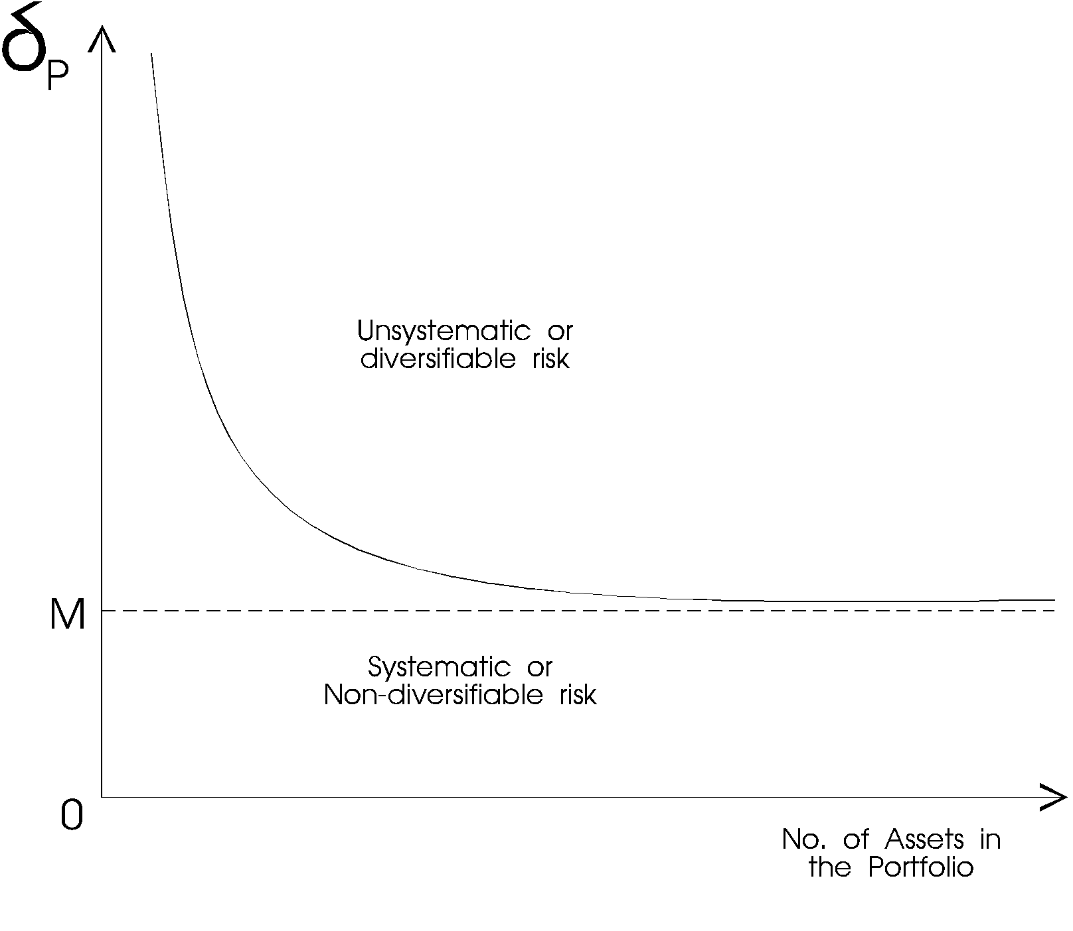
Figure 8 Diversification of Risk
From the graph shown above as the number of assets increases, the portfolio risk reduces up to point M. At this point the lowest risk has been achieved and adding more assets to the portfolio will not reduce the portfolio risk.

An efficient portfolio therefore is well diversified portfolio.

Note: The non-diversifiable risk can also be referred to as the market risk.

EFFICIENT SET OF INVESTMENT

If consider many assets, the feasible set of investment will be given by the following graph
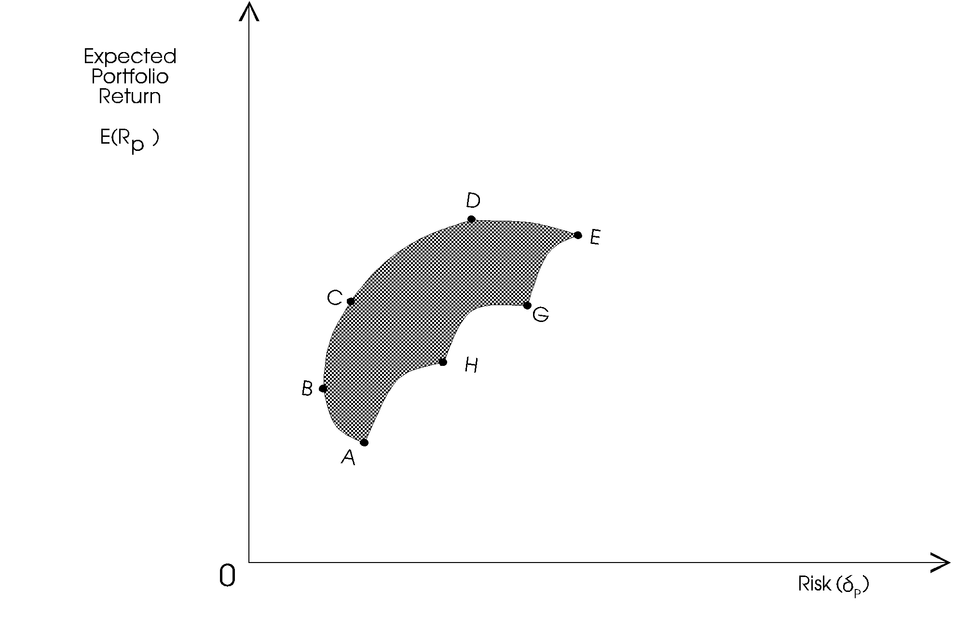

Figure 9
The shaded area is the attainable set of investment. However, investors will invest in a portfolio with the highest return at a given risk or the lowest risk at a given return. The efficient set of investment, therefore, will be given by the frontier B C D E. This frontier is referred to as the Efficient Frontier.

Any point on the efficient frontier dominates all the other points on the feasible set.

2.1 THE CAPITAL ASSET PRICING MODEL

The Capital Asset Pricing Model (CAPM) specifies the relationship between risk and required rate of return on assets when they are held in well-diversified portfolios.

Basic assumptions of CAPM

1. Investors are rational and they choose among alternative portfolios on the basis of each portfolio's expected return and standard deviation.
2. Investors are risk averse.
3. Investors maximise the utility of end of period wealth. Thus CAPM is a single period model.
4. Investors have homogeneous expectations with regard to asset return. Thus all investors will perceive the same efficient set.
5. There exist a risk-free asset and all investors can borrow and lend at this rate.
6. All assets are marketable and perfectly divisible.
7. The capital market is efficient and perfect.

The CAPM is given as follows:

R_{i} = R_{F} + [E(R_{M} - R_{F})]ß

Where R_{i} is required return of security i
R_{F} is the risk free rate of return
E(R_{M}) is the expected market rate of return
ß is Beta.

Note ß_{i} = Cov_{(im)}
δ²_{m}

Where Cov_{(im)} is the covariance between asset i and the market return.
δ²_{m} is the variance of the market return.

If we graph ß_{i} and E(R_{i}) then we can observe the following relationship

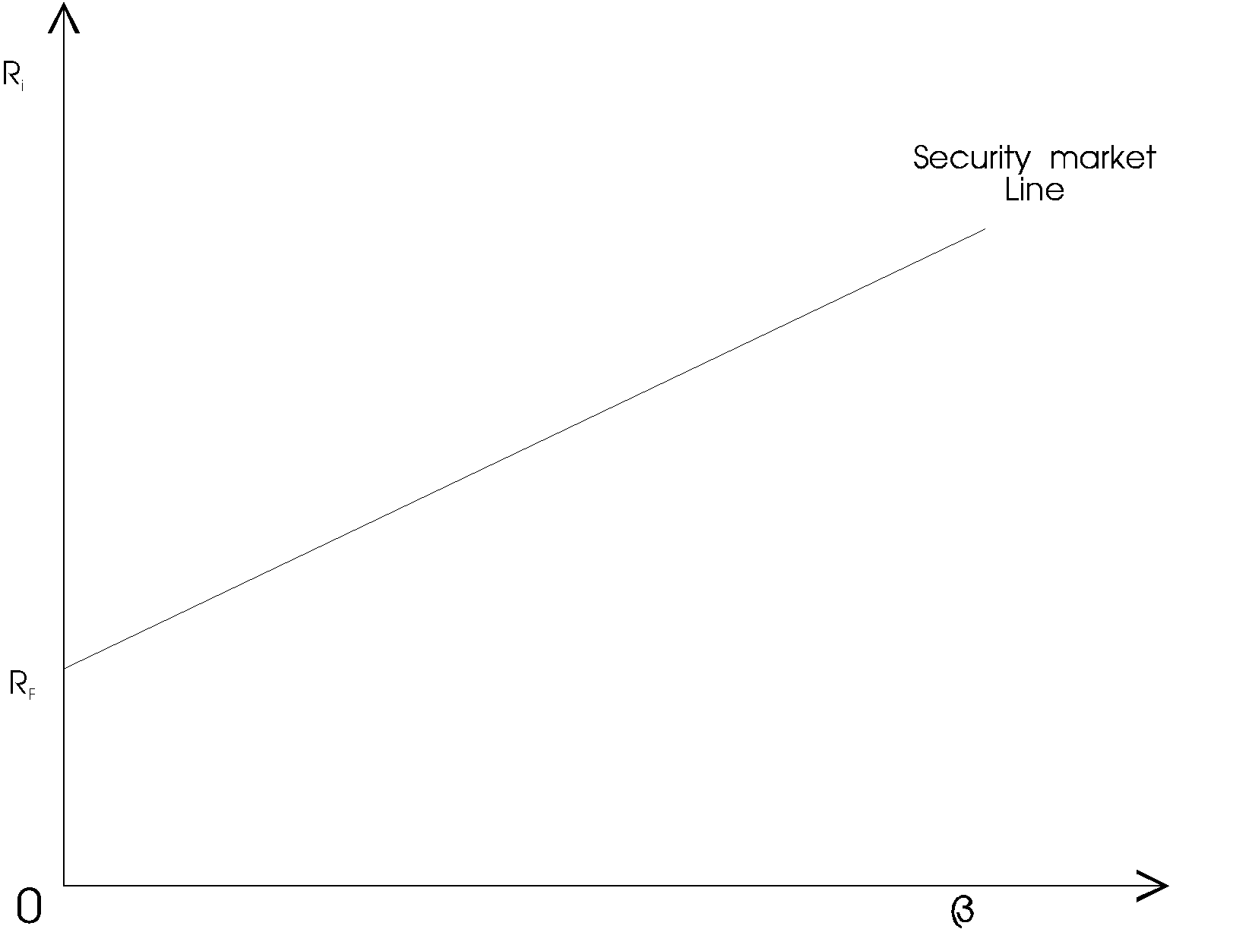
Figure 10
All correctly priced assets will lie on the security market line. Any security off this line will either be overpriced or underpriced.

The security market line therefore shows the pricing of all asset if the market is at equilibrium. It is a measure of the required rate of return if the investor were to undertake a certain amount of risk.

Illustration:

Assume that the risk free rate of return is 8%, the market expected rate of return is 12%. The standard deviation of the market return is 2% while the covariance of return for security A and the market is 2%.

REQUIRED:

What is the required rate of return on Security A?

Solution

R_{i} = R_{F} + (E(R_{M}) - R_{F})ß

ß = Cov_{(AM)} = 2 = 2 = 0.5
δ_{M}² 2² 4

R_{i} = 8% + (12 - 8)0.5 = 10%

The required rate of return on security A is therefore 10%.

2.2 LIMITATIONS OF CAPM

CAPM has several weaknesses e.g.

a. It is based on some unrealistic assumptions such as:

i. Existence of Risk-free assets
ii. All assets being perfectly divisible and marketable (human capital is not divisible)
iii. Existence of homogeneous expectations about the expected returns
iv. Asset returns are normally distributed.

b. CAPM is a single period model—it looks at the end of the year return.
c. CAPM cannot be empirically tested because we cannot test investors expectations.
d. CAPM assumes that a security's required rate of return is based on only one factor (the stock market—beta). However, other factors such as relative sensitivity to inflation and dividend payout, may influence a security's return relative to those of other securities.

The Arbitrage pricing theory is designed to help overcome these weaknesses.

ARBITRAGE PRICING THEORY (APT)
Formulated by Ross(1976), the Arbitrage Pricing Theory(APT) offers a testable alternative to the capital market pricing model(CAPM). The main difference between CAPM and APT is that CAPM assumes that security rates of returns will be linearly related to a single common factor- the rate of return on the market portfolio. The APT is based on similar intuition but is much more general.
APT assumes that, in equilibrium, the return on an arbitrage portfolio (i.e. one with zero investment, and zero systematic risk) is zero. If this return is positive, then it would be eliminated immediately through the process of arbitrage trading to improve the expected returns. Ross (1976) demonstrated that when no further arbitrage opportunities exist, the expected return (E(Ri)) can be shown as follows:
E(R_{i})=R_{f} + β₁(R₁-R_{f})+β₂(R₂ -R_{f})+--------+ β_{n}(R_{n}-R_{f})+έ_{i}
Where,
E(R_{i}) is the expected return on the security
R_{f} is the risk free rate
Β_{i} is the sensitivity to changes in factor i
έ_{i} is a random error term.

3.2 APT and CAPM compared
The Arbitrage Pricing Theory (APT) is much more robust than the capital asset pricing model for several reasons:

- The APT makes no assumptions about the empirical distribution of asset returns. CAPM assumes normal distribution.
- The APT makes no strong assumption about individuals’ utility functions (at least nothing stronger than greed and risk aversion).
- The APT allows the equilibrium returns of asset to be dependent on many factors, not just one (the beta).
- The APT yields a statement about the relative pricing of any subset of assets; hence one need not measure the entire universe of assets in order to test the theory.
- There is no special role for the market portfolio in the APT, whereas the CAPM requires that the market portfolio be efficient.
- The APT is easily extended to a multi-period framework.

Since APT makes fewer assumptions than CAPM, it may be applicable to a country like Kenya. However, the model does not state the relevant factors. Cho(1984) has, however, shown the security returns are sensitive to the following factors: Unanticipated inflation, Changes in the expected level of industrial production, Changes in the risk premium on bonds, and Unanticipated changes in the term structure of interest rates

Illustration
Security returns depend on only three riskfactors-inflation, industrial production and the aggregate degree of risk aversion. The risk free rate is 8%, the required rate of return on a portfolio with unit sensitivity to inflation and zero-sensitivity to other factors is 13.0%, the required rate of return on a portfolio with unit sensitivity to industrial production and zero sensitivity to inflation and other factors is 10% and the required return on a portfolio with unit sensitivity to the degree of risk aversion and zero sensitivity to other factors is 6%. Security i has betas of 0.9 with the inflation portfolio, 1.2 with the industrial production and-0.7 with risk bearing portfolio—(risk aversion)

Assume also that required rate of return on the market is 15% and stock i has CAPM beta of 1.1

REQUIRED:

Compute security i's required rate of return using

a. CAPM
b. APT

Using APT R_{i} = 8% + (13% - 8%)0.9 + (10% - 8%)1.2 + (6% - 8%)(-.7)
= 16,3%

Using CAPM R_{i} = R_{F} + (E(R_{M}) - R_{F})ß_{i}

R_{i} = 8% + (15% - 8%)1.1 = 15.7%

3.3 LIMITATIONS OF APT

APT does not identify the relevant factors that influence returns nor does it indicate how many factors should appear in the model. Important factors are inflation, industrial production, the spread between low and high grade bonds and the term structure of interest rates.
REINFORCING QUESTIONS

QUESTION ONE
Securities D, E and F have the following characteristics with respect to expected return, standard deviation and correlation coefficients.

Security Expected Return Standard Deviation Correlation Coefficient D - E D - F E - F
D 0.08 0.02 0.4 0.6
E 0.15 0.16 0.4 0.8
F 0.12 0.08 0.6 0.8

REQUIRED:
Compute the expected rate of return and standard deviation of a portfolio comprised of equal investment in each security.

QUESTION TWO
The risk free rate is 10% and the expected return on the market portfolio is 15%. The expected returns for 4 securities are listed below together with their expected betas

SECURITY EXPECTED RETURN EXPECTED BETA
A 17.0% 1.3
B 14.5% 0.8
C 15.5% 1.1
D 18.0% 1.7

REQUIRED:
a. On the basis of these expectations, which securities are overvalued? Which are undervalued?
b. If the risk-free rate were to rise to 12% and the expected return on the market portfolio rose to 16%, which securities would be overvalued? which would be under-valued? (Assume the expected returns and the betas remain the same).

QUESTION THREE
XYZ ltd. is considering three possible capital projects for next year. Each project has a 1 year life, and project returns depend on next years state of the economy. The estimated rates of return are shown below.

STATE OF THE PROBABILITY RATE OF RETURN
ECONOMY OF OCCURRENCE A B C

Recession 0.25 10% 9% 14%
Average 0.50 14 13 12
BOOM 0.25 16 18 10

REQUIRED:

a. Find each project expected rate of return, variance, standard deviation and coefficient of variation.

b. Compute the correlation coefficient between

i. A and B
ii. A and C
iii. B and C

c. Compute the expected return on a portfolio if the firm invests equal wealth on each asset.

d. Compute the standard deviation of the portfolio.

CHECK YOUR ANSWERS WITH THOSE GIVEN IN LESSON 9 OF THE STUDY PACK

LESSON FOUR

MERGERS AND TAKE- OVERS

INSTRUCTIONS

1. Read Chapter 32 of Pandey I.M. and the Study Text below.
2. Complete answers to reinforcing questions at the end of the lesson.
3. Check model answers given in lesson 9 of the Study Pack.

CONTENTS

4.1 Merger And Acquisition Defined
  - Types Of Mergers
  - Reasons For Mergers
  - The Overall Merger Process
  - Reasons Behind Failed Mergers
4.6 Due Diligence
4.7 Making Due Diligence Work
4.8 Financial Terms Of Exchange
4.9 Valuing The Target Firm
Cash Flow Statements
Role Of Investment Bankers In Mergers
Anti-Takeover Defenses
Corporate Alliances

4.1 MERGER AND ACQUISITION DEFINED
When we use the term "merger", we are referring to the joining of two companies where one new company will continue to exist.
The term "acquisition" refers to the purchase of assets by one company from another company. In an acquisition, both companies may continue to exist.
However, throughout this topic we will loosely refer to mergers and acquisitions ( M & A ) as a business transaction where one company acquires another company. The acquiring company (also referred to as the predator company) will remain in business and the acquired company (which we will sometimes call the Target Company) will be integrated into the acquiring company and thus, the acquired company ceases to exist after the merger.
4.2 TYPES OF MERGERS
Mergers can be categorized as follows:
Horizontal: Two firms are merged across similar products or services. Horizontal mergers are often used as a way for a company to increase its market share by merging with a competing company. For example, the merger between Total and ELF will allow both companies a larger share of the oil and gas market.
Vertical: Two firms are merged along the value-chain, such as a manufacturer merging with a supplier. Vertical mergers are often used as a way to gain a competitive advantage within the marketplace. For example, a large manufacturer of pharmaceuticals, may merge with a large distributor of pharmaceuticals, in order to gain an advantage in distributing its products.
Conglomerate: Two firms in completely different industries merge, such as a gas pipeline company merging with a high technology company. Conglomerates are usually used as a way to smooth out wide fluctuations in earnings and provide more consistency in long-term growth. Typically, companies in mature industries with poor prospects for growth will seek to diversify their businesses through mergers and acquisitions.
REASONS FOR MERGERS
a. Synergy
Every merger has its own unique reasons why the combining of two companies is a good business decision. The underlying principle behind mergers and acquisitions ( M & A ) is simple: 2 + 2 = 5. The value of Company A is Sh. 2 billion and the value of Company B is Sh. 2 billion, but when we merge the two companies together, we have a total value of Sh. 5 billion. The joining or merging of the two companies creates additional value which we call "synergy" value.
Synergy value can take three forms:
1. Revenues: By combining the two companies, we will realize higher revenues than if the two companies operate separately.
2. Expenses: By combining the two companies, we will realize lower expenses than if the two companies operate separately.
3. Cost of Capital: By combining the two companies, we will experience a lower overall cost of capital.

For the most part, the biggest source of synergy value is lower expenses. Many mergers are driven by the need to cut costs. Cost savings often come from the elimination of redundant services, such as Human Resources, Accounting, Information Technology, etc. However, the best mergers seem to have strategic reasons for the business combination. These strategic reasons include:
Positioning - Taking advantage of future opportunities that can be exploited when the two companies are combined. For example, a telecommunications company might improve its position for the future if it were to own a broad band service company. Companies need to position themselves to take advantage of emerging trends in the marketplace.
Gap Filling - One company may have a major weakness (such as poor distribution) whereas the other company has some significant strength. By combining the two companies, each company fills-in strategic gaps that are essential for long-term survival.
Organizational Competencies - Acquiring human resources and intellectual capital can help improve innovative thinking and development within the company.
Broader Market Access - Acquiring a foreign company can give a company quick access to emerging global markets.

b. Bargain Purchase
It may be cheaper to acquire another company than to invest internally. For example, suppose a company is considering expansion of fabrication facilities. Another company has very similar facilities that are idle. It may be cheaper to just acquire the company with the unused facilities than to go out and build new facilities on your own.
c. Diversification
It may be necessary to smooth-out earnings and achieve more consistent long-term growth and profitability. This is particularly true for companies in very mature industries where future growth is unlikely. It should be noted that traditional financial management does not always support diversification through mergers and acquisitions. It is widely held that investors are in the best position to diversify, not the management of companies since managing a steel company is not the same as running a software company.
d. Short Term Growth
Management may be under pressure to turnaround sluggish growth and profitability. Consequently, a merger and acquisition is made to boost poor performance.
e. Undervalued Target
The Target Company may be undervalued and thus, it represents a good investment. Some mergers are executed for "financial" reasons and not strategic reasons. A compay may, for example, acquire poor performing companies and replace the management team in the hope of increasing depressed values.
4.4 THE OVERALL MERGER PROCESS
The Merger & Acquisition Process can be broken down into five phases:
Phase 1 - Pre Acquisition Review:
The first step is to assess your own situation and determine if a merger and acquisition strategy should be implemented. If a company expects difficulty in the future when it comes to maintaining core competencies, market share, return on capital, or other key performance drivers, then a merger and acquisition (M & A) program may be necessary.
It is also useful to ascertain if the company is undervalued. If a company fails to protect its valuation, it may find itself the target of a merger. Therefore, the pre-acquisition phase will often include a valuation of the company - Are we undervalued? Would an M & A Program improve our valuations?
The primary focus within the Pre Acquisition Review is to determine if growth targets (such as 10% market growth over the next 3 years) can be achieved internally. If not, an M & A Team should be formed to establish a set of criteria whereby the company can grow through acquisition. A complete rough plan should be developed on how growth will occur through M & A, including responsibilities within the company, how information will be gathered, etc.
Phase 2 - Search & Screen Targets:
The second phase within the M & A Process is to search for possible takeover candidates. Target companies must fulfill a set of criteria so that the Target Company is a good strategic fit with the acquiring company. For example, the target's drivers of performance should compliment the acquiring company. Compatibility and fit should be assessed across a range of criteria - relative size, type of business, capital structure, organizational strengths, core competencies, market channels, etc.
It is worth noting that the search and screening process is performed in-house by the Acquiring Company. Reliance on outside investment firms is kept to a minimum since the preliminary stages of M & A must be highly guarded and independent.
Phase 3 - Investigate & Value the Target:
The third phase of M & A is to perform a more detail analysis of the target company. You want to confirm that the Target Company is truly a good fit with the acquiring company. This will require a more thorough review of operations, strategies, financials, and other aspects of the Target Company. This detail review is called "due diligence." Specifically, Phase I Due Diligence is initiated once a target company has been selected. The main objective is to identify various synergy values that can be realized through an M & A of the Target Company. Investment Bankers now enter into the M & A process to assist with this evaluation.
A key part of due diligence is the valuation of the target company. In the preliminary phases of M & A, we will calculate a total value for the combined company. We have already calculated a value for our company (acquiring company). We now want to calculate a value for the target as well as all other costs associated with the M & A.
Phase 4 - Acquire through Negotiation:
Now that we have selected our target company, it's time to start the process of negotiating a M & A. We need to develop a negotiation plan based on several key questions:
- How much resistance will we encounter from the Target Company?
- What are the benefits of the M & A for the Target Company?
- What will be our bidding strategy?
- How much do we offer in the first round of bidding?

The most common approach to acquiring another company is for both companies to reach agreement concerning the M & A; i.e. a negotiated merger will take place. This negotiated arrangement is sometimes called a "bear hug." The negotiated merger or bear hug is the preferred approach to a M & A since having both sides agree to the deal will go a long way to making the M & A work. In cases where resistance is expected from the target, the acquiring firm will acquire a partial interest in the target; sometimes referred to as a "toehold position." This toehold position puts pressure on the target to negotiate without sending the target into panic mode.
In cases where the target is expected to strongly fight a takeover attempt, the acquiring company will make a tender offer directly to the shareholders of the target, bypassing the target's management. Tender offers are characterized by the following:
- The price offered is above the target's prevailing market price.
- The offer applies to a substantial, if not all, outstanding shares of stock.
- The offer is open for a limited period of time.
- The offer is made to the public shareholders of the target.

A few important points worth noting:

- Generally, tender offers are more expensive than negotiated M & A's due to the resistance of target management and the fact that the target is now "in play" and may attract other bidders.
- Partial offers as well as toehold positions are not as effective as a 100% acquisition of "any and all" outstanding shares. When an acquiring firm makes a 100% offer for the outstanding stock of the target, it is very difficult to turn this type of offer down.
Another important element when two companies merge is Phase II Due Diligence. As you may recall, Phase I Due Diligence started when we selected our target company. Once we start the negotiation process with the target company, a much more intense level of due diligence (Phase II) will begin. Both companies, assuming we have a negotiated merger, will launch a very detailed review to determine if the proposed merger will work. This requires a very detail review of the target company - financials, operations, corporate culture, strategic issues, etc.
Phase 5 - Post Merger Integration:
If all goes well, the two companies will announce an agreement to merge the two companies. The deal is finalized in a formal merger and acquisition agreement. This leads us to the fifth and final phase within the M & A Process, the integration of the two companies.
Every company is different - differences in culture, differences in information systems, differences in strategies, etc. As a result, the Post Merger Integration Phase is the most difficult phase within the M & A Process. Now all of a sudden we have to bring these two companies together and make the whole thing work. This requires extensive planning and design throughout the entire organization. The integration process can take place at three levels:
Full: All functional areas (operations, marketing, finance, human resources, etc.) will be merged into one new company. The new company will use the "best practices" between the two companies.
Moderate: Certain key functions or processes (such as production) will be merged together. Strategic decisions will be centralized within one company, but day to day operating decisions will remain autonomous.
Minimal: Only selected personnel will be merged together in order to reduce redundancies. Both strategic and operating decisions will remain decentralized and autonomous.
If post merger integration is successful, then we should generate synergy values. However, before we embark on a formal merger and acquisition program, perhaps we need to understand the realities of mergers and acquisitions.
4.5 REASONS BEHIND FAILED MERGERS
Mergers and acquisitions are extremely difficult. Expected synergy values may not be realized and therefore, the merger is considered a failure. Some of the reasons behind failed mergers are:
Poor strategic fit - The two companies have strategies and objectives that are too different and they conflict with one another.
Cultural and Social Differences - It has been said that most problems can be traced to "people problems." If the two companies have wide differences in cultures, then synergy values can be very elusive.
Incomplete and Inadequate Due Diligence - Due diligence is the "watchdog" within the M & A Process. If you fail to let the watchdog do his job, you are in for some serious problems within the M & A Process.
Poorly Managed Integration - The integration of two companies requires a very high level of quality management. In the words of one CEO, "give me some people who know the drill." Integration is often poorly managed with little planning and design. As a result, implementation fails.
Paying too Much - In today's merger frenzy world, it is not unusual for the acquiring company to pay a premium for the Target Company. Premiums are paid based on expectations of synergies. However, if synergies are not realized, then the premium paid to acquire the target is never recouped.
Overly Optimistic - If the acquiring company is too optimistic in its projections about the Target Company, then bad decisions will be made within the M & A Process. An overly optimistic forecast or conclusion about a critical issue can lead to a failed merger.

We should also recognize some cold hard facts about mergers and acquisitions. In the book The Complete Guide to Mergers and Acquisitions, the authors Timothy J. Galpin and Mark Herndon point out the following:
- Synergies projected for M & A's are not achieved in 70% of cases.
- Just 23% of all M & A's will earn their cost of capital.
- In the first six months of a merger, productivity may fall by as much as 50%.
- The average financial performance of a newly merged company is graded as C - by the respective Managers.

In acquired companies, 47% of the executives will leave the first year and 75% will leave within the first three years of the merger.

4.6 DUE DILIGENCE
There is a common thread that runs throughout much of the M & A Process. It is called Due Diligence. Due diligence is a very detailed and extensive evaluation of the proposed merger. In
An over-riding question is - Will this merger work? In order to answer this question, we must determine what kind of "fit" exists between the two companies. This includes: Investment Fit - What financial resources will be required, what level of risk fits with the new organization, etc.?
Strategic Fit - What management strengths are brought together through this M & A? Both sides must bring something unique to the table to create synergies.
Marketing Fit - How will products and services compliment one another between the two companies? How well do various components of marketing fit together - promotion programs, brand names, distribution channels, customer mix, etc?
Operating Fit - How well do the different business units and production facilities fit together? How do operating elements fit together - labor force, technologies, production capacities, etc.?
Management Fit - What expertise and talents do both companies bring to the merger? How well do these elements fit together - leadership styles, strategic thinking, ability to change, etc.?
Financial Fit - How well do financial elements fit together - sales, profitability, return on capital, cash flow, etc.?
Due diligence is also very broad and deep, extending well beyond the functional areas (finance, production, human resources, etc.). This is extremely important since due diligence must expose all of the major risk associated with the proposed merger. Some of the risk areas that need to be investigated are:
- Market - How large is the target's market? Is it growing? What are the major threats? Can we improve it through a merger?
- Customer - Who are the customers? Does our business compliment the target's customers? Can we furnish these customers new services or products?
- Competition - Who competes with the target company? What are the barriers to competition? How will a merger change the competitive environment?
- Legal - What legal issues can we expect due to an M & A? What liabilities, lawsuits, and other claims are outstanding against the Target Company?

Another reason why due diligence must be broad and deep is because management is relying on the creation of synergy values. Much of Phase I Due Diligence is focused on trying to identify and confirm the existence of synergies between the two companies. Management must know if their expectation over synergies is real or false and about how much synergy can we expect? The total value assigned to the synergies gives management some idea of how much of a premium they should pay above the valuation of the Target Company. In some cases, the merger may be called off because due diligence has uncovered substantially less synergies then what management expected.
4.7 MAKING DUE DILIGENCE WORK
Since due diligence is a very difficult undertaking, you will need to enlist your best people, including outside experts, such as investment bankers, auditors, valuation specialist, etc. Goals and objectives should be established, making sure everyone understands what must be done. Everyone should have clearly defined roles since there is a tight time frame for completing due diligence. Communication channels should be updated continuously so that people can update their work as new information becomes available; i.e. due diligence must be an iterative process. Throughout due diligence, it will be necessary to provide summary reports to senior level management.
Due diligence must be aggressive, collecting as much information as possible about the target company. This may even require some undercover work, such as sending out people with false identities to confirm critical issues. A lot of information must be collected in order for due diligence to work. This information includes:
Corporate Records: Articles of incorporation, by laws, minutes of meetings, shareholder list, etc.
Financial Records: Financial statements for at least the past 5 years, legal council letters, budgets, asset schedules, etc.
Tax Records: Federal, state, and local tax returns for at least the past 5 years, working papers, schedules, correspondence, etc.Regulatory Records: Filings with the NSE, reports filed with various governmental agencies, licenses, permits, decrees, etc.
Debt Records: Loan agreements, mortgages, lease contracts, etc.
Employment Records: Labor contracts, employee listing with salaries, pension records, bonus plans, personnel policies, etc.
Property Records: Title insurance policies, legal descriptions, site evaluations, appraisals, trademarks, etc.
Miscellaneous Agreements: Joint venture agreements, marketing contracts, purchase contracts, agreements with Directors, agreements with consultants, contract forms, etc.

Good due diligence is well structured and very pro-active; trying to anticipate how customers, employees, suppliers, owners, and others will react once the merger is announced. When one analyst was asked about the three most important things in due diligence, his response was "detail, detail, and detail." Due diligence must very in-depth if you expect to uncover the various issues that must be addressed for making the merger work.
4.8 FINANCIAL TERMS OF EXCHANGE

When two companies are combined, a ratio of exchange occurs, denoting the relative weighting of the firms. The ratio of exchange can be considered in respect to earnings, market prices and the book values of the two companies involved.

a. Earnings
In evaluating possible acquisition, the acquiring firm must at least consider the effect the merger will have on the earnings per share of the surviving company. We can discuss this through an illustration:

Illustration (4.1)
Company A is considering the acquisition by shares of Company B. The following information is also available.

Company A Company B
Present earnings Shs 20,000,000 Shs 5,000,000
Shares 5,000,000 2,000,000
Earnings per share Shs 4 Shs 2.50
Price/earning ratio 16 12
Price of shares Sh 64 Sh 30

Company B has agreed to an offer of Shs 35 a share to be paid in Company A shares.

REQUIRED:
Consider the effect of the acquisition to the earnings per share.

SOLUTION
The exchange ratio = 35/64 = 0.546875 shares

of Company A's stock for each share of Company B's stock.

The total number of shares needed to acquire company B's share
= 0.546875 X 2,000,000 = 1,093,750 shares of Company A

The earnings per share therefore can be computed as follow:

EPS combined = Earnings of A + Earnings of B
Companies Total No. of shares

= 20,000,000 + 5,000,000
5,000,000 + 1,093,750

= 25,000,000
6,093,750

= Shs 4.10

Therefore the earnings for share of the combined firm is Shs 4.10.
There is therefore an immediate improvement in earnings per share for Company A as a result of the merger.

However, Company B's former shareholders experience a reduction in earnings per share. These EPS will be given by

0.546875 X 4.10 = Shs 2.24 from Shs 2.50

b. Future Earnings
If the decision to acquire another company were based solely on the initial impact on earnings per share, an initial dilution in earnings per share would stop any company from merging with another. However, due to synergetic effects discussed earlier, the merger may result in increased future earnings and therefore a high EPS in future.

c. Market Value
The major emphasis in the bargaining process is on the ratio of exchange of market price per share. The market price per share reflects the earnings potential of the company, dividends, business risk, capital structure, asset values and other factors that bear upon valuation. The ratio of exchange of market price is given by the following formula:

Market price ratio = Market price per share of acquiring company X No. of shares offered
of exchange Market price per share of the acquired company

Considering the previous example (example 4.1)

Market price ratio = 64 X 0.546875 = 1.167.
30

Therefore, Company B receive more than its market price per share. It is common for the company being acquired to receive a little more than the market price per share. Shareholders of the acquired company would therefore benefit from the acquisition because their shares were originally worth Shs 30 but they receive Shs 35.

Illustration (4.2)
The following information relates to Company X and Y.

Company X Company Y
Present earnings Shs 20,000,000 Shs 6,000,000
No. of shares 6,000,000,000 2,000,000
Earnings per share Shs 3.33 Shs 3.00
Market price per share Shs 60.00 Shs 30.00
Price/earning ratio 18 10

Company X offers 0.667 shares for each share of Company Y to acquire the company.

The market price exchange ratio = 60 X 0.667 = 1.33
3

Shareholders of Y are being offered a share with a market value of Shs 40 for each share they own (i.e. 1.333 X 30). They benefit from acquisition with respect to market price because their shares were formerly worth Shs 30. We can consider the combined effect.

Combined Effect
Total earnings Shs 26,000,000
No. of shares 7,333,333
Earnings per share Shs 3.55
Price/earning ratio 18
Market price per share Shs 63.90

Note:
Both companies tend to benefit due to the merger. This can be seen by the increased market price per share for both company. This is due to the assumption that the price earnings ratio of the combined company will remain 18. If this is the case, companies with high price/earning ratios can be able to acquire companies with lower price/earnings ratio to obtain an immediate increase in earnings per share (even if they pay a premium for the share.)

d. Book value
Book value per share is not a useful basis for valuation in most mergers. However, it may be important if the purpose of an acquisition is to obtain the liquidity of another company. The ratio of exchange of book value per share of the two companies are calculated in the same manner as is the ratio for market values computed above. The application of this ratio in bargaining is usually restricted to situations in which a company is acquired for its liquidity and asset values rather than for its earning power.

4.9 VALUING THE TARGET FIRM
To determine the value of the target firm, two key items are needed:

a. A set of proforma financial statements which develop the incremental cashflows expected from the merger, and
b. A discount rate or cost of capital, to apply to these projected cashflows.

4.10 CASH FLOW STATEMENTS
In a pure financial merger, the post-merger cash flows are simply the sum of the expected cashflows of the two firms if they were to continue operating independently. If the two firm's operations are to be integrated however, forecasting future cashflows is a more complex task.

The following illustration can be used to determine the value of target company.

Illustration: (4.3)
XYZ Ltd. is considered acquiring ABC Ltd. The following information relates to ABC Ltd. for the next five years. The projected financial data are for the post-merger period. The corporate tax rate is 40% for both companies.

Amounts are in Shs `000'
1994 1995 1996 1997 1998
Net sales 1,050 1,260 1,510 1,740 1,910
Cost of sales 735 882 1,057 1,218 1,337
Selling & admn. expenses 100 120 130 150 160
Interest expenses 40 50 70 90 110

Other information

a. After the fifth year the cashflows available to XYZ from ABC is expected to grow by 10% per annum in perpetuity.
b. ABC will retain Shs 40,000 for internal expansion every year.
c. The cost of capital can be assumed to be 18%.

REQUIRED:

i. Estimate the annual cash flows.
ii. Determine the maximum amount XYZ would be willing to acquire ABC at.

SOLUTION:

XYZ LTD

i. PROJECTED POST-MERGER CASHFLOWS FOR ABC LTD.
Amounts in Shs `000'
1994 1995 1996 1997 1998
Net sales 1,050 1,260 1,510 1,740 1,910
Less cost of sales 735 882 1,057 1,218 1,337
315 378 453 522 573
Less selling and admn. costs 100 120 130 150 160
EBIT 215 258 323 372 413
Less interest 40 50 70 90 110
EBT 175 208 253 282 303
Less tax 40% 70 83.2 101.2 112.8 121.2
Net income 105 124.8 151.8 169.2 181.8
Less Retention by ABC 40 40.0 40.0 40.0 40.0
Cash available to XYZ 65 84.8 91.8 129.2 141.75
Add terminal value . . . 1,949.75
Net cash flows 65 84.8 91.8 129.2 2,091.55

Computation of terminal value

TV = 141.8 (1 + 0.1) = Shs 1,949.75
0.18 - 0.10

ii. Assuming the discount rate of 18%, the maximum price of ABC can be determined by computing the PV of the projected cashflows.

Year Cashflow PVIF_{18%} PV
1 65 0.847 55.055
2 84.8 0.718 60.886
3 91.8 0.607 55.723
4 129.2 0.516 66.667
5 2,091.55 0.437 914.24
1,152.57

The maximum price will therefore be Shs 1,152,570

Note: Estimating the discount rate will be discussed in Lesson 6.

4.11 THE ROLE OF INVESTMENT BANKERS IN MERGERS

The investment banking community is involved with mergers in a number of ways:

1. They help arrange mergers
The bankers will identify firms with excess cash that might want to buy other firms, companies that might be willing to be bought and companies which might be attractive to others.

2. They help target companies develop and implement defensive techniques
Target firms that do not want to be acquired generally enlist the help of an investment banking firm, along with a law firm that specializes in helping to block mergers. Defensive techniques include:

(a) Changing the by-laws e.g require special resolution (75%) to approve mergers.
(b) Trying to convince the target firm's shareholders that the price being offered is too low.
(c) Raising antitrust issues between shareholders of the two firms.
(d) Repurchasing shares in an open market in an effort to push the prices above that being offered by the potential acquirer.
(e) Being acquired by a more friendly firm.
(f) Taking a poison pill (commiting economic suicide) e.g. borrowing on terms that require immediate repayment of all loans if the firm is acquired, selling off at a bargain the assets that originally made the firm a desirable target, heavy cash overflows in dividends, executive benefits etc.
3. Establishing a fair value
Investment bankers are experts that can help the firms determine a fair ratio of exchange that is beneficial (if possible) to both shareholders.
4. They help finance mergers
If the acquiring company has cashflow problems, then investment bankers will provide required finance for the merger.
They speculate in the shares of potential merger candidates and thereby make arbitrage gains.

4.12 ANTI-TAKEOVER DEFENSES
Throughout this entire lesson we have focused our attention on making the merger and acquisition process work. In this final part, we will do just the opposite; we will look at ways of discouraging the merger and acquisition process. If a company is concerned about being acquired by another company, several anti-takeover defenses can be implemented. As a minimum, most companies concerned about takeovers will closely monitor the trading of their stock for large volume changes.

a. Poison pill
One of the most popular anti-takeover defenses is the poison pill. Poison pills represent rights or options issued to shareholders and bondholders. These rights trade in conjunction with other securities and they usually have an expiration date. When a merger occurs, the rights are detached from the security and exercised, giving the holder an opportunity to buy more securities at a deep discount. For example, stock rights are issued to shareholders, giving them an opportunity to buy stock in the acquiring company at an extremely low price. The rights cannot be exercised unless a tender offer of 20% or more is made by another company. This type of issue is designed to reduce the value of the Target Company. Flip-over rights provide for purchase of the Acquiring Company while flip-in rights give the shareholder the right to acquire more stock in the Target Company. Put options are used with bondholders, allowing them to sell-off bonds in the event that an unfriendly takeover occurs. By selling off the bonds, large principal payments come due and this lowers the value of the Target Company.

b. Golden Parachutes
Another popular anti-takeover defense is the Golden Parachute. Golden parachutes are large compensation payments to executive management, payable if they depart unexpectedly. Lump sum payments are made upon termination of employment. The amount of compensation is usually based on annual compensation and years of service. Golden parachutes are narrowly applied to only the most elite executives and thus, they are sometimes viewed negatively by shareholders and others. In relation to other types of takeover defenses, golden parachutes are not very effective.

c. Changes to the Corporate Charter
If management can obtain shareholder approval, several changes can be made to the Corporate Charter for discouraging mergers. These changes include:

Staggered Terms for Board Members: Only a few board members are elected each year. When an acquiring firm gains control of the Target Company, important decisions are more difficult since the acquirer lacks full board membership. A staggered board usually provides that one-third are elected each year for a 3 year term. Since acquiring firms often gain control directly from shareholders, staggered boards are not a major anti-takeover defense.

Super-majority Requirement: Typically, simple majorities of shareholders are required for various actions. However, the corporate charter can be amended, requiring that a super-majority (such as 80%) is required for approval of a merger. Usually an "escape clause" is added to the charter, not requiring a super-majority for mergers that have been approved by the Board of Directors. In cases where a partial tender offer has been made, the super-majority requirement can discourage the merger.

Fair Pricing Provision: In the event that a partial tender offer is made, the charter can require that minority shareholders receive a fair price for their stock. Since many countries have adopted fair pricing laws, inclusion of a fair pricing provision in the corporate charter may be a moot point. However, in the case of a two-tiered offer where there is no fair pricing law, the acquiring firm will be forced to pay a "blended" price for the stock.

Dual Capitalization: Instead of having one class of equity stock, the company has a dual equity structure. One class of stock, held by management, will have much stronger voting rights than the other publicly traded stock. Since management holds superior voting power, management has increased control over the company.

    - Re-capitalization
One way for a company to avoid a merger is to make a major change in its capital structure. For example, the company can issue large volumes of debt and initiate a self-offer or buy back of its own stock. If the company seeks to buy-back all of its stock, it can go private through a leveraged buy out (LBO). However, leveraged re-capitalization require stable earnings and cash flows for servicing the high debt loads. And the company should not have plans for major capital investments in the near future. Therefore, leveraged recaps should stand on their own merits and offer additional values to shareholders. Maintaining high debt levels can make it more difficult for the acquiring company since a low debt level allows the acquiring company to borrow easily against the assets of the Target Company.
Instead of issuing more debt, the Target Company can issue more stock. In many cases, the Target Company will have a friendly investor known as a "white squire" which seeks a quality investment and does not seek control of the Target Company. Once the additional shares have been issued to the white squire, it now takes more shares to obtain control over the Target Company.
Finally, the Target Company can do things to boost valuations, such as stock buy-backs and spinning off parts of the company. In some cases, the target company may want to consider liquidation, selling-off assets and paying out a liquidating dividend to shareholders. It is important to emphasize that all restructuring should be directed at increasing shareholder value and not at trying to stop a merger.
    - Other Anti Takeover Defenses
Finally, if an unfriendly takeover does occur, the company does have some defenses to discourage the proposed merger:
      - Stand Still Agreement:
The acquiring company and the target company can reach agreement whereby the acquiring company ceases to acquire stock in the target for a specified period of time. This stand still period gives the Target Company time to explore its options. However, most stand still agreements will require compensation to the acquiring firm since the acquirer is running the risk of losing synergy values.
      - Green Mail: If the acquirer is an investor or group of investors, it might be possible to buy back their stock at a special offering price. The two parties hold private negotiations and settle for a price. However, this type of targeted repurchase of stock runs contrary to fair and equal treatment for all shareholders. Therefore, green mail is not a widely accepted anti-takeover defense.

      - White Knight: If the target company wants to avoid a hostile merger, one option is to seek out another company for a more suitable merger. Usually, the Target Company will enlist the services of an investment banker to locate a "white knight." The White Knight Company comes in and rescues the Target Company from the hostile takeover attempt. In order to stop the hostile merger, the White Knight will pay a price more favorable than the price offered by the hostile bidder.

      - Litigation: One of the more common approaches to stopping a merger is to legally challenge the merger. The Target Company will seek an injunction to stop the takeover from proceeding. This gives the target company time to mount a defense. For example, the Target Company will routinely challenge the acquiring company as failing to give proper notice of the merger and failing to disclose all relevant information to shareholders.

      - Pac Man Defense: As a last resort, the target company can make a tender offer to acquire the stock of the hostile bidder. This is a very extreme type of anti-takeover defense and usually signals desperation.
One very important issue about anti-takeover defenses is valuations. Many anti-takeover defenses (such as poison pills, golden parachutes, etc.) have a tendency to protect management as opposed to the shareholder. Consequently, companies with anti-takeover defenses usually have less upside potential with valuations as opposed to companies that lack anti-takeover defenses. Additionally, most studies show that anti-takeover defenses are not successful in preventing mergers. They simply add to the premiums that acquiring companies must pay for target companies.

4.13 CORPORATE ALLIANCE

Mergers are one way for two companies to completely join assets and management but many companies enter into corporate deals which fall short of merging. Such deals are called corporate alliances and they take many forms, from straight forward marketing agreements to joint ownership of world scale operations. Joint venture is one method of corporate alliance. In a joint venture parts of companies are joined to achieve specific limited objectives. A joint venture is controlled by management teams consisting of representation of both the two or more parent companies.

REINFORCING QUESTIONS

QUESTION ONE
The following data are pertinent for companies A and B.

A B
Present Earnings Shs 20 million Shs 4 million
No of shares 10 million 1 million
Price/earning ratio 18 10

a. If the two companies were to merge and the exchange ratio were one share of Company A for each share of Company B, what would be the initial impact on earnings per share of the two companies? what is the market value exchange ratio? Is the merger likely to take place?
b. If the exchange ratio were two shares of Company A for each share of Company B what would happen with respect to the above?
c. If the exchange ratio were 1.5 shares of Company A for each share of Company B, what would happen?
d. What exchange ratio would you recommend?

QUESTION TWO
a. "A well planned merger can result to both companies benefiting". Discuss.
b. "Synergy is the necessary mainspring of a successful merger"

REQUIRED:
i. What is synergy?
ii. Discuss the above statement.

QUESTION THREE
X Ltd intends to take-over Y Ltd by offering two of its share for every five shares in Y Company Ltd. Relevant financial data is as follows:

X Ltd Y Ltd
EPS Shs 2 Shs 2
Market price per share Shs 100 Shs 40
Price earnings ratio 50 20
No. of shares 100,000 250,000
Total earnings Shs 200,000 Shs 500,000
Total market value Shs 10,000,000 Shs 10,000,000

REQUIRED:

a. Compute the combined EPS & MPS
b. Has wealth been created for shareholders?

CHECK YOUR ANSWERS WITH THOSE GIVEN IN LESSON 9 OF THE STUDY PACK

COMPREHENSIVE ASSIGNMENT NO.2

TO BE SUBMITTED AFTER LESSON 4

To be carried out under examination conditions and sent to the Distance Learning Administrator for marking by the University.

EXAMINATION PAPER. TIME ALLOWED: THREE HOURS. ANSWER ALL QUESTIONS

QUESTION ONE
a. Explain the key issues to be considered by a Financial Manager in the day to day operations of an enterprise. (10 marks)
b. Discuss the merit of the notion that the Finance Manager's aim is to maximise the value of the firm in light of the views expressed under the agency theory. (10 marks)
(Total 20 marks)
QUESTION TWO
Taabu Ltd has an investment opportunity for which the outlay and cashflows are uncertain. Analysis produced the subjective probability assessments as follows:

Subjective Probability Estimates

OUTLAY ANNUAL CASHFLOWS
Probability Amount (Shs) Probability Amounts (Shs)

0.4 240,000 0.2 42,000
0.3 300,000 0.5 48,000
0.2 360,000 0.3 54,000
0.1 420,000

The cost of capital is assumed at 12 percent, life expectancy of ten years and salvage value zero.

REQUIRED:

a. Construct a decision tree for this investment to show probabilities payoffs and expected Net Preset Value (NPV). (10 marks)
b. Calculate the expected NPV using the expected cashflows and the expected outlays. (5 marks)
c. What is the probability of, and the NPV of the worst possible outcomes? (3 marks)
d. What is the probability of, and the NPV of the best possible outcomes? (3 marks)
e. Compute the probability that this will be a good investment. (3 marks)
(Total 24 marks)

QUESTION THREE
a. Outline the major government policies that influence business decisions and financial management.
(6 marks)
b. Briefly, illustrate how government activities affect companies in achieving their financial objectives. (Give suitable examples in your country). (6 marks)

QUESTION FOUR
Maxi Ltd. is considering acquiring Mini Ltd. Selected financial data for the two companies are as follow:

Max Ltd. Mini Ltd.

Annual sales (millions) Shs 750 Shs 90
Net income (millions) Shs 60 Shs 7.50
Ordinary shares outstanding (millions) 15 3
Earnings per share (EPS) Shs 4 Shs 2.50
Market price per share Shs 44 Shs 20

Both companies are in the 40% income tax bracket.

REQUIRED:

a. i. Calculate the maximum exchange ratio Max Ltd. should agree to if it expects no dilution in EPS. (6 marks)
ii. How much premium would the shareholders of Mini Ltd. receive on a price of Shs 24.20.
(4 marks)
b. Calculate Maxi Ltd's post merger EPS if the two companies settled on a price of Shs 24.20. (4 marks)
c. Calculate Max Ltd's EPS if Mini Ltd. shareholders accept one Shs 6 convertible preference share (stated value Shs 100) for every 5 ordinary shares they own. (4 marks)
d. Calculate Maxi Ltd's EPS if every 50 shares of Mini Ltd. are exchanged for one 8% debenture of par value Shs 1,000. (4 marks)
e. What one fundamental assumption have you made in your calculations in b., c. and d. above?
(2 marks)
(Total 24 marks)
QUESTION FIVE
Abba investments wants to invest in securities C and D of firms in two different industries. The following information relates to the two securities.

C D
Expected return 14% 12%
Standard deviations 5 3
Beta 1.70 1.20
Amount of money invested Shs 720,000 Shs 480,000

REQUIRED:
a. Calculate the expected portfolio return. (5 marks)
b. Calculate the beta of the portfolio. (5 marks)
c. Explain what happens to the portfolio risk if the returns of the two securities are:
i. Perfectly positively correlated. (5 marks)
ii. Perfectly negatively correlated. (5 marks)
(Total 20 marks)

END OF COMPREHENSIVE ASSIGNMENT No.2

NOW SEND YOUR ANSWERS TO THE DISTANCE LEARNING CENTRE FOR MARKING

LESSON FIVE

FINANCING AND ANALYSIS OF PUBLIC PROJECTS

INSTRUCTIONS:

  - Read the study text below
  - Complete answers to reinforcing questions at the end of the lesson
  - Check model answers given in lesson 9

CONTENTS:

1.1 Introduction
1.2 Private versus public financial management
2.1 Borrowing and debt management
2.2 Types of debt financing
2.3 Short term debt
2.4 Long term debt
3.1 Financial analysis of public projects
3.2 The capital budgeting process
3.3 Benefits of capital budgeting in public sector
3.4 Basic steps in capital improvement program
3.5 Priority setting

1.1 INTRODUCTION
Public financial management is the process wherein a governmental unit or agency:

1. Employs the means to obtain and allocate resources and/or money, based on implied or articulated priorities; and
2. Utilizes methods and controls to effectively achieve publicly determined ends.

Two important elements are emphasized: efficient raising of resources, and wise and accountable use of funds to achieve the highest quality end products possible. Though the definition does not stress time and uncertainty (and the literature seldom articulates these concepts), both have particular importance to the field of applied public financial management. So defined, public financial management is viewed not as a staff specialty concerned only with controlling government or agency funds but as an integral part of management.

In general terms, public financial management comprises three main activities:

1. It determines the scope and content of fiscal policies. This is a process in which an agency, a community, or relevant political leaders set forth programs and provide the appropriation or resources required to accomplish their objectives. (Issues such as employment, inflation, borrowing, taxation, and revenue raising are considered and resolved.)
2. It establishes general guidelines and standards to ensure that funds are spent honestly and wisely to achieve publicly determined purposes.
3. It provides organizational structures and controls to effectively carry out fiscal duties and responsibilities.

Traditionally, the main financial management components include budgeting, taxation (revenue raising), accounting, treasury management, purchasing, and auditing.
Changing Orientation in Financial Management. The financial crises experienced by governments have led to increased interest in financial management at all levels of government. While the traditional emphases on control and compliance (conforming activities to laws, rules, and procedures laid down by the purchasing, accounting, auditing, and budget systems) are still important, new critical concerns have emerged. These concerns can be stated as a series of questions, including the following:

1. What indicators would permit us to assess the fiscal health of a governmental unit?
2. What is the most effective approach for forecasting revenue and expenditures?
3. What are the best methods for effecting cutback management while balancing the needs and demands of the community?
4. What methods are used to evaluate the adequacy of financial management systems in:
- Permitting managers to anticipate financial problems, and
- Allowing managers to solve them before they reach critical limits?

1.2 PRIVATE VERSUS PUBLIC FINANCIAL MANAGEMENT
Financial management in government departments is different from financial management in an industrial or commercial company for some fairly obvious reasons.
      - Government departments do not operate to make a profit, and the objectives of a department or of a programme of spending cannot be expressed in terms of maximizing the return on capital employed.
      - Government services are provided without the commercial pressure of competition. There are no competitive reasons for controlling costs, being efficient or, when services are charged for (such as medical prescriptions), keeping prices down.
      - Government departments have full-time professional civil servants as their managers, but decisions are also taken by politicians.
      - The government gets its money for spending from taxes, other sources of income and borrowing (such as issuing gilts) and the nature of its fund-raising differs substantially from fund-raising by companies.

        - Financial markets regard the government as a totally secure borrower, and so the government can usually borrow whatever it likes, provided it is prepared to pay a suitable rate of interest.
        - Central government borrowing is co-ordinated centrally by the Treasury and the Central Bank. Individual departments of government do not have to borrow funds themselves.
        - Local governments raise some taxes locally and can do some borrowing in the financial markets, but they also rely for some of their funds on central government.
        - Companies rely heavily on retained profits as a source of funds. Government departments cannot rely on any such source, because they do not make profits. Some government services must be paid for by customers, for example health and educational services, although the price that is charged might not cover the costs in full.
Since managing government is different from managing a company, a different framework is needed for planning and control. This is achieved by:

- Setting objectives for each department;
- Careful planning of public expenditure proposals;
- Emphasis on getting value for money.

BORROWING AND DEBT MANAGEMENT
The responsibility for long-term borrowing and debt management is critical in public agencies. Particularly in developing countries such as Kenya, imprudent decisions can lead to serious financial problems. Because of this, it is very important for the government officials that oversee borrowing and debt management to have a general understanding of and a degree of familiarity with the different types of debt, the structure of debt, debt instruments, and the process by which bonds are bid and sold.

Debt financing takes place at all levels of government. Despite this reality misunderstanding about the scope and nature of public debt is common, due perhaps to the minimal amount of information that is exchanged about public financial undertakings. Another contributing factor is the unwise attempt to equate public and private debt. Additionally; there has long been an antipathy against borrowing, suggested by the following comment: "It (borrowing) is a system which tends to make us less thrifty-to blind us to our real situation.”

Borrowing is a substitute for taxing citizens immediately, replacing present taxes with future taxes and thus necessitating the payment of interest on the debt. In essence, "public borrowing is a means by which people with relatively low preference for present consumption lend to those with relatively high preference for present consumption. Until the late 1930s government borrowing was considered a very abnormal event. It was referred to as "extraordinary” finance, suggesting that it was a method that was used only during extraordinary times such as war and depression.

Government borrowing can be classified as either current or capital, depending on the purposes for which it is being used. Goods and services to be consumed in a period of a year or less are viewed as current, while those that will be consumed over longer periods (a year or more) are capital expenditures, typically for long-lived physical assets such as schools, utility plants, and highways. Because of the long time span for capital projects, benefits generated and outlays made cannot be easily synchronized.

While the government may run deficits as a permissible policy to fund current spending, this option is closed to local government and to most other not-for-profit agencies. Borrowing for current operations is not permitted for periods longer than a year. Such borrowing typically coincides with tax revenue inflow for the period or with grants from other governmental units. Short-term debts so created are known as tax or revenue anticipation loans.

Besides the restrictions on current borrowing, most countries have constitutional provisions limiting their debt-creating capacity. They require a constitutional amendment beyond a specified debt limit. State restrictions on local government debt are quite specific and stringent. Usually there are stipulations regarding the following:

            - The purposes of the borrowing,
            - Methods indicating how the debt should be incurred
            - The amount of local debt,
            - The interest rate,
            - The term of the debt,
            - The retirement provisions, and
            - The form of the debt.

2.2 TYPES OF DEBT FINANCING
A number of avenues are open to public and other not-for-profit organizations to finance borrowing needs, typically for long-lived assets or capital projects. The financing option pursued will be influenced by a number of factors, among them the financial strength of the governmental unit or organization, the nature and scope of the project being financed, and the predictability of the cash financing flow. Among the general options that may be available are;

              - Pay cash,
              - Set aside cash reserve for the prospective acquisition, and
              - Borrow.

Before selecting a financing option, a thorough analysis of the costs and
benefits of each should be made. Generally, a sound approach will involve a combination of the three approaches.

The payment of cash or the pay-as-you-go approach is essentially self-
financing but allows interest payments to be avoided; it enhances the borrowing capacity of the organizational unit or other not-for-profit agency.
Though very popular, it has distinct shortcomings. This approach assumes that a community or organization will have sufficient revenues to meet current operations plus an excess to meet capital facilities requirements. "Pay as you use” is a related concept, suggesting that the payment of the borrowed funds will be returned as people pay user charges for the services rendered.

2.3 SHORT- TERM DEBT
This comprises obligations that will mature within a year. Most often short-term debt is assumed to provide temporary or interim funding. Short-term debt may be used for the following purposes:

                - Cash to initiate or begin a project
                - Provision of cash as an interim financing means to await improved market conditions before issuing long-term debt
                - Start-up cash for initial construction
                - Provision of cash as a stopgap measure while resolving financial problems
                - Provision of cash to accommodate under budgeted expenditures
                - Minimizing cash flow fluctuations'

There are a number of short-term instruments used to generate cash to meet expected spending needs. The following are three important instruments with which financial managers should familiarize themselves:

- Tax anticipation notes (TANs) are used to meet shortfalls occasioned by lags in tax collection; the anticipated revenue is used as security or pledged for the bank's advancing the loan.
- Revenue anticipation notes (RANs) are used to provide cash to overcome lags involved in receipt of intergovernmental revenue. The anticipated revenues are pledged as security for the cash advance. Upon receipt of the revenues the loan is repaid.
- Bond anticipation notes (BANs) are used to generate funds to initiate a capital project, especially in cases in which interest rates are volatile. In such situations, it may be necessary to wait until interest rates stabilize for long-term debt issues.
2.4 LONG-TERM DEBT
This is typically used to provide permanent financing for major capital improvements, construction, and acquisition of capital facilities. As a general rule, long-term debt should not be used to fund current expenditures. It is important that the term of the bond issued be at least equal to the life of the asset being financed.

There are several categories of long-term bonds:

General obligation bond (GO) indicates that the security standing behind the bond is the total credibility and unrestricted resource of the government unit or other not-for-profit agency. The bond is said to be issued with the full faith and credit of source of funds. In a governmental unit, the general tax revenue provides the ultimate source of funds.
Revenue bonds are obligations issued to finance a revenue-generating project or enterprise. Both the principal and interest of revenue bonds are required to be paid exclusively from the generated earnings. The massive growth in revenue bonds has come about as a way of reducing dependence on general obligation bonds. It has had the effect of shifting the burden away from taxpayers to users, avoiding referendums and imposed debt ceilings. Typical uses of the revenue bond include financing of sewer and water systems, airports, toll roads, hospitals, parking facilities, and industrial developments.
Industrial bonds are issued by governments to construct facilities for a private corporation that makes lease payments to the government to service those bonds. Such bonds may be general obligation bonds, combination bonds, or revenue bonds. The state legislature enacts enabling legislation to permit local governments, typically municipalities, to finance the acquisition or construction of industrial facilities. The major purpose of these bonds is to encourage local economic development efforts. Originally industrial bonds were used almost entirely to attract, expand, or retain industrial facilities in a community. The uses of industrial bonds have expanded in recent years to include financing of span facilities/stadiums, hospitals, transportation, pollution control, and industrial parks.

3.1 FINANCIAL ANALYSIS OF PUBLIC PROJECTS
The need for Capital Budgeting arises in public and other Not For Profit (NFP) organizations because it is not always possible to find sufficient revenues to accommodate all the capital needs. The heavy expenditure which are usually needed for capital outlay cannot always be met from revenues received every fiscal year.

3.2 THE CAPITAL BUDGETING PROCESS
A number of terms are used interchangeably to refer to capital budgeting in public sector, e.g. public work planning, capital improvement planning, capital facility planning or capital outlay planning. Capital Budget in public sector refer to the legislative plan for proposed capital outlay and the means of financing them for the coming fiscal period. The capital planning and programming role of the chief executive guides the capital budgeting and programming process and makes recommendations to the legislature.

The guidelines for preparing and submitting the capital plan are determined by parliament which establishes the time frame for the program, project or activities, the extent of the citizen participation and the administrative responsibilities for the capital planning process. The authority to analyse the financial implication and impact of the capital program on the operating budget and to make recommendation on the financing approaches to assign to the finance department (Ministry of Finance) where a planning commission exists.

3.3 BENEFITS OF CAPITAL BUDGETING IN PUBLIC SECTOR
A number of important results flow from an effective plan and executed capital improvement program. These include:

- It forces communities to examine their goals and needs capabilities.
- It promotes greater efficiency in the use of tax resources.
- It provides an important guide in and the growth and development of the community.
- It encourages government or public organizations to improve their administrative systems.

- It is an important means for promoting Regional Corporation.
- It facilitates and promotes sound financial management.
- It offers an effective way to replace or repair capital facilities.
- It enhances the government or the organization’s opportunity to participate because of the many programs that the government maintain to aid in the planning and construction of infrastructure.

3.4 BASIC STEPS IN CAPITAL IMPROVEMENT PROGRAM
Among the basic steps that should be followed in formulation of capital improvement program are:

- Assessing the existing condition of the infrastructure and establishing s/term and long-term physical needs.
- Developing alternative projects to meet the short and long-term needs.
- Select alternatives and establish priority classification for short and long-term needs.
- Estimate the required resources and short term funding.
- Assess the impact on the governmental or organizational financial policy.
- Establish a monitoring system, control work schedules and financing.
- Initiate a replacement and maintenance strategy.

The capital budgeting process begins with the development of a capital improvement program. This involves the identification of projects that will meet the government needs or public needs for a specified number of years. A vast majority of projects are identified by government agencies although private organizations may also make suggestions. Each project submitted is accompanied by supporting rational selling for cost data and justifying narratives.

In carrying out the review process the inter relationships are determined, costs are evaluated and priorities are identified. As part of the review process, schedules for proposed implementation of projects are synchronized to minimize wasteful use of resources. In addition, projects that can reasonably be postponed are identified. Capital improvement plan (C.I.P) may be viewed as an instrument through which a community raises its short-term and long-term physical growth and development plan. Ideally the C.I.P. is linked to community’s master and long-term plan for identifying public improvement needs or requirements. C.I.P. is essentially a schedule listing capital improvement in order of priority together with cost estimate and proposed method of financing them. C.I.P.s are subject to constant charges since each year the C.I.P. is reviewed and updated with regard to changing needs and priorities of the community or the organization.

By means of the C.I.P, the following activities are undertaken:

      - Projects are scheduled over a 5 year period
      - A budget is developed for high priority projects
      - A revenue policy is developed for project improvement
      - Departmental activities are co-ordinated to meet project schedules
      - A system is developed to monitor, evaluate and inform the public about the proposed capital improvement.

PRIORITY SETTING
Priority setting is a necessity setting activity because the scarcity of resources does not permit a community or organization to undertake all projects that it would like to implement. The agency charged with developing the capital improvement program can provide valuable assistance to cost projections. The agency staff can stress the importance of long-range needs, interpret instructions and complete forms required to promote uniform application policies and procedures.

In addition, a number of officials (e.g. the budget director or the city engineers) may be needed to answer questions such as the following:

        - In what ways and to what extent would the proposed project impact on general in the city or government development?
        - Who will be benefited or hurt by this project.
        - Is it a replacement of an existing structure or a new added responsibility to the government?
        - Will the project expand the taxable property and economic base of the community? I.e. what will be the impact on the existing revenue?
        - What effect would the project have on the efficiency and cost effectiveness of service performance?
        - Can the city or the government afford the proposed capital improvement.
        - Will the project be a revenue producer?
        - What is likely to be the extent of citizen or political opposition?

In the priority setting process an initial review should be conducted to eliminate proposals that appear impractical during the coming period. Once this is done, simply and precisely defined selection criteria should be established to enhance the community or the organization’s present and future financial viability.

Perhaps a general criterion, such as shown in the table below, for a capital improvement system may be employed.

Table1 Capital improvement programme
Rank | Category | Applicable Criteria
1 | Urgently needed in a  health, 1 year or less | Immediate implementation to relieve danger to public  welfare or safety.
2 | Those that are necessary  or essential (in 2 to 3 years) | Complete project to bring about major improvement to remove existing deficiency and impediments.
3 | Desirable improvement  (5 – 6 yrs) | Here the project identified to meet anticipated or projected  future needs.
4 | Deferrable improvements | Foreseeable needs for project cannot be effectively supported as part of the present C.I.P.

REINFORCING QUESTIONS

QUESTION ONE
In a mixed economy, two of the objectives of a government could be;

(a) To minimise its borrowing requirements; and
(b) To reduce the taxation of incomes.

Required
(a) Identify the general economic effects of these policies on private sector businesses.
(b) Discuss what particular effects might result from attempts to achieve these objectives by each of:

(i) Reductions in public expenditure;
(ii) Increases in charges made for the products or services of nationalised industries;
(iii) Selling nationalised assets.

QUESTION TWO
Outline how a major refurbishment of publicly funded hospital facilities might affect the Public Sector Borrowing Requirement.
Discuss and give examples of how governments assist companies in their financing requirements.

QUESTION THREE
The problem with selling off profitable publicly owned undertakings is that in the long term government, and therefore the taxpayer, loses out by forfeiting the future stream of profits.
Required:
Discuss briefly the validity of the above statement.

CHECK YOUR ANSWERS WITH THOSE GIVEN IN LESSON 9 OF THE STUDY PACK

LESSON SIX

COST OF CAPITAL AND CAPITAL STRUCTURE DECISIONS
INSTRUCTIONS:

1. Read Chapter 13, 17 and 18 of Financial Management by Panday I.M. and the study text below.
2. Complete answers to reinforcing questions at the end of the lesson.
3. Check model answers given in Lesson 9 of the Study Pack.

CONTENTS:

1.0 Introduction
1.1 Cost of capital
2.0 Capital structure
2.1 The net income approach (NI)
2.2 Net operating income (NOI) approach
2.3 Traditional approach to capital structure
2.4 The Modigliani-Miller (MM) Hypothesis
Capital structure under imperfections

3.1 Financial & operational gearing
Adjusted present value
Term structure of interest rates
1.0 INTRODUCTION
The firm's mix of different securities is known as its capital structure. A firm can issue dozens of distinct securities in countless combinations that maximises its overall market value. It is important to ask ourselves whether these attempts to affect its total valuation and its cost of capital by changing its financial mix, are worthwhile. This will be discussed in this lesson.

The cost of capital has already been discussed in Business Finance and therefore we shall only give a general discussion of the various costs of capital structure theories so far put forth.

1.1 COST OF CAPITAL
Usually the cost of debt is lower than the cost of equity. This is so because debt is a fixed obligation while equity is not. However, firms cannot operate on debts alone since this will subsequently increase the risk of bankruptcy (that is the firm being unable to meet its fixed obligations). This risk of bankruptcy is also associated with the stability of sales and earnings. A firm with relatively unstable earnings will be reluctant to adopt a high degree of leverage since conceivably it might be unable to meet its fixed obligations at all.

Note: Financial leverage is the change in the EPS induced by the use of fixed securities to finance a company's operation.

Cost of Debt:

The cost of debt to a firm can be given by the following formulae:

K_{d} = Annual interest charges
Market value of outstanding debt

Where K_{d} is the yield of the company's debts. The market value of outstanding debt will therefore be given by the following formulae.

Market value of debt = Annual interest charges
K_{d}

K_{d} is the before tax cost of debt. However, the effective cost of debt is the after tax cost because interest on debt is tax deductible. The effective cost of debt (K_{b}) therefore is

K_{b} = K_{d} (I - T)

Where K_{b} is the effective (after tax) cost
T is the corporate tax rate

Cost of Preferred Stock

Preferred dividend is not tax deductible and therefore the tax adjustment is required when considering the cost of preferred stock. The cost is therefore:

K_{p} = D_{p}
P_{r}

Where D_{p} is the annual preferred dividend
P_{r} is market price of preferred stocks (net of floatation costs)

Cost of Equity

Equity can be divided into two:

(a) Retained Earnings
(b) External Equity

Cost of Retained Earnings
The cost of retained earnings is the rate of return shareholders require on the firm's common stock. This is an opportunity cost. The firm should earn on its retained earnings at least as much as its stockholders themselves could earn on alternative investments of equivalent risk. We can use several methods to estimate the cost of retained earnings. These are:

(a) The CAPM approach
CAPM has already been discussed in Lesson 2. Under this approach we assume that common shareholders view only market risk as being relevant. The cost of retained earnings therefore can be given as:

K_{r} = K_{f} + (K_{m} - K_{f}) ß_{i}

Where K_{r} is the cost of retained earnings

K_{m is} the required rate of return on the market
K_{f} is the risk free rate
ß_{i} is the stock's beta coefficient

If we can be able to estimate the risk free rate, the market rate and the stock's beta, then we can easily estimate the cost of retained earnings (or the cost of external equity).

(b) The DCF Approach (Dividend Yield Model)
The second method is the discounted cashflow (DCF) method. The intrinsic value of a share is the present value of its expected dividend stream:
given the above equation
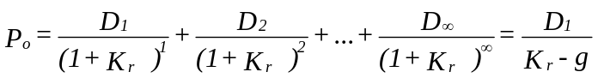

Where g is a constant growth rate
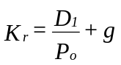

D₁ is the expected dividend
P_{o} is the market value of shares

Cost of Newly issued external equity
When a firm sells shares in the market it incurs floatation costs. This causes a difference between the cost of retained earnings and external equity.
If we use the DCF method, then
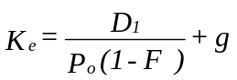

Where F is the floatation costs expressed as a percentage of market price of shares.

Weighted Average Cost of Capital (WACC)

The WACC is the overall cost of using the various forms of fund. It can be given by:

WACC = Net operating Earnings (NOE)
Total Market Value of the firm

It can also be expressed as

Where
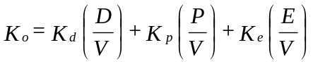

K_{o} is the weighted average cost of capital
K_{d} is the cost of debt
K_{p} is the cost of preference shares
K_{e} is the cost of equity

D, P, E are the proportions of debt, preferred stocks
V V V and equity in capital structure

For easy analysis we shall assume that the firm uses only debt and equity. The overall cost of capital will therefore be given by:

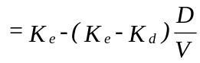
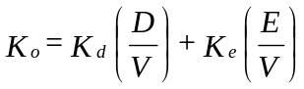

With this background we can look at what happens to K_{d}, K_{e} and K_{o} as the degree of leverage (denoted by D/E changes). This will be done by looking at the theories of capital structure.

2.0 CAPITAL STRUCTURE THEORIES

2.1 THE NET INCOME APPROACH (NI)

The essence of the NI approach is that the firm can increase its value or lower the overall cost of capital by increasing the proportion of debt in the capital structure. The crucial assumption of this approach are:

(a) The use of debt does not change the risk perception of the investor. Thus K_{d} and K_{e} remain constant with changes in leverage.
(b) The debt capitalization rate is less than equity capitalization rate (i.e. K_{d} < K_{e}).

The implications of these assumptions are that with constant K_{d} and K_{e}, increased use of debt, by magnifying the shareholders earnings will result in a higher value of the firm via higher value of equity. The overall cost of capital will therefore decrease. If we consider the equation for the overall cost of capital,
K_{o} decreases as D/V increases because K_{e} and K_{d} are constant as per our assumptions and K_{d} is less than K_{e}. This also implies that K_{o} will be equal to K_{e} if the firm does not employ any debt (i.e. when D/V = 0) and that K_{o} will approach K_{d} as D/V approaches 1. This argument can be illustrated graphically as follows.
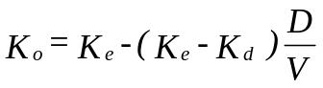

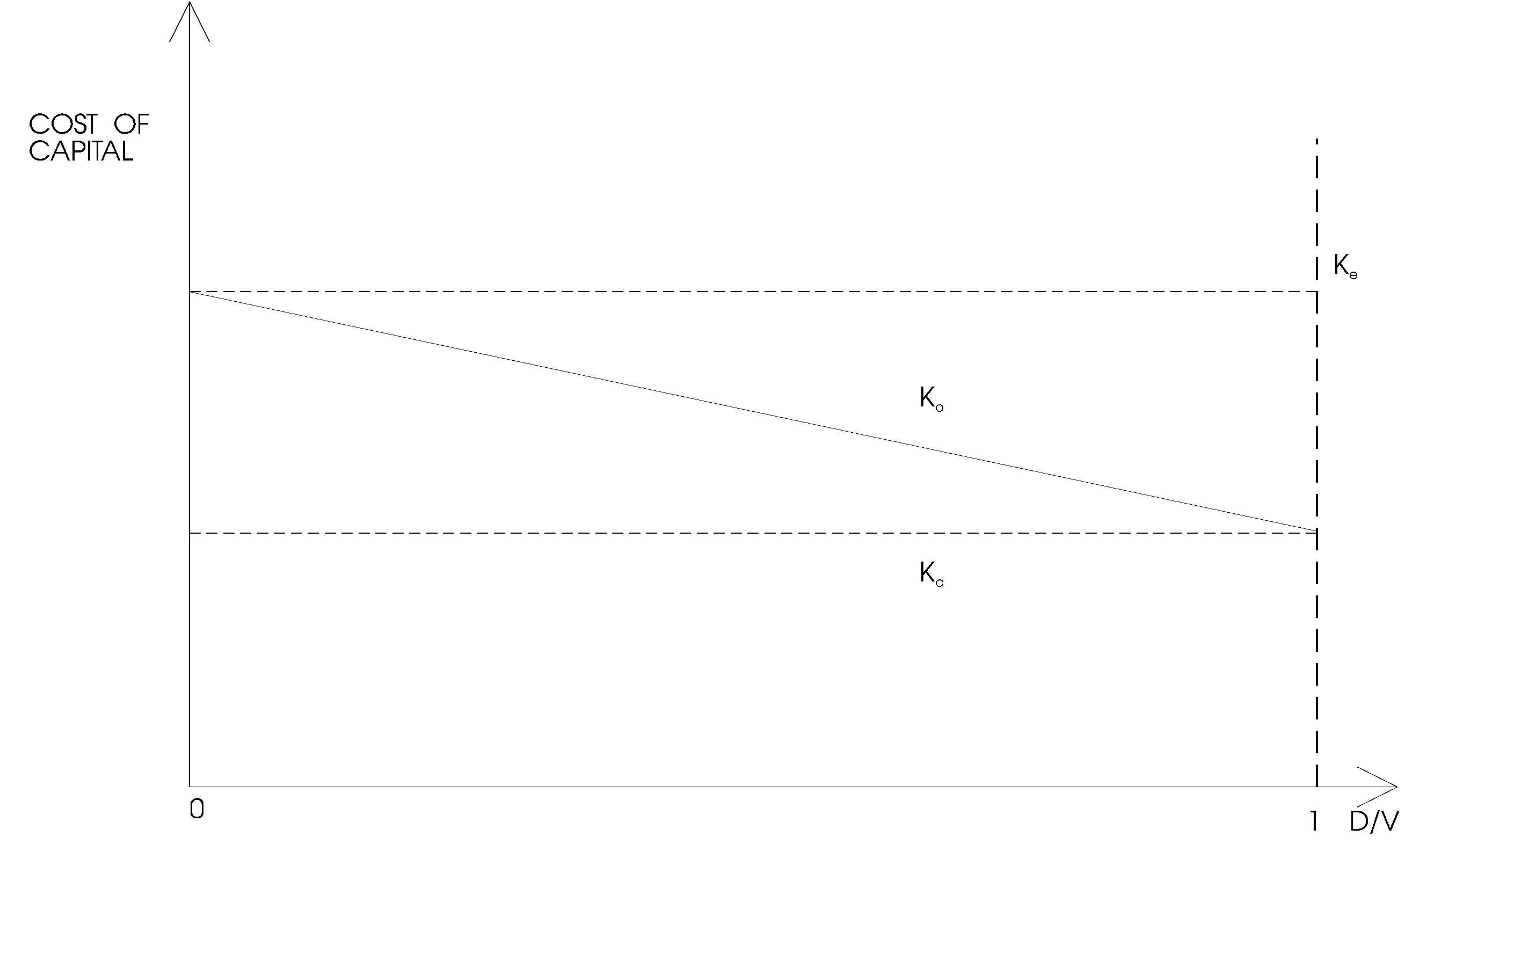

2.2 NET OPERATING INCOME (NOI) APPROACH

The critical assumptions of this approach are:

- The market capitalizes the value of the firm as a whole.
- Ko depends on the business risk. If the business risk is assumed to remain constant, then Ko will also remain constant.
- The use of less costly debt increases the risk of the shareholders. This causes Ke to increase and thus offset the advantage of cheaper debt.
- Kd is assumed to be constant.
- Corporate income taxes are ignored.

The implications of the above assumptions are that the market value of the firm depends on the business risk of the firm and is independent of the financial mix. This can be illustrated as follows:

2.3 TRADITIONAL APPROACH TO CAPITAL STRUCTURE
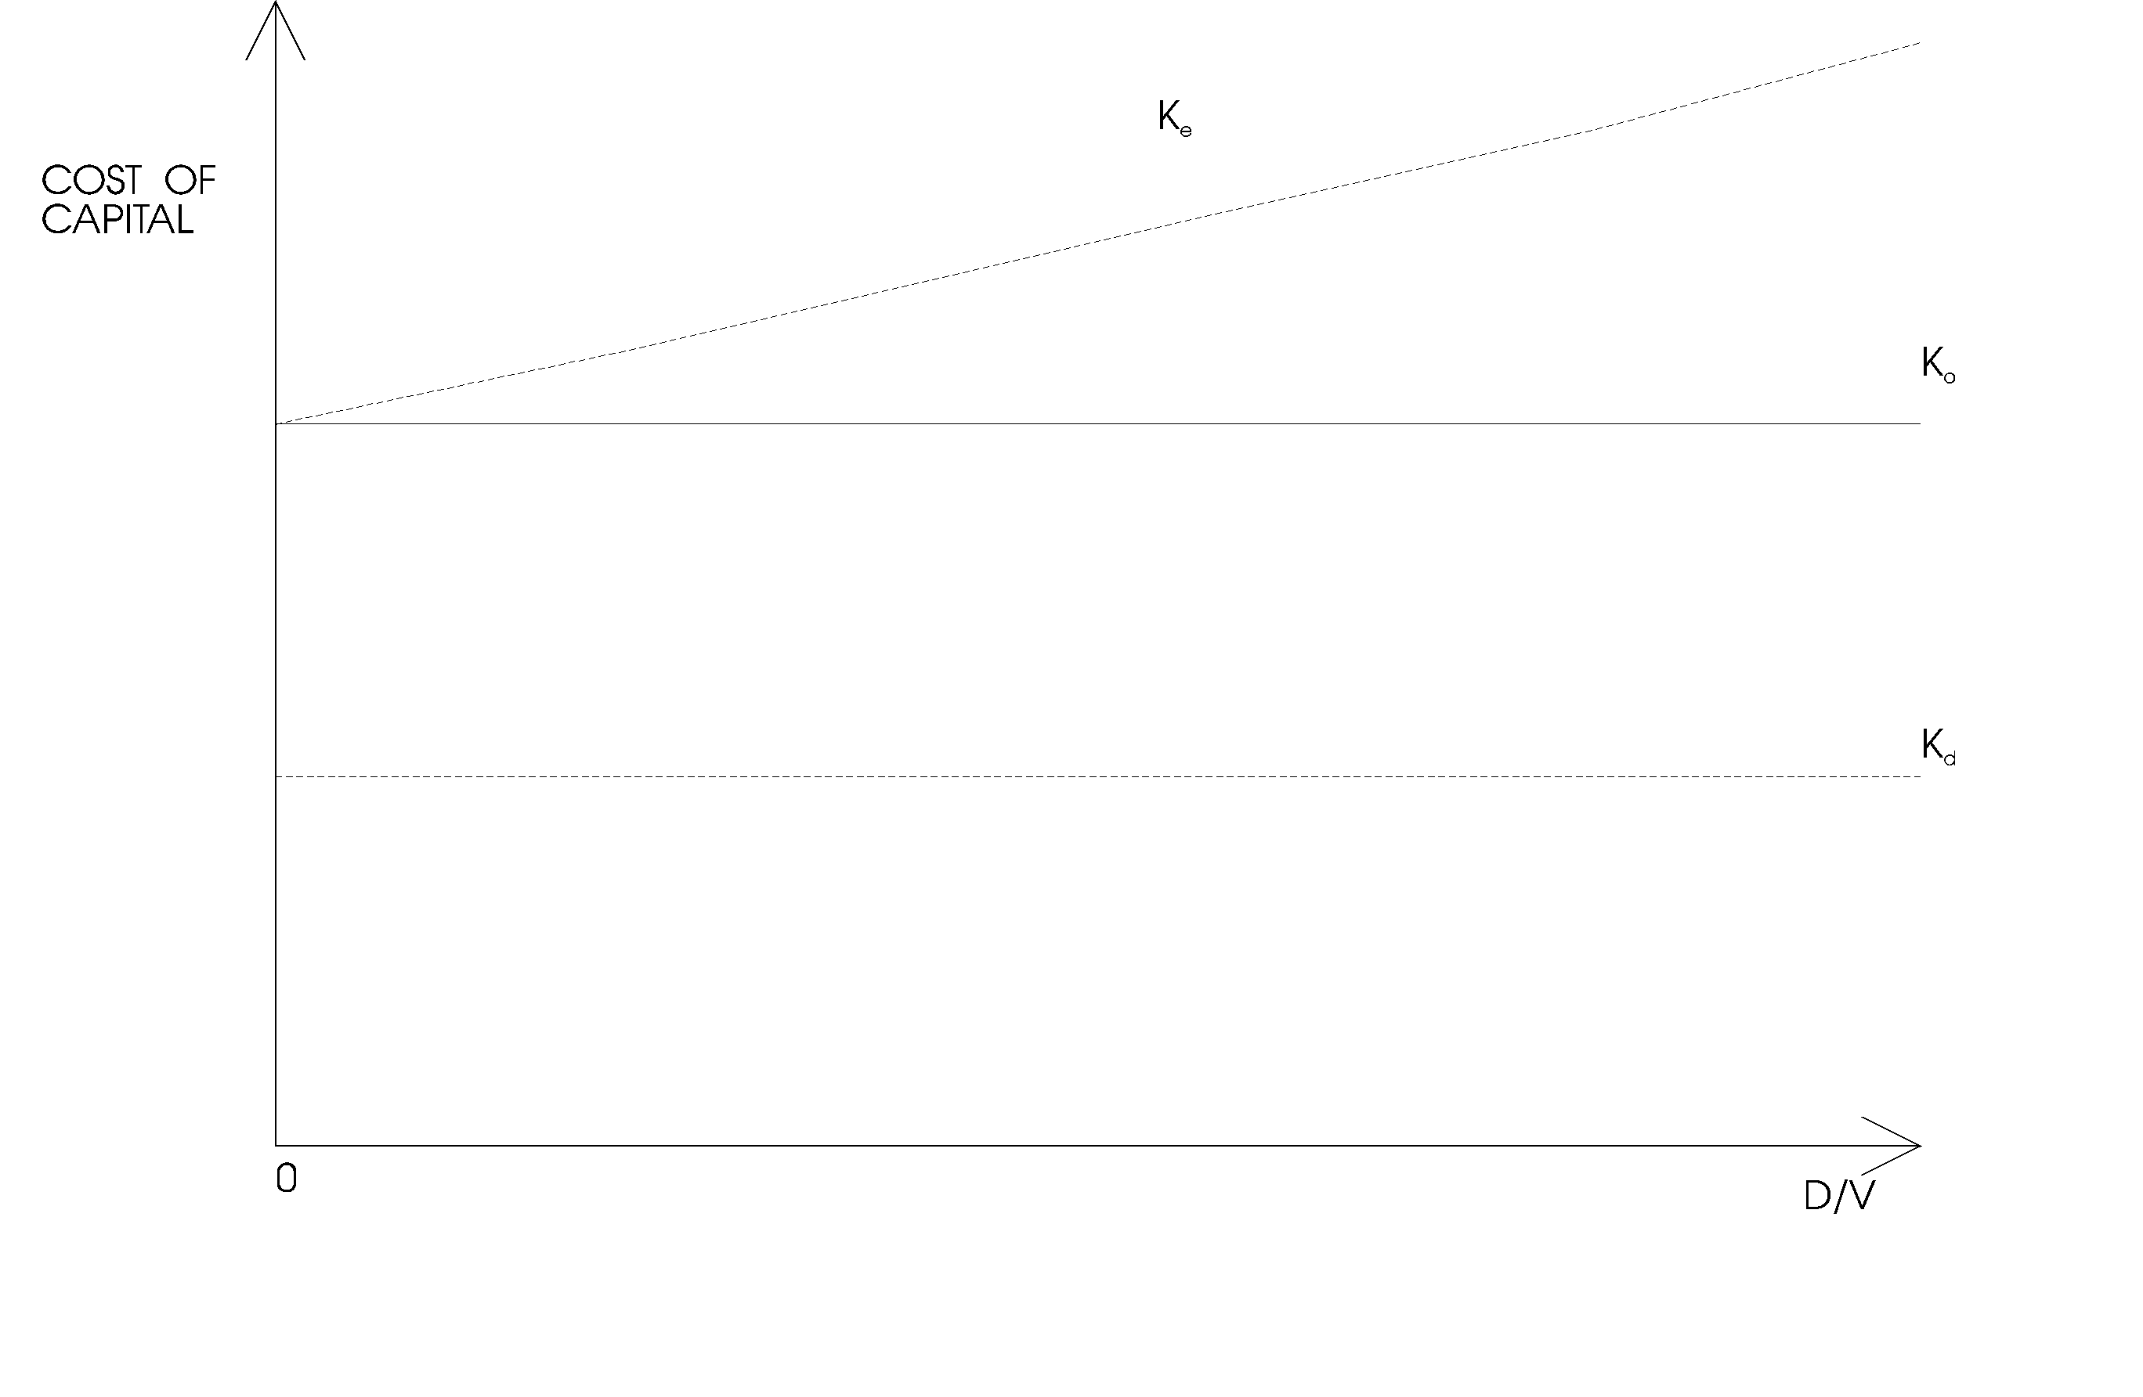

The traditional approach to the valuation and leverage assumes that there is an optimal capital structure and that the firm can increase total value through the judicious use of leverage. It is a compromise between the net income approach and the net operating income approach. It implies that the cost of capital declines with increase in leverage (because debt capital is cheaper) within a reasonable or acceptable limit of debts and then increases with increase in leverage.

The optimal capital structure is the point at which K_{o} bottoms out. Therefore this approach implies that the cost of capital is not independent of the capital structure of the firm and that there is an optimal capital structure. Graphically this approach can be depicted as follows:

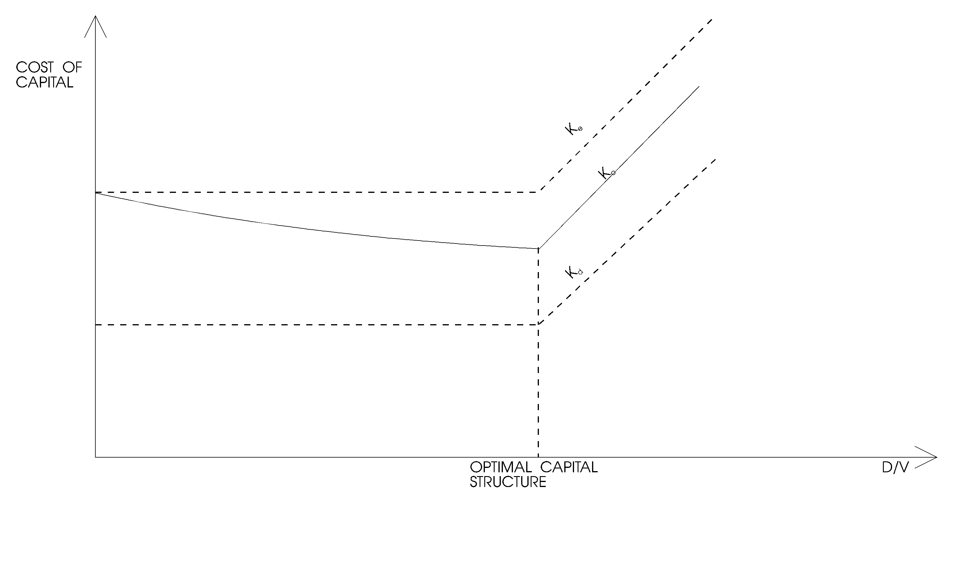

The traditional approach has been criticized as follows:

(a) The market value of the firm depends on the net operating income and the risk attached to it, but not how it is distributed;

(b) The approach implies that totality of risk incurred by all security holders of a firm can be altered by changing the way this totality or risk is distributed among the various classes of securities. In a perfect market this argument is not true.

The traditional approach however has been supported due to tax deductibility of interest charges and market imperfections.

2.4 THE MODIGLIANI-MILLER (MM) HYPOTHESIS

The MM, in their first paper (in 1958) advocated that the relationship between leverage and the cost of capital is explained by the net operating income approach. They argued that in the absence of taxes, a firm's market value and the cost of capital remains invariant to the capital structure changes. The arguments are based on the following assumptions:

(a) Capital markets are perfect and thus there are no transaction costs.
(b) The average expected future operating earnings of a firm are represented by subjective random variables.
(c) Firms can be categorized into "equivalent return" classes and that all firms within a class have the same degree of business risk.
(d) They also assumed that debt, both firm's and individual's is riskless.
(e) Corporate taxes are ignored.

Proposition I
The value of any firm is established by capitalizing its expected net operating income (If Tax = 0)

V_{L} = V_{U} = EBIT = EBIT
WACC K_{O}

1. The value of a firm is independent of its leverage.
2. The weighted cost of capital to any firm, levered or not is

(a) Completely independent of its capital structure and
(b) Equal to the cost of equity to an unlevered firm in the same risk class.

Proposition II
The cost of equity to a levered firm is equal to

(a) The cost of equity to an unlevered firm in the same risk class plus
(b) A risk premium whose size depends on both the differential between the cost of equity and debt to an unlevered firm and the amount of leverage used.
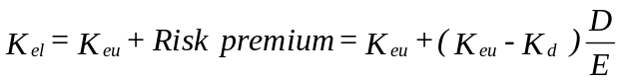

As a firm's use of debt increases, its cost of equity also rises. The MM showed that a firm's value is determined by its real assets, not the individual securities and thus capital structure decisions are irrelevant as long as the firm's investment decisions are taken as given. This proposition allows for complete separation of the investment and financial decisions. It implies that any firm could use the capital budgeting procedures without worrying where the money for capital expenditure comes from. The proposition is based on the fact that, if we have two streams of cash, A and B, then the present value of A +B is equal to the present value of A plus the present value of B. This is the principle of value additivity. The value of an asset is therefore preserved regardless of the nature of the claim against it. The value of the firm therefore is determined by the assets of the firm and not the proportion of debt and equity issued by the firm.

The MM further supported their arguments by the idea that investors are able to substitute personal for corporate leverage, thereby replicating any capital structure the firm might undertake. They used the arbitrage process to show that two firms alike in every respect except for capital structure must have the same total value. If they don't, arbitrage process will drive the total value of the two firms together.

Illustration
Assume that two firms the levered firm (L) and the unlevered firm (U) are identical in all important respects except financial structure.

Firm L has Sh 4 million of 7.5% debt, while Firm U uses only equity. Both firms have EBIT of Sh 900,000 and the firms are in the same business risk class.

Initially assume that both firms have the same equity capitalization rate K_{e(u)} = K_{e(L)} = 10%.

Under these conditions the following situation will exist.

Firm U

Value of Firm U's Equity = EBIT - K_{D} = 900,000 - 0
K_{e} 0.1

= Sh 9,000,000

Total market value = D_{u} + E_{u}
= 0 + 9,000,000
= Sh 9,000,000

Firm L

Value of Firm L's Equity = EBIT - K_{d}D = 900,000- 0.075(4,000,000)
K_{e} 0.10

= Sh 6m

Total market value = D_{L} + E_{L}
= 4m + 6m
= Sh 10,000,000

Thus the value of levered firm exceeds that of unlevered firm. The arbitrage process occurs as shareholders of the levered firm sell their shares so as to invest in the unlevered firm.

Assume an investor owns 10% of L's stock. The market value of this investment is Sh 600,000. The investor could sell this investment for Sh 600,000, borrow an amount equal to 10% of L's debt (Sh 400,000) and buy 10% of U's shares for Sh 900,000. The investor would remain with Sh 100,000 which he can invest in 7.5% debt. His income position would be:

Sh Sh
Old income 10% of L's Sh 600,000 equity income 60,000
New income 10% of U's income 90,000
Less 7.5% interest on 400,000 (30,000) 60,000
Plus 7.5% interest on extra Sh 100,000 7,500
Total new investment income 67,500

The investor has therefore increased his income without increasing risk.

As investors sell L's shares, their prices would decrease while the purchaser of U will push its prices upward until an equilibrium position is established.

Conclusion:

Taken together, the two MM propositions imply that the inclusion of more debt in the capital structure will not increase the value of the firm, because the benefits of cheaper debt will be exactly offset by an increase in the riskiness, and hence the cost of equity.

MM theory states that in a world without taxes, both the value of a firm and its overall cost of capital are unaffected by its capital structure.

2.5 CAPITAL STRUCTURE UNDER IMPERFECTIONS

The irrelevance of capital structure as discussed above rests on the absence of market imperfections. However, with introduction of imperfections, it is possible for the value of the firm and its cost of capital to change with changes in its capital structure. These imperfections are:

(a) Corporate Income Taxes

In a world with corporate taxes, where interest payments are tax deductible, it was recognized by MM that the issuance of debt can enhance the value of the firm. This is because the levered firm will pay less corporate taxes than the unlevered firm since the dividend payments are not tax deductible. The total amount of payments available for both debt holders and stockholders is greater if debt is employed. If the debt used is perpetual then the present value of the tax shield is given by:
Where t_{c} is the corporate tax rate
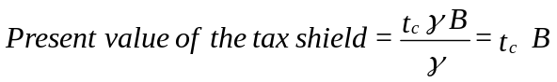

τ is the interest rate on debt
B is the market value of debt

The value of the firm will be:

Value of the firm = Value of Unlevered Firm + Value of the Tax Shield

From this formulae it can be seen that the greater the amount of debt, the greater the tax shield and thus the greater the value of the firm, other things remaining constant.

MM therefore concluded that the optimal capital structure is one with maximum amount of leverage.

(b) Personal Taxes
The above arguments may not hold in the presence of personal taxes as well.

It was shown by Merton Miller (M) in 1977 that when personal taxes are present, the present value of the tax shield is given by:
Where t_{c} and B are as before, t_{pd} is the personal income tax rate applicable to debt income, and t_{ps} is the personal tax rate applicable to common stockholders income.
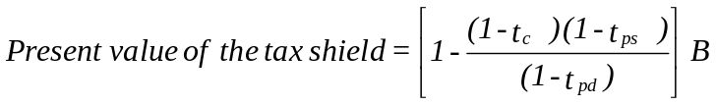

Miller argued that where t_{pd} = t_{ps} the present value of the tax shield remains as before (t_{c}B) and under this condition the levered firm has a higher value than the unlevered firm. However, the overall tax advantages associated with corporate debt is reduced by the fact that overall stock income is taxed at a lower personal rate than is debt income. This is so because stock income is divided into capital gain and dividend (capital gains tax has been suspended in Kenya).

Note that in a case where t_{c} = t_{pd} and t_{ps} = 0 then the tax shield will be equal to zero.

(c) Financial Distress and Agency Costs

Use of debt in the capital structure has a limit after which it becomes very hard to acquire more debt. Furthermore, the probability of the firm failing increases with increase in the use of debt. If such a situation would occur, then the firm would incur extra cost in the form of lawyers's fee, accountants and other court fees which would absorb part of the firm's value. The process of liquidation usually involves a lot of legal processes which result in the firm's loss of value. In some cases managers in a bid to guard against losing their jobs may make poor decisions so as to delay the process of bankruptcy. Such decisions may dilute the future value of the assets. Therefore, the levered firm should consider the cost of bankruptcy and financial distress.

Agency cost is the cost incurred by one party to monitor the activities of another. Protective covenants can be thought of as a way for the creditors to monitor the actions of stockholders, to preclude the erosion in value of their interest and this reduces the value of the firm to its shareholders. The value of the levered firm will therefore be:

V_{L} = V_{u} + T_{c}B – COD - AC

Where COD is the present value of expected financial distress costs and AC is the expected value of agency costs.

(d) Asymmetric Information Theory
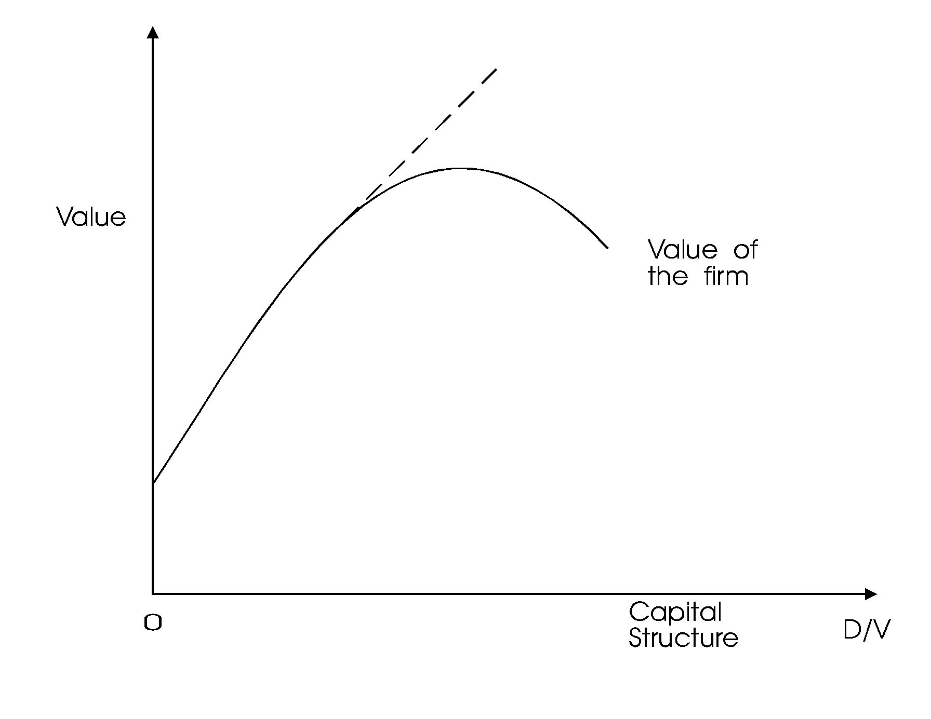

In early 1960s, Prof. Donaldson (Harvard University) conducted an extensive survey of how corporations actually establish their capital structure. Prof. Stewart Myers used the conclusion of Donaldson to advance a theory on the asymmetry information.

Illustration

Assume that a firm has 10,000 shares outstanding at a current price of Sh 19 per share. Managers have better information about the firms prospects than shareholders, and managers believe that the "actual share" value based on existing assets is Sh 21 giving the equity a total value of Sh 210,000. Suppose further that the firm identifies a new project which requires external financing of Sh 100,000 and which has an estimated net present value (NPV) of Sh 5,000. This project is unanticipated by the firm's investors and hence Sh 5,000 NPV has not been incorporated into the firm's Sh 190,000 market value of equity. The firm wants to sell new equity to raise the Sh 100,000 to finance the project. Several possibilities are available.

1. Symmetric Information: First, consider a situation where management can convey its information to the public and hence all investors do have the same information as management regarding existing assets values. Under these conditions, the stock would be selling at Sh 21 per share, so the firm would have to sell 100,000/21 = 4,762 new shares.

The new share price =210,000 + 100,000 + 5,000 = Sh 21.34
10,000 + 4,762

Both old and new shareholders would benefit.

2. Asymmetric Information: Assume that the firm's management can in no way inform investors about the shares true value. In this situation, new shares would be sold for only Sh 19 per share.

No. of new shares = 100,000 = 5,263 shares
19

New share price = New market value + New Money Raised + NPV
Original shares + New shares

= 210,000 + 100,000 + 5,000
10,000 + 5,263

= Sh 20.64

Under this condition the project should not be undertaken. This is because if the shares were not sold and the information asymmetry was removed, then the share price would rise to Sh 21.

The sale of new shares at Sh 19 leads to a Sh 0.36 loss to the firm's existing shareholders and a Sh 1.64 gain to the new shareholders.

A more profitable project

Assume that the project had an NPV of Sh 20,000 and other conditions were unchanged.

New share prices = 210,000 + 100,000 + 20,000
10,000 + 5,263

= Sh 21.62

The firm should take the project. However, the new shareholders gain more than existing shareholders. Sh 2.62 vs 0.62.

Dark Clouds on the Horizon

Suppose that shareholders think the firm is worth Sh 19 per share but the firm's managers think

(a) That outsiders are entirely too optimistic about the firm's growth opportunities and
(b) That investors are not properly recognising profound legislation which will require large non earning investment in pollution control equipment. Faced with these problems managers conclude that the true value of the firm's stock is only Sh 17 per share.

Assume that the managers issue 10,000 new shares to raise Sh 190,000 to retire debt or support these years capital budget.

New "true" value = Old `true' value + New Money
Original share + New shares

= 170,000 + 190,000
10,000 + 10,000

= Sh 18
Current shareholders will lose when the information is released but the sale of shares reduces the loss.

If debt was used

New share price = 210,000 + 5,000
10,000

= Sh 21.50

All the true value of firm's existing assets plus the NPV of the new project goes to the existing shareholders.

3.1 FINANCIAL & OPERATIONAL GEARING

FINANCIAL GEARING
In financial management the term financial gearing (leverage) is used to describe the way in which owners of the firm can use the assets of the firm to gear up the assets and earnings of the firm. Employing debt allows the owner to control greater volume of assets than they could if they invested their own money only. The higher the debt equity ratio, the higher the firm equity and therefore the firm level of financial risk. Financial risk occurs due to the higher proportion of financial obligations in the firms cost structure. The degree to which the firm is financially geared can be measured by the degree of financial gearing given by:

Degree of Financial Gearing (DFG) = (% Δ in EPS)
(% Δ in EBIT)

The degree of financial gearing indicates how sensitive a firm’s E PS is to changes in earnings before changes in interest and taxes (EBIT).

ILLUSTRATION
The financial manager of ABC Ltd expects earnings before interest and taxes of £50,000 in the current financial year and pays interest of 10% as long-term loan of £200 000. The company has 100 000 ordinary shares and the tax rate is 20%. The finance manager is currently examining 2 scenarios.
A case where EBIT is 25% less than expected.
A case where EBIT is 25% more than expected.

REQUIRED
Compute the EPS under the 3 cases and the degree of financial gearing for both scenario 1 and 2.

Solution:

Scenario 1 Base Case Scenario 2
(-25%) £ (+25%)
EBIT 37 500 50 000 62 500
Interest 20 000 20 000 20 000
EBT 17 500 30 000 42 500
Tax (20%) (3 500) (6 000) 8 500
EAT 14 000 24 000 34 000
EPS £0.14 £0.24 £0.34

DFG = %Δ in EPS
%Δ in EBIT

Scenario 1 DFG = (0.24 – 0.14) / 0.24 = 1.67
0.23

Scenario 2 DFG = (0.34 – 0.24) / 0.24 = 1.67
0.25
The degree of financial gearing can be calculated more easily using the following formulae.

DFG = EBIT
EBT

= 50 000 = 1.67
30 000

Note that this formulae should be used for the base case only.

A degree of financial gearing greater than one indicates that the firm is financially geared. The higher the ratio, the more vulnerable the firm’s earnings available to shareholders are to changes in firm’s EBIT.

Operating Gearing

Financial gearing is related to the proportion of fixed financial cost in the firm’s overall cost structure. Operating gearing however relate to the proportion of fixed operating cost in the firm’s overall cost structure. Operating gearing mainly considers the relationship between changes in EBIT and changes in sales. The degree to which a firm is operationally geared can be measured as follows:

D.O.G. = %Δ in EBIT
%Δ in Sales

D.O.G. therefore measures the sensitivity or vulnerability of EBIT to changes in sales. It can also be used to measure Business Risk. If D.O.G is more than one, then the business is operationally geared.
Illustration:
Assume that the finance manager of ABC Ltd expects to generate sales of £50 000 in the current financial year. Analysis of the firms operating cost structure reveals that variable operating cost is 40% of sales and fixed operating cost at £250 000.

The manager wishes to explore the effect of changes in sales and has developed 2 scenarios.

Sales revenue is 10% less than expected
Sales revenue is 10% greater than expected

Required:

Compute EBIT for each of the scenarios and the degree of operating gearing.

Scenario 1 Base Case Scenario 2
(-10%) ₤ (+10%)
Sales 450 000 500 000 550 000
Variable cost 180 000 200 000 220 000
Contribution 270 000 300 000 330 000
Fixed cost 250 000 250 000 250 000
20 000 50 000 80 000

D. O. G. = (50 000 – 20 000) / 50 000 = 6
(500 000 – 450 000) / 500 000

For the Base Case the degree of operating gearing can be given by the following formulae:

D.O.G. = Contribution
EBIT

= 300 000
50 000

= 6
Total Gearing
Its possible to obtain an assessment of the firms total gearing by combining its financial gearing and operating gearing so that the degree of total gearing (D.T.G) is equal to degree of operating gearing multiplied by degree of financial gearing.

D.T.G. = D.O.G. X D. F. G.

= %Δ in EPS
%Δ in sales

D.T.G. therefore measures the sensitivity (vulnerability) of EPS to changes in company’s sales.

ILLUSTRATION
Consider the ABC illustration and compute the degree of total gearing.

Solution:
Base case Scenario 2
£ +10%
Sales 500 000 550 000
Variable cost 200 000 220 000
Contribution 300 000 330 000
Fixed cost 250 000 250 000
EBIT 50 000 80 000
Interest 20 000 20 000
EBT 30 00 60 000
Less Tax(10%) 6 000 12 000
EAT 24 000 48 000
EPS 0.24 0.48

D.T.G = (0.48 – 0.24) / 0.24 = 10
(550 000 – 500 000) / 500 000)

For the base case,

D.T.G = Contribution
EBT

= 300 000 = 10
30 000

3.2 ADJUSTED PRESENT VALUE (APV)
It has been noted that the company’s gearing level has an implication for both the value of equity and the overall cost of capital. The viability of an investment project would depend partly on how it is financed and partly on how the method of financing affects the company’s gearing. Investment projects can be evaluated using NPV method by discounting the cash flows at the projects overall cost of capital or the risk adjusted discount rate. An alternative method of carrying out project appraisal is use of NPV method involving 2 stages:
Evaluate a project as if its an all equity financed to determine the base case NPV
Make adjustments to allow for the effect of the method of financing that has been used

APV = Base case NPV + PV of financing effect

Illustration
Assume XYZ ltd is considering a project which costs sh.100 000 to be financed by 50% equity with a cost of 21.6% and 50% debt with a pre-tax cost of 12%.
The financing method would maintain the company’s overall cost of capital to remain unchanged. The project is estimated to generate cash flows of sh.36 000 p.a. before interest charges and corporate tax at 33%.

Required:
Evaluate the project using:
NPV method
APV method

Solution:
1 K_{o} = K_{d} (I – T) (^{B}/_{V}) + Ko (^{E}/_{V})
= 0.12 (1 – 0.33) 0.5 + 0.216 (0.5)
= 14.82%
After tax cash flows = 36 000 (1 – 0.33) = 24120
NPV = (24120) -100 000
0.1482
= sh.62 753

Amounts of debt = 50% (162 753) = £81376.5
Amount of equity = 50% (162 753) = £81376.5

2. Kel = Keu + (1 – T) (Keu – K_{d}) B/E
0.216 = Keu + (1- 0.33) (Keu – 0.12) 0.5/0.5
Keu = 0.177485029

Step 1 Base Case NPV = 24120 – 100 000
0.177485029
= 35899
APV =Base case NPV + PV of the interest tax shield (tcB)
= 35899 + 0.33 (81376.5)
= sh.62753

Decision:
Accept because NPV > 0

Note:APV and NPV method produce the same conclusion since the capital structure remains constant. However, the NPV and APV method will produce different results in cases where the financing method used changes the firm’s capital structure.

Illustration:
Assumes in the above illustration that the entire project were to be financed by debt.

The APV would be:

APV = 35899 + 0.33 (100 000)
= sh.68 899

APV is a better method where initial capital is raised in such a way that it changes the capital structure proportions. It can be used to evaluate the effect of the method of financing a project and therefore is better than NPV.

However, APV has the following Limitations:

    - Computation of the cost of a no equity-financed company may not be easy.
    - Identifying all costs associated with the method of financing would be difficult e.g. the transaction costs, agency cost, etc.

3.3 TERM STRUCTURE OF INTEREST RATES

The term structure of interest rates describes the relationship between long-term and short-term interest rates. It explains whether short-term bonds will attract higher interest rates than long-term bonds and vice versa. This relationship is depicted by a yield curve which shows the interest rate against the maturity. The yield curve could either be upward sloping, downward sloping or constant as shown below.

Term structure theories
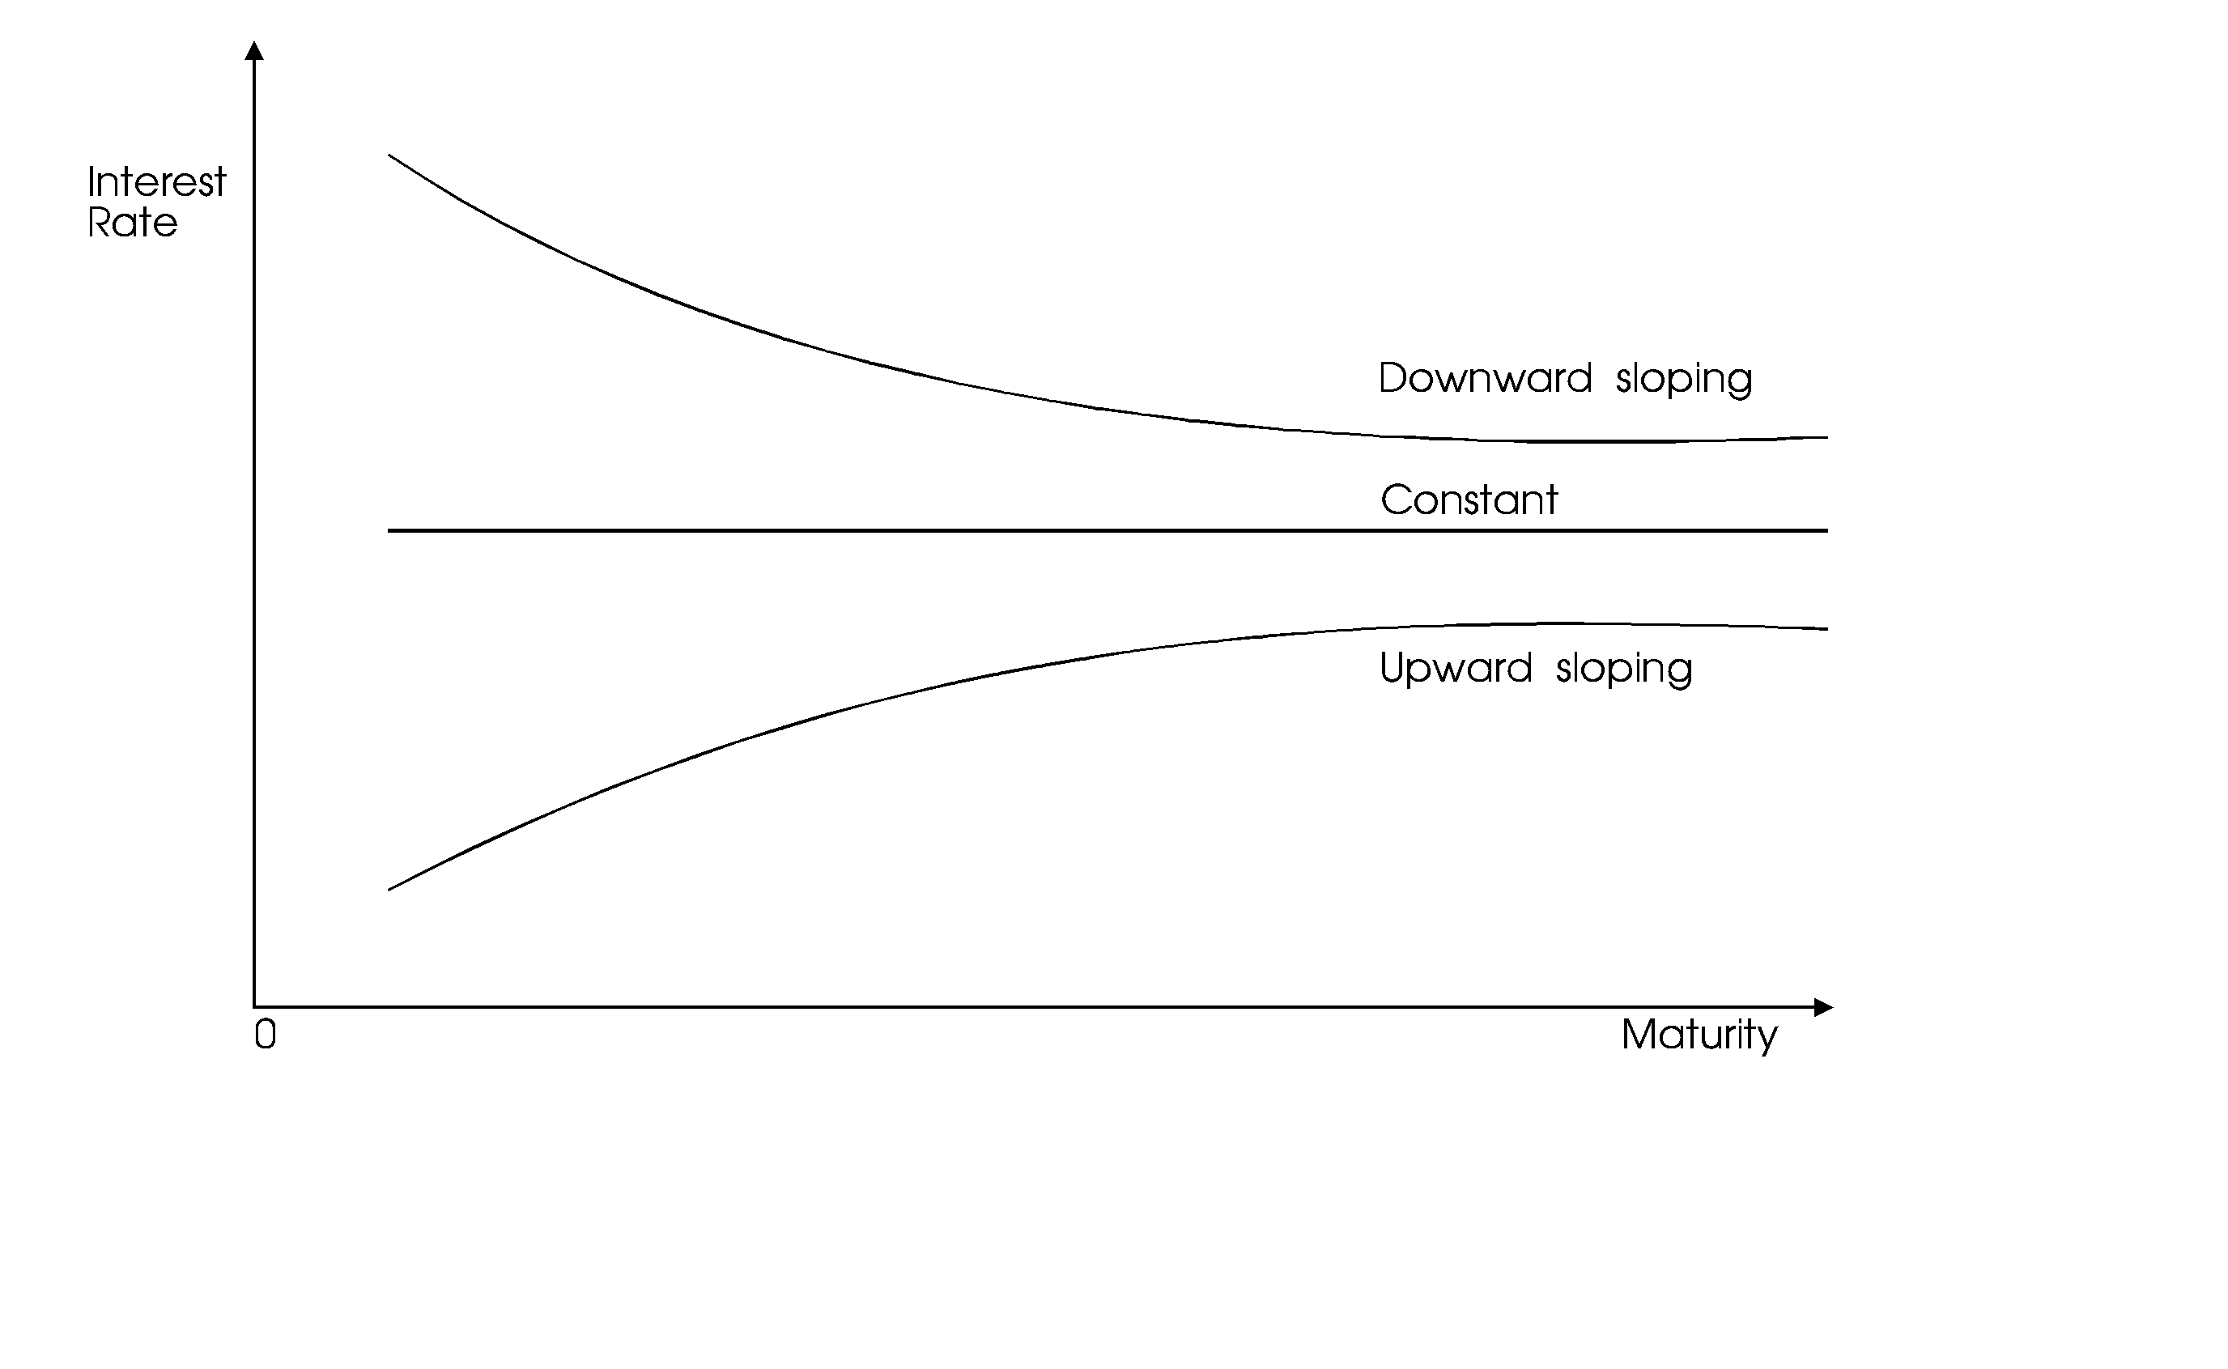

Several theories have been used to explain the shape of the yield curve. Three major theories are:

(a) Market segmentation theory
(b) Liquidity preference theory
(c) Expectation theory

(a) The Market Segmentation Theory

This theory states that each lender and each borrower has a preferred maturity. For example a company borrowing to buy long term assets like plant and equipment would want to borrow in the long-term market. However, a retailer borrowing to build the level of inventories in anticipation for increased sale would borrow in the short term market. Similarly differences exist among lenders (or savers). For example a person saving to pay school fees next term would lend in the short-term market while one saving for retirement twenty years hence would save in the long-term market.

The market segmentation theory states that there exist two separate markets the short term and long term markets. The slope of the yield curve depends on the demand and supply conditions in both markets. An upward sloping curve would occur when there is a large supply of funds relative to demand in the short term market but a relative shortage of funds in the long term market. Similarly a downward sloping curve would indicate relatively strong demand in the short term market compared to long term market while a flat curve would indicate balanced demand in the two markets.

(b) Liquidity Preference Theory

This theory states that long term bonds normally yield more than short term bonds for two reason:

i. Investors generally prefer to hold short-term securities because such securities are more liquid since they can be converted to cash with little danger of loss of principal. Hence other things being constant investors will accept lower yields on short term securities.

ii. At the same time borrowers react in the opposite way. Generally, they prefer long-term debt to short-term debt because short term debt expose them to the risk of having to repay the debt under adverse conditions. Accordingly borrowers are willing to pay a higher rate, other things remaining constant, on long-term funds than short term funds. Taken together, these two sets of preferences imply that under normal conditions a true maturity risk premium exist which increases with increase in maturity and thus the yield curve is upward sloping.

(c) Expectations Theory

This theory states that the yield curve depends on expectations about factors affecting future expected returns on similar assets. Examples of such factors include economic conditions such as inflation, recession and boom or political conditions. Taking inflation as an example: If the annual rate of inflation is expected to decline, the yield curve will be downward sloping whereas it will be upward sloping if the inflation rate is expected to increase.

Other factors influencing interest rates are:

i. Central bank monetary policy
ii. Government fiscal policy
iii. The level of business activities etc.

REINFORCING QUESTIONS
QUESTION ONE
Company A and B are in the same risk class and are identical in every respect except that Company A is geared while B is not. Company A has Sh 6 million in 5% bonds outstanding. Both companies earn 10% before interest and taxes on their Sh 10 million total assets. Assume perfect capital markets, rational investors, a tax rate of 60% and a capitalization rate of 10% for an all equity company.

Required:

(a) Compute the value of firms A and B using the net income (NI) approach and Net operating income (NOI) approach.
(b) Using the NOI approach, calculate the after tax weighted average cost of capital for firms A and B. Which of these firms has the optimal capital structure according to NOI approach? Why?
(c) According to the NOI approach, the values of firms A and B computed in (a) are not in equilibrium. Assuming that you own 10% of A's shares, show the process which will give you the same amount of income but at less cost. At what point would this process stop?

QUESTION TWO
A company's current EPS is KSh 12. The firm pays out 40% of its earnings as dividend and has a growth rate of 6% p.a. which is expected to continue into perpetuity. The company has a beta value of 1.4 and the risk free rate is 10%. The expected market return is 15%.

Required:

(a) Using CAPM, compute the expected return on the company's equity.
(b) What implications does CAPM bring if it is used to determine a firm's cost of equity?

QUESTION THREE
Companies U and L are identical in every respect except that U is unlevered while L has Sh 10 million of 5% bonds outstanding. Assume

(a) That all of the MM assumptions are met
(b) That there are no corporate or personal taxes
(c) That EBIT is Sh 2 million
(d) That the cost of equity to company U is 10%

Required:
i. Determine the value MM would estimate for each firm
ii. Determine the cost of equity for both firms
iii. What is the overall cost of capital for both firms
iv. Suppose the value of U is Sh 20 million and that of L is Sh 22 million. Explain the arbitrage process for a shareholder who owns 10% of company L's shares.

CHECK YOUR ANSWERS WITH THOSE GIVEN IN LESSON 9 OF THE STUDY PACK

COMPREHENSIVE ASSIGNMENT NO.3

TO BE SUBMITTED AFTER LESSON 6

To be carried out under examination conditions and sent to the Distance Learning Administration for marking by the University.

EXAMINATION PAPER: TIME ALLOWED: 3 HRS. ANSWER ALL QUESTIONS.

QUESTION ONE
The management of Kinyongoro Publishers has estimated the following net cashflows and probabilities for a new printing process.

Year Net Cashflows
P = 0.2 P = 0.6 P = 0.2
0 (100,000) (100,000) (100,000)
1 20,000 30,000 40,000
2 20,000 30,000 40,000
3 20,000 30,000 40,000
4 20,000 30,000 40,000
5 20,000 30,000 40,000
5* 0 20,000 30,000

Year 0 is the cost of the new process and Year 5* is the estimated salvage value. The cost of capital for a project of average risk is 10% p.a.

Required:

(a) Assuming that the above project has average risk, compute the projects base case net present value (NPV). (12 marks)
(b) Assume that all cashflows are positively perfectly correlated (i.e. there is only three possible cashflow scenarios over time namely worst case, most probable case and best case with probabilities 0.2, 0.6 and 0.2 respectively).
Find the projects expected NPV, standard deviation and coefficient of variation. (8 marks)
(c) Should the project be accepted? (2 marks)
(Total 22 marks)
QUESTION TWO
(a) The Capital Asset Pricing Model (CAPM) has been identified as a method for estimating the cost of Equity Capital.
Identify and describe how this model might be applied in actual practice by a company. What is the major weakness in using CAPM as a method of valuing a firm? (10 marks)
(b) Why would you consider the Arbitrage Pricing Theory to be much more robust than the Capital Asset Pricing Model. (8 marks)
(Total 18 marks)

QUESTION THREE
Explain the role played by bankruptcy and agency costs in capital structure theory. (15 marks)
(Total 15 marks)

QUESTION FOUR
(a) A single working capital investment and financing policy that is optimal for all firms is not practical. Why is this? (5 marks)
(b) Prime Shoes Ltd manufactures various types of shoes. The company is now considering its working capital policy for 1994. Fixed assets are projected at Sh 30 million and current liabilities at Sh 27 million. Sales and Earnings before interest and Taxes (EBIT) are partially a function of the company's investment in working capital particularly its investment in stocks and debtors. Prime Shoe Ltd is considering the following three different working capital investment policies:

Aggressive policy — small investment in current assets
Conservative policy — large investment in current assets
Moderate policy — moderate investment in current assets

The following information relates to three policies:

Aggressive Moderate Conservative
Sh`000' Sh`000' Sh`000'
Investment in
Current Assets 42,000 45,000 48,000
Projected Sales 88,500 90,000 91,500
EBIT 8,500 9,000 9,150

Required:

(a) Determine the working capital investment policies for each of the following:

i. Rate of return on total assets (3 marks)
ii. Net working capital (3 marks)
iii. Current ratio (3 marks)
(b) Describe the profitability-risk trade offs of these three policies. (6marks)
(Total 20 marks)
QUESTION FIVE
Umma Ltd and Lemma Ltd are identical in every respect except that Umma is unlevered while Lemma has Sh 10 million of 5% loan stock outstanding. You are also informed that:

- All of MM assumptions are satisfied
- There are no corporate or personal taxes
- Earnings before interest and taxes (EBIT) is Sh 2 million
- The cost of equity to Umma is 10% p.a.

Required:
(a) What market value would MM estimate for each firm? (4marks)
(b) What is the cost of equity for Lemma? (3marks)
(c) What is the market value of Lemma's equity? (3marks)
(d) What is the weighted average cost of capital for each firm? (3 marks)
(e) Suppose the market value of the assets of Umma is Sh 20 million and the market value for those of Lemma is Sh 22 million.
Are these equilibrium valuations? Use these figures to explain how equilibrium is established.
(7 marks)
(Total 20 marks)

END OF COMPREHENSIVE ASSIGNMENT No.3

NOW SEND YOUR ANSWERS TO THE DISTANCE LEARNING CENTRE FOR MARKING

LESSON SEVEN

LONG TERM FINANCING DECISIONS
INSTRUCTIONS

1. Read Chapter 28-31, 20, 21 of Panday I.M. and the study text below
2. Complete answers to reinforcing questions at the end of the lesson.
3. Check model answers in Lesson 9 of the Study Pack.

CONTENTS

1.0 Introduction
2.0 Common Shares
3.0 Methods of Issuing Common Shares
4.0 Debentures
5.0 Term Loans
6.0 Preference Shares
7.0 Warrants and Convertible Securities
Venture Capital
Lease Financing
10.0 Options
11.0 Dividend Theory
1.0 INTRODUCTION
This lesson looks at financing decisions of the financial managers. It places special emphasis on the different sources of long-term funds and the dividend decisions. We shall initially discuss the common shares, debentures and term loans before moving over to options and futures. The Dividend decisions will also be discussed.
The student should note that this topic is also covered in Business Finance and some of the materials may have already been covered. However, the examiner has been examining this topic and therefore it is worth repeating these materials.

2.0 COMMON SHARES

Common shares represent the ownership position in a company. The holder of common shares are the legal owners of the company and they are entitled to dividends from the company. Common shareholders therefore bear the risk of ownership.

We can define three different share capital terms:

(a) Authorised share capital represent the maximum amount of capital which a company can raise from shareholders. However, this maximum can be changed by a company altering its Memorandum of Association.
(b) Issued share capital is that portion of the authorised share capital that has been offered to the shareholders.
(c) Outstanding share capital is that portion of issued share capital that is still held by shareholders at any particular time. That is shares that have not been repurchased by the issuing company.
(Note: Share Repurchase is illegal in Kenya and therefore issued shares will always be equal to outstanding shares for companies in Kenya).

2.1 MAJOR FEATURES OF COMMON SHARES

(a) Claim on Income
Common shareholders have a residual ownership claim. They have claim to residual income after paying expenses, interest charges, taxes and preference dividend.
(b) Claim on Assets
Common shareholders have a residual claim on the company's assets in case of liquidation. Out of the realized value of assets, the claims of debt-holders and preference shareholders are satisfied first and the remaining balance, if any is paid to common shareholders.
(c) Right to Control
Common shareholders have the legal powers to control the operations and the decisions of the firm. They do this through representatives (directors) who manage the firm on behalf of the shareholders. The shareholders are therefore required to vote on a number of important matters such as election of directors or change of memorandum of association.
Shareholders may vote either in person or by proxy. A proxy gives a designated person right to vote on behalf of a shareholder at the company's annual general meeting.
Directors are elected at the annual general meeting by either a majority rule or a cumulative voting rule.
Under the majority voting system each share receives one vote and a decision is made if it receives over 50% votes. It is therefore possible, under this system, for a majority shareholder to make all decisions in the firm and therefore elect all directors.
Under cumulative voting system however, it is possible for those who hold less than 50% interest to elect some of the directors. Under this process a shareholder gets one vote for each share held multiplied by one vote for each director to be elected (or similar decisions to be made). The shareholder may then accumulate votes in favour of a specified number of directors.
The number of shares required to elect a given number of directors would be given by the following formula.

r = d (n) + 1
N + 1

Where:
r is the number of shares required
d is the number of directors the shareholders desire to elect
n is the total number of shares outstanding and entitled to vote
N is the total number of directors to be elected

Illustration 1
ABC Ltd will elect six directors at the AGM. There are 100,000 shares outstanding and entitled to vote. If a group desires to elect two directors, how many shares must it have?

Solution
In this question d = 2, n = 100,000, N = 6 and therefore r will be:

r = 2 x 100,000 + 1 = 28,572
6 + 1

The group therefore must have at least 28,572 shares to elect 2 directors.

Illustration 2
If a group held 40,000 shares in the ABC Ltd (Illustration 1), how many directors would be possible for the group to elect?

This can be done by making d the subject of the formula

d = (r - 1) (N + 1)
n
= (40,000 - 1) (6 + 1)
100,000
= 2.8 directors
r = 40,000
n = 10,000
N = 6

The group can therefore elect at least 2 directors.

Note:

The above formula is based on Game theory and it assumes that all the other shareholders are opposed to the candidate of the group (or the shareholder).

(d) Limited Liability
Common shareholders are the true owners of the company, but their liability is limited to the amount of their investment in shares. If the shareholder has already fully paid the issue price of the shares purchased, he has nothing more to contribute in the event of financial distress or liquidation.

(e) Preemptive rights
The preemptive rights entitle the shareholder to maintain his proportionate share of ownership in the company. The right, therefore, allows shareholders to purchase new shares in the same proportion as their current ownership. The shareholders' options to purchase a stated number of new shares at a specified price during a given period are called rights. (Rights issue will be discussed in the next section).

3.0 METHODS OF ISSUING NEW COMMON SHARES
If stock is to be sold to raise new capital, the new shares may be sold in one of five ways:

(a) On a pro-rata basis to existing shareholders through a rights issue
(b) Through investment bankers to the general public in a public issue
(c) To a single buyer (or a very small number of buyers) in a private placement
(d) To employees through an employee stock purchase plan
(e) Through a dividend reinvestment plan by a bonus issue

3.1 RIGHTS ISSUE OF COMMON SHARES
A rights issue involves selling of common shares to existing shareholders of the company on a prorata basis. Shares becoming available on account of non-exercise of rights are allotted to shareholders who have applied for additional shares on a pro-rata basis. Any balance of shares can be sold in the open market.

When rights are issued the shareholder has three options available:

(a) He can exercise the rights and therefore buy the new shares
(b) He can sell the rights in the market
(c) He can ignore the rights

The number of rights required to buy one new share can be given by the following formula

N = S_{o}
S

Where S_{o} is the number of existing shares
S is the number of new shares to be sold
N is the number of rights required to buy one new share

The ex-right price of shares can be given by:

P_{x} = S_{o} P_{o} + S P_{s}
S_{o} + S

Where:

P_{x} is the ex-right price of shares
P_{o} is the cum-right price (current market prices of shares)
S_{o} is the number of existing shares
S is the number of new shares
P_{s} is the subscription price of rights

It can also be given by:

P_{x} = P_{s} + (P_{o} - P_{s}) N
N + 1

Rights have value and the value of each right can be given by the following formulae:

R = P_{x} - P_{s}
N

Where R is the theoretical value of rights P_{x}, P_{s} and N have previously been defined.

It can also be given by:

R = P_{o} - P_{x}

or R = P_{o} - P_{s}
N + 1

Note:

All the above formulae give the same value and the student should use whichever is most convenient.

Illustration:

XYZ Ltd has 900,000 shares outstanding at current market price of Sh 130 per share. The company needs Sh 22,500,000 to finance its proposed expansion. The board of directors has decided to issue rights for raising the required funds. The subscription price has been fixed at Sh 75 per share.

Required:

(a) How many rights are required to purchase one new share?
(b) What is the price of one share after the rights issue (Ex-right price)?
(c) Compute the theoretical value of each right
(d) Consider the effect of the rights issue on the shareholders' wealth under the three options available to the shareholders (Assume he owns 3 shares and has Sh 75 cash on hand).

Solution:

(a) To compute the number of rights required to buy one new share, we must first compute the number of new shares to be issued.

No. of shares = Desired funds
Subscription price

= 22,500,000
75

= 300,000 shares

N = S_{o} S_{o} = 900,000 shares
S S = 300,000 shares

N = 900,000 = 3
300,000

Therefore a shareholder will require 3 rights to buy one new share in the company.

Notes

The shareholder will receive one right for each share held and therefore a total of 900,000 rights will be issued by the company.

(b) The price of the shares after the rights issue will be lower than the price before the rights issue because the new shares are usually sold at a price which is below the market price.

P_{x} = P_{s} + (P_{o} - P_{s}) N
N + 1
P_{s} = 75
P_{o} = 130
N = 3

P_{x} = 75 + (130 - 75) 3/4
= Sh 116.25

After the rights issue the price of the shares would fall from Sh 130 to Sh 116.25. However, in an inefficient market, this may not be the case.

(c) Value of each right

R = P_{o} - P_{s} = 130 - 75
N + 1 3 + 1

= Sh 13.75

Each right will therefore have a theoretical value of Sh 13.75.

(d) To consider the effects of the rights issue on the shareholders wealth, we need to consider the current wealth of the shareholder.

Current Wealth Sh
Wealth in the company (3 x 130) 390
Cash in hand 75
Total Wealth 465

Option 1 - Exercise the rights Sh
Wealth in the company 4 x 116.25 465
Cash in hand (75 - 75) 0
Total Wealth 465

Therefore, the wealth remains constant if the shareholder exercises the rights and buys the new shares.

Option 2 - Sell the rights at their theoretical value Sh

Wealth in the company 3 x 116.25 348.75
Cash in hand - previous 75
From sale of rights 3 x 13.75 41.25 116.25
Total Wealth 465.00

The wealth also remains constant if the shareholder sells the rights at their theoretical value.

Option 3 - Ignore the rights Sh
Wealth in the company 3 x 116.25 348.75
Cash in hand 75.00
Total Wealth 423.75

The wealth declines by Sh 41.25 from Sh 465 to Sh 423.75 if the shareholder ignores the rights. The shareholder should therefore never ignore a rights issue because his wealth will decline.
Note:
In an inefficient capital market the announcement of the rights issue may carry additional information not yet known by the market and therefore the share price may increase or decrease depending on the informational content of the rights issue.
The major advantage of a rights issue is that the shareholders maintain their proportionate ownership of the company.

3.2 PUBLIC ISSUE OF COMMON SHARES
The decision to issue ordinary shares is made in two stages:

Stage I
The firm itself makes some initial decisions such as:

(a) Amounts to be raised by the new shares
(b) The type of securities to be used—either preference shares or ordinary shares
(c) The method of issue—either competitive bids or negotiated deals
(d) Selection of investment banker

Stage II decisions
These are made jointly by the firm and its selected investment banker and include:

(a) Re-evaluating the initial decisions
(b) Deciding on the relationship between the banker and the firm. It may either be an under-writing relationship or best effort relationship
(c) The Bankers compensation and other expenses will have to be agreed upon

The investment banker will thereafter undertake to sell the shares to the public on behalf of the firm.

3.3 PRIVATE PLACEMENTS AS A METHOD OF ISSUING COMMON SHARES

In a private placement, securities are sold to one or a few investors, generally institutional investors. The primary advantages of private placement are:

(a) Lower floatation costs
(b) Greater speed since shares will not have to go through the capital market authority (CMA)

The major disadvantage however is that the securities will not have been approved by CMA and therefore cannot be sold in stock exchange except to another large investor. Privately placed securities, therefore, lack liquidity.

3.4 DIVIDEND REINVESTMENT SCHEME

An issue of bonus shares represent a distribution of shares in addition to or instead of, the cash dividend to the existing shareholders. The shares are distributed proportionately. A bonus issue does not affect the shareholder's wealth. It however, has the following advantages:

(a) Tax benefit
When a shareholder receives cash dividend from the company, he pays tax but a bonus issue does not attract taxes. The shareholder can sell the new shares received to generate cash and thereby realize a capital gain which is currently not taxable.
(b) Indication of higher profits in future
The issue of bonus shares is normally interpreted by shareholders as an indication of higher profitability especially in an inefficient market. This is because a bonus issue is declared by management when they expect a rise in earnings to offset additional outstanding shares. The bonus issue thus convey important information to the market.

(c) Increase in future dividends
If a company has been following a policy of paying fixed dividend per share and continues it after the declaration of the bonus issue, the total cash dividend the shareholder receives will increase because of the increase in the number of shares.

(d) Conservation of cash
A company that issues bonus shares conserves cash that would otherwise have been paid as dividend. This is particularly important if the company is facing cashflow or liquidity problems.

3.5 EMPLOYEES STOCK PURCHASE PLAN

Some companies have plans that allow employees to purchase shares on favourable terms. These plans may be organized under the following options:

(a) Under executive incentive option plans where key managers are given options to purchase shares. These managers usually have a direct, material influence on the company's fortunes and so if they perform well the stock prices will go up and the option will become valuable.
(b) There are plans for lower-level employees where the company uses its profits to buy the shares for the employees.

3.6 ADVANTAGES OF COMMON SHARES

(a) Since common shares have no maturity date, the company has no liability for cash outflow associated with the redemption of common shares. It is therefore a permanent capital which is available for the firm's use as long as the firm remains a going concern.
(b) The issue of common shares increases the company's financial base and thus its borrowing limit increases since lenders usually provide capital in proportion to the company's equity.
(c) A company is not legally obliged to pay dividend and therefore in times of financial difficulties, it can reduce or suspend common dividends.

3.7 DISADVANTAGES OF COMMON SHARES

(a) Common shares have a higher cost because:

i. Dividend is not tax deductible as is debt interest
ii. Floatation costs on equity are higher than on debt
iii. Common shares are more risky from the investors point of view due to uncertainty regarding dividends and capital gain. They therefore require a higher rate of return

(b) The issue of new shares dilutes the shareholders earning per share usually because profit does not increase immediately in proportion to the increase in the number of common shares.
(c) The issue also dilutes the ownership and control of existing shareholders.

4.0 DEBT INSTRUMENTS

4.1 Debentures
A debenture is a long-term promissory note used to raise debt funds. The firm promises to pay periodic interest and principal at maturity. Ideally, a debenture is a long-term bond that is not secured by a pledge of a specific property. However, like other general creditors claims, its secured by a pledge of a specific property not otherwise pledged.

4.2 Bonds
Bonds are long term promissory notes issued by a company to raise debt funds and usually secured specifically on company’s assets.

4.3 Mortgage
Represents a pledge of a designated property for a loan. Under a mortgage bond, a company pledges certain real assets as security for the bond. A mortgage bond therefore is secured by real property (i.e. land and buildings).

4.4 Subordinated Debentures
The term subordinated means below or inferior and therefore subordinated debts have claims in assets after unsubordinated debts in the event of liquidation. Debentures can be subordinated to designated notes payable (usually bank loans) and to any other specific debt. In the case of liquidation the subordinated debentures cannot be paid until senior debts as named in the indenture has been paid. The long-term relationship between the borrower and lender of long-term promissory notes is contained in a document called indenture. This document discusses a number of factors important to the contracting parties such as:

      - 1. The form of bond and instrument
      - 2. A complete description of the property pledged
      - The authorized account of the bond issue
      - Detailed protective clauses or covenants
      - Minimum current ratio requirements.
      - The provision for redemption or core privileges.

4.5 Income Bonds
Income bonds provide that interest must be paid only if earnings of the firm are sufficient to meet the interest obligation. The principal must however be paid when due. Main advantage of income bond in the company is that interest is not affixed, charged and is not payable if the company does not make profit. Some income bonds however are cumulative.

4.6 Floating Rate Notes (Bonds)
When inflation forces interest rates to high levels, borrowers are reluctant to commit themselves to a long-term debt. Yield curves are typically inverted at such times with short-term interest rates being higher than long term ones. The main reason for this is that a borrower would rather pay prevention for short-term funds than lock themselves into a long-term rate. The floating rate bond addresses this problem. In a floating rate bond the interest rate varies at a given percentage above prevailing short term or long-term treasury bond yields.

4.7 Features of Debentures

(a) Interest rate
The interest rate on a debenture is fixed and known. It is called the contractual or coupon interest rate. It indicates the percentage of the par value that will be paid out annually (or semi-annually) in form of interest. The interest must be paid whether the firm makes profit or not. However, debenture interest is tax deductible on the part of the company.
(b) Maturity
Debentures are usually issued for a specific period of time. The maturity of a debenture indicates the length of time the debenture remains outstanding before the company redeems it. However, there are debentures that have no maturity period.
(c) Redemption
The redemption of debentures can be accomplished either through a sinking fund or call provision.
A sinking fund is cash set aside periodically for retiring the debentures. The fund is placed under the control of the trustee who redeems the debenture either by purchasing them in the market or calling them in an acceptable manner. The advantage of a sinking fund is that it reduces the amount required to redeem the remaining debt at maturity. Particularly when the firm faces temporary financial difficulties at the time of debt maturity, the repayment of huge amount of principal could endanger the firm's financial viability.

Call provisions enable the company to redeem debentures at a specific price before the maturity date. The call price is usually higher than the par value, the difference being a call premium.

(d) Security
Debentures are either secured or unsecured. A secured debenture is secured by a claim on the company's specific assets. When debentures are not protected by any security, they are known as unsecured or naked debentures.
(e) Convertibility
A convertible debenture is one which can be converted, fully or partly into shares at a specified price at a given date. Debentures without a conversion feature are called non-convertible or straight debentures.

(f) Yield
We can distinguish two types of yield: the current yield and the yield to maturity. The current yield on a debenture is the ratio of the annual interest payment to the debentures market price.

Current yield = Annual interest
Market price

The yield to maturity takes into account the payments of interest and principal over the life of the debenture. It is an internal rate of return on the debenture and is given by the following formula.
Where C is the annual interest
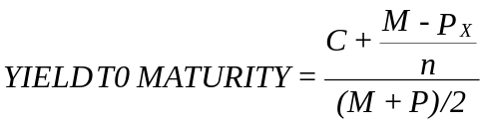

M is the maturity value = Face Value
P is the current market value
n is the number of periods to maturity

Claim on Assets and Income
Debentures have a claim on the company's earnings prior to that of the shareholders since their interest has to be paid before paying any dividend to preference and common shareholders.
In case of liquidation, the debenture holders have a claim on assets prior to that of shareholders. The secured debentures will have priority over the unsecured debentures.

4.8 Refunding Of The Bonds
Bond refunding means calling the issue and replacing it with new issue of bonds. In this regard the focus is on profitability (which is due to the fact that interest have declined since the bonds were issued). Some other reasons however may force the company to redeem the bonds. These reasons include

- The elimination of every restructure covenant in the bond indenture
- To show higher profits since the difference between the purchase price of the old bonds and their book value is treated as income in the year in which they are called.

The refunding decision can be regarded as a form of capital budgeting. There is an initial cash over flow followed by future interest saving. The savings are represented by the difference between the annual cash flow required under the old bond and the net cash flow required on the new bond.
Illustration
A company currently has Shs 20 000 000, 12% debenture issue outstanding which has 20 years remaining to maturity. The company can now sell a Shs 20 million 20 year bond or debenture with a normal or coupon rate of 20% that will net Shs 19.6 million, after the underwriting expenses of the old bond. The core premium and the unamortized discount of the old bond are deductible as expenses in the year of refunding. The old issue has Shs 200 000 unamortized discounts outstanding and unamortized legal fee of Shs 100 000. The core right of old bond is Shs 109 and the issuing expenses on the new bond are Shs 150, 000 and there is a 30 day period of interest overlap. Assume that the effective income tax is 50%.

Required:
Advice the company on whether to replace the old issue with the new bonds.

Solution:
Shs.
Cost of calling old bonds 12 800 000
Net proceeds of new bonds 19 600 000
Difference 2 200 000

Expenses:
Issuing expenses of new bonds 150 000
Interest in old bonds during overlap 200 000 350 000
2 550 000
Less Tax savings
Interest Overlap 200 000
Call premium 1 800 000
Unamortized discount as old 200 000
Unamortized legal fees 100 000
2 300 000
Tax savings 50% 1 150 000
Net cash out flow 1 400 000
Interest on old bond = 12% x 20,000,000 x 1/12

ANNUAL CASH FLOW ON OLD BONDS
Shs Shs
Interest expenses (12%) 2 400 000
Less: Tax savings
Interest expense 2 400 000
Amortization of discount
(200 000/20) 10 000
Amortization of legal fee
(100 000/20) 5 000
24 150 000
Tax savings (50%) 1 207 500
1 192 500

ANNUAL CASH OUT FLOW FOR NEW BONDS

Shs Shs
Interest expense (10%) 2 000 000

LESS TAX SAVING
Interest expenses 2 000 000
Amortization of discount
(400 000/20) 20 000
Amortization of issue costs
(150 000/20) 7 500
2 027 500
Tax shield (50% 1 013 750
Annual net cash flow 986 250

The net effect is therefore:
Cash outflow on old 1 192 500
Cash outflow on new 986 250
Annual cash savings 206 250

Effective discount rate = 10% (1 – 0.5) = 5%
NPV = 206 250 PVAF 5%, 20 years – 1 400 000
= 206 250 x 12.4622 – 1 400 000
= 1 170 328.75

Decision:
Refund the old bond because the NPV of refunding decision is positive.

4.9 Bond Rating
Agency rating is an integral part of the bond market because most corporate bonds are rated by one or more of rating agencies. The exceptions are very small issues and bonds from certain industries such as banks. These are known as Non-rated bonds. There are 4 main Rating Agencies internationally:
These are:
Duff & Pbelps
Fitch
Moody’s
Standard & Poor’s

Bond rating provides the fundamental analysis for thousands of issues. The rating agencies analyse the issuing organization and a specific issue to determine the probability of default and inform the market of their analyses through their rating. The primary question in Bond Credit Rating is whether the company can service its debts in a timely manner of the life of the issue along with the historical and convent financial position of the company.
The original rating assigned to bonds have an impact on their marketability and effectiveness interest rate. Seasoned issues are regularly reviewed to ensure that their assigned rating is still valid. If not, revisions are made either upward or downward.

4.10 ADVANTAGES OF DEBENTURES
It involves less cost to the firm than the equity financing because:

i. Investors consider debentures as a relatively less risky investment alternative and therefore require a lower rate of return.
ii. Interest payments are tax deductible.
iii. The floatation costs on debentures is usually lower than floatation costs on common shares.
(b) Debenture holders do not have voting rights and therefore, debenture issue does not cause dilution of ownership.
(c) Debenture holders do not participate in extraordinary earnings of the company. Thus their payments are limited to interest.
(d) During periods of high inflation, debenture issue benefits the company. Its obligations of paying interest and principal, which remain fixed, decline in real terms.

4.11 DISADVANTAGE OF DEBENTURES

(a) Debentures issue results in legal obligation of paying interest and principal, which, if not paid can force the company into liquidation.
(b) Debenture issue increases the firm's financial leverage and reduces its ability to borrow in future.
(c) Debentures must be paid at maturity and therefore at some point, it involves substantial cash outflows.
(d) Debentures may contain restrictive covenants which may limit the firm's operating flexibility in future.

5.0 TERM LOANS

Term loans represent medium term debt which is obtained from the banks and financial institutions. They are generally obtained from financial institutions for financing major expansions, modernization or diversification projects. This method is also called project financing.

Features of Terms Loans

(a) Direct Negotiation
A firm negotiates term loans for project financing directly with a bank or financial institution through private placement. The firm therefore avoids underwriting commission and other floatation costs.

(b) Security
Term loans are usually secured specifically by the asset required using term loan funds. (This is called primarily security). They are also generally secured by the company's current and future assets (Secondary Security). The lender may create either a fixed or floating charge against the firm's assets. Fixed security means legal mortgage of specific assets, while floating charge is a general mortgage covering all assets.

(c) Restrictive Covenants
Financial institutions normally add a number of restrictive covenants to protect the loan. Such covenants include:

i. Asset related covenants which restricts the minimum asset base to be held.
ii. Liability related covenants which restricts incurrence of additional debt.
iii. Cashflow related which restricts the firm's cash outflow (e.g. payment of future dividends).
iv. Control related which restricts the management operating flexibility.

(d) Convertibility
Term loans are usually not convertible to ordinary shares unless under special cases where the lender agrees to restructure the capital structure of the firm.

5.1 REPAYMENT SCHEDULE
The repayment schedule or the loan amortisation specifies the time schedule for paying interest and principal. The general practice is to require repayment of interest and principal in equal instalments. The interest is based on the outstanding balance. Paying loan in instalments saves the company from repaying huge amounts at the end of the loan maturity.
Illustration
A company negotiates a Sh 30 million loan for eight years from a financial institution. The interest rate is 14% per annum on the outstanding balance of the loan. The principal and interest will be repaid in eight equal year-end instalments.

Required

Prepare a loan repayment schedule

Solution

We need to compute the annual instalment first before preparing the repayment schedule. We shall do this by using the following formula:

Present value of the loan = Instalment amounts X PVIFA _{r%, n yrs}

30,000,000 = A x PVIFA _{14%, 8 yrs}

Where A is the instalment amount

A = 30,000,000
4.6389

= 6,467,000

Year Loan at the Instalments Interest Principal Loan at
beginning the end
Shs `000' Shs `000' Shs `000' Shs `000' Shs `000'
1 30,000 6,467 4,200 2,267 27,733
2 27,733 6,467 3,883 2,584 25,149
3 25,149 6,467 3,521 2,946 22,203
4 22,203 6,467 3,108 3,359 18,844
5 18,844 6,467 2,638 3,829 15,015
6 15,015 6,467 2,102 4,365 10,650
7 10,650 6,467 1,491 4,976 5,674
8 5,674 6,467 794 5,673 1

Note:

The interest is 14% of loan at beginning while the principal is the difference between the instalment and the interest. The loan at the end is equal to the loan at the beginning less the principal payment.

Term loans have the same advantages as debentures except that they are privately negotiated and therefore have less costs of floatation.

6.0 PREFERENCE SHARES

Preference shares are often considered to be hybrid securities since they have features similar to both common shares and debentures. They are similar to common shares in that:

(a) The non-payment of dividend does not force the company into liquidation
(b) Dividends are not tax deductible
(c) Usually they are perpetual securities without a maturity period

On the other hand, it is similar to debenture in that

(a) The dividend rate is fixed
(b) Preference shareholders do not participate in residual income
(c) Preference shareholders have claims on income and assets prior to that of common shareholders
(d) Preference shareholders usually do not have voting rights

Because of the above similarities, we are not going to spend further time on preference shares.

7.0 WARRANTS AND CONVERTIBLE SECURITIES

A warrant is an option to buy a stated number of shares at a specified price over a given time period. Warrants are generally issued in conjunction with debentures (or sometimes preference shares) as "sweeteners". They are issued by financially weaker companies to attract investors.

7.1 FEATURES OF WARRANTS

(a) Exercise Price
The exercise price (which is the price at which holders of warrants can purchase common shares) remain constant over the life of the warrant.
(b) Exercise Ratio
The exercise ratio (which states the number of common shares that can be purchased at the exercise price per warrant) is usually 1:1.
(c) Expiry date
Warrants have an expiry date after which they cannot be exercised.
(d) Nature
A warrant can either be detachable or non-detachable. Detachable warrants can be sold separately from the debenture (or preference share) to which it was originally attached. A non-detachable warrant cannot be sold separately from the debenture to which it was originally attached.
(e) Theoretical Value
The theoretical value of warrants depend on the market price of the ordinary shares. It is given by the following formulas:

Theoretical Value =(Market share price — Exercise Price) Exercise Ratio of warrant

When the share price is less than the exercise price, the warrants theoretical value will be zero. This is because warrants are options rather than contracts and therefore warrant holders will not exercise them if their value is negative.

7.2 CONVERTIBLE SECURITIES
A convertible security is a debenture or a preference share that can be changed into a specified number of common shares at the option of the owner. The most notable feature of the convertible security is that it promises a fixed income associated with debenture or preference shares as well as a chance of capital gain associated with common shares.

When a company issues a convertible security, it will clearly indicate the conversion terms which specifies the number of common shares to be exchanged for the convertible security, the conversion price, and the conversion date.

The conversion price is the price paid for common shares at the time of conversion while the conversion ratio is the number of common shares that an investor can receive when he exchanges his convertible securities. The conversion ratio is given by:

Conversion ratio = Par value of convertible security
Conversion Price

7.3 VALUATION OF CONVERTIBLE SECURITIES

The valuation of convertible securities is more complex than that of non-convertible (or straight) securities since they combine features of both common shares and fixed income securities. The market value of a convertible security will therefore depend on the market price of common shares, conversion value and the value of a straight debenture (or preference share).
The conversion value is equal to the conversion ratio multiplied by common shares market value

Conversion value = Conversion ratio x Share price

The straight debenture value is the value of the debenture if it was not convertible. It is equal to the present value of future cashflows expected from the debenture. This can be given by the following formulas
Where V_{b} is the value of the straight debenture
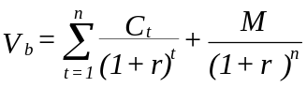

C_{t} is interest expected at the end of Period _{t}
M is terminal value (= Face Value)
r is the investors required rate of return

The value of a convertible security will therefore be given by:
Where C.V. is the expected conversion value at the date of conversion.
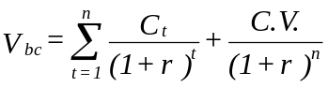

8.0 VENTURE CAPITAL

Venture capital is a form of investment in new, small, risky enterprises required to get them started by specialists called venture capitalists. Venture capitalists are therefore investment specialists who raise pools of capital to fund new ventures which are likely to become public corporations in return for an ownership interest. They buy part of the stock of the company at a low price in anticipation that when the company goes public, they would sell the shares at a higher price and therefore make a considerably high profit.

Venture capitalists also provide managerial skills to the firm. Example of venture capitalists are pension funds, wealthy individuals, insurance companies etc.

Since the goal of venture capitalists is to make quick profits, they will invest only in firms with a potential for rapid growth.

9.0 LEASE FINANCING
A lease is an agreement whereby the right to possession and enjoyment of real estate is transferred for a definite period of time. The person transferring the right is called the leasor and the pension obtaining the rights is called the lessee.
Leases may be classified according to term or according to payment.

9.1 CLASSIFICATION ACCORDING TO PAYMENT PROVISION

1. A Net Lease.
One which the lessee pays substantially all of the operations and maintenance cost.
2. A Flat Lease
Is one that calls for fixed periodic payments for the use of the property over term of the lease. It is usually for a short period of time.
3. A Step-Up Lease
It provides for a fixed payment to be adjusted periodically. The adjustment can be made either by new rentals taking effect after the passage of a specific period of time or by periodically adjusting the rent in accordance with a pre-determined formula. The increase is meant to cover appreciation of property as well as increase in insurance, taxes and maintenance cost.
4. Percentage Lease
This is one where the lessee is required to pay a fixed basic rent percentage of the sales volume. The percentage factor acts as an inflation hedge.
5. Escalator Lease:
This is a lease that calls for increases in taxes, insurance and operating costs to be paid by lessee.
6. A Sandwich Lease
This refers to a multiple lease situation in which the lessee intern subleases the property to a sub lessee for a higher sum than what is paid to a sub lessee. The sub lessee further subleases at a higher profit. For example assume that ‘A’, the original lesser leases to B and B executes a sublease to C and C then subleases to D. In this case, B is the sandwich leasor, and D is the Sandwich leasee.

9.2 CLASSIFICATION ACCORDING TO TERM
Under this category we have 2 forms of leases

FINANCIAL OR CAPITAL LEASE
A finance lease is a longterm lease. A lease is regarded as a capital lease if it meets any one of the financial conditions.

- It transfers title of the asset to the lessee by the end of the lease period.
- The lease contains an option to purchase the asset at the end of the lease period at a bargain price.
- The lease period is equal to or greater than 75 percent of the estimated economic life of the asset.
- At the beginning of the lease period, the present value of the minimum lease payments is at least 90 percent of the fair value of the leased property to the lessor (less any investment tax credit realized by the lessor).

OPERATING LEASE OR SERVICE LEASE
These are short term and they give the lesser the right to use the leased property but they do not give the lessee all the benefits that are associated with ownership. The lease does not meet conditions of financial lease.

Additional conditions of an operating lease are:

    - Operating lease includes both financing and maintenance services. The lease ordinarily calls for the leasor to service and maintain the lease.
    - Operating leases are not fully amortized. The lease contract is written for substantially less than economical life of the asset.
    - Operating Lease has a cancellation clause, giving the leasor the right to cancel the lease before expiration of initial agreement.

9.3 A Sale-Lease Back Agreement
Under a sale-lease back agreement, a firm owning an asset, sells it to another firm (usually a financial institution) and executes an agreement to lease back the asset for a certain period of time.
9.4 LEVERAGE LEASING
A leverage lease involves 3 parties:

        - The lessee
        - The lessor (or Equity participants)
        - The lender

From the stand point of the lessee there is no difference between a leverage lease and any other lease. The lessee contracts to make periodic payments (over the basis lease period and in return is entitled to use the asset over that time period.
The role of the lessor, however, is changed. The lessor acquires the asset in keeping with the term of the lease and finances the acquisition in part by an equity investment (say 20% equity investments) and the remaining 80% is provided by a long-term lender (provider of debt fund). The long-term loan is covered by a mortgage on the asset as well as an assignment of the lease and the lease payment. In this case therefore, the lessor is the borrower (equity participant).

REASONS FOR LEASING
            - Short term Leases are Convenient
Assume that you want to use an asset for a short period e.g. a car for a week, you could buy the car and sell it after 7 days. You would spend a lot of time selecting the car and purchasing, arranging insurance registration etc. But at the end of the week, you have to re-negotiate sale, cancel registration and insurance etc. In such a case, it would be appropriate to organize for operating lease.
            - Cancellation Options are Valuable
Equipment is frequently leased on a short-term cancelable basis because it’s difficult to estimate how rapidly such equipment would become obsolete because of changes in technology. Leasing with an opinion to cancel passes the risk of obsolescence from the user to the leasor. The lessee however, pays a higher rental due to the option to cancel.
            - Maintenance is provided
Under a full service (operating) lease, the user receives maintenance and other services. Many leasors are well equipped to provide efficient maintenance.
            - Low administration and Transaction Cost
Leasing is a relatively cheap source of funds for small companies. It offers long-term financing on a flexible piece-meal basis, with a lower transaction cost than in a private placement or public issue of bonds or stocks.
            - Tax Shield Can be used
Sometimes the leaser can make better use of depreciation tax shield generated by an asset than the asset user. It may make sense therefore for the leasing company to own the equipment and pass over some of the tax benefits to the lessee in form of low lease payments.

In markets that are efficient, the following reasons are usually given are “Dubious” reasons for leasing

(i) Leasing Is An Off Balance Sheet Financing
When a firm obtains off-balance sheet financing, the conventional measures of financial leverage such as the debt equity ratio understate the true degree of financial gearing. Some people believe financial analysis do not always notice off balance sheet lease obligation (which are still referred to as foot note) or the greater volatility of earnings that result from fixed lease payments. Note that in an efficient market, price would reflect all the available information including the lease obligation.

(ii) Leasing Avoids Restrictive Covenants
When a company borrows money it must usually consent to certain restrictions on future borrowing. If the bond indenture does not include any restriction on leasing then leasing can be seen as a way of avoiding restrictive covenants. Note that loopholes such as this are easily stopped and most debt indentures include limits on leasing.

(iii) Leasing Affects Book Income
A lease which qualifies as off-balance sheet financing affects book income in one way. The lease payment are an expense. If the firm buys the assets instead and borrows to finance it, then both depreciation and interest expenses are deducted. Leases are usually set up so that payment in the early years is less than depreciation and interest under the buy and borrow alternative. Leasing therefore increases book income in the early years of an asset life. The return on investment would increase more because the book value of assets (the denominator is understated).

ROI = Capital Turnover x Profit Margin
or Reserves x Incomes
Investments Reserves
or Income
Investments
Note;
Leasing impact on book income should not in itself have any effect in firms value in efficient capital market.

(iv) Leasing Avoids Capital Expenditure Control
In some companies, lease proposals are not subject to the elaborate capital expenditure approval procedures needed to buy an asset. This may be important in the public sector e.g. a public hospital may find it easier to lease medical equipment that to ask the government to provide funds for purchase.

Note: Bypassing such controls may result in poor investment decision on the part of the company.

(v) Leasing Preserves Capital
Leasing companies provides 100% financing. They advance the full cost of the lease asset. It may be argued therefore that leasing preserves capital allowing the firm to save its cash for other things.

Illustration:
ABC Ltd has decided to acquire a piece of equipment costing Shs 240 000 of five years. The equipment is expected to have no salvage value ate the end and the company uses straight-line depreciation method on all it Fixed Assets. The company has two financing alternative methods available, leasing or borrowing.

The loan has an interest rate of 15% requiring equal-year-end installments to be paid. The lease would be set at a level that would amortize the cost of equipment over the lease period and would provide the lessor with a 14% return on capital. The company’s tax rate is 40%.

Required:

              - Compute the annual lease payments.
              - Compute the PV of the cash out flow under lease financing
              - Calculate the annual loan installment payment
              - For each of the 5 years, calculate the interest and the principal component of the loan repayment.
              - Calculate the PV of after tax cash flow under the loan alternative
              - Which alternative is better and why?

Solution:
a) 240 000 = A + A PVAF 14%, 4 years

240 000 = A (1 + 2.9137)

A = 240 000 = Shs 61, 323
3.9137

b) Year Lease payments Lease Rental Net Payments PVIF 14% PVs
Tax shield (40%)

0 61 323 - 61 323 1.000 61 323
1 61 323 (24 529) 36 794 0.9174 33 755
2 61 323 (24 529) 36 794 0.8417 30 970
3 61 323 (24 529) 36 794 0.7722 28 412
4 61 323 (24 529) 36 794 0.7084 26 065
5 61 323 (24 529) (24 529) 0.6499 (15 941)
Total PV’s 164 584

c) Annual Loan Installments

240 000 = A PVAF 15%, 5 years
A = 240 000 = Shs 71 595
3.3522

d) Loan Amortization Schedule

Year bal. at Installment Interest Principle Outstanding Bal. the beg.
1 240 000 71 595 36 000 35 595 204 405
2 204 405 71 595 30 661 40 934 163 471
3 163 471 71 595 24 521 47 074 116 397
4 116 397 71 595 17 460 54 135 62 262
5 62 262 17 595 9 339 62256 6*

* rounding off error

Depreciation of the asset = 240 000 – 0 = 48 000
5
e)
Year Depreciation Interest Total Tax shield (40%) Cash flows PVIF 9% Pv’s
(71595-tax)

1 48 000 36 000 84 000 33 600 37 995 0.9174 34 857
2 48 000 30 661 78 661 31 464 40 131 0.8417 33 778
3 48 000 24 521 72 521 29 008 42 587 0.7722 32 886
4 48 000 17 460 65 460 26 184 45 411 0.7084 32 169
5 48 000 9 339 57 339 23 936 48 659 0.6499 31 623
165 313

f) Decision:
Leasing is better than borrowing because it’s cheaper and results in lower cost of transaction.

N.P.V of leasing = 240 000 – 164 584 = Shs 75, 416
N.P.V of borrowing = 240 000 – 165 313 = Shs 74 687
Net benefit of leasing 729
9.6 SALE – LEASE BACK ARRANGEMENT
This is a transaction involving the simultaneous sale of an asset and the leasing back of the property to the seller by the purchase for a long term (long period of time). The sale-lease back can be traced back to early 1940’s in America.

It occurred due to:

  - Institutional investors were limited by state laws to loan to value ratio of 66% to 76%. A method was required which was legal and would increase the amount of money that could be loaned against real estate security.
  - Corporations had large sums of money tied up in real estate and were anxious to put those funds to work in a more advantageous and active way. The sale lease back technique therefore appeared as an alternative to mortgage and as a means of increasing the amount of financing available for any single real estate transaction. It also presented a feasible and workable method of exchanging ownership but not possession for costs. It also provided a way of financial institution continuing to lend even when they have exhausted that lending limit.

There are 2 types of sale lease back arrangements. These are:
1 Prime Credit Transaction
In this case the tenant is a large and prominent corporation and in the past has conducted a number of sales lease back transaction e.g. a petrol station with a sale lease back with an oil company.
In such a transaction 100% financing is usually available since the purchaser is entering the transaction on the basis of the seller’s credit rating but not the value of the asset.
2 Reality Transaction
Here the purchaser (the leasor) is investing on the basis of the property without much regard for the seller (lessee) credit status. The asset must therefore be a general-purpose asset. Usually the purchase price is about 80% to 90% of the property’s value rather than 100%.

10.0 OPTIONS
An option is a contract which gives its holder the right to buy (or sell) an asset at some predetermined price within a specified period of time. Pure options are instruments that

(a) Are created by outsiders rather than the firm (usually investment bankers)
(b) Are bought and sold primarily by investors
(c) Are of greater importance to investors than to financial managers

10.1 TYPES OF OPTIONS

(a) Call Option
A call option gives the holder the right to buy an asset (or security) at a specified price (exercise price or striking price) within a specified period (exercise date). The seller is called a writer.
An investor who writes a call option against securities held in his portfolio is said to be selling covered options. Options sold without the stock to back them up are called naked options.
When the exercise price exceeds the current stock price, the option is said to be out-of-money. When the exercise price is less than the current price of the underlying stock, the option is said to be in-the-money.

(b) Put Options
An investor can also buy an option which gives him/her the right to sell a security at a specified price within some future period. This is called a put option.

10.2 FACTORS THAT AFFECT THE VALUE OF A CALL OPTION

(a) The market price of the underlying shares.
The higher the share price, the higher will be the call options price.
(b) The higher the striking price, the lower will be the call option's price.
(c) The longer the option period, the higher will be the option price because the longer the time before expiry, the greater the chance that the stock price will increase substantially above the exercise price.

Theoretical value = Current market — Exercise Price
of option (Expiry Value) price per share

E.g.
If a share has a market price of Sh 50 and its option has an exercise price of Sh 40 then the value of the warrant is Sh 10.

The minimum value of an option which is out-of-money is zero. The value of a call option can be shown by the following graph:

Option premium = Market Price — Theoretical value
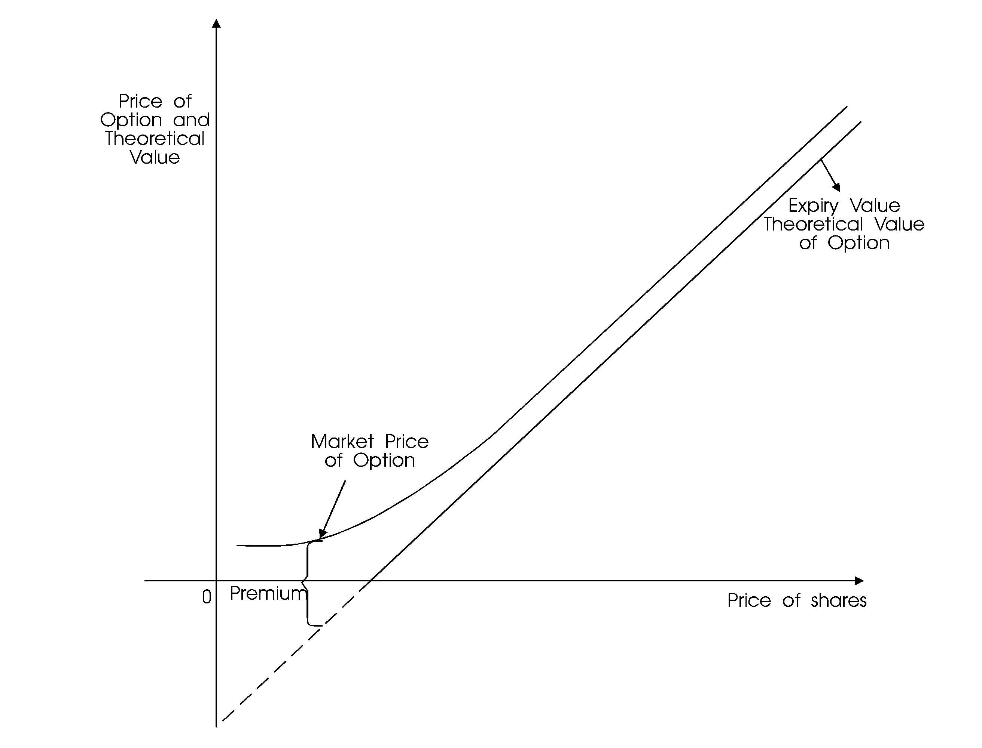

of option of option

10.3 THE BLACK AND SCHOLES OPTION PRICING MODEL (OPM)

This model was developed in 1973 and, it has the following assumptions:
Assumptions
1. The stock underlying the call option provides no dividends or other distribution during the life of the option.
2. There are no transaction costs in buying or selling either the stock or the option.
3. The short—term, risk free rate is a known constant during the life of the option.
4. Any purchaser of a security may borrow any fraction of the purchase price at short—term risk free interest rate.
5. Short selling is permitted without penalty and the short seller will receive immediately the full cash proceeds of today's price for a security sold short.
6. The call option can be exercised only on its expiration date (European option).

Trading in all securities takes place in continuous time and the stock prices move randomly in the continuous time.
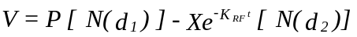

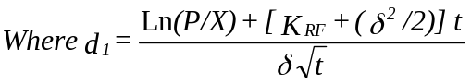

The model can be given by the following formulas
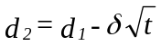

Where V = Current value of option with time t until expiration
P = Current price of the underlying stock

N(d₁) = Probability that a deviation less than d₁ will occur in a standard normal distribution. This N(d₁) and N(d₂) represent areas under a standard normal distribution function.
X = is the exercise price of the option
e = is exponential function ≈ 2.7183
K_{RF} = is the risk-free interest rates
t = time until the option expires (the option period)
Ln P/X = natural logarithm of P/X
δ² = Variance of the rate of return on the stock

The value of an option is therefore a function of

(a) P the stock price
(b) t the options time to expiry
(c) X the exercise price
(d) δ² the variance of underlying stock
(e) K_{RF} the risk free rate

Illustration

Assume that the following information has been obtained:

P = Sh 20
X = Sh 20
t = 3 months (0.25 years)
K_{RF} = 12%
δ² = 0.16

Determine the value of the option
Solution:

d₁ = Ln (20/20) + [0.12 + (0.16/2)] 0.25
0.4 √0.25

= 0 + 0.05 = 0.25
0.2

d₂ = d₁ - 0.20 = 0.05

N(d₁) = N(0.25) = 0.5987 Using the standard normal table
N(d₂) = N(0.05) = 0.5199

V = 20(0.5987) — 20e^{-(0.12)(0.25)}(0.5199)
= 20(0.5987) — 20(0.9704)(0.5199)
= 11.97 — 10.09
= Sh 1.88

10.4 APPLICATION OF OPTION PRICING MODEL

The equity of a levered firm can be thought of as a call option. When a firm issues debt it is equivalent to the shareholders selling the assets of the firm to the debtholders, who pay for the assets with cash plus an implied call option whose exercise price is equal to the principal value of the debt plus interest. If the company is successful, the stockholders will buy the company back by exercising their call option and thus paying the principal and interest on the debt. Otherwise stockholders will default on the loan, which amounts to not exercising their call option and thus giving the company to the creditors.

Illustrations

ABC Company is being formed to make a 1 year investment in producing and marketing presidential campaign badges. The firm requires an investment of Sh 10,000,000 of which Sh 7,500,000 will be obtained by selling debt with a 10% interest rate and the other Sh 2,500,000 will be raised by selling common shares. All cash distribution to debt holders and shareholders will be made at the end of the one year. After this year is over the value of the firm will depend primarily on which candidates make it through the primary elections. The estimated probability of distribution of the firm is:

Probability Value `000'
0.7 20,000
0.2 5,000
0.1 0

Consider the shareholders value under the three states of nature and under the expected value.

Solution:

Expected value of the firm = 0.7(20,000) + 0.2(5,000) + 0.1(0) = Sh 15,000

Sh`000' Sh`000'
Expected Value 15,000
Less
Debt principal 7,500
Interest 750 8,250
Value to shareholders before taxes 6,750

If value is Sh 20,000,000

Sh`000'
Value of the firm 20,000
Less debt principal and interest 8,250
Shareholders value 11,750

Sh`000'
If value is 5,000
Value of the firm 5,000
Less Debt Principal and Interest 8,250
Shareholders value (3,250)

Sh`000'
If value is 0
Value of the firm 0
Less Debt principal and interest 8,250
Value to shareholders (8,250)

Under the value of Sh 5,000 and 0 the shareholders will not buy the company back and therefore the actual value will be zero but not negative.

11.0 DIVIDEND THEORY AND DECISION

Dividend policy determines the division of earnings between payments to stockholders and reinvestment in the firm. This section, therefore, looks at:

(a) How to pay dividend
(b) When to pay dividend
(c) How much dividend to pay
(d) Why dividend is paid

11.1 DIVIDEND PAYOUT DECISION

In principle, a company is supposed to pay cash dividends but under financial constraints or otherwise, it can pay stock dividends.

A stock dividend is paid in additional shares of stock instead of cash and simply involve a bookkeeping transfer from retained earnings to ordinary share capital.

Payment of stock dividend has already been considered in Section 7.2.5.

The company can buy back some of its outstanding shares instead of paying cash dividend. This is known as stock repurchase and shares that have been bought back are referred to as treasury stock. If some outstanding share are repurchased, few shares will remain outstanding and assuming the repurchase does not adversely affect the firm's earnings, the earning per share of the remaining shares will increase. This increase may result in a higher market price per share, so capital gains will be substituted for dividends.

Stock repurchase has the following advantages:

(a) It may be seen as a positive signal because the repurchase may be motivated by management's belief that the firm's shares are undervalued.
(b) The shareholders has a choice to sell or not to sell. On the other hand, one must accept a dividend payment and pay tax.
(c) The repurchase reduces the number of outstanding shares and thus increases the market price per share.

(d) The firm can use repurchased stock when stock options are exercised.
(e) A company may use repurchased stocks to undertake a major restructuring such as changing its capital structure.
(f) A company can repurchase its shares to make it impossible for the company to be acquired.

However, stock repurchase has the following disadvantages:

(a) The selling shareholders may not have all the information about the firm and thus may sell their shares at a lower price.
(b) If the shares are not actively traded in the market, the company may offer a price which is above equilibrium. This reduces the wealth of remaining shareholders.

11.2 ALTERNATIVE DIVIDEND POLICIES

There are four major dividend policies that can be followed by a firm. These are:

(a) Constant amount of dividend per share
Under this policy a company will pay a fixed amount per annum per share regardless of the fluctuations in its profits. Dividends are increased only after an increase in earnings appear clearly sustainable and relatively permanent. The following graph can show this policy:
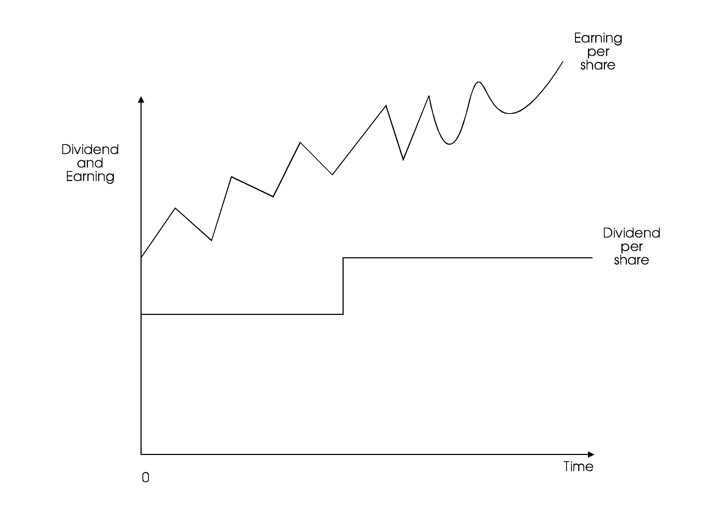

(b) Constant payout ratio

Under this policy, the firm will pay a fixed dividend rate (e.g. 10% of earnings). The dividend per share would therefore fluctuate as the earnings per share changes. This policy can be shown by the following graph:
(c) Constant dividend per share plus extras
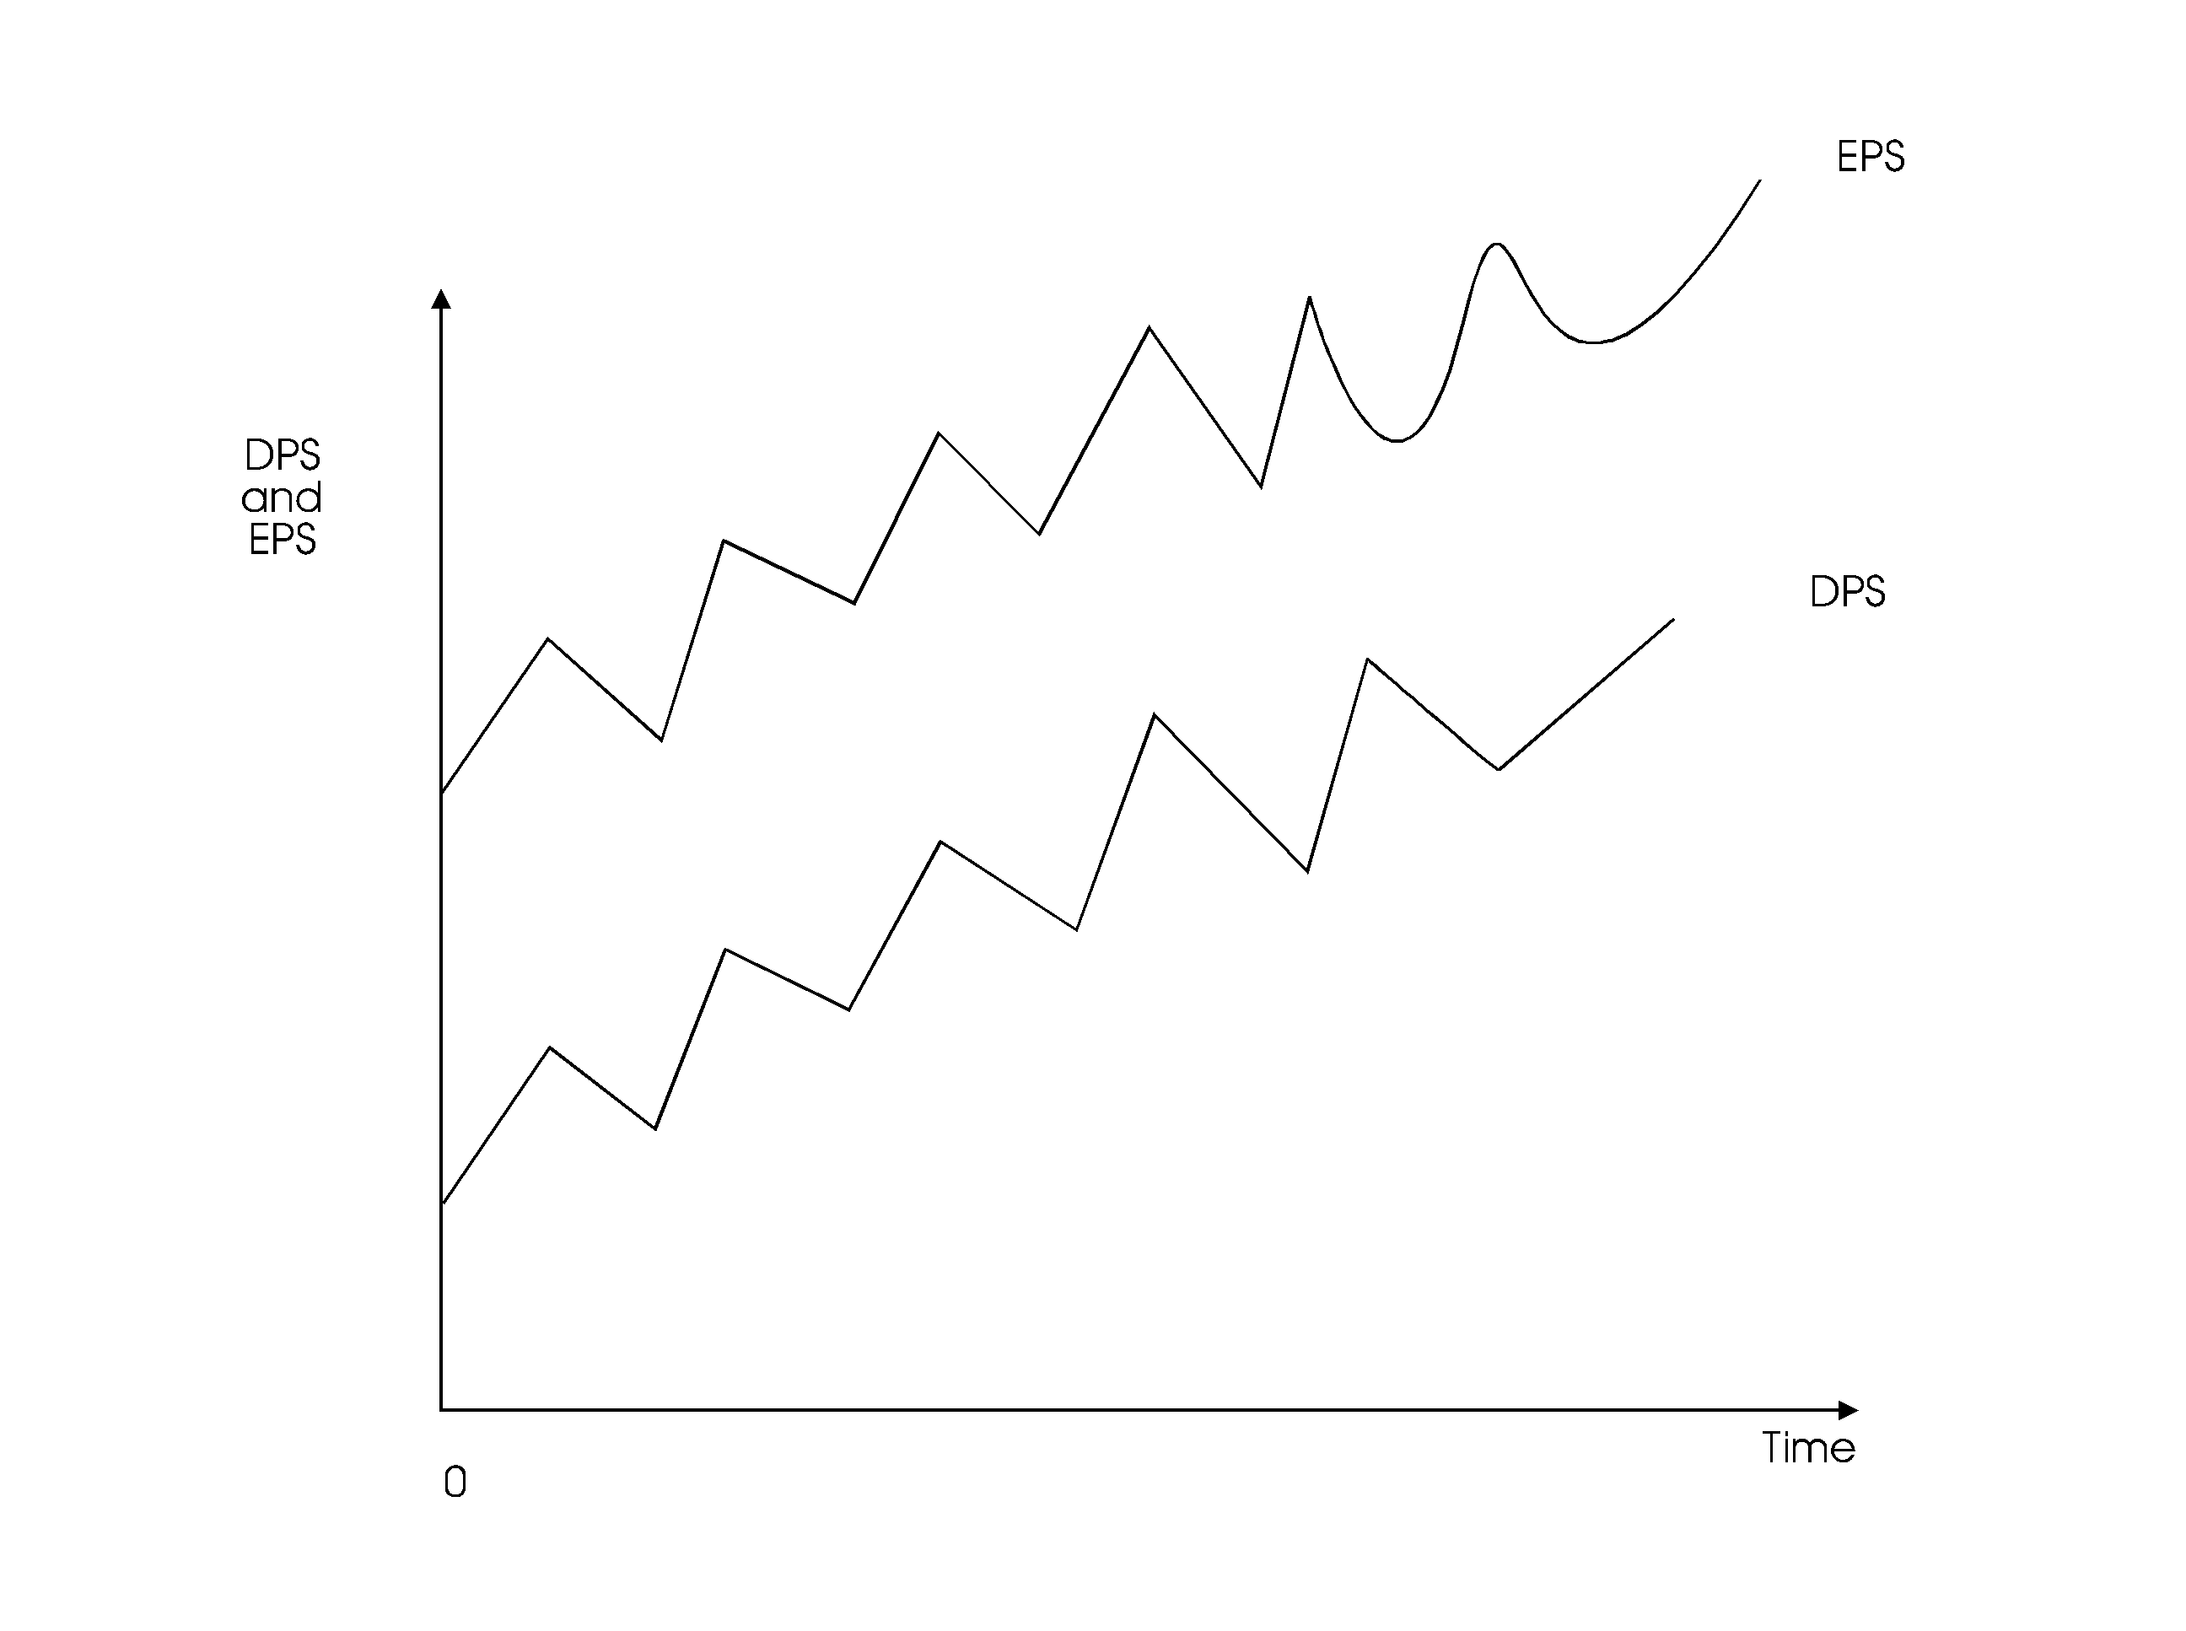

This is a compromise between the two policies discussed above. It gives the firm flexibility to increase dividend during years of high earnings. The extra dividend is given to the shareholders in such a way that they don't perceive it as a commitment on the part of the company to continue this extra dividend in the future. This policy can be shown as follows:
(d) Residual dividend policy
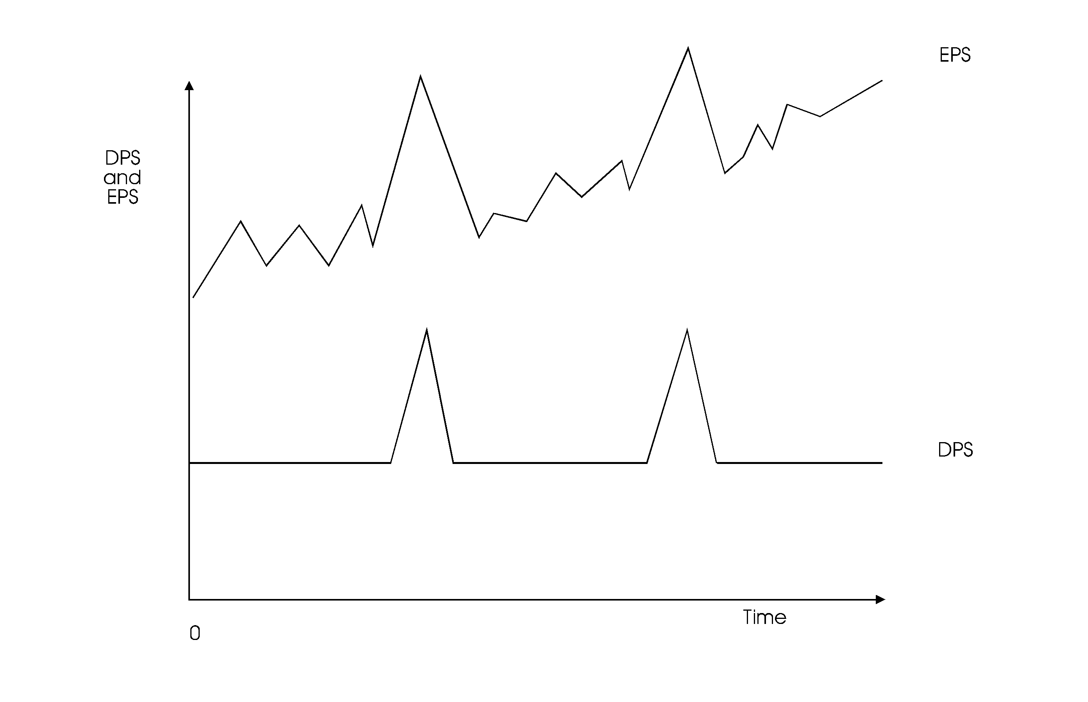

Under this policy dividend is paid out of earnings left over after investment decisions have been financed. Dividend will only be paid if there are no profitable investment opportunities available. This policy is consistent with shareholders wealth maximization objective.

Note: The student should look at the advantages and disadvantages of each of the above policies.

11.3 DIVIDEND THEORIESThere are several theories which try to look at the relevancy or irrelevancy of dividend payment. We shall discuss some of these theories:

1. M-M dividend irrelevancy theory
This theory was proposed by Franco Modgliani and Merton Miller in 1961 who argued that the value of the firm is determined by the basic earning power and the firm's risk and not by the distribution of earnings. The value of the firm therefore depends on the investment decisions but not the dividend decision. Their argument was however based on the following assumptions:
(a) No corporate or personal taxes
(b) No transaction costs associated with share floatation (The market is perfect and frictionless)
(c) The firm's investment policy is independent of the dividend policy
(d) The market is efficient and therefore investors and managers have the same set of information regarding future investment opportunities.

They were able to prove that dividend is irrelevant in the determination of the value of the firm using the dividend yield model.

M-M's Proof of the dividend irrelevancy

Let P_{o} be share price at time t₀
P₁ be share price at time t₁
D₁ be dividend per share at time t₁
N be number of share at time t₀
M be number of new shares at time t₀
I be total value of new investment
X be net income at period t₁
Ke be cost of equity capital

Using the dividend yield model, the value of a share in time t₀ will be
The value of the firm will be
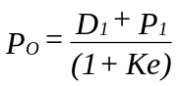

If M additional shares are sold at period t₁ then
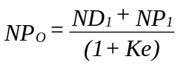

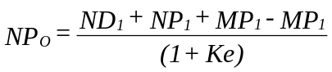

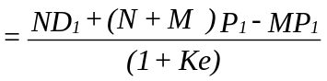

If no debt is used then the sources of funds will be equal to the uses of fund.
If we substitute MP₁ in the above equation, then
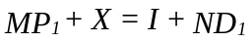

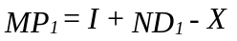

Since D₁ does not appear, then the dividend decision has no value in determining the value of the firm.
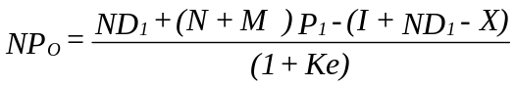

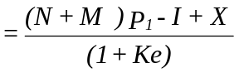

(2) The Bird-in-hand theory
This theory was advanced by Myron Gordon and John Litner in 1963 who argued that a bird in hand is worth two in the bush and thus when a shareholder receives cash dividend he is better off than one receiving capital gain.
Investors therefore value dividend more than capital gains and a firm that pays dividend will have a higher market value.
They concluded that dividend decisions are relevant and a firm that pays higher dividend has higher value.

(3) Tax differential theory
This theory was advanced by Litzenberger and Ramaswamy in 1979 who noted that the tax rate on dividend is higher than the rate on capital gain (In Kenya Capital gain tax has been suspended). A firm that pays dividend will therefore have a lower value since shareholders will pay taxes on this dividend. Dividend decisions are relevant and a firm that pays no dividend has the highest value.

(4) Signalling theory
Stephen Ross in 1977 argued that in an inefficient market, management can use dividend payment to signal important information to the market which is only known to them. If management increases dividend, it signals expected high profit and therefore share prices will increase. Therefore dividend decisions are relevant and a firm that pays higher dividend will have a higher value (especially in an inefficient market).

(5) The Clientele effect theory
This theory was proposed by Richardson Pettit in 1977 who stated that different groups of shareholders have different preference for dividend. For example the low income earners will prefer higher dividend to meet their consumption needs while the high income earners will prefer less dividend so as to avoid the payment of taxes. Therefore when a firm sets a certain dividend policy there will be shifting of investors to it and out of it until equilibrium position is reached. At equilibrium, the dividend policy set by the firm will be consistent with the clientele it has. Therefore dividend decision is an irrelevant decision especially at equilibrium.
REINFORCING QUESTIONS
QUESTION ONE
XYZ Ltd has an issued share capital of 10 million ordinary shares with a par value of £1, on which it pays a constant dividend of £0.4 per share. The market value per share was £2 ex-dividend.

The company then proposed a 1 for 4 rights issue with an issue price of £1.50. The money raised would be used to finance a major new project, which was expected to increase annual profits after taxation by £950,000. This information is released together with the announcement of rights issue.

Required:

(a) Compute the cum-right price at the eve-of the rights issue
(b) Compute the theoretical ex-rights price
(c) Calculate the market price per share at the time of the rights issue if the money raised was to be used to redeem £3,750,000 of 8% debentures. The tax rate is 50%.

QUESTION TWO
Dimango Company is considering whether it would be financially advisable to retire its existing long term debt with a cheaper loan. The current loan of Sh 10 million has an annual interest charge of 15% and has 10 years to maturity. The company has Sh 125,000 of unamortized loan expenses still in the books.

If the company decides to redeem the loan, there is an early payment penalty amounting to 10% of the loan. A new Sh 10 million loan can be raised at 13% per annum for a ten year period. It is expected that underwriting costs will amount to Sh 600,000. In addition to these costs, the company will be further required to pay interest for the two months which would allow the normal interest payment due to be reached for the old loan.

Dimango Company is in the 40% income tax bracket.

Required:

(a) Calculate the net amount of cash investment required for the refunding of the loan.
(b) Compute the annual cash savings which result from refunding
(c) Determine whether refunding is advantageous to the company
(PVIFA 8% = 6.71)
(CPA, JUNE 1989)

CHECK YOUR ANSWERS WITH THOSE GIVEN IN LESSON 9 OF THE STUDY PACK

LESSON EIGHT

INTERNATIONAL FINANCIAL ORGANIZATIONS AND ARRANGEMENTS
INSTRUCTIONS

1. Read Chapter 33 of Financial Management by Pandey I. M. and the study text below.
2. Complete answers to reinforcing questions at the end of the lesson.
3. Check model answers given in Lesson 9 of the Study Pack.

CONTENTS:

1.0 Reasons for foreign investment
1.1 Foreign exchange
1.2 Determinants of foreign currency
1.3 Factors affecting exchange rates
1.4 Types of exchange rates
Exchange rate exposure
Management of transaction exposure
2.0 International borrowing and investment
2.1 Eurocurrency market
2.2 International capital markets
2.3 Types of eurocurrency loans
2.4 Factors to consider when choosing between eurocurrency or domestic markets
3.0 International financial organisation
3.1 Purposes of IMF
3.2 Special drawing rights
3.3 International bank of reconstruction and development
3.4 International finance corporation (IFC)
International development association (IDA)
Structural adjustment programmes (SAPs)
Characteristics and effects of SAPs
Why the need for SAPs?

1.0 REASONS FOR FOREIGN INVESTMENT
The decision to invest capital in a project abroad should be based upon considerations of expected return and risk (just like investing locally). However, these factors are different in different countries.

(a) Risk considerations
International diversification is often more effective than domestic diversification in reducing risk in relation to expected return. This is due to differences in economic cycles in different countries.
(b) Return considerations
Domestically, competitive pressures may be such that only a normal rate of return can be earned. A firm may invest abroad so as to produce more efficiently due to existence of cheaper factors of production.
(c) Taxation
Tax laws are different in different countries and therefore a firm may invest abroad to minimize tax payment to the government.

1.1 FOREIGN EXCHANGE
Foreign Exchange refers to currencies and other instruments of payment denominated in other countries currencies.

TERMS AND DEFINITIONS
An Exchange rate can be defined as the number of units of one currency that must be given to acquire one unit of a currency of another country. It is the price paid in the home currency to purchase a certain quantity of funds in the currency of another country. It is therefore the link between different national currencies that makes international price and cost comparisons possible.

If the rate is quoted for current foreign currency transactions, it is called the spot rate. The spot rate applies to interbank transactions for delivery within two business days or immediate delivery for over-the-counter transactions that usually involve non bank customers.

If the rate is quoted for delivery of foreign currency in the future, it is called the forward rate. This is a contractual rate between the foreign exchange trader and the trader's client.

The spread in the spot market is the difference between the bid (buy) and offer (sell) rates quoted by the foreign exchange trader.
The forward spread is the difference between the spot and forward exchange rates.
The direct quote is the number of units of the domestic currency for one unit of the foreign currency.
The indirect quote is the number of units of the foreign currency for one unit of the domestic currency.
The cross rate is an exchange rate computed from two other exchange rates.

1.2 DETERMINANTS OF FOREIGN CURRENCY
The demand for foreign currency is fixed by the supply and demand curve (just like any other commodity in an open market). The demand for foreign currency arises from the traders who have to make up payments for imported goods. The supply arises from those who have exported goods and services abroad. This depends largely on how much foreigners are willing to buy goods and services from a particular country.

FACTORS AFFECTING EXCHANGE RATES

1. Export/Imports
If a country exports more goods, the importing country will have a higher demand for the currency of the exporting country so as to meet its obligation. The value of the currency of the exporting country will therefore appreciate. The opposite is the case if a country imports more goods than exports.

2. Political Stability
Unsuitable political climate will make the citizens lose confidence in their currency. They would therefore wish to invest or just buy the currency of the other countries they deem to be stable. In so doing, the demand for currency of more political stable countries will appreciate as compared to those of politically unstable countries.

3. Inflation rate differential (purchasing power parity theorem)
Parity between the purchasing powers of two currencies establishes the rate of exchange between the two currencies. When inflation rate differential between two countries changes, the exchange rate also adjusts to correspond to the relative purchasing powers of the currencies.

The purchasing power theorem states that the:

% E(f) = I (h) – I (f) x 100
I (f) + 1

Where % E (f) is the percentage change in the direct quote
I (h) is the inflation rate in the home market
I (f) is the inflation rate in the foreign market.

Illustration
Assume that the direct quote between the $ and £ is £1 = $ 1.5 and that the inflation rate in UK is 10% and the inflation rate in the US is 6%

Required
Compute the % change in the direct quote and determine the new exchange rate.

% E (f) = 0.06 – 0.1 x 100 = -3.64%
0.1+ 1
The New Direct Quote
£1 = £1.5*(1 – 3.64%)
£1 = $1.4454

4. Interest Rate Parity (International Fisher Effect)
This theory states that differences in interest rate in different market can cause a flow of funds from markets with low interest rate to markets with high interest rates.
The international fisher effect can be explained as follows:

%E (f) = I (h) – I (f) x 100
1+ I (f)
% E (f) = is the % change in direct quote.
I (h) = is the interest rate in the home market.
I (f) = is the interest rate in the foreign market.

Illustration
Assume that the direct quote is deuchemark is DM 1 - $ 0.5 while the general interest rate in US is 6% and general interest rate in Germany is 3%.
Required:
Compute the percentage change in direct quote and the new exchange rate.

Solution
%E (f) = 0.06 – 0.03 x 100 = 2.9126%
1 + 0.03

New Direct Quote
DM 1 = $0.5* ( 1 –2.9126%)
= $0.4854

5. Balance of Payment
The term balance of payment refers to a system of government accounts that catalogues the flow of economic transactions between the residents of one country and the residents of other countries. It is therefore the fund flow statement.
Continuous deficit in the balance of payments is expected to depress the value of a currency because such deficit would increase the supply of that currency relative to its demand.
6. Government Policies
A national government may through its Central Bank intervene in the foreign exchange market, buying and selling its currency as it sees fit to support its currency relative to others. In order to promote cheap export, a country may maintain a policy of undervaluing its currency.

1.4 TYPES OF EXCHANGE RATES

(a) Fixed Exchange Rate
This is that rate at which the value of a currency remains stable vis-a-vis other currencies for a long period of time. These rates of exchange are fixed by the Central Bank through the process of pegging the currency concerned e.g. if the currency is pegged to a Dollar, then its value remains fixed to the value of the dollar and will move with movement in the value of the dollar.

Advantages of Using Fixed Exchange Rates

i. It stabilizes the export proceeds and therefore it may stimulate exports for the period in which it is fixed.
ii. Foreign investors gauge the return on their investments in local currency vis-a-vis their own currencies. A fixed exchange rate will assure these investors of a stable return on their investment which may induce foreign investors, thus increasing the inflow of foreign exchange to the country.
iii. It enables the government to meet its development plans whose budgets are set in local currencies but may be financed by foreign loans and aid.
iv. It may keep inflation under control because the prices of imported goods will remain stable as long as the exchange rate is fixed. This is particularly true for imported inflation.
v. Long term investment plans can be worked out with substantial accuracy and may minimize budget deficits with their negative effects.

(b) Floating Exchange Rate
When the rate of exchange of a currency is floating, it is left to move in response to different forces (especially the balance of payments). It is left to be determined by the forces of demand and supply of foreign currencies of a given currency.
This rate may discourage investment by foreign investors as they are uncertain about the return to be earned on investment made under floating rates of exchange. It may also discourage export trade and may increase inflation rates.

1.5 EXCHANGE RATE EXPOSURE
The extent to which a firm is exposed or vulnerable to fluctuations in exchange rate is referred to as the exchange rate exposure and can be perceived in three different ways:

Transaction exposure
This defines the foreign exchange rate risk in terms of the impact of exchange rate movement on the firm’s future cash flows. This type of exposure arises from an obligation to either accept or deliver foreign currency at a future date. The most important transactions leading to transaction exposure are accounts receivable and accounts payables denominated in foreign currency.

Translation Exposure
Translation exposure defines exchange rate risk in terms of the impact of exchange rate movement on the financial statement of the firm. When a business is organized as several separate corporations, then financial statements must be filed on a consolidated basis so as to give shareholders concise and complete information as to the financial position and the operating performance of the firm as a whole. When subsidiary operate in a foreign country then major complications occur in consolidation process. This problem arises from the fact that financial statements of the foreign subsidiary are usually in a currency which is different form that of the parent company. The foreign currency must be converted into the home currency before accounts can be consolidated. Translation exposure therefore is the extent to which multinational firms consolidated financial statements are affected by the need to convert its foreign subsidiary accounts to the home currency. As the value of the exchange rate fluctuates, so would be the value of the foreign subsidiary.

Economic Exposure
Economic exposure defines exchange rate risk as the total impact on all the cash flow of the firm (both contractual and non-contractual) It is broader than the other types of exposure and may be considered to be the overall impact of the foreign exchange fluctuations on the shareholders wealth. It affects both the companies that enter into foreign currency transactions and those that do not.

MANAGEMENT OF TRANSACTION EXPOSURE
Non-Contractual Techniques
Several non-contractual techniques may be used. These include:
Undertaking transactions denominated in home currency only.

- Entering into transactions denominated in foreign currency which is considered to be stable. E.g. dollar, sterling pound, Yen, etc.
- The use of leads or lags. Leads are advance payments while lags are delayed payments.

Contractual Techniques
Contractual techniques include forward exchange rates, money market hedge currency options, currency futures and swaps. These techniques are explained below:

Forward Exchange Contract
A forward exchange contract is an immediate, firm and binding contract between the bank and its customer for the purchase or sale of a specified quantity of a stated foreign currency at a rate of exchange fixed when the contract is made but requiring performance at a specified future date.

A forward exchange contract can either be fixed or option. A fixed forward exchange contract requires performance to take place on a specified future date. While an option forward exchange contract requires performance to take place at any date between two specified dates

Quoting a forward rate
Forward exchange rate might be higher or lower than the spot rate. If it is higher, then the quoted currency would be cheaper forward than spot (using indirect quote)

Illustration
Assume that the foreign currency (F) has been quoted against the £ as follows :

Spot rate £1: F2156 – 2166
3 months forward rate £1: F2207 – 2222

Required:
            - Determine the amount required in sterling pound to buy 2 million foreign currencies

- At the spot
- In 3 months time under the forward exchange contract.

            - Compute the amount a customer would get if he were to sell 2 million foreign currency.

- At the spot rate
- In 3 months time under forward exchange contract

Solution
(i) At the spot market

a) = 2 000 000 = £927.644
2156
(ii) At the forward exchange
= 2 000 000 = £906.21
2207
The forward rate is higher than spot rate and therefore the foreign currency is cheaper in the forward exchange market.

b) Spot market

(i) 2 000 000 = £923.36
2166

3 months forward:
2 000 000 = £900.1
2222

In both cases the quoted foreign currency is worth less against the sterling £ in the forward contract than in the spot. This is because it is quoted forward at a discount. If the forward exchange rate were lower than the spot rate, then the quoted currency would be more expensive than the spot and will be said to be quoted forward at a premium. The forward rate are not quoted independently but are quoted as adjustments to the spot rate. If the forward rate of a currency is cheaper than the spot rate, then its quoted at a discount to the spot rate and the forward rate would be higher than the spot rate by the amount of the discount (a discount is added to the spot rate to get the forward rate).

If the forward rate of a currency is more expensive than the spot rate then its quoted as a premium to the spot rate. The forward rate would be lower than the spot rate by the amount of the premium (a premium is subtracted from the spot rate).

Closing Out A Forward Exchange Contract
When the time to carry out the transaction in a forward exchange contract is due but the party buying or selling the foreign currency does not have the required currency, then the party may organize a cross out of the contract. If the customer had contracted to sell foreign currency to the bank but cannot perform his part of the contract, then the bank will sell the currency at the spot rate to the customer and then buy it back at the agreed rate. If the difference in this transaction is a loss (on the part of the customer), then the bank is compensated by the customer to offset the loss. If there is a gain then the bank compensates the customer.

Cost Of The Forward Cover

= (Premium or (discount)) x 12/months forward) x 100
Forward rate

Illustration
Assume that the following quotation is given:

Spot rate £1: $1.635 - $ 1.6385
One month forward 0.5 – 0.47 cents premium

Required:
Compute the cost of the forward cover for a customer
Buying dollars 1 month forward.
Selling dollars one month forward.

Solution
(i) Cost of forward cover
= 0.005 x 12 x 100
(1.635 – 0.005)
= 3.68%
(ii) Selling dollars one-month forward
= 0.0047 x 12 x 100
(1.685 – 0.0047)
= 3.45%

Money-Market Hedge
An exporter who invoices foreign customers in foreign currency can hedge against the exchange risk by:

- Borrowing an amount in foreign currency immediately
- Converting the foreign currency to domestic currency at the spot rate
- Repaying the loan and interest out of the foreign currency received from the customer

Similarly, if a company has to make foreign currency payment in the future, it can buy the currency now at the spot rate and put it in a foreign currency deposit account. Eventually the company should use the principle and interest earned to make the payment when they fall due.

Illustration
XYZ Ltd, a UK firm has bought goods from a US supplier and must pay US $ 4 million in 3 months time. The company finance director wishes to hedge against the foreign exchange risk and is considering 3 methods:

- Using the forward exchange contract
- Using the money market hedge
- Using a lead payments

Annual interest rate and foreign exchange rate are given below:
US $ UK £
Deposit Rate Borrowing Rate Deposit Rate Borrowing Rate
1 month 7% 10.25% 10.75% 14.0%
3mnths 7% 10.75% 4.0% 4.25%

Spot rate £1: $ 1.8625 – 1.8635
1 month forward 0.60 – 0.58 cents premium
3 months forward 1.80 – 1.75 cents premium

Required
Advise the company on the best method to use.

Solution
Forward exchange contract

Amounts required = 4 000 000 __ = £2, 165 609.4
In 3 months time in £ (1.5625 – 0.018)

Effective Rate = (14.25%) = 3.5625%
4
PV of amount = 2165609.4 = £3094010.3
1 + 0.035625

b. Money market hedge

Effective deposit rate = 7/4 = 1.75%
The amount to deposit in US $
= 4 000 000 = US $ 3, 931, 203.9
(1 + 0.0175)

The amount in Sterling pound:
= (3931203.9) = £2, 110, 713.5
1.8625

c. Lead payment

Amount in £ = 4 000 000 = £2147651
1.8625

The best option is therefore the 3 month forward exchange contract

Currency Option
A major drawback of a forward exchange contract is that it’s a binding contract which must be performed. Some investors may be uncertain about the earnings they will make in several months time and therefore would be unable to enter into a forward exchange contract without the risk of contraction to sell more or less than they will receive.

The use of a currency option overcomes this problem. A currency option is an agreement that gives the holder the right but not the obligation to buy or sell a certain quantity of foreign currency at a specified exchange rate at a specified future time.

Currency options are useful to companies in the following situations.
When there is uncertainty about foreign currency receipt or payment either in timing or amount. If the foreign exchange transaction does not materialise then the currency option can be sold in the market (if it has any value) or it can be exercised if it will make a profit

- It can be used to support a tender for an overseas contract priced in foreign currency.
- It can be used to allow publication of price-lists for goods in foreign currency.
- It can be used to protect the imports or exports of price sensitive goods.

Currency options have the following limitations:

- The cost of the option is very high, approximately 5% of the total value
- Options must be paid for as soon as they are bought.
- Traded options are not available in every currency. They are only available in standard currency.

Illustration
ABC Ltd a UK firm has been invited to tender for a contract in Blueland with the local currency of Blues (B). The company thinks that the contract should cost £1 850, 000 and is prepared to price the contract at £2 million. The current exchange rate for Blues and £ is £1: B2.80. The company therefore bids for B5.6 million. The contract will not be awarded until after six months. A 6 month currency option to sell B5.6 million at an exchange rate of £1: B2.8 is currently costing £40 000.

ABC Ltd can either buy the option or enter into forward Exchange contract at a rate of £1: B 2.80,

Assume that the company fails to win the contract and the spot rate in 6 months time is £1:B2.50.

Required:
Advice the company on which alternative is better.

Solution

Forward Exchange contract

Buy B 5.6 million at the spot rate
5 600 000 = £2 240 000
2.5

Sell at the forwarded rate = 5 6000 000 = 2 000 000
2.8
Net loss (cost of the close out) __240 000

Currency Option
Cost of buying the option (loss incurred) £40 000

The option will not be exercised and therefore the company’s net loss is £40,000 if it had purchased the option.

Currency Futures
A financial future is a standard contract between a buyer and a seller in which a buyer has a binding obligation to buy a fixed amount (i.e. the contract size) at a fixed price (the future price), on a fixed date (delivery date or the expiration date) of some underlying assets. E.g. if we bought sterling pound futures than we will have a binding obligation to buy a fixed amount of sterling pound at a fixed rate at a fixed date. Similarly a seller would have a binding obligation to deliver a sterling pound. This is similar to a forward exchange contract to buy sterling pound from a bank.

However, certain important differences exist. These are:

- Each currency future is traded in units of a fixed size such that fractions of contracts cannot be bought or sold.
- Whereas forward exchange contract with banks can be drawn up for any date in future, delivery date for currency futures occur only on 4 dates per year, (March, June, September and December). This may appear to be a severe restriction but in practice most future contracts are sold before they reach maturity.
- A financial future exchange offers a physical meeting place for buyers and sellers. Dealing on floor between member firms is by open outcry.
- Transaction costs on future exchange are paid as a percentage commission.
- Buyers and sellers are required to deposit margins to ensure credit worthiness. Profit or losses on contracts are also received and paid throughout the life of the future.

2.0 INTERNATIONAL BORROWING AND INVESTMENT
Small and medium sized companies are usually limited in their sources of finance to their domestic markets. Larger companies are able to seek funds in international financial markets.
International banks, most of which are large multinational enterprises are the most common financial intermediaries in the international financial markets. These banks assist multinational enterprises in the following ways:

(a) The financing of foreign trade
(b) The financing of capital projects
(c) International cash management services
(d) Providing full local banking services in different countries
(e) Trading i foreign exchange and currency options
(f) Lending and borrowing in the eurocurrency markets
(g) Participating in syndicated loan facilities
(h) Underwriting of eurobonds
(i) Provision of advice and information

The international money market and markets for short and medium term funds, includes the eurocurrency market.

2.1 EUROCURRENCY MARKET

A Eurocurrency deposit is a deposit with a bank in the currency of a country which is not the country in which the bank is located, e.g. the deposit of sterling pounds with a bank in USA or a deposit of US dollars with a bank in UK. Most bank deposits of currency outside the country of the currency's origin are in US dollars and so the term "eurodollars" is occasionally used to describe all eurocurrencies.

The eurocurrency market describe the depositing and lending of eurocurrencies. In other words, the eurocurrency markets are international money markets in which:

(a) Banks obtain deposits of foreign currencies and re-lend them, often to other banks; or
(b) Banks borrow eurocurrencies from other banks and then re-lend them

2.2 INTERNATIONAL CAPITAL MARKETS

Larger companies may arrange borrowing facilities from their bank, in the form of bank loans or bank overdrafts. Instead, however, they might prefer to borrow from private investors by issuing Eurobonds.

A eurobond is a bond issued in a capital market denominated in a currency which often differs from that of the country of issue and sold internationally. Eurobonds are therefore, longterm loans raised by international companies or other institutions in several countries at the same time.

The interest rate on a eurobond issue may be fixed or variable (floating rate bonds). Many variable rate issues have a minimum interest rate which the bondholders are guaranteed, even if market rates fall even lower. These bonds therefore, convert to a fixed rate when market rates fall to the minimum interest rate.

An investor subscribing to a bond issue will be concerned about:

(a) Security: The borrower must be of high quality
(b) Marketability: Investors wish to have a ready market in which bonds can be bought and sold
(c) The return on the investment as indicated by the coupon interest rates

2.3 TYPES OF EUROCURRENCY LOANS

The types of eurocurrency loans available are:

(a) Fixed Interest loans, which is usually a medium term loan of up to 5 years. The borrower knows in advance what his interest payments will be.
(b) Roll over (variable interest rates) loans. These are loans whereby the bank agrees to provide finance to the borrower for a given period but the interest rate on the loan is subject to renegotiation at pre-arranged intervals of every 3 or 6 months.
(c) Stand by credit: This is an overdraft facility offered by a bank to its customers in a eurocurrency. The bank charges an agreed interest rate together with a commitment fee of about 1% for funds made available to the customer under the credit, but which he then fails to draw.
(d) Syndicated credit, which are large Eurocurrency loans put together for a single customer by a syndicate of banks, usually for a longer term than the Eurocurrency loans. The customer approaches a bank for a loan and if the bank is unable or unwilling to provide all the loan itself, it can arrange, by means of a placement memorandum, for a number of other banks to contribute to the loan as a member of a syndicate. The bank which sets up the syndicate is known as the managing bank.
(e) Euro commercial paper (or euro notes): This is a short-term financial instrument:

i. Issued in the form of unsecured promissory notes with a fixed maturity of up to one year
ii. Issued in bearer form
iii. Issued on a discount basis (so the rate of interest) on the commercial paper is implicit in its sales value)

The eurocommercial paper is denominated in any currency - usually a hand currency.

2.4 FACTORS TO CONSIDER WHEN CHOOSING BETWEEN EUROMARKETS OR DOMESTIC MARKETS

(a) The currency that the borrower wants to obtain
Multinational companies usually want to borrow in foreign currency to reduce their foreign exchange exposure and therefore borrow in euromarkets rather than the domestic market.
(b) The cost
There is often a small difference in interest rate between eurocurrency and domestic markets. On large borrowings, however, even a small difference in interest rate result in a large difference in the total interest charged on the loan.
(c) Timing and speed
It may be possible to raise money on the euromarket more quickly than in the domestic markets.
(d) Security
Euromarket loans are usually unsecured. Whereas domestic market loans are more commonly secured. Large borrowers may therefore prefer euromarkets.
(e) The size of the loans
It is often easier for a large multinational to raise very large sums on the euromarkets than in a domestic financial market.

3.0 INTERNATIONAL FINANCIAL ORGANIZATION
After the first World War there was complete lack of monetary co-operation among the countries of the world. The gold coin standard used before World War I, was abandoned during the war. As a result of the breakdown in gold standard, the World lost the most efficient automatic standard upon which nations had for a long time a vehicle for restoring equilibrium in their balance of payments whenever it was disturbed.

It was therefore necessary that a concerted effort be made on international level to create some effective international arrangement whereby exchange stability could be guaranteed. A common plan evolved at United Nations Monetary and Fiscal Conference of 44 world nations held at Bretton Woods, New Hampshire in July 1944. Out of the deliberation of this conference sprang up the Brettonwoods twins - the International Monetary Funds (IMF) and the International Bank for Reconstruction and Development (IBRD).

3.1 The International Monetary Fund
According to Article one of Agreement of the International Monetary Fund, the purposes of the IMF are:
      - To promote international monetary cooperation through a permanent institution which provides the machinery for consultation and collaboration on international monetary problems.
      - To facilitate the expansion and balanced growth of international trade, and to contribute thereby to the promotion and maintenance of high levels of employment and real income and to the development of the productive resources of all members as primary objectives of economic policy.
      - To promote exchange stability, to maintain orderly exchange arrangements among members, and to avoid competitive exchange depreciation.
      - To assist in the establishment of a multilateral system of payments in respect of current transactions between members and in the elimination of foreign exchange restrictions which hamper the growth of world trade.
      - To give confidence to members by making the general resources of the Fund temporarily available to them under adequate safeguards, thus providing them with opportunity to correct maladjustments in their balance of payments without resorting to measures destructive of national or international prosperity.
      - In accordance with the above, to shorten the duration and lessen the degree of disequilibria in the international balances of payments of members.
The IMF achieves these objectives by advising member countries on their economic policies and by providing conditional assistance to member countries experiencing balance of payments problems.
The IMF often escapes close scrutiny by groups who tend to focus their advocacy efforts on the World Bank. Yet, the IMF has played a very significant, if not more important, role in exacerbating the impoverishment of developing countries. Critics argue that the IMF has strayed far from its original mandate of providing member countries with funds to alleviate short-term balance of payments crises and stabilizing exchange rates. The IMF is increasingly under attack for its inappropriate role in exacerbating the economic crisis in Africa during the 1980s and for the fiasco surrounding Mexico's recent collapse.

The IMF played a significant role during the 1980s in "bailing out the commercial banks." By providing IMF credits to developing countries, essentially to service commercial debt, the IMF took upon itself the role of "gatekeeper" for creditors, forcing highly indebted countries to adopt SAPs as a condition not only for receiving IMF credits, but as the "stamp of approval" debtor countries needed as a condition for receiving further grants and aid from all donor sources.

By disbursing funds to developing countries in the 1980s to service commercial debt, the IMF essentially postponed the debt crisis by providing short term funds on very hard terms for what was essentially a structural problem of insolvency which required long-term solutions. It is widely believed that the IMF financed the "recovery" with the wrong resources and the wrong approach. Consequently, the IMF is now in the position of extracting large net transfers of resources, especially from those countries which can least afford.
3.2 SPECIAL DRAWING RIGHTS
Special Drawing Rights (SDR) is defined as paper money introduced by IMF as a unit of measuring the value of the worlds currencies. Originally one SDR was supposed to be equal to slightly more than one dollar and equal to one European Currency Unit (ECU). SDR was introduced in 1974 solely to solve international liquidity problems.
Under this scheme the fund created SDR 9.5 billion additional drawing facility for its members.

3.3 INTERNATIONAL BANK OF RECONSTRUCTION AND DEVELOPMENT

The functions of this bank (also known as the world bank) are:

(a) To assist in the reconstruction and development of the territories of its members governments by facilitating investments of capital for productive purposes.
(b) To promote foreign private investment by guarantees of or through participation in loans and other investments made by private investors.
(c) Where private capital is not available on reasonable terms, to make loans for productive purposes out of its own resources or out of the funds borrowed by it.
(d) To promote the long term growth of international trade and the maintenance of equilibrium in balance of payments by encouraging international investment for the resources of members.

The bank advance loans to member countries in the following three ways:

i. By making or participating in direct loans out of its own funds.
ii. Out of funds raised in the markets of a member or otherwise borrowed by the bank.
iii. By guaranteeing in whole or part loans made by private investors through the investments channels.

The bank has made loans for specific development projects in the field of Agriculture, Power, Transport, Industry and Education, Railway Rehabilitation, Highway Constructions etc.

3.4 INTERNATIONAL FINANCE CORPORATION (IFC)
IFC was established in 1956 as an affiliate of the World Bank. The purpose of IFC is to further economic development by encouraging the growth of productive private enterprise in member countries particularly in less developed areas thus supplementing the activities of the World Bank. In carrying out this purpose, the corporation shall:

(a) In association with private investors, assist in financing the establishment, improvement and expansion of productive private enterprises which would contribute the development of its member countries by making investments, without guarantee of repayment by the member government.
(b) Seek to bring together investment opportunities, domestic and foreign private capital and experienced management and
(c) Seek to stimulate, and to help create conditions conducive to the flow of private capital, domestic and foreign into productive investment in member countries.

IFC also engages in a number of activities designed to promote the growth of private investments.

These include:

i. Project identification and promotion
ii. Helping to establish finance and improve privately owned development finance companies and other institutions which are themselves engaged in promoting and financing private enterprises.
iii. Encouraging the growth of capital markets in the developing countries.
iv. Giving advice to less developed member countries on measures that will create a climate conducive to the growth of private investment.

3.5 INTERNATIONAL DEVELOPMENT ASSOCIATION (IDA)

IDA started its operations on Nov. 8 1962. IDA grants development loans more generously to the developing countries. The IDA loans bear a lower interest rate than is charged by the World Bank. IDA Funds come from the subscriptions from its members and from the earnings of IBRD. Credit terms are usually extended to 50 years and at times with no interest. Repayment should begin after a 10 year grace period and can be paid in the local currency, as long as it is convertible.

STRUCTURAL ADJUSTMENT PROGRAMMES (SAPs)
Structural adjustment is the name given to a set of free market economic policy reforms imposed on developing countries by the Bretton Woods institutions as a condition for receipt of loans.
SAPs were developed in the early 1980s as a means of gaining stronger influence over the economies of debt-strapped governments in developing countries. To ensure a continued inflow of funds, countries already devastated by debt obligations have little choice but to adhere to conditions mandated by the IMF and World Bank. Most donor countries, condition their bilateral assistance upon a country's adoption of structural adjustment programmes.
SAPs are designed to improve a country's foreign investment climate by eliminating trade and investment regulations, to boost foreign exchange earnings by promoting exports, and to reduce government deficits through cuts in spending.

4.1 CHARACTERISTICS AND EFFECTS OF SAPS
Although SAPs differ somewhat from country to country, they typically have the following features:

      - Reduction in Trade Barriers
SAP’s require the removal of barriers to imports, including tariffs, to facilitate integration into the international market. In practice, these measures allow cheaper imports to flood the country, depressing local industry and agriculture and leading to massive unemployment.
      - Currency Devaluation
By making imports more expensive and exports cheaper, neo-liberal economist (such as McKinnon (1973) and Shaw (1973)) asserts that devaluation will reduce trade imbalances, freeing more resources for debt repayment. In practice however, devaluation makes essential imports like medicines and oil far more costly, placing a strain on the poor countries.
      - Price Liberalisation
Price controls and subsidies are removed to eliminate artificial disincentives for production. In theory, this encourages food production. What is certain is that these measures increase the price of food and basic services, making life difficult for the poor.
      - Export promotion
Priority is given to production for export since this earns the country hard currency needed for debt repayment. As a result, more and more land is used for cash crops and food production falls. Pesticide use and deforestation increase, leading to ecological destruction. Labour laws are weakened to drive down wages and increase foreign investment in assembly plants for export products.
      - Cutting government budgets
National budgets are slashed to free up resources for debt repayment. In particular, expenditures to social services, health, and education are normally reduced drastically. As a result, the future prospects for the poor are severely diminished. Governments must also sell state corporations to raise money and increase efficiency. Layoffs in the civil service and privatized enterprises however, cause more unemployment.
      - Raising interest rates
Interest rates rise to depress excess demand and decrease inflation. As a result, internal investment is restricted and farm credit disappears. Local production falls and unemployment rises (which does, in fact, depress demand by ensuring that people can no longer buy essentials like food, housing, and medicine).
4.2 WHY THE NEED FOR SAPS?
The World Bank and the IMF argue that SAPs are necessary to bring a developing country from crisis to economic recovery and growth. Economic growth driven by private sector foreign investment is seen as the key to development. These agencies argue that the resulting national wealth will eventually "trickle down" or spread throughout the economy and eventually to the poor.

Many groups argue that SAPs impose harsh economic measures which deepen poverty, undermine food security, and self-reliance and lead to unsustainable resource exploitation, environmental destruction, and population dislocation and displacement. These groups, which include non-governmental organizations (NGOs), grassroots organizations, economists, social scientists and United Nations agencies have rejected the narrow conception of economic growth as the means to achieve social and environmental objectives. They believe SAP policies have increased the gap between rich and poor in both local and global terms.

REINFORCING QUESTIONS

QUESTION ONE
(a) State the differences between free trade areas, customs unions and common markets.
(b) What economic benefits might countries gain from forming a common market?

QUESTION TWO
You have been retained by the management of an international group to advise on the management of its foreign exchange exposure.

Required:

(a) Explain the main types of foreign exchange exposure
(b) Advise on policies which the corporate treasurer could consider to provide valid and relevant methods of reducing exposure to foreign exchange risk.

CHECK YOUR ANSWERS WITH THOSE GIVEN IN LESSON 9 OF THE STUDY PACK

COMPREHENSIVE ASSIGNMENT NO.4

TO BE SUBMITTED AFTER LESSON 8

To be carried out under examination conditions and sent to the Distance Learning Administration for marking by the University.

EXAMINATION PAPER: TIME ALLOWED: 3 HRS. ANSWER ALL QUESTIONS.

Answer ALL Questions Time Allowed: 3 Hours

QUESTION ONE
(a) What are financial futures? (4 marks)
(b) Explain how financial futures could be used as a tool of foreign exchange risk management and the limitation of such strategies. (10 marks)
(Total: 14 marks)

QUESTION TWO
Foreign Ventures Ltd. is a multi-national company with a head office in London and many subsidiaries in Africa and Asia. A subsidiary in Africa is considering the possibility of raising funds either in the domestic market or in the foreign market using eurocurrency and eurobond markets.

Required:
(a) What are the main features of the eurocurrency, eurobond and euroequity markets? (13 marks)
(b) What factors will be relevant to the choice for a large multinational company between borrowing funds on the domestic market or the eurocurrency and eurobond markets? (12 marks)
(Total: 25 marks)
QUESTION THREE
Avilas Ltd is about to make a 1 for 3 rights issue. Its existing equity and debt in its capital structure is as follows:

Sh`000'
6 million ordinary shares of sh 1 6,000
15% Debenture (redeemable at par in 10 years) 6,000
15% Bank loan (Repayable after 10 years) 6,000

The money raised from the rights issue would be used to do two things:

1. Buy back all the 15% debentures at their current market value. It is expected that their market value will be price to offer investors a yield of 9% on their investment since market interest rates have fallen substantially since the debenture were issued some years ago. (9% is the current market yield on debentures and bank loans with 10 years remaining to maturity).
2. Finance a new project costing Sh 1.6 million. The profitability index of this project is 1.8. The company's intention to undertake this project and its expected profitability have been made known to the investing public for some time.

The total finance required for (a) and (b) should be rounded up to the nearest Sh 100,000 for the purpose of rights issue.

The rights issue has not been formally announced. The announcement of the issue will take place on March 15th and the market value share is then expected to be Sh 6.20.

Required:

(a) Calculate the issue price per share (10 marks)
(b) The theoretical ex-rights price (6 marks)
(c) The value of the right attached to each share before being traded ex-right (4 marks)
(Total: 20 marks)
QUESTION FOUR
XYZ Ltd is considering whether to invest in a project which would entail immediate expenditure on capital equipment of Sh 40 million.

Expected sales from the project are as follows:

Probability Sales Volume (units)
0.10 2,000,000
0.25 6,000,000
0.40 8,000,000
0.15 10,000,000
0.10 14,000,000

Once sales are established at certain volumes in the first year, they will continue at that same volume in subsequent years. The unit sales price will be Sh10, the unit variable cost Sh 6 and additions fixed costs (except depreciation) Sh 20 million.

The project would have a life of 6 years, after which the equipment would be sold at Sh 4 million. The company cost of capital is 10% and it is in the 40% tax bracket.

Required:
(a) Compute the expected NPV. (12 marks)
(b) What is the minimum volume of sales per annum required to justify this project? (8 marks)
(c) Is the project acceptable? Why or why not? (4 marks)
(Total: 24 marks)

QUESTION FIVE
The Managing Directors of three profitable listed companies discussed their companies dividend policies at a business lunch.
Company A has deliberately paid no dividends for the last five years.
Company B always pays a low dividend per share (after adjusting for the general price index) and offer regular bonus issues.
Company C always pays a dividend of 50% of earnings after taxation.
Each Managing Director is convinced that his company policy is maximising shareholders wealth.

Required:
Discuss the dividend policies used by the three companies. (17 marks)
(Total 17 marks)
END OF COMPREHENSIVE ASSIGNMENT No.4

NOW SEND YOUR ANSWERS TO THE DISTANCE LEARNING CENTRE FOR MARKING

LESSON NINE

REVISION AID

CONTENTS
KASNEB SYLLABUS
MODEL ANSWERS TO REINFORCING QUESTIONS

- LESSON 1
- LESSON 2
- LESSON 3
- LESSON 4
- LESSON 5
- LESSON 6
- LESSON 7
- LESSON 8

PAST CPA EXAMINATION PAPERS

- July 2000
- December 2000
- June 1994

ANSWERS TO PAST CPA EXAMINATION PAPERS

- July 2000
- December 2000
- June 1994

MOCK EXAMINATION

NOTE: ALL MODEL ANSWERS HAVE BEEN PROVIDED BY THE STAFF OF THE DISTANCE LEARNING CENTRE

KASNEB SYLLABUS
Objective
To ensure that the candidate is competent and up-to-date in the theories and practice of financial management and on interdependence of the various financial and management functions.

Contents
Purpose Of Financial Management
- Goals of the Firm
- Role of FM in achieving corporate goals and objectives
- Social Responsibility and Financial Management
- Evaluation of The Agency Theory. Relationship Btw Shareholders And Management, management and creditors and shareholders and creditors
- The theory of interest rates

Investment Decisions
- Theory of Choice
- Capital budgeting under uncertainty: Certainty Equivalents; Risk Adjusted interest Rates; Sensitivity Analysis, Decision and simulation
- Abandonment decisions
- Capital Rationing
- Portfolio mangement: Risk RETURN trade-off’; Mean-varriance Analysis, Capital Efficient Portfolios
- Mergers, Amalgamation and take-overs as investment decisions

Valuation Models for Business
- Concept of Value
- Market Value, Intrinsic Value, replacement Value
- Application of valuation concepts; Capital Assets Pricing Model, Arbitrage Pricing Theory, Optim Pricing Theory, Valuation of Futures and Swaps
- Application of valuation models in developing countries

Financing and Dividend Decisions

- Overview of sources of corporate finance; short-term, medium-term and long-term financing
- Internally generated finance
- Cost of capital
- Capital structure decisions; Modigliani-and Miller propositions and others
- Impact of inflation and uncertainty on the cost of capital
- Dividend policy and valuation

Financing and Analysis of Public Projects

- Social cost of capital
- Viability of public projects
- Project proposals
- Project management
- Performance of state corporations
- Internal and External debt management.

International Financial Management

- Operation and policies of international financial institutions and capital flows; the World Bank, International Monetary Fund, the International Development Association, International Finance Corporation, the Commonwealth Development Corporation, the United Nations Development Programme (UNDP)
- Impact of the above organizations in Kenya and other developing countries
- Current developments in the International and National Financial Markets
- Instruments used in International Financial Markets for Euro Bonds, Euro Dollars, the Euro
- Foreign exchange trading and hedging of foreign exchange risks

Contemporary Issues in Financial Management

- Financial innovations and their application in developing countries
- Use of finance research in current management practices

MODEL ANSWERS TO REINFORCING QUESTIONS

LESSON 1

1. Agency relationship exist when one or more persons (the principal) hire another person (the agent) to perform some tasks on his or their behalf. The principal will delegate some decision making authority to the agent. The problems of agency relationships occur when there is a conflict of interest (or lack of goal congruence) between the principal and the agent. The relationship can be explained as follows:

A. Shareholders and Managers

The relationship between shareholder and manager may clearly be described as one of agency. This is so because shareholders appoint managers to run the company on their behalf.

Unless managers are themselves major shareholders, their interests may not coincide with those of the firm's owners. Examples of possible conflict include:

i. Managers might not work industriously to maximize shareholders wealth if they feel that they will not fairly share in the benefits of their labour.
ii. There might be little incentive for managers to undertake significant creative activities, including looking for profitable new projects (ventures) or developing new technology.
iii. Managers might pursue projects which they find personally satisfying at the expense of other projects offering a better return to the company.
iv. Managers might award themselves high salaries (or executive packages) than what the shareholders would consider to be justified.

In order to try to ensure that managers act in the best interests of shareholders, the shareholders incur agency costs such as:

(a) Cost of monitoring management activities (e.g audit fee).
(b) Cost of structuring corporate organization to minimize undesirable management actions (e.g. internal controls).
(c) Pegging managers renumeration to the success of the firm. Such remuneration schemes might include:

• Profit based salaries and bonuses
• Share option schemes
• Performance shares

(d) In addition, the threat of firing can also be seen as an incentive for efficient management as is the possibility of job loss if a company's share price through management action is low and a takeover occurs.

B. Shareholders and Creditors
Creditors are providers of debt funds to the firm and their interest may conflict with those of shareholders in the following ways:

(a) If the funds they provide are invested in more risky projects than they expect
(b) If the company borrows more funds from other sources thus increasing its leverage position. The provider of "old debt" will face a greater risk of the company getting into financial distress or going into liquidation.

Creditors can attempt to protect their position in a variety of ways:

1. The main way is to insist on restrictive covenants being incorporated into the loan agreements. Such covenants might

i. Restrict the level of additional debt finance that can be raised.
ii. Prevent the firm from disposing off major fixed assets without the consent of the providers of debt.
iii. Restrict the level of dividend that can be paid.

2. If creditors perceive that they are being unfairly dealt with, they can refuse to provide further credit or only provide future credit at higher than normal rates, both of which are likely to have adverse effects on shareholder's wealth and are deterrent to managers acting unfairly against the creditors interest.

2. (a) The objectives of the nationalised electricity supply industry are likely to be strongly influenced by the government and may not be primarily financial. State owned enterprises exist to provide a service and to ensure that social needs are satisfied: they are not usually profit maximising. The prime objective of a nationalised electricity supply industry might be to promote the development of an efficient co-ordinated and economic system of electrical supply with subsidiary objectives concerned with earning an acceptable return on capital employed (acceptable being defined by the government) and achieving efficiency through cost control. Service considerations might mean the provision of electricity facilities to remote areas at far less than the cost price. In order to provide reasonably priced electricity for all people a government might be prepared to subsidize the nationalised industry and set a negative target return on capital. Alternatively the target return might be set such that the industry is a substantial contributor to government finances.

The objectives of a private sector electrical supply company will mainly be determined by the senior management of the company. The prime objective of a company is mainly the maximisation of shareholders wealth. In practice they might be content to achieve a "satisfying level of shareholders wealth" and also be concerned with a number of non-financial objectives. Such objectives include market share, growth, environmental factors, good working conditions and to facilitate employee and corporate survival. Some of these non-financial objectives will strongly affect the financial success of the company and shareholders wealth. A vital industry like provision of electricity, even if privately owned, might still be subject to strong government influence and constraints especially in provision of services and pricing.

(b) Strategic investment planning in a nationalised industry is subject to government approval. Small scale investments will be planned and approved by the management of the nationalised industry. However, the amount of investment undertaken is likely to be influenced by the government and the use of external sources from the capital market will usually be limited by the government.

Strategic investment planning in the private sector is strongly influenced by market forces with managers considering the possible effects of investments on share prices and shareholder's wealth. Private sector investment appraisal techniques usually assume that the company is seeking to maximize shareholders wealth in an efficient market. As there are no share prices in a nationalised industry and investor wealth maximisation is not the assumed objective, some private sector investment appraisal techniques will not be appropriate. However, this does not mean that all private sector techniques cannot be used in the public sector. Discounted cashflow for example is often used in a nationalised industry.

3. Refer to text in Lesson 1.

LESSON 2

1. ZEDA COMPANY LTD

STATEMENT INDICATING THE FINANCIAL IMPLICATIONS OF EACH OF THE TWO INVESTMENT SCENARIOS

INVESTMENT A |  |  |  | INVESTMENT B
Year | Prob. | Cashflows | Exp.Cash Flow  Sh million | Prob. | Cashflows  Sh million | Exp. Cash Flow
1 - 4 | 0.4 | 6 | 2.4 | 0.3 | 10 | 3.0
5 - 10 | 0.4 | 5 | 2.0 | 0.3 | 7 | 2.1
1 - 4 | 0.4 | 6 | 2.4 | 0.5 | 8 | 4.0
5 - 10 | 0.4 | 2 | 0.8 | 0.5 | 4 | 2.0
1 - 4  5 - 10 | 0.2 | 2 | 0.4 | 0.2 | 1 | 0.2

EXPECTED CASHFLOWS

Year 1 - 4 = 2.4 + 2.4 + 0.4 = 5.2
Year 5 - 10 = 2.0 + 0.8 + 0.4 = 3.2

Expected NPV = 5.2 PVIFA_{10%, 4 years} + 3.2 (PVIFA_{10%, 10 years} - PVIFA_{10%, 4 years}) - 20
= 5.2 x 3.170 + 3.2 (6.140 - 3.170) - 20
= 25.988 - 20.000 = Sh 5.988 million

Project B

Expected cashflows

Year 1 - 4 = 3.0 + 4.0 + 0.2 = 7.2
Year 5 - 10 = 2.1 + 2.0 + 0.2 = 4.3

Expected NPV = 7.2 PVIFA_{10%, 4 years} + 4.3 (PVIFA _{10%, 10 years} - PVIFA_{10%, 4 years}) - 30
= 7.2 (3.170) + 4.3 (6.140 - 3.170) - 30
= 5.595 ≈ Sh 5.6 million

Investment A is better because the expected NPV is higher.

(b) Other factors

• Consider risk
• Availability of funds
• Investors attitude toward risk
• Effect of the project on labour force - retaining expenses
• Whether the project will be used to its capacity

2. (a) The rate of interest is the rate used to convert amounts offered at different times to equivalent amount at the present. It is the charge required by lenders for the use of their funds. It can also be referred to as the investors required rate of return and can be given by the following formula

R = Riskfree rate + Risk premium

Where R is the investors required rate of return. To the company it is the opportunity cost of capital.

(b) Depreciation of the equipment = 2,000,000 = Sh 200,000
10

Cashflows Sh`000'
Sales 35 x 30,000 1,050
Less Direct costs 15 x 30,000 450
Contribution margin 600
Less Depreciation 200
Profits before taxes 400
Less tax 40% 160
Profits after taxes 240
Add back depreciation 200
Annual cashflows 440

i. NPV = 440 x PVIFA15%, 10 years - 2,000
= 440 x 5.019 - 2,000
= Sh 208.36 (Thousands)

Therefore the NPV = 208,360
The project should be undertaken because NPV > 0

ii. Pay back period = 2,000 = 4.54 years
440

Average profits = 240

Average investment = ½(2,000 - 0) = 1,000

ARR = 240 = 0.24 or 24%
1,000

iii. IRR

440 X PVIFA_{(8%, 10 years)} - 2,000 = 0

Where r is the IRR

PVIFA_{(8%, 10 years)} = 2,000 = 4.545
440

From the tables it lies between 17% & 18%.

NPV at 17% = 49.96
NPV at 18% = -22.64

Using Linear Interpolation

X - 17 = 18 - X
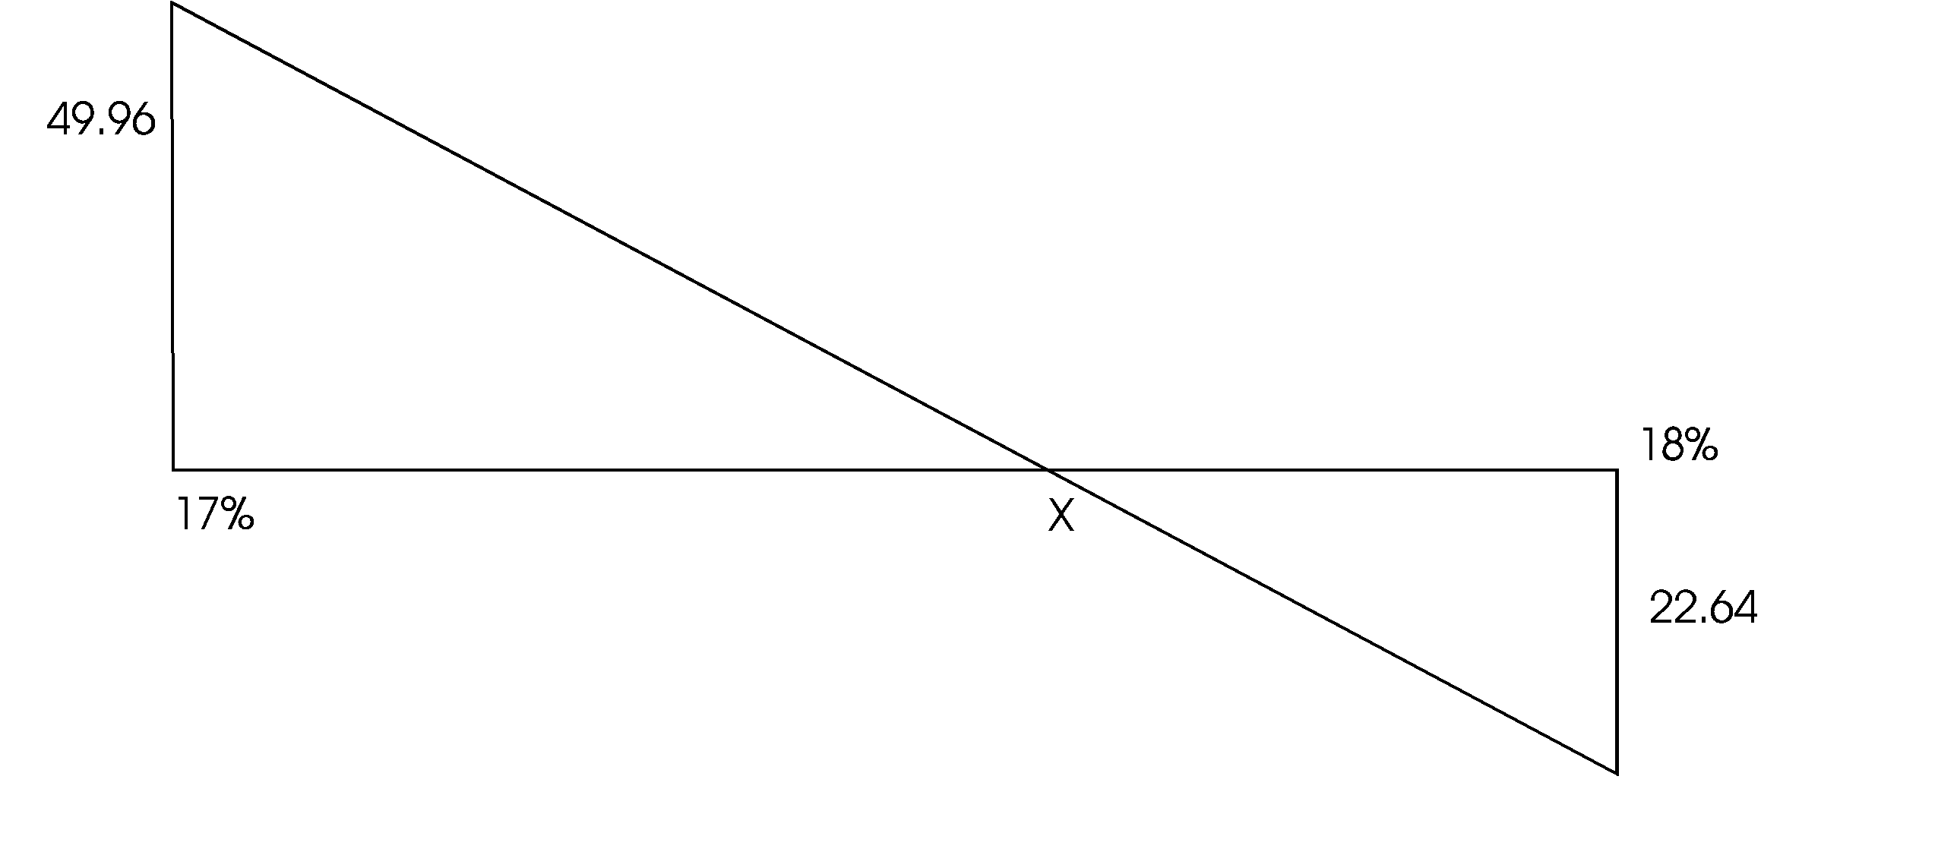

49.96 22.64

X = 17.96 Therefore IRR = 17.96% ≈ 18%

iv. The project should be undertaken because

NPV > O
IRR > cost of capital

Other matters to consider:

- Reliability of the purchasing firm (Demand)
- Effect of the project on staff

3. (a) Depn = 2,200,000 - 200,000 = Sh 200,000
10

expected cash earnings = 400,000(0.4) + 500,000(0.6)
= 460,000

Expected cash flows: Sh
Expected cash earnings 460,000
Less Depreciation 200,000
260,000
Less tax 40% 104,000
156,000
Add back depreciation 200,000
Expected annual cash flows 356,000

(b) NPV = 356,000 x PVIFA_{12%, 10 yrs} + 200,000 x PVIF_{12%, 10 yrs} - 2,200,000
= 356,000 x 5.65 + 200,000 x 0.322 - 2,200,000
= (124,200)

It should not be accepted

(c) Replacement

INCREMENTAL SALVAGE = 200,000 - 40,000 = 160,000

Tax savings in year 10 = 160,000 x 0.4 = 64,000
Cash flow in the 10th year = 224,000

NPV = 356,000 x PVIFA_{10%, 10yrs} + 224,000 x PVIFA_{10%, 10yrs} - 2,200.000
= 356,000 x 6.145 + 224,000 x 0.386 - 2,200,000
= Sh 74,084

The project should be replaced.

(d) i. The discount rate will not be accurate.
ii. No secondary market for the project if it has to be replaced.
iii. Information is not available to all investors
iv. Market prices will not be equal to the theoretical value of assets.
LESSON 3

1. E(R_{p}) = 1/3 (0.08) + 1/3 (0.15) + 1/3 (0.12) = 0.1167 = 11.67%

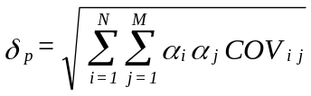

= [(1/3)(1/3)(0.02)² + (1/3)(1/3)(0.16)² + (1/3)(1/3)(0.08)² + 2 (1/3)(1/3)(0.4)(0.02)(0.16) + 2 (1/3)(1/3)(0.6)(0.02)(0.08) + 2 (1/3)(1/3)(0.8)(0.16)(0.08)]^{½}

= (6.373333 x 10⁻³)^{½}

= 0.0798

= 7.98%

2. Required return = R_{F} + (E(R_{m}) - R_{F}) ß_{i}

Security A: Ri = 10% + (15% - 10%)1.3
= 16.5%

Security B: Ri = 10% + (15% - 10%)0.8
= 14%

Security C: Ri = 10% + (15% - 10%)1.1
= 15.5%

Security D: Ri = 10% + (15% - 10%)1.7
= 18.5%

Security Expected Return Required Return
A 17.0% 16%
B 14.5% 14%
C 15.5% 15.5%
D 18.0% 18.5%

Security D is overvalued while security A and B are undervalued. Security C is properly valued.

(b) R_{F} = 12%
E(R_{M}) = 16%

Security A: Ri = 12% + (16% - 10%) 1.3 = 17.2%
Security B: Ri = 12% + (16% - 12%) 0.8 = 15.2%
Security C: Ri = 12% + (16% - 12%) 1.1 = 16.4%
Security D: Ri = 12% + (16% - 12%) 1.7 = 18.8%

Securities A, B, C, and D will all be overvalued.

3.

(a) SECURITY A

STATE OF ECONOMY PROB. RETURN [Ri - E(Ri)]² [Ri - E(Ri)]Ri

Recession 0.25 10.0% 12.25% 3.0625
Average 0.50 14.0% 0.25 0.125
Boom 0.25 16.0% 6.25 1.5625
Expected Return 13.5 Σ[Ri - E(Ri)]² = 4.75%

Variance = 4.75%

Standard deviation = 2.179%

Coefficient of variation = 3.179
13.5 ≡ 0.16

SECURITY B

STATE OF ECONOMY PROB. RETURN [Ri - E(Ri)]²Pi

Recession 0.25 9.00% 4.515625%
Average 0.50 13.00% 0.03125
Boom 0.25 18.00% 5.640625
E(R) 13.25% 10.1875%

Variance = 10.19%

Standard deviation = 3.19%

Coefficient of variation = 3.19
13.25 = 0.24

SECURITY C

STATE OF ECONOMY PROB. RETURN [Ri - E(Ri)]²Pi

Recession 0.25 14% 1
Average 0.50 12% 0
Boom 0.25 10% 1
E(R) 12% 2

Variance = 2%

Standard deviation = 1.41%

Coefficient of variation = 1.41
12 = 0.1%

(b) CORRELATION COEFFICIENT

A & B
Probability (R_{A} - ER_{A}) (R_{B} - ER_{B}) (R_{A} - ER_{A})(R_{B} - ER_{B})P_{i}

0.25 -3.5 -4.25 3.71875
0.50 0.5 -0.25 -0.0625
0.25 2.5 4.75 2.96875
COV_{AB} 6.625

τ_{AB} = COV _{AB} = 6.625 = 0.953
δ_{A} δ_{B} (2.179)(3.19)

A and C

Probability (R_{A} - ER_{A}) (R_{C} - ER_{C}) (R_{A} - ER_{A})(R_{C} - ER_{C})Pi

0.25 -3.5 2 -1.75
0.50 -0.5 0 0
0.25 2.5 -2 -1.25
COV _{A & C} -3.00

τ_{AC} = -3.00
(2.179)(1.41) = - 0.976

B and C

Probability (R_{B} - ER_{B}) (R_{i} - ER_{i}) (R_{B} - ER_{B})(R_{i} - ER_{i})P_{i}

0.25 -4.25 2 -2.125
0.50 -0.25 0 0
0.25 4.75 -2 -2.375
-4.5

τ_{BC} = -4.5 = -1
(3.19)(1.41)

(c) E(R_{p}) = 1/3(13.5%) + 1/3(13.25%) + 1/3(12%)

= 12.83%

(d)
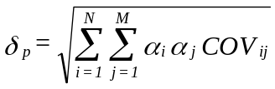

= [(1/3)(1/3)(4.75) + (1/3)(1/3)(10.19) + (1/3)(1/3)(2) + 2(1/3)(1/3)(6.625) + 2(1/3)(1/3)(-3) + 2(1/3)(1/3)(-4.5)]^{½}

= √1.6877778

= 1.3%

LESSON 4
1. (a) A B

EPS 20m = Sh 2 4m = Sh 4
10m 1m

MPS 2 x 18 = Sh 36 4 x 10 = Sh 40

Combined EPS = 20 + 4 = 24 = Sh 2.18
11 11

The EPS for A's shareholders increases from Sh 2 to Sh 2.18 while that of B's shareholders reduces from Sh 4 to Sh 2.18, since the exchange ratio is 1:1.

Market Value Exchange ratio = Market Price/Share of acquiring company x No. of shares offered
Market price per share of the acquired company
= 36 x 1
40
= 0.9

The merger is not likely to take place since shareholders of the acquired company will not accept less than their shares worth.

(b) If the exchange ratio 2:1

Total number of shares = 10m + 2 x 1 = 12m

Combined EPS = 24 = Sh 2
12

Effective EPS for shareholders of B = 2 x 2 = Sh 4

Both the companies shareholders will not gain nor lose at this exchange ratio if EPS method is used. However using MPS then

Market Value Exchange Ratio = 36 x 2
40

= 1.8

The shareholders of B gets more than their market value.

The merger is likely to occur if the shareholders use MPS.

(c) At an exchange ratio of 1.5:1

Total no. of shares = 1.5 + 10 = 11.5m

Combined EPS = 24 = Sh 2.087
11.5

Effective EPS for B's Shareholders = 2.087 x 1.5

= Sh 3.13

Shareholders of A will gain since EPS increase by Sh 0.087 while shareholders of B will lose using the EPS, the mergers is not likely to occur.

Using MPS

Market Value Exchange Ratio = 36 x 1.5 = 1.35
40

Shareholders of B get more than their shares worth and thus should accept the merger.

(d) I would recommend an exchange ratio of 1.5 shares since shareholders use the MPS rather than the EPS in carrying out their analysis. This ratio is fairer to both A's and B's shareholders.

2. (a) This question requires a discussion of a case where combined EPS is greater than the addition of the EPS of both companies (Refer to illustration 4.2 in Lesson 4).

(b) (Refer to 1.1 in Lesson 4).

3. (a) COMBINED EPS

No. of ordinary shares = 100,000 + 250,000 x 2
5
= 100,000 + 100,000
= 200,000

Total combined earnings = 200,000 + 500,000 = Sh 700,000

Combined EPS = 700,000 = Sh 3.50
200,000

Combined MPS = Combined EPS x P/E ratio of X
= 3.50 x 50
= Sh 175

Assumption price earning ratio of combined firm is equal to P/E ratio of X Ltd.

(b) To answer this question we need to compute effective wealth of Y Ltd shareholders.

Effective MPS = 2 X 175 = Sh 70
5

The wealth of both shareholders increases

Effective EPS for Y's shareholders = 3.50 x 2/5

= Sh 1.40

EPS for Y's shareholders however decreases.
However, using MPS wealth may be said to be created for the shareholders.

Note:
However, the limiting assumption that combined P/E ratio = P/E ratio of the acquiring company.

LESSON 5
ANSWER ONE
a) Minimizing government borrowing requirements

                - A lower public sector borrowing requirement (PSBR) will reduce the total market demand for long term funds, since the government's demand for funds will be lower. This could result (through supply and demand) in lower long term interest rates, and so make it cheaper for businesses to raise long term debt capital.
                - In theory, if long term debt capital is cheaper, a company's overall cost of capital should fall, and so companies might be encouraged to invest in more marginal capital expenditure projects.
                - Since investors, particularly institutional investors, might be unable to invest as much as before in gilts, more investment capital might be diverted into shares, thus pushing share prices up.
                - The purpose of reducing the PSBR might be to control the growth in the money supply, as a means towards keeping inflation under control. If such a policy is successful, lower inflation would affect companies' costs and prices, as well as the general state of the economy.
                - If the PSBR is reduced to zero, and if the country has a balance of payments deficit on current account, the deficit would have to be financed by private sector borrowing from abroad, or by the sale of assets by the private sector. This would have implications for the ownership of some firms in the country and for divestments of foreign subsidiaries.

Reducing tax on incomes

  - Lower income tax is thought by some economists to provide greater incentives to entrepreneurs and employees to work harder. If so, the consequences of lower taxes would include more new businesses, greater productivity and stronger industrial growth.
  - Lower income taxes would leave consumers with more income after tax. This could be saved, or invested in the stock market. Alternatively, the extra income might be spent, leading to a growth in consumer spending. Higher consumer spending will increase market demand for firms' goods and services. If a consumer-spending boom is too fast, the rate of inflation will increase.
  - It is possible that if employees have more after-tax income because of lower taxation, annual wage settlements will be lower than they otherwise would be, because employees are already better off.
  - Lower taxes on the profits of companies will leave companies with bigger after-tax profits which they can either re-invest or pay out as dividends.

(b) Reductions in public expenditure

    - If the government spends less, the firms that supply the government will suffer a loss of business; for example, a firm of defense equipment manufacturers might suffer a loss of orders. Firms suffering a loss of business will need to look to other markets for sales growth, perhaps by exporting more. If they fail to do this, their sales turnover and profits will fall.
    - A consequence of lower public expenditure is likely to be a reduction of government assistance for industry. Grants and subsidies might be cut, and government offices that provide specialist advice to industries might be closed.
    - It is conceivable that the cuts in public expenditure might persuade firms to pay for services or benefits that have been lost. This would increase firms' costs. (For example, a cut in public health services might persuade a firm to spend more on in- house medical services for its employees.)
    - Lower government spending will probably create new competitive opportunities for firms in the private sector. For example, lower government spending on schools and hospitals will create more market opportunities for private schools, private hospitals, private education funding schemes, medical insurance schemes and so on.

Increases in nationalized industries prices

      - While government finances will benefit from the increased revenue, for companies that buy the goods and services of nationalized industries, higher prices will result in higher production costs. Higher costs in turn mean lower profits, unless they put their own prices up.
      - Employees are likely to suffer from the higher prices of the nationalized industries, and there will be higher annual wage demands.
      - (If demand for the goods and services of the nationalized industries falls, because of higher prices, suppliers of materials and services to the nationalized industries will suffer a loss of business. However, they might be able to raise their own unit prices.
      - Higher prices from nationalized industries will, in industries where there is private sector competition, make the goods of the private sector firms more competitive.

Selling nationalized assets

            - The sale of nationalized assets could result in the creation of a competitive private sector market
            - The opportunity might arise for firms to purchase some of the assets that are being sold off, or to buy shares in the privatized business.
            - The government will benefit from the revenue generated by asset sales. With large privatizations, there might be an effect on the general level of share prices, since the stock market will be flooded with new shares for sale.
            - One consequence of privatization might be higher prices for customers. The nationalized industry, just before or just after privatization, is likely to put up its prices, in order to become more profitable and so be more attractive to investors. This would result in higher costs for firms that buy goods and services from these industries.
            - A further consequence of privatization might be a change in buying policy by the privatized company, to a more commercial footing. There might, for example, be a greater willingness to buy from abroad. This would have implications for supplier firms.

ANSWER TWO
              - The amount which the government has to borrow each year to finance public spending is called the Public Sector Borrowing Requirement (PSBR).
Expenditure on public hospitals will increase the PSBR if the expenditure is funded from increasing the government's borrowings, but will have a neutral effect on the PSBR if it is funded instead from increased taxation. This is because the PSBR reflects the gap between the government's income (mainly taxation) and it’s spending.
Expenditure on a major hospital refurbishment is likely to be incurred over a period of more than one year, while the benefit of the refurbishment should arise over many more years into the future. However, the effect on the government's accounts will arise when the expenditure is incurred because of the cash accounting methods employed by the government, which does not currently encompass the matching concept of the private sector accounting framework. The investment could be appraised using a cost-benefit model which evaluates the social costs and the social benefits of an investment project over its anticipated life.
              - Governments can assist company financing through direct and indirect means as follows.

                - Interest rate policy. The government can exert direct control over the level of interest rates. It might pursue a high interest rate policy with the primary purpose of restricting consumer credit, and one side effect of this will be to raise the cost of finance for companies. However, such a policy can also be of help to a company since it may serve to attract foreign investment and thus improve the availability of finance. High interest rates will also serve to support the exchange rate, and this may reduce the need for external financing for importers since they are able to generate funds internally through better margins.

A low interest rate policy is often pursued with the aim of promoting industrial growth. The cost of finance to industry is reduced, allowing firms to compete more easily against foreign competition. The currency is likely to be weaker, and therefore exporters are able to earn better margins and to generate more funds internally.
                - Demand management. The government will often try to achieve growth in aggregate demand by creating conditions which promote industrial investment and which seek to improve the balance of payments. This may involve help for exporters who are again able to earn better margins and thus to generate more funds internally.
                - Encouragement of free market forces. Governments try to stimulate economic growth (and therefore investment) by a greater liberalization of markets and by attempting to open up wider global markets
                - Regional aid. This can be administered on a national and on a reginal level. The aim is to help areas with a depressed local economy to achieve economic growth. In order to do this direct grant aid may be available to companies who locate in assisted areas.
                - Selective national assistance. Where the government wishes to promote the development of a particular industrial sector that is seen to have strategic importance for the national economy, assistance may be given.
                - Fiscal incentives. The government may seek to encourage investment through the tax system. Capital allowances are available on capital expenditure, and the fact that corporation tax is collected in arrears, can help company cash flows.
                - Export Credit Guarantee Department. This provides long-term guarantees to banks on behalf of exporters.

ANSWER THREE
On the scale of the country as a whole, the selling off of profitable publicly owned undertakings will make no difference to the wealth of the nation, since the GDP will remain unaltered. However, the distribution of wealth will change since profits no longer go in full directly to the government, but will be attributable to the shareholders after taxes have been paid.

The proceeds of sale will provide a future stream of potential cash flows (eg reduced government debt servicing costs) for the government that will, at least partially, offset the loss of revenues, and taxes will be- received on the privatized companies' profits. These potential inflows are likely to be smaller than the former profit stream, and therefore the taxpayer who is not also a shareholder will lose out. However, in practice it has generally been the case that profits have increased following privatization, and in this situation it is often true that taxes paid exceed former profits. As a result, the government and the taxpayer benefit.

Thus it is not sufficient to look at the simple effect of privatization on the distribution of revenues: it is also necessary to consider the likely effect of the changes on the efficiency and profitability of the company.

LESSON 6
1. NET INCOME APPROACH
FIRM A FIRM B
Shs Shs
Net operating income 1,000,000 1,000,000
less interest 300,000 —
700,000 1,000,000
less tax (60%) 420,000 600,000
Earnings available to owners 280,000 400,000

Market value of equity 280,000 400,000
0.1 0.1

= 2,800,000 = 4,000,000
Add Market value of debt 6,000,000 —
Total value of the firm 8,800,000 4,000,000

NET OPERATING INCOME APPROACH

Market Value of equity 1,000,000 - 300,000 1,000,000
0.1 0.1

= 7,000,000 = 10,000,000
Market Value of debt 6,000,000 0
Total value of the firm 13,000,000 10,000,000

K_{O} = Ke - (Ke - Kb) D/V

FIRM A

Kb = 0.05 (100% - 60%) = 0.02

K_{O} = 0.1 - (0.1 - 0.02) 6/10 = 0.052 = 5.2%

FIRM B

K_{O} = 0.1 - 0 = 0.1 = 10%

Firm A has the optimal capital structure because it is utlising debt.

(c) Arbitrage Process

Sh
Ownership in Firm A = 1% x 7m = 70,000
Leverage attributable to investor = 1% x 6m = 60,000
130,000

Sell shares of Firm A and then buy 1% of Firm B
Borrow Sh 60,000 and lend the excess funds.

INVESTORS INCOME Sh Sh
1% of Firm B's income 10,000
Less interest on homemade leverage (5%) 3,000
7,000
Add interest from borrower (5% x 30,000) 1,500
8,500
If the investor remained in A his income would have been

1% [1,000,000 - 0.05 (6,000,000)] = Sh 7,000

Net borrowing = Sh 30,000

Cost of borrowing = 5% x 30,000 = Sh 1,500

2. (a) R_{i} = R_{F} + (ER_{M} - R_{F})ß_{i}

R_{i} = 10% + (15% - 10%) 1.4

= 17%

(b) Implications

Discuss the Assumptions of CAPM
which are given in the text.

3. i. Value of U

V_{u} = EBIT = 2,000,000 = Sh 20 million
K_{Ou} 0.1

Value of L

V_{L} = V_{U} = 2,000,000 = Sh 20 million
0.1
ii. Cost of Equity

K_{eu} = 10% as given

K_{eL} = K_{eu} + (K_{eu} - K_{b}) D/E

= 10% + (10% - 5%) 10/20

= 15.0%

iii. Overall Cost of Capital

K_{OU} = K_{eu} = 10%

K_{OL} = K_{eL} (E/V) + K_{d} (D/V)

= 15.0% (10/20) + 5% (20/20)

= 10% = K_{OU}

iv. Market value of equity

U = Sh 20 m L = Sh 12 m

Earnings available to shareholders

For U = Sh 2,000,000 For L = Sh 2,000,000 - 0.05 x 10m
= Sh 1,500,000
A shareholder who owns 10% of equity share of Company L could sell 10% equity interest in the company for Sh 1.2 million and buy 10% equity of U Ltd for Sh 2 million. This will be done by using Sh 1.2 million of his own fund and borrowing the difference Sh 800,000 at 5% interest.

His expected return will be:

10% of Firm U's earnings = 10% x 2m = Shs 200,000
less interest 5% x 800,000 40,000
Net earnings 160,000

The shareholder gets more income without chaning his risk.

LESSON 7
1. (a) Since the issue price is expected to lead to an increase in earnings, the total market value of equity will be expected to rise by the present value of the incremental annual profits.

P.V of incremental profits
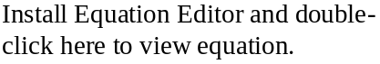

Where K_{e} is the cost of equity.

Using the dividend yield model, K_{e} = d₁ + g
P_{O}

Since the growth rate is not given it is assumed to be equal to zero. Therefore

K_{e} = 0.4 = 0.2 or 20%
2

Incremental value of the firm = 950,000 = £ 4,750,000
0.2

Incremental funds = 10,000,000 x 1.50 = £3,750,000
4

The value of the shares would therefore rise by a net £ 1,000,000 (4,750,000 - 3,750,000).
The cum-right value of existing shares will therefore be expected to rise by
1,000,000 = £0.1
10,000,000

Therefore the cum-right price at at the eve of the rights issue will be £2.10 (2 + 0.1).

(b) The ex-right price

P_{S} = £1.5
P_{O} = £2.0
S_{O} = 4
S = 1

P_{X} = 1.50 + (2.10 - 1.50) 4/5
= £1.98

(c) If the funds raised were used to redeem loan stock, the increase in annual earnings would be:
£
Savings on interest (8% x 3,750,000) 3,000,000
Less tax relief on interest (50%) 150,000
Increase in earnings 150,000

If the cost of equity remains at 20%, the increase in the market valuation of equity would be:

£150,000 = £ 750,000
0.2

The rights issue will raise £ 3,750,000 but the increase in market value is only £750,000. There would, therefore, be a capital loss of £ 3,000,000.

The cum-right price of the existing 10 million shares will be expected to reduce by

3,000,000 = £ 0.30
10,000,000

New price = £2 - 0.3 = £1.70

2. (a) We can assume that penalty and interest during overlap are allowable for tax purposes.

Calculation of initial investments outlay
Sh
Direct penalty 10% (10m) 1,000,000
Add: 2 months of interest overlap
(0.15(10m) x 2/12 250,000
Issuing cost 600,000 850,000
1,850,000
Less tax @ 40% 740,000
1,110,000

(b) Calculating the annual cash benefit to be derived from refinancing the current debenture
Sh
Interest with current loan 15% (10m) 1,500,000
Less interest with proposed rate 13% (10m) 1,300,000
Before tax interest savings 200,000
Less tax @ 40% 80,000
120,000
Add issuing cost tax shield (600,000/10) 40% 24,000
Net cash influence 144,000

(c) NPV = 144,000 PVIFA _{Kd, 10 yrs} = 1,110,000

K_{d} = 0.13(1 - 0.4) = 8%

NPV = 144,000 (6.71) - 1,110,000
= Sh (143,760)

The refunding is not advantageous since it results in negative NPV.
LESSON 8
1. (a) A free trade area exists when there is no restriction on the movement of goods and services between countries. This may be extended into a customs union when there is a free trade area between all member countries of the union, and in addition there are common external tariffs applying to imports from non-member countries into any part of the union. In other words, the union promotes free trade among its members but acts as a protectionist bloc against the rest of the world.
A common market encompasses the idea of a customs union but has a number of additional features. In addition to free trade among member countries there is also complete mobility of the factors of production. A British citizen has the freedom to work in any other country of the European Community, for example. A common market will also aim to achieve stronger links between member countries, for example by harmonising government economic policies and by establishing a closer political confederation.

(b) The most obvious benefits which countries might gain from forming a common market are associated with free trade between them. The benefits of free trade are illustrated by the law of comparative advantage which states that countries should specialise in producing those goods where they have a comparative advantage. Specialisation, together with free trade, will result in an increase in total output and all countries will be able, to a great or lesser extent, to share in the benefits.
In particular, different countries have different factor endowments and, as the international mobility of these factors tends to be severely limited, trade increases the range of goods and services available in a particular country. By becoming part of a common market, imports from other member countries are available more cheaply and easily. Imports of certain raw materials or types of capital equipment not otherwise available in a particular country will improve its productive potential, enabling a faster rate of economic growth to be achieved.

Similarly, improvements in the range and quality of consumer goods available will tend to enhance a country's standard of living.

In addition, there is a larger market for domestic output and firms may be able to benefit from economies of scale by engaging in export activities. Economies of scale improve efficiency in the use of resources and enable output to be produced at lower cost. This also raises the possibility of benefits to consumers if these cost savings are passed on in the form of lower prices. In addition, the extension of the market in which firms operate increases the amount of competition they face and hence should improve efficiency.

Establishment of a common market is often accompanied by some form of exchange rate agreement between members and this in turn is likely to encourage further trade as it reduces uncertainty for both exporters and importers. Stability of exchange rates is also beneficial to a government in formulating its domestic economic policies.

Membership of a common market may be particularly beneficial to smaller or weaker economies, as in addition to increasing the availability of essential factors of production and the range of goods and services available to domestic consumers, it also enables them to benefit from any economic growth experienced by their fellow members. Spin-offs may be in the form of larger markets for their exports, lower import prices, improved employment opportunities and so on.In addition to fostering economic ties between countries, common markets provide the basis for stronger political links. Again, this may be particularly important for smaller countries enabling them to benefit from an enhanced position in the world economy. It may also encourage further international economic co-operation, in turn providing an additional stimulus to growth.

2. (a) Foreign exchange exposure can be defined as the vulnerability of the group to risk arising from its transactions denominated in more than one currency. For an international company, exposure may arise in three ways:

i. Transaction exposure. This arises as a result of the time taken to complete normal trading transactions. For example, there is normally a time delay between invoicing and receipt of payment. During this time the exchange rate may move against the supplier causing a loss to be made in the settlement of the account and its conversion into a different currency.
ii. Translation exposure. This arises when the group holds assets and liabilities which a denominated in different currencies. The value of these items will fluctuate with the exchange rate and this may influence lenders and investors in their dealings with the group.
iii. Economic exposure. This relates to the longer term competitiveness of the group and arises from the economic performance of the countries in which the group operates and with which it trades. For example, the group might decide to serve the European market from a facility in France. If the franc strengthens, then the competitiveness of the operation will be eroded.

(b) The precise policy to be adopted will depend on the group's attitude to risk. Difference approaches and techniques are available to handle the different types of exposure described above.

i. Transaction exposure

(1) Forward exchange contracts can be used to arrange to buy or sell currency at a predetermined future date and rate. Such contracts can be matched to known future operational transactions to reduce the uncertainties associated with exposure. However, the group may miss the opportunity to make a profit on the exchange rate.
(2) Matching receipts and payments in a given currency, generally using a bank account denominated in that currency, is another means of minimising exposure to risk.
(3) Using the currency market to borrow or lend amounts in local currency immediately which will subsequently be offset against the payment or receipt which has to be made in the future.
(4) Currency options can be useful in situations where the actual date and amount of the transaction are uncertain, for example where the company issues a price list in a local currency. the company buys an option to buy or sell currency at an agreed rate and date in the future. If exchange rate movements are unfavourable, the option can be abandoned. Options are expensive, but they do allow the company to take advantage of any favourable movements in rates as well as avoiding any losses.
(5) Currency swaps may be made directly with another company or through a bank.
The futures market can be used to hedge against possible gains or losses on exchange.

ii. Translation exposure can be minimised by ensuring that as far as possible assets and liabilities denominated in given currencies are held in balanced amounts. However, if the group is willing to tolerate a higher level of risk then it may try to arrange its financial structure to take advantage of the relative strengthening or weakening of the different economies.

iii. Economic exposure is harder to avoid since much longer term decisions are involved, such as where to locate production facilities. However it can be reduced by diversifying the trading base across different countries. Capital structure decisions will also be important.

KASNEB PAST PAPER QUESTIONS
KENYA ACCOUNTING TECHNICIANS CERTIFICATE EXAMINATION
CPA PART III

YEAR 2000 SYLLABUS – PILOT PAPER

FINANCIAL MANAGEMENT

July 2000 Time Allowed: 3 hours

Answer ALL questions. Marks allocated to each question are shown at the end of the question. Show ALL your workings.

1. (a) Agency theory presents the firm as a combination of competing interest groups, two of which
are shareholders and management.

REQUIRED
Discuss how the firm’s attitude to risk might vary depending on whether shareholders
objectives or management oriented goals predominate in the firm’s planning. (10 marks)

(b) The directors of Gatimu Ltd are in the process of establishing shareholders utility function.
They have approached Mr. Kilo, the principle shareholder and given him the following lotteries:-

- 0.5 chance of receiving Sh. 0 and 0.5 chance of receiving Sh. 100,000. He is willing to pay a maximum of Sh. 45,000 for this lottery.
- 0.4 chance of receiving Sh.45,000 and 0.6 chance of receiving Sh.100,000. He is willing to pay a maximum of Sh. 85,000 for this lottery.
- 0.3 chance of receiving Sh. 0 and 0.7 chance of receiving Sh. 45,000. He is willing to pay a maximum of Sh. 30,000 for this lottery.

Assume that utile values of 0 and 1 are assigned to a pair of wealth representing the two extremes (Sh 0 and sh. 100,000 respectively).

REQUIRED
Compute the utile value of Sh. 45,000, Sh. 85,000 and Sh 30,000. Construct the utility function of Mr. Kilo and state his risk attitude. (10 marks)
(Total: 20 marks)

2. (a) What is meant by separability theorem? How does this contradict the “interior decorator” school ofthought? (10 marks)

(b) An investor is evaluating six portfolio with the following characteristics:

Portfolio Portfolio Portfolio
Expected Standard
Return (%) Deviation (%)
1 19 8
2 25 12
3 16 6
4 32 16
5 22.5 10
6 8 2
The expected return on the market portfolio is 12% with an accompanying standard deviation of 4%. The risk free rate of interest is 5%.

REQUIRED:-
i. Using the capital market line, advise the investor on which of the above portfolios are efficient and inefficient (7 marks)
ii. In the case of an inefficient portfolio in (i) above state what the standard deviation should be for efficiency to be achieved with the given expected return. (3 marks)
(Total: 20 marks)

3 The following information relates to the operations and capital structure of Kagocho Company Ltd.

Installed capacity 1200 units
Actual production 800 units
Selling price/unit Sh.15
Variable cost/unit Sh.10

Fixed cost Sh.

Situation A 1000
Situation B 2000
Situation C 3000

Capital Structure Financial Plan
1 2 3
Sh. Sh. Sh.
Equity 5,000 7,500 2,500
Debt 5,000 2,500 2,500
Cost of debt (For all plans) 12%

REQUIRED:-

(a) (i) Determine operating leverage under situations A,B and C respectively (6 marks)
(ii) Determine financial leverage under financial plans 1, 2 and 3 respectively (6 marks)
(iii) Determine the highest and lowest value of combined leverage (6 marks)
(b) How are the above calculations useful to the financial manager of a company? (2 marks)
(Total: 20 marks)

4. (a) Identify the methods that a financial manager can use to manage risk (8 marks)
(b) Mr. Mambo the financial manager of Littlerock Ltd is considering investing in a risky project
which would be added to an existing portfolio. He foresees five possible states of the economy as follows:-

State of economy Probability existing Return on Return on
Portfolio proposed
Investment
A 0.2 16% 12%
B 0.4 18% 11%
C 0.2 20% 10%
D 0.1 22% 9%
E 0.1 24% 8%
The risk free market of interest is 9% per annum. Is the proposed project acceptable (12 marks)
(Total: 20 marks)

5. (a) The finance director of XYZ Ltd, recently attended a workshop where the use of financial futures were explained. He has now approached you to prepare a brief for him. (10 marks)

REQUIRED: -
A brief report outlining:
(i) The advantages of financial futures (3 marks)
(ii) Risks of using financial futures (3 marks)
(iii) Internal strategies of minimizing futures risks (4 marks)

(b) Discuss the role of the International Monetary Fund (IMF) and its significance to the activities of multinational companies. (10 marks)
(Total: 20 marks)

KENYA ACCOUNTING TECHNICIANS CERTIFICATE EXAMINATION
CPA PART III

FINANCIAL MANAGEMENT

FRIDAY: 8 December 2000 Time Allowed: 3 hours

Answer ALL questions. Marks allocated to each question are shown at the end of the question. Show ALL your workings.

1. Jabali Ltd is a quoted company which if financed by 10,000,000 ordinary shares and
Sh. 50,000,000 of irredeemable 8% debentures. The market value of the shares is
Sh.20 ex-div and an annual dividend of Sh.4 per share is expected to be paid in perpetuity. The debentures are considered to be risk-free and are valued at par.

Mr. Jabali the managing director of the company is wondering whether to invest in a project which would cost Sh. 20 million and yield Sh.3.8 million a year before tax in perpetuity. The project has an estimated beta value of 1.25. The return from a well-diversified market portfolio is 16%

REQUIRED:

(a) The weighted average cost of capital of the company (5 marks)
(b) The beta of the company (4 marks)
(c) The beta of an equivalent ungeared company ignoring taxes (4 marks)
(d) Advise the company whether or not the project should be accepted. In your explanation,
highlight the significance of your calculations in (a), (b) and (c) above. (7 marks)
(Total: 20 marks)

2. (a) The Arbitrage Pricing Theory (APT) and the Capital Asset Pricing Model (CAPM) have received much attention from practitioners and academicians for use in asset pricing and valuation

REQUIRED:

Explain the conceptual difference between the Arbitrage Pricing Theory (APT) and Capital Asset
Pricing Model (CAPM). (10 marks)

(b) The following are the historical returns for the Anita Computer Company Ltd

Year Anita Computer Company Ltd General Index
1 37 15
2 9 13
3 -11 14
4 8 -9
5 11 12
6 4 9

REQUIRED:

(i) Compute the correlation coefficient between Anita Computer Company LTd. And the
general index. (8 marks)
(ii) Compute the beta for the Anita Computer Company Ltd. (2 marks)
(Total: 20 marks)

3. (a) Futures contracts and options on futures contracts can be used to modify risk.

REQUIRED:
Identify the fundamental distinction between a futures contract and an option on a futures contract and explain the difference in the manner that futures and options modify portfolio risk. (10 marks)

(b) Maendeleo Industries is concerned about interest rates rising. It needs to borrow in the bond markets three months hence the company believes that an option on treasury bond futures is the best hedging device.

(i) Should the company buy a put option or a call option? Explain (3 marks)
(ii) Presently, the futures contract trades at Sh. 1,000 and 3 month put and call options both involve premiums of 1½ per cent based on this strike price. During the 3 months, interest rates rise so that the price on a treasury bond futures contract goes to Sh. 950. What is your gain or loss on the option per Sh. 1,000,000 contract? (4 marks)
(iii) What would be the outcome if the interest rates fell and the price went to Sh.1,030?
(3 marks)
(Total: 20 marks)

4. Gome Drug Products Ltd (GDPL) is faced with several possible investment projects. For each, the total cash outflows required will occur in the initial period. The cash outflows expected net present values and standard deviations are as follows:

Project Cost Sh. ‘000’ Net present value Standard deviations

A 10,000 1,000 2,000
B 5,000 1,000 3,000
C 20,000 2,500 1,000
D 1,000 500 1,000
E 50,000 7,500 7,500

All projects have been discounted at a risk-free rate of 8% and it is assumed that the distribution of their possible net present values are normal.

REQUIRED:

(a) Construct a risk profile for each of these projects n terms of the profitability index (5 marks)
(b) Ignoring size problems do you find some projects clearly dominated by others? (5 marks)
(c) What is the probability that each of the projects will have a net present value 0 (10 marks)
(Total: 20 marks)

5. KK Ltd and KT Ltd are two companies in the printing industry. The companies have the same business risk and are almost identical in all respects except for their capital structures and total market values. The companies capital structures are summarised below:

KK Ltd Sh ‘000’
Ordinary shares (sh. 50 par value) 40,000
Share premium account 90,000
Profit and loss account 73,000
Shareholders’ funds 203,000

KK Ltd shares are trading at sh.140

KT Ltd Sh ‘000’
Ordinary shares (Sh. 100 per value) 50,000
Share premium account 16,000
Profit and loss account 88,000
Shareholders’ funds 154,000
12% debentures (newly issued) 50,000
204,000

KT’s ordinary shares are trading at Sh 170 and debentures at Sh. 100. Annual earnings before interest and tax for each company is Sh. 50 million
Corporate tax is at the rate of 30%

REQUIRED:

(a) If you owned 4% of the ordinary shares of KT Ltd. and you agreed with the arguments of Modigliani and Miller, explain what action you would take to improve your financial position. (4 marks)
(b) Estimate by how much your financial position is expected to improve. Personal taxes may be ignored and the assumptions made by Modigliani and Miller may be used. (8 marks)
(c) If KK Ltd was to borrow Sh. 40 million, compute and explain the effect this would have on the company’s cost of capital according to Modigliani and Miller? What implications would this suggest for the company’s choice of capital structure? (8 marks)
(Total: 20 marks)
KENYA ACCOUNTANTS AND SECRETARIES NATIONAL EXAMINATIONS BOARD

CPA PART III

FINANCIAL MANAGEMENT

WEDNESDAY: 15 June 1994 Time Allowed: 3 hours

Answer ALL questions. Marks allocated to each question are shown at the end of the question. Show all your workings.
1. (a) What are financial futures? (4 marks)
(b) Explain how financial futures could be used as a tool of foreign exchange risk management and the limitations of such strategy. (10 marks)
(Total: 14 marks)

2. (a) Explain what is meant by the "term structure of interest rates". (5 marks)
(b) Describe briefly the major theories which explain the term structure of interest rates. (15 marks)
(Total: 20 marks)

3. A piece of newly developed equipment has been introduced into the Kenyan market. The equipment, now commonly referred to as the "Diesel Master", facilitates the cleaning of diesel truck engines. Western Hauliers owns a fleet of trucks which serve the entire Eastern Africa region. It is now faced with the decision whether to buy this equipment or lease it. The cost price, including incidentals, amounts to Sh 570,000. If leased the instalment payments will be Sh 225,000 per year for five years. These lease payments include service and maintenance costs. The salvage value of the equipment in five years is estimated at Sh 45,000. The company uses straight-line method of depreciation.

If the equipment is owned, service and maintenance charges would average Sh 61,200 per year. The company can borrow an amortizable loan at 22% per annum. Its after-tax cost of capital based on a target debt of total assets ratio of 30% is 18%. Assume a marginal tax rate of 40%.

REQUIRED:

(a) A loan repayment plan (schedule) if money is borrowed to buy the equipment. (10 marks)
(b) A cost analysis to show whether the company should buy or lease the equipment. (Round your figures to the nearest whole number). (14 marks)
(c) State the fundamental assumptions in your calculations. (3 marks)
(Total: 27 marks)

4. Highlands Dairy is considering investing in a new milk cooling system with the following characteristics:

A Initial investment: Sh 7,360,000 no scrap value
B Expected economic life: 5 years
C Sales Volume: 1,120,000 litres per annum
D Selling price: Sh 15 per litre
E Variable Costs: Sh 11 per litre
F Fixed costs excluding depreciation Sh 1,628,000 per annum

The company's hurdle rate is 15% and uses straight line method of depreciation. Its marginal tax rate is 40%.

Required:

(a) Calculate the project's internal rate of return (IRR). (5 marks)

(b) Recalculate the IRR assuming each of the characteristics A, C, D and E above, in isolation, varies adversely by 10%. (Round your IRR to the nearest whole percentage). (20 marks)

(c) Comment briefly on the vulnerability of the four variables in (b) above and suggest what further work needs to be done to improve the value of sensitivity analysis undertaken.
(4 marks)
(Total: 29 marks)

5. ETC Ltd. is planning to pay Sh 7,500,000 as dividends payable by cheque to its shareholders on 18 July. Historical records indicate that none of the cheques clears through the firm's bank until fourth day after mailing. It takes another five days for the balance of the cheques to clear. This pattern is depicted in the following table:

Days since Mailing % Expected to clear this Day
4 5
5 18
6 31
7 25
8 14
9 7
100

ETC's policy is to deposit into its current account each day the amount that is expected to clear plus 4% of the total payment as a safety amount.

Required:
How much money should the firm deposit each day to meet the planned dividend payment?
(10 marks)
Discount Factors (5 Years)

 | 1% | 2% | 3% | 4% |  | 10% | 12% | 14%
PVF | .951 | .906 | .863 | .822 | .... | .621 | .567 | .519
PVAF | 4.854 | 4.713 | 4.580 | 4.452 | .... | 3.791 | 3.605 | 3.433

 | 16% | 18% | 20% | 22% | 24% | 26% | 28% | 30%
PVF | .476 | .437 | .402 | .370 | .344 | .315 | .291 | .269
PVAF | 3.273 | 3.127 | 2.991 | 2.864 | 2.745 | 2.635 | 2.532 | 2.436

MODEL ANSWERS TO KATC PAST PAPERS
MODEL ANSWERS TO THE PAST PILOT EXAMINATION PAPER SET IN JULY 2000

ANSWER 1

(a) The agency theory of the firm sees the company as a team whose members act in their own self interest but who at the same time accept that their individual success is dependent on the survival of the company in competition with other firms.
Traditional theory holds that the main objective of a company is to maximise the wealth of the ordinary shareholders and thus much attention has been directed to the attitudes and desires of the shareholders.
The return to the shareholders will be maximised through some combination of dividend payments and capital growth. In general, a shareholder will prefer a certain current income to an uncertain future income. In other words will demonstrate risk aversion. In practical terms, this means that shareholders will prefer to see a satisfactory level of dividends in the short term rather than sacrifice these in the expectation with a greater level of risk attached. The effect of this on policy making within the firm is that there will be some tendency towards short termism and risk avoidance; however at the same time there will be a concern to secure the survival and growth of the firm in the long-term which tampers this tendency. It is also true that a shareholder can spread his risk by investing in a number of different companies and therefore he may well be prepared to accept a degree of risk in an individual company in anticipation of higher returns.

Managers on the other hand are in a significantly different position. Their financial security is primarily determined by the futures of the employing company. In practice this means that they are likely to be more risk averse in their decision making. The difference is that managers are interested in the total risk position of the company while a diversified shareholder is only interested in the systematic risk of the company.

Due to the separation of ownership and control these factors mean that in practice organisations often behave differently from the manner predicted by traditional theory. The agency theory of the firm seeks to provide a behavioural explanation for some of these divergences.

(b) U(Sh. 45,000) = 0.5 U(Shs) +0.50 (Sh. 100,000)
= 0.5 x 0 + 0.5 x 1 = 0.5
U(Sh. 85,000) = 0.4 U(Sh 45,000) + 0.6 U(Sh. 100,000)
= 0.4 x 0.5 + 0.6 x 1 = 0.8
U( Sh. 30,000)= 0.3 U(Sh. 0) + 0.7 U(Sh. 45,000)
= 0.3 x 0 + 0.7 x 0.5
= 0.35

The points are

Wealth (X) Utilities (Y)
Sh Sh
30,000 0.35
45,000 0.50
85,000 0.80
100,000 1

1.0
0.9
0.8
0.7
0.6
0.5
0.4

0.3
0.3
0.2
10
20
30
40
50
60
70
80
90
100
0.1

Wealth Sh.’000’

Attitude of investor – approximately risk neutral
The risk attitude is approximately risk neutral.

ANSWER 2
The theorem states that all investors regardless of their attitude towards risk should hold the same mix of risky assets in their portfolio, as show below:-

Capital Market Line (CML)
C •
E(R_{P}) efficient frontier

• M

B •
A•

(R_{f})

Standard Deviation (risk σ)

The crucial differences in portfolios held by investors of differing psychologies are in the mix of risky stocks (taken together) and non-risk stocks. Differing investors will choose different points on the capital market line. In the above figure point M represent the market portfolio and R_{f} is the rate or return on the riskless asset. All investors combine R_{f} and M but in different proportions. The market portfolio is the ‘same mix of risky stocks’. Investors A for example prefers to play safe with emphasis on riskless assets. Person B has most of his funds in market portfolio. Person C has leveraged portfolio having added to his original funds by borrowing at R_{f} and sinking all into the market portfolio.

Interior decorator school of thought

The interior decorator school of thought suggest that different portfolio of risky assets should be prepared for differing investors to suit their tastes. In other words, points other than M on the all risky portfolio should be taken. This will clearly lead to inefficiencies in the presence of riskless asset provided that all the assumptions of CAPM hold. If the assumptions do not hold, in particular the borrowing assumption then the separability theorem falls.

C

M^{II}

B

M^{I}

Rb

A

Rf

0
σp

In the above figure, person A combines the riskless asset with risky portfolio M person B selects his own
interior decorator policy, while C combines yet another risky portfolio with borrowing at R_{b}

(b) (i) R_{P} = R_{F} + (Є(R_{M} ) - R _{F}) δ _{P}
δ _{M}
Portfolio 1 R_{P} = 0.05 + (0.12 – 0.05) δ _{P}
0.04
= 0.05 + 1.75 δ _{P}
for Portfolio 1 = 0.05 + 1.75(0.08) = 0.19
The other portfolios are computed likewise

The others are as follows:

Portfolio Portfolio expected return Portfolio required return
1 19 19 efficient
2 25 26 inefficient
3 16 15.5 super efficient
4 32 33 inefficient
5 22.5 22.5 efficient
6 8 8.5 inefficient

(ii) For Portfolio 2
0.25 = 0.05 + 1.75 δ _{P}
δ _{P} = 11.43%

For Portfolio 4
0.32 = 0.05 + 1.75 δ _{P}
δ _{P} = 0.1543 = 15.43%

For Portfolio 6
0.08 = 0.05 + 1.75 δ _{P}
δ _{P} = 0.01714 = 1.71%

ANSWER 3

(a) (i)
A (Sh.) B (Sh) C(Sh)

Sales 12,000 12,000 12,000
Variable costs 8,000 8,000 8,000
Contribution 4,000 4,000 4,000
Less Fixed costs 1,000 2,000 3,000
EBIT 3,000 2,000 1,000

D.O.G = Contribution = 1.33 2 4
EBIT

(ii) Financial Plan 1
A B C
EBIT 3,000 2,000 1,000
Less interest 600 600 600
EBT 2,400 1,400 400

DFG = EBIT = 1.25 1.43 2.5
EBT

Financial Plan 2
A B C
EBIT 3,000 2,000 1,000
Less interest 300 300 300
EBT 2,700 1,700 700
DFG = EBIT = 1.11 1.18 1.43
EBT

Financial Plan 3:-

A B C
EBIT 3,000 2,000 1,000
Less interest 300 300 300
EBT 2,700 1,700 700

DFG = EBIT = 1.11 1.18 1.43
EBT

(iii) DTG = DOG x DFG

Situations Financial Plan
1 2 3
A 1.66 1.48 1.48
B 2.38 2.36 2.36
C 10 5.72 5.72

The highest is 5.72 and lowest is 1.48

(b) The above calculations helps a manager determine the business and financial risk of his firm.

ANSWER 4
(a) Methods of managing risk:-

A number of techniques to handle risk are used by managers in practice. They range from simple rules of thumb to sophisticated statistical techniques. These methods include:-

- Payback period
- Risk-adjusted discount rate
- Certainty equivalent coefficient
- Sensitivity analysis
- Simulation analysis

Refer to lesson 2 for a discussion of these methods.

(b) E(R) on investment = 0.2 (12) + 0.4 (11) + 0.2(10) + 0.1(9) + 0.1 (8) = 10.5%

Prob R_{M} (R_{M} - R_{M} ) ( R_{M} - R_{M} )P_{t} R_{i} R_{i} - R_{i} (R_{M} - R_{M} ) (R_{i} - R_{i} ) P_{t}

0.2 16 -3 1.8 12 1.5 -0.9
0.4 18 -1 0.4 11 0.5 -0.2
0.2 20 1 0.2 10 -0.5 -0.1
0.1 22 3 0.9 9 -1.5 -0.45
0.1 24 5 2.5 8 -2.5 -1.25
E(R_{M}) = 19 5.8 10.5 -2.9

β_{i} = Covim = -2.9 = -0.5
δ ²_{M} 5.8 R_{i} =R_{F} (E(R_{M}) – R_{F}) B_{i}
= 0.09 + (0.19 – 0.09) (-0.5)
= 0.04 = 4%
NB:Assumption: The Portfolio is well diversified

The project is acceptable since E(R) = 10.5% while the required rate of return = 4%

ANSWER 5
(a)

To: Board of Directors
From: Accountant
Subject: Use of financial futures within the company:

The purpose of this report is to deal with three main areas: the benefit of financial futures: the risks of futures; strategies for the minimisation of future risks.

(i) The benefit of futures
Futures are a form of forward contract which gives a fixed rate for a financial instrument, such as
security prices, exchange rates or interest rates, at a future date. Financial futures can be used
to hedge against risks of movements in:-

- Gilt prices
- Interest rates
- Foreign currency exchange rates
- Share prices
- Bond prices

For a manufacturing company, the principal advantage of future is hedging of interest rates and possibly share prices where the company holds an equity portfolio. Other products such as forward contracts are available for the reduction of exchange rate exposure. A company with a large amount of borrowing that is concerned about possible rise in the level of interest rates could sell interest rate futures in the expectation that if interest rates rise the same type and amount of future contracts could be bought at a cheaper price to close out the futures commitment and the profit made on the futures deals will compensate for any extra interest that the company must pay.

(ii) The risks of futures:-
Futures hedges are unlikely to be perfect for the following reasons:-

- The movement in futures prices may not be an exact reflection of the movement in interest rates.
- Futures contracts are of a standard size and it may not be possible to match exactly the
amount of the borrowings.

(iii) Strategies for the minimisation of futures risk:-
Internal rules should be formulated to allow the use of futures to hedge against known specific financial risks, but to restrict the use of futures in open speculation. Principles to be used include the following:-

      - There should be strick limits on the size of contracts that may be used.
      - The responsibility for reporting on futures activity should be separate from the responsibility
for decision making on futures trading.
      - The use of derivatives should be centralised, with local management not being allowed to
trade in derivatives.
      - Futures activity should be subject to regular detailed scrutiny by independent department
such as internal or external audit, reporting to the audit committee.

(b) Refer to lesson 8 for the answer to this part.

MODEL ANSWERS TO THE PAST CPA EXAMINATION PAPER SET IN DECEMBER 2000
ANSWER 1
(a) WACC

K_{S} = d_{o} = 4 = 20%
p_{o} 20

Kd = 8%
WACC = 8%(50) + 20% (200) = 17.6%
250 250

(b) R_{i} = R _{F} = (E(R _{M} ) - R _{F} ) β_{I}

β _{I} = R _{I} - R _{F} = 20% - 8% = 1.5%
E(R _{M} ) - R _{F} 16 % - 8%

(c) Beta of ungeared firm

β _{I U} = B _{I} = 1.5
1 + B/S (1 – T) 1 + 50 Since T = 0
200
= 1.2

(d) R _{I} = 8% = (16% - 8%) 1.25 = 0.18

NPV = 3,800,000 - 20,000,000 = Sh. 1,111,111
0.18

Decision
Accept the project because NPV>0. Its risk is also lower than the current risk of the company as shown by its beta of 1.25 while the company’s beta is 1.5

ANSWER 2
(a) The basic CAPM assumes that investors care only about portfolio risk and expected return i.e they are risk averse. From this assumption comes the conclusion that a portfolio’s expected return will be related to only one attribute – its beta (sensitivity) relative to the broadly based market porfolio.

Arbitrage Price Theory (APT) takes a different approach. It is not much concerned about investors preferences, and it assumes that returns are generated by a multi-factor model. APT reflects the fact that several major (systematic) economic factors may affect a given asset in varying degrees. Further, unlike the CAPM, whose single factor is unchanging, APT recognizes that these key factors can change over time (as can investor preferences).

Summarizing APT:
- Identifies several key systematic macroeconomic factors as part of the process that generates security returns vs. only one factor recognised by CAPM.
- Recognises that these factors can change over time whereas CAPM’s single factor is unchanging.
- Makes fewer assumptions about investor preferences than CAPM and
- Recognise, that these preferences can change over time.
(b)(i) Year Anita General R _{I} - E(R _{I} ) R _{M} –E(R _{M} ) (R _{I} -ER _{I} )(R _{M} -E(R _{M} )
Index
(R _{M} )
1 37 15 27.33 6 163.98
2 9 13 -0.67 4 -2.68
3 -11 14 -20.67 5 -103.35
4 8 -9 -1.67 -18 30.06
5 11 12 1.33 3 3.99
6 4 9 -5.67 0 0.00
Sum 58 54 Sum = 92.00

E(R) 9.67 9
δ² 201.89 68.33
δ 14.21 8.27

Cov_{im} = 92 = 15.33 r_{im} = Cov_{im} = 15.33_______ = 0.13
6 δ_{i} δ_{m} (14.21)(8.27)

(ii) β _{I} = Cov_{im} = 15.33 = 0.2244
δ_{M}² 68.33

ANSWER 3
(a) A futures contract is an agreement to buy or sell an asset at a certain time in the future for a stated price. Option on futures gives the buyer the right (but not the obligation) to buy or sell a futures contract at a later date at a price agreed upon today. The writer of the call option on futures, upon exercise, establishes a short position in the futures contract at the exercise price. The writer of the put option on futures establishes a short position in the futures contract at the exercise price. The holder of a put option on futures, upon exercise, establishes a short position in the futures contract at the exercise price. The writer of the put option on futures establishes a long futures position at the exercise price. Futures and options can affect the risk and return distribution for a portfolio. In effect, being long (short) in futures is identical to subtracting (adding) cash from (to) the portfolio. Long futures positions have the effect of increasing the exposure of the portfolio to the asset. Shorting futures decreases the portfolio’s probability distribution of returns. Long position’s in futures on the portfolio’s underlying asset increases the portfolio’s exposure (or sensitivity) to price changes of the asset. Shorting futures has the effect of decreasing the portfolio’s sensitivity to the underlying asset. Since options provide the choice of whether or not to exercise the option, it means that options do not have a symmetrical impact on returns.

(b) (i) The company should buy a put option so that if interest rate increase, it can still sell bonds at a future date at a lower interest rate.

(ii) Gain per Sh. 1000 = (1000 – 950)- 1½% x 1000 = Sh. 35
Gain per Sh. 1m contract = 35 x 1,000,000 = Sh 35,000
1000
(iii) Don’t exercise because it is out of the money. The company would loose sh. 15000 premium.

ANSWER 4

(a) Profitability index = PV of cash flows
initial cost

Project PI δ/(cost + NPV)
A 1.100 0.18
B 1.200 0.50
C 1.125 0.04
D 1.500 0.67
E 1.150 0.13

(b) Project A is clearly dominated by both E and C, project B by A, C & E. Project C by none. Project D by all other projects. Project E by C.

(c) Project NPV/δ Probability. Greater than
A 0.5 δ 0.692
B 0.33 δ 0.629
C 2.5 δ 0.994
D 0.5 δ 0.692
E 1.0 δ 0.841
Size problems should not be ignored

ANSWER 5
(a) You should sell the shares of KT Ltd and borrow an equivalent proportional amount of the KT debt. You should use the funds realised to buy 4% of KK Ltd and lend the remaining funds. This is the arbitrage process.

(b) No. of shares owned in KT = 4% x 500,000 = 20,000 shares
value of shares owned = 170 x 20,000 = Sh. 3,400,000
Amount of debt borrowed on behalf = 4% x 50 m = Sh. 2m
Amount to buy 4% shares of KK = 4% x 40,000,000 x 140 = Sh. 4,480,000
50

KK KT
Sh. ‘000’ Sh. ‘000’
EBIT 50,000 50,000
Less interest -___ 6,000
EBT 50,000 44,000
Less tax (30%) 15,000 13,200
EAT 35,000 30,800
Amount attributable to investor (4%) 1,400 1,232

Sh. ‘000’
Earnings from KK 1,400
Less personal interest 12% x 2 m 240
1,160
Add interest earned 110.4
12% (5.4m – 4.480) 1,270.4
Less earnings from KT 1,232.0
Improvement in earnings 38.4

(c) The overall cost of capital will remain the same according to MM. However the cost of equity will increase due to the increased risk.

The value of the firm however will increase since V_{L} = V_{U} + t_{L}B
= 112m + 0.3(40m) = Sh. 124m
Assuming that debt replaces equity, therefore the value of equity would Sh.84 million (124 – 40)

Sh’000’
EBIT 50,000
Interest .12 x 40 4,800
45,200
less tax @ 30% 13,560
31,640
Cost of equity before gearing = Sh.35,000,000 = 31.25%
Sh. 112,000,000

Cost of equity after gearing = Sh.31,640,000 = 37.66%
Sh. 84,000,000

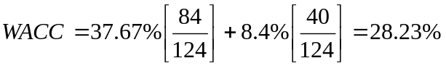 The WACC has dropped from 31.25% to 28.23%
MODEL ANSWERS TO THE PAST CPA EXAMINATION PAPER SET IN JUNE 1994

1. (a) Most financial and real assets transactions occur in what is known as the spot, or cash market. Here the asset is delivered immediately (or within a few days). Futures or future contracts, on the other hand, call for the purchase or sale of a financial or real asset at some future date, but at a price which is fixed today.

Future contracts are divided into two:

i. financial futures and
ii. commodity futures

Financial futures include treasury bills, eurodollar deposits, foreign currencies and stock indexes.

Commodity futures include grains, livestock, fibres, metals etc.

A future contract is therefore a definite agreement on the part of one party to buy something on a specific date and at a specific price and the other party agrees to sell on the same terms.

(b) Financial futures could be used as a tool of foreign exchange risk management by entering into future currency contracts which are standardized contracts that trade on organized future markets. The trader in foreign currency transaction therefore reduces the risk of foreign currency exchange rate fluctuations since he will buy or sell foreign currency at a fixed exchange rate.

The major limitation of using financial futures to hedge risk is transaction costs which tend to be very high. The exchange rate may also move against the future contracts and therefore the trade losses.

2. Refer to Lesson 6 of the Study Pack.

3. (a) Loan repayment plan

Year Outstanding Interest Total payment Outstanding
loan at beg. @ 22% (114,000 + interest) loan at end
Sh Sh Sh Sh

1 570,000 125,400 239,400 456,000
2 456,000 100,320 214,320 342,000
3 342,000 75,240 189,240 228,000
4 228,000 50,160 164,160 114,000
5 114,000 25,080 139,080 0

Loan annual amortisation = 570,000 = 114,000
5

(b) Cost analysis if purchased

Present Value of Interest Payment

Year Interest payment PVIF_{18%} PVs

1 125,400 0.847 10,6213.8
2 100,320 0.718 72,029.76
3 75,240 0.609 45,821.16
4 50,160 0.516 25,882.56
5 25,080 0.437 10,959.96
TOTAL PV 260,907.24
Less PV of salvage value
(45,000 x 0.437) 19,665
PV of Deprn tax shield
[(105,000 x 0.6) x 3.12] 197,001 216,666.00
Net PV of cash outflow 44,241.24

If leased

PV of cash outflow = 225,000 x PVIFA _{18%, 5 yrs} - lease tax shield

= 225,000 x 3.127 - 225,000 (0.6) x 3.127

= 703,575 - 422,145

= Shs 281,430

The purchase decision is better

(c) Fundamental assumptions

i. Lease payments are tax deductible.
ii. The cashflows are discounted at the company's opportunity cost of capital.
iii. Certainty in the cashflows have been assumed.

4. (a) The IRR is the rate of return that equates the NPV to zero. To compute this rate we first compute the projects cashflows.

Annual depreciation = 7,360,000 = 1,472,000
5

Annual cashflows Shs`000'
Sales 15 x 1,120 16,800
Less variable costs 11 x 1,120 12,320
Contribution 4,480
Less fixed costs 1,628
Depreciation 1,472 3,100
Profits before taxation 1,380
Less taxation 40% 552
Add back depreciation 828
Net cashflows 1,472
Net cashflows 2,300

NPV = 2,300 x PVIFA _{r%, 5 yrs} - 7,360 = 0

PVIFA _{r%, 5yrs} = 7,360 = 3.20
2,300

From the tables IRR lies between 16% and 18%.

Using the linear interpolation:
= 17%

Decision - accept the project since IRR > hurdle rate.

(b) (A) Cost = 110% x 7,360 = 8,096

Depn = 8,096 = 1,619.2
5

Annual Cashflows Sh`000'
Contribution 4,480
Fixed costs 3,247.20
1,232.80
Less tax 493.12
739.68
Add back depreciation 1,619.20
Net cashflows 2,358.88

PVIFA_{r%, 5 yrs} = 8,096
2,358.88

= 3.432

From the table IRR ≈ 14%

Decision - Reject the project

(C) New Sales volume = 1,120 x 90% = 1,008
Shs`000'
Sales = 15 x 1,008 15,120
Variable costs 11 x 1,008 11,008
4,032
less fixed costs 3,100
932
less tax 40% 372.8
559.2
Add back depn 1,472.0
Net cashflows 2,031.2

NPV = 2,031.2 X PVIFA _{r%,5yrs} - 7,360 = 0

PVIFA _{r%,5yrs} = 3.623

= 10% + 1.8

= 11.8% ≈ 12%

Decision - Reject the project

(D) Reduction in sales price

New selling price = 90% x 15 = Shs 13.50

Sh
New Sales 1,120 x 13.50 15,120
Less variable costs 12,320
2,800
Less fixed costs 3,100
Profits (300)
Add back depreciation 1,472
Net cashflows 1,172

Note: We assume that tax on negative profit is zero.

NPV = 1,172 x PVIFA _{r%, 5 yrs} - 7,360 = 0

PVIFA _{r%, 5 yrs} = 7,360 = 6.280
1,172

From the tables

IRR is negative. So reject the project.

(E) Variable cost increase by 10%

New variable cost = 11 x 110% = Sh 12.10

Cashflows Shs`000'
Sales 16,800
Variable costs 12.10 x 1,120 13,552
Contribution 3,248
less fixed expenses 3,100
148.0
less tax 59.2
88.80
Add back depreciation 1,472.00
1,560.80

PVIFA _{r%, 5yrs} = 7,360 = 4.716
1,560.8

From tables r ≈ 2%

Decision: Reject the project.

(c) The four variables can be arranged in the following ways in order of vulnerability.

i. Selling price per unit
ii. Variable cost per unit
iii. Sales volume
iv. Initial cost

5. The following table can be used to answer this question:

Day since mailing % expected to clear Amount to deposit
1 0 300,000
2 0 300,000
3 0 300,000
4 5 675,000
5 18 1,650,000
6 31 2,325,000
7 25 2,175,000
8 14 1,350,000
9 7 825,000

Note
We have assumed that the amount deposited and does not clear will be withdrawn before depositing the next days amount.

MOCK EXAMINATION

To be carried out under examination condition and sent to the Distance Learning Administrator for marking by the University.

Time Allowed: 3 hours

Answer ALL questions. Marks allocated to each question are shown at the end of the question. Show all your workings.

QUESTION ONE
(a) Discuss how agency theory explains the relationship between the management and shareholders of a corporation. (8 marks)
(b) How is wealth maximisation as a goal of the corporate firm consistent with agency theory? (8 marks)
(c) Is it true under agency theory that a corporate manager will always undertake projects with positive net present value, under conditions of no capital rationing? Explain. (4 marks)
(Total: 20 marks)

QUESTION 2
Mr. Pesa is very happy with the current aspects of encouraging investments through the Stock Exchange. He wishes to put some money on Q Corporation Shares traded on the Exchange. He has approached you for an evaluation. The returns on the Nairobi Stock Exchange Index (NSE) and on Q Corporation shares are shown below for the five possible states of the economy that might prevail next year.

Economic Condition | Probability | Market Return:  NSE—Index | Q Corporation Return
Rapid Expansion  Moderate Expansion  No growth  Moderate contraction  Serious contraction | 0.12  0.40  0.25  0.15  0.08 | 0.23  0.18  0.15  0.09  0.03 | 0.12  0.09  0.05  0.01  -0.02

REQUIRED:
(a) What is the expected return of Q Corporation shares? (2 marks)
(b) What is the correlation between the returns on the NSE with the return on Q Corporation shares?
(14 marks)
(c) Comment on the results obtained in (b) above. (3 marks)
(d) Mr. Pesa is thinking of undertaking an alternative project but similar to Q Corporation. If the Risk Gree rate of return is 8%, what will be the expected return of this project? Explain the basis of your computation.
(Total 19 marks)

QUESTION THREE
(a) Explain the relationship between cost of capital and inflation and its implications for capital budgeting.
  - The management of Kiboko Corporation have recently attended a seminar where the concept of weighted average cost of capital was mentioned in the discussion. The following information on corporations financing costs has been prepared by the managment accountant.

Type of Financing | Book value  Shs | Market Value  Shs | Before Tax Cost
Long term debt  Short term debt  Ordinary Shares | 25,000,000  25,000,000  50,000,000  100,000,000 | 10,000,000  25,000,000  65,000,000  100,000,000 | 18%  16%  23%

Kiboko Corporation has a debt equity ratio target of 50%. Kiboko's managers would like to keep the market values of short term and long-term debt equal. Assume a tax rate of 405.

REQUIRED:

(i) The weighted average cost of capital (WACC) for Kiboko Corporation using:

• Book value weights;
• Market value weights;
• Target weights. (6 marks)

(ii) Explain the difference between the WACCs and show the correct weights to be used in the WACC calculations. (3 marks)

(c) Kiboko Corporation has the following investments available during the coming year.

Project Outlay Expected Return
Shs
1 100,000 30%
2 400,000 28%
3 200,000 25%
4 1,000,000 23
5 800,000 22%
6 1,000,000 20%
7 2,000,000 19%
8 1,500,000 18%

The firm's average cost of capital is estimated as in (b) above. However, the financial manager has determined that financing the entire budget of Shs 7 million would result in a higher cost of capital, and in fact only Shs 2 million could be raised without increasing the present cost. The cost of raising more than Shs 2 million are estimated as:

Additional Financing Cost of Capital for the
Additional Funds

Shs 2 million (to get Shs 4 million) 19%
Shs 1.5 million (to get Shs 5.5 million) 20%
Shs 1.0 million (to get Shs 6.5 million) 21%
Shs 0.5 million (to get Shs 7 million) 22%

What should the company do? (5 marks)
(Total: 22 marks)

QUESTION FOUR
Future Motors Ltd. Are considering the purchase of a new computer controlled workshop machine to replace the two machines which are currently used for tuning the GLX model. The new machine would result in reduced labour costs because of the more automated nature of the process and in addition, would permit service levels to be increased by creating greater capacity at various stages.
With anticipated rise in demand of the model, it has been estimated that the new machine will lead to increased profits in each of the next three years. Due to uncertainty in demand however, the annual cash flows (including savings) resulting from purchase of new machine cannot be fixed with certainty and have therefore been probabilistically estimated as follows:

Annual Cash Flows (Sh. ‘000’)
Year Cash Flow Probability
1 10 0.30
15 0.40
20 0.30

2 10 0.10
20 0.40
30 0.30
40 0.30

3 10 0.30
20 0.50
30 0.20

You are informed that because of the overall uncertainty in the sales of the GLX model, it has been decided that only three year’s cash flows will be considered in deciding whether or not to purchase the new machine. After allowing for the scarp value of the existing machines, the net cost of the new machine will be Sh.42,000.
The effects of taxes are to be ignored.

Required:
- Identify the combinations of annual cash flows that will lead to an overall negative net cash flow and determine the total probability of this occurring. (5 marks)
Ignore the time value of money in your calculations.
- Based on the average annual cash flows, calculate the NPV of the new machine given that the company’s cost of capital is 15%. (5 marks)
- Analyse the risk inherent in this situation by simulating the NPV calculation. On the basis of your simulation results:

    - Determine the NPV
    - What is the probability of the new machine yielding a negative NPV?

Use the following random numbers in answering part (c) above:
Set A Set B Set C Set D Set E
Year I 4 7 6 5 0
Year II 2 4 8 0 1
Year III 7 9 4 0 3

(10 marks)
(Total 20 marks)

QUESTION FIVE

Stock market analysts sometimes use fundamental analysis and sometimes technical analysis to forecast future prices of shares. What are fundamental analysis and technical analysis? (8marks)

The following is the summarised financial information for Keys Limited:

Profit and Loss Accounts
1993 1994 1995
Sh. (‘000’) Sh. (‘000’) Sh. (‘000’)
Turnover 76,270 89,410 102,300

Taxable income 10,140 12,260 14,190
Taxation 3,549 4,291 4,966
6,591 7,969 9,224
Dividend
Retained earnings

Balance Sheet
1995
(Sh. ’000’)
Fixed assets 54,200
Current assets 39,500
Current liabilities (26,200)
67,500

Ordinary shares (Sh. 0.5 par value) 20,000
Reserves 32,500
10% debentures 1999(Sh.100 par value) 15,000
67,500

As a result of recent capital investments, stock markets analysts expect post tax earnings and dividends to increase by 25% for two years and then to revert to the company’s existing growth rates.
Keys’ asset (overall) beta is 0.763 and beta of equity is 0.82. The risk free rate is 12% and the market return 17%. The current market price of Keys’ ordinary shares is Sh.2.17, cum 1995 dividend, and the debenture price is Sh.89.50 ex interest. Corporate tax is at the rate of 35%.
Required:
  - Using the dividend growth model, estimate what a fundamental analyst might consider to be the realistic (intrinsic) value of the company’s shares. (The cost of capital may be estimated using CAPM). (9 marks)
  - Comment upon the significance of your estimates for the fundamental analyst. (3marks)
(Total 20 marks)

END OF MOCK EXAMINATION
NOW SEND ANSWERS TO THE DISTANCE LEARNING CENTRE FOR MARKING

